**Accuracy vs Learning Rate**

|  |  |
| --- | --- |
| Learning Rate | Accuracy |
| 0.001 | 72 |
| 0.01 | 78 |
| 0.05 | 80.5 |
| 0.1 | 78.5 |
| 0.2 | 76 |

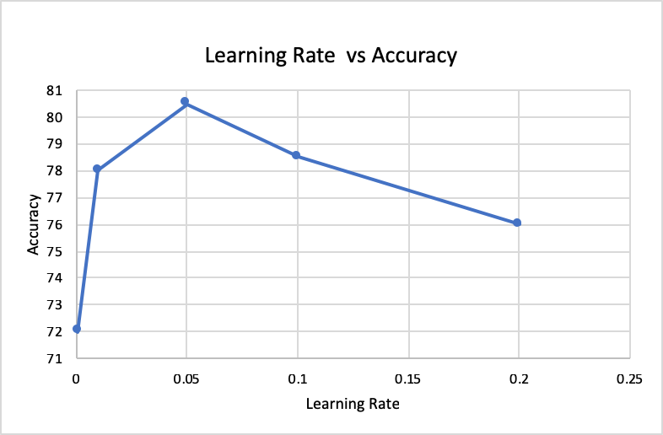

**Accuracy vs Epochs**

|  |  |
| --- | --- |
| Epochs | Accuracy |
| 3000 | 76.5 |
| 2000 | 78 |
| 1000 | 80.5 |
| 500 | 80 |
| 100 | 69 |

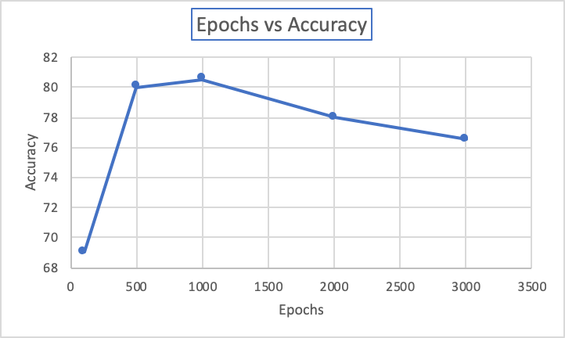

**Accuracy vs Window Size**

|  |  |
| --- | --- |
| Window Size | Accuracy |
| 1 | 86.5 |
| 3 | 76 |
| 6 | 60.5 |

