**Hyper Parameter Tuning:**

1. **Varying Learning Rate**

**Experiment 1:**

Training Data = 2000

epochs = 1000

batch_size = 50

window_size = 3

embeddings_size = 5

Learning_rate = 0.01

Accuracy = 78%

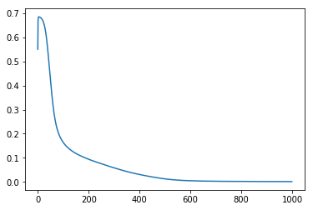

**Experiment 2:**

Training Data = 2000

epochs = 1000

batch_size = 50

window_size = 3

embeddings_size = 5

learning_rate = 0.05

Accuracy = 80.5%

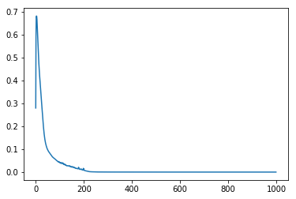

**Experiment 3:**

Training Data = 2000

epochs = 1000

batch_size = 50

window_size = 3

embeddings_size = 5

learning_rate = 0.1

Accuracy = 78.5%

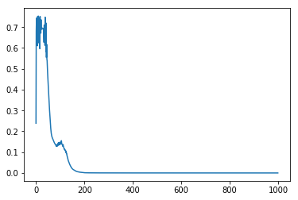

**Experiment 4:**

Training Data = 2000

epochs = 1000

batch_size = 50

window_size = 3

embeddings_size = 5

learning_rate = 0.001

Accuracy = 72%

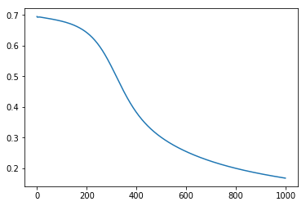

**Experiment 5:**

window_size = 3

embeddings_size = 10

batch_size = 50

epochs = 1000

lr = 0.2

batch_size = 50

Accuracy = 76

**2) Varying Epoches**

**Experiment 1:**

window_size = 3

embeddings_size = 10

batch_size = 50

epochs = 100

lr = 0.02

batch_size = 50

Accuracy = 69%

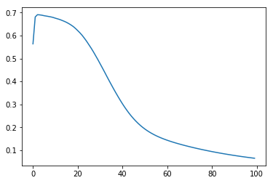

**Experiment 2:**

window_size = 3

embeddings_size = 10

batch_size = 50

epochs = 1000

lr = 0.02

batch_size = 50

Accuracy = 80.5%

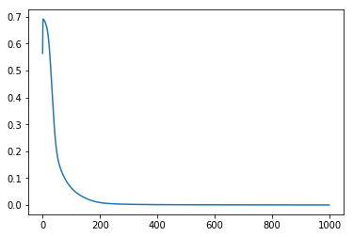

**Experiment 3:**

window_size = 3

embeddings_size = 10

batch_size = 50

epochs = 500

lr = 0.02

batch_size = 50

Accuracy = 80%

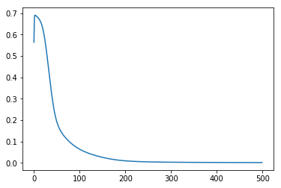

**Experiment 4:**

window_size = 3

embeddings_size = 10

batch_size = 50

epochs = 2000

lr = 0.02

batch_size = 50

Accuracy = 78

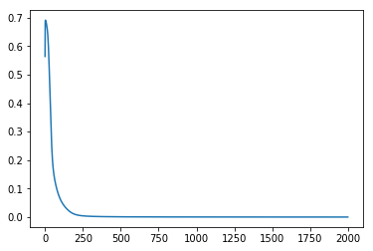

**Experiment 5:**

window_size = 3

embeddings_size = 10

batch_size = 50

epochs = 3000

lr = 0.02

batch_size = 50

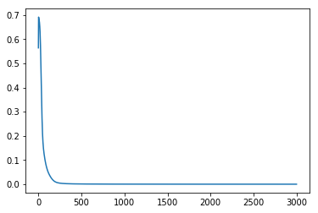

3)

**Experiment 1:**

window_size = 1

embeddings_size = 10

batch_size = 50

epochs = 1000

lr = 0.2

batch_size = 50

Accuracy = 86.5

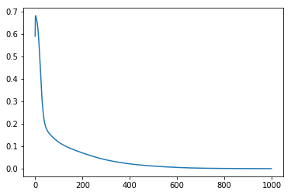

**Experiment 2:**

window_size = 3

embeddings_size = 10

batch_size = 50

epochs = 1000

lr = 0.2

batch_size = 50

Accuracy = 76



**Experiment 3:**

window_size = 6

embeddings_size = 10

batch_size = 50

epochs = 1000

lr = 0.2

batch_size = 50

Accuracy = 60.5

