**EIR – THE MED APP**

**Team 4MCA 1**

**Aravind S**

**Asvinth A**

**Mariyan J Rooban**

**Topic: Surgery**

**Title: Eir - The Med App.**

**Abstract**

We are proposing an Android application that helps a doctor in a relatively small hospital to refer a patient who requires immediate surgical attention to a hospital with a better facility for the same. The app will show all nearby hospitals that support the required kind of surgery, and provides an interface to book an emergency appointment with the selected surgery wing of the hospital. The interface provided will show all the above-mentioned hospitals in a map, along with the estimated distance and time it will require to reach them from the current location. Since the app is to be used only by authorized personnel, we also provide a login system, which helps prevent unauthorized/false alarms.

**Introduction**

In a fast-paced world like ours, medical care is one of the most important things that is required. In fact, it is the driving force of our very existence. It cannot be ever stressed enough how important human life is. Advancements in medical and technological fields have seen critical medical procedures like surgery become accessible to the common man. We aim to provide a solution for doctors working in small hospitals to refer a patient to major hospitals if they require surgical attention. This helps eliminate the normal routine of making calls from a hospital to make a referral. Not only does this make the whole process faster, it will also make it fool-proof, as only an authorized personnel, such as a doctor, can make this referral using their user id and password.

**Tools used**

* Android
* Firebase

**Workflow**

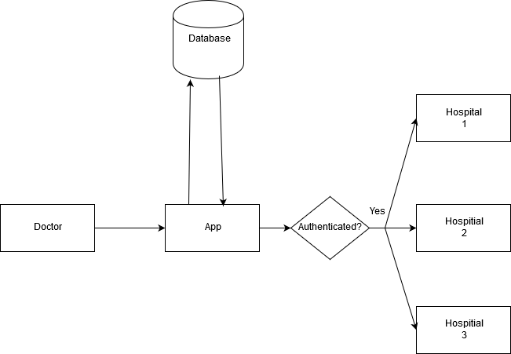

1. Splash Screen

The screen shows a splash screen along with the app logo.

1. Surgery_activity

We have provided a search bar for the doctors to choose which surgery to be chosen for the patient.

1. Map_Activity

This activity helps to shows which ever hospitals are providing the facility for appropriate surgery.

1. Description_Activity

Details such us location, name, doctor details will be provided in this activity.

1. Request_Activity

Here the request will get passed to the hospital, so that respective wing can take appropriate arrangements.

**Basic Design**

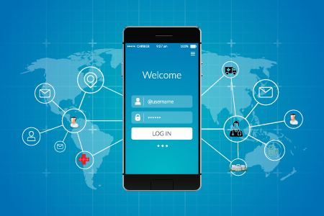

**Conclusion**

We believe that our application can prove to be an asset to the medical industry, and can potentially save a lot of unwanted hassles and confusion that can be caused in manual exchange of data.

**Screenshots**

