BILL ORGANISER PROPOSAL DOCUMENT

**TITLE:** BILL ORGANISER

**OBJECTIVE:** The purpose of the app is to store and organize bills as pictures. Bills could be of restaurants, shopping or any other relevant bills can be uploaded and organized in tile views.

**FUNCTIONALITY:** My app requires a registered user to store his/her particular pictures. I use SQLite database for storing images and user information.

**DETAILS:** The app has 4 layouts so far. The app opens with a login page and if a registered user logins successfully, the home page will be displayed which contains the uploaded bills, preferably in a grid view of size 2xm where m>=0. The user is provided with a menu layout where, the user has options to upload or logout. The app consists of a registration page, where any user can register in order to upload pictures of bills.

**FUTURE WORK:** I am planning to add the database in the cloud instead of the device storage, where in the user can access the data on any device through the app. And also I would like to use image processing techniques to read the data from the bill and convert it to text for better understanding of the bills that the user has spent.

The work flow is shown in the below diagram: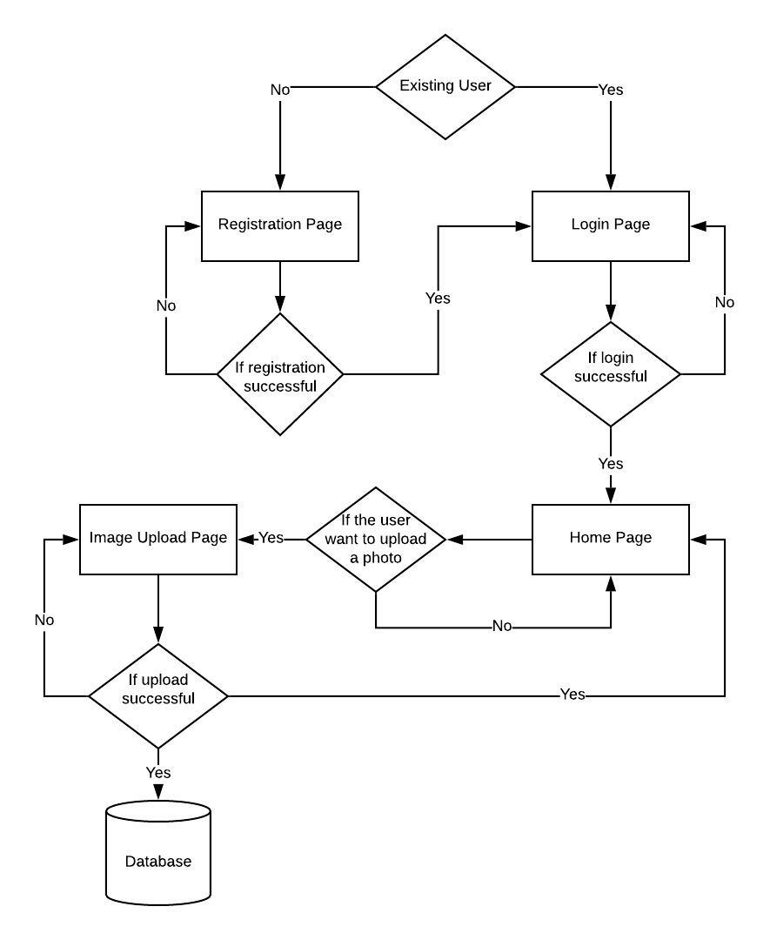

So far I have done the layouts of login page and registration page for Google Nexus 5 device with Android Pie version.

Below is the snapshot of login page:

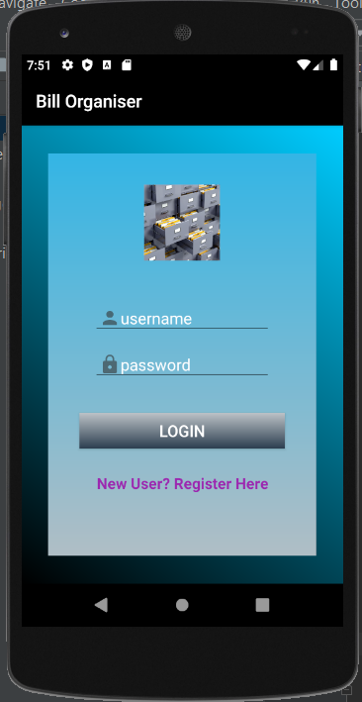

Below is the screenshot of registration page:

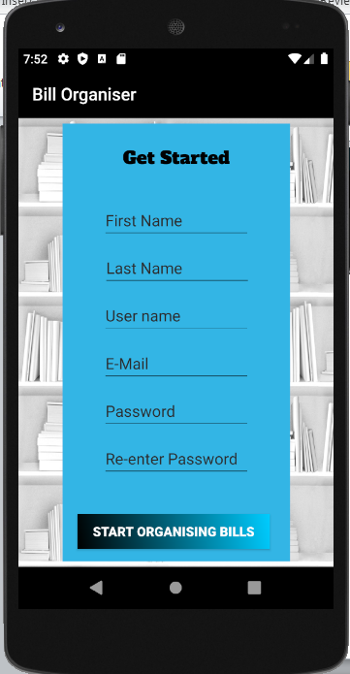

My upload page could look like below:

Bill Organiser

Image Preview

Upload Bill

Home page could be as shown below:

Image View

Image View

Image View

Image View

Bill Organiser