USEME FILE

Commands Supported

1. Loading of an image:

Syntax: load imagePath imageName

Example: load ../src/images/manhattan-small.png Manhattan

1. Saving of an image:

Syntax: save imagePath imageName

Example: Save save ../res/bmp_to_jpg.jpg blackbuck

1. Brightening of an image:

Syntax: brighten increment sourceImage destinationImageName

Example: brighten 50 manhattan manhattan-brighter-by-50

1. Vertical Flip of an image:

Syntax: vertical-flip sourceImage destinationImageName

Example: vertical-flip manhattan manhattan-vertical

1. Horizontal Flip of an image:

Syntax: horizontal-flip sourceImage destinationImageName

Example: horizontal-flip manhattan-vertical manhattan-vertical-horizontal

1. Greyscale of an image (With component):

Syntax: greyscale component-type sourceImage destinationImageName

Example: greyscale value-component manhattan manhattan-greyscale-value

1. Greyscale of an image (Without component takes luma by default):

Syntax: greyscale sourceImage destinationImageName

Example: greyscale manhattan manhattan-greyscaled

1. RGB combine of an image:

Syntax: rgb-combine destinationImageName sourceRedComponentImage sourceGreenComponentImage

sourceBlueComponentImage

Example: rgb-combine manhattan-combine manhattan-red manhattan-green manhattan-blue

1. RGB split of an image:

Syntax: rgb-split sourceImageName destinationRedComponentImage

destinationGreenComponentImage

destinationBlueComponentImage

Example: rgb-split manhattan manhattan-red manhattan-green manhattan-blue

1. Bluring of an image:

Syntax: blur sourceImage destinationImageName

Example: blur manhattan manhattan-blur

1. Sharpening of an image:

Syntax: sharpen sourceImage destinationImageName

Example: sharpen manhattan manhattan-sharpen

1. Sepia of an image:

Syntax: sepia sourceImage destinationImageName

Example: sepia manhattan manhattan-sepia

1. Dither of an image:

Syntax: dither sourceImage destinationImageName

Example: dither manhattan manhattan-dither

**How to execute the main class from CMD and run the script:**

1. Go to src/ folder -> cd src/
2. Compile the main class -> javac SimpleImageManipulations.java
3. Execute the main class by passing the arguments for running the script -> java SimpleImageManipulations -file ../res/Script_File.txt

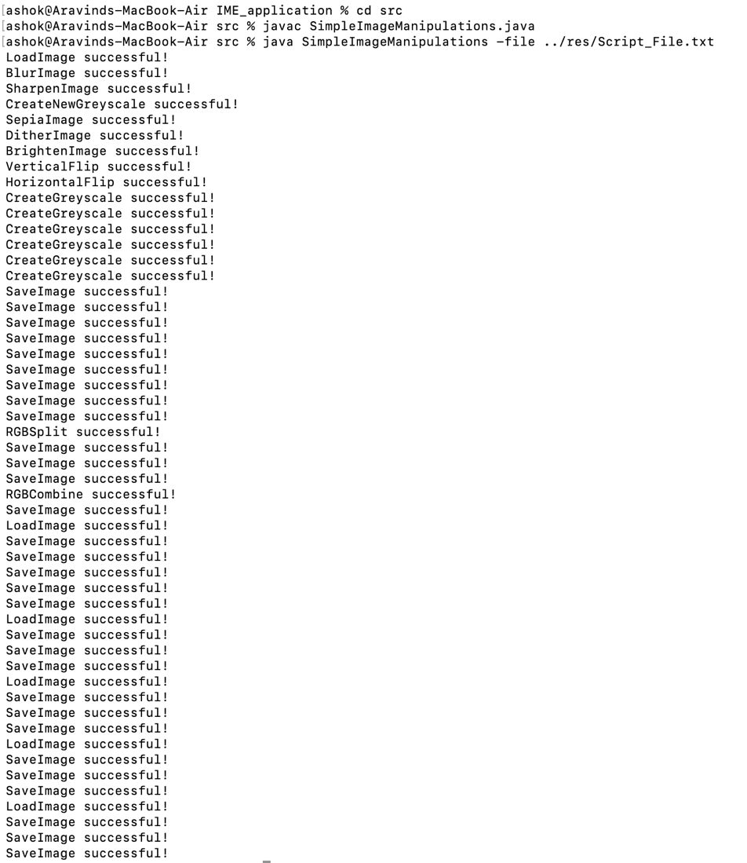

**How to execute the main class from CMD and run the commands:**

1. Follow steps 1 and 2 of the above procedure.
2. Execute the main class alone -> java SimpleImageManipulations
3. Welcome menu would pop up along with the list of operations. User can enter any command he/she wishes until ‘q’ or ‘Q’ is entered which would terminate the application.

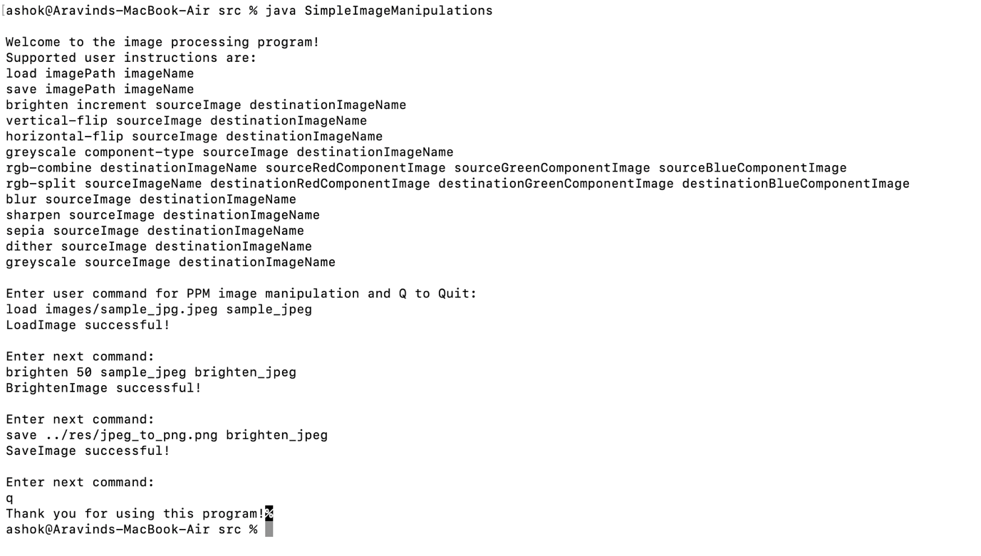

**How to execute the JAR from res/ folder:**

1. Go to res/ folder -> cd res/
2. Execute the JAR file present in the folder -> java -jar Assignment5_MIME_Part2.jar
3. Welcome menu would pop up along with the list of operations. User can enter any command he/she wishes until ‘q’ or ‘Q’ is entered which would terminate the application.

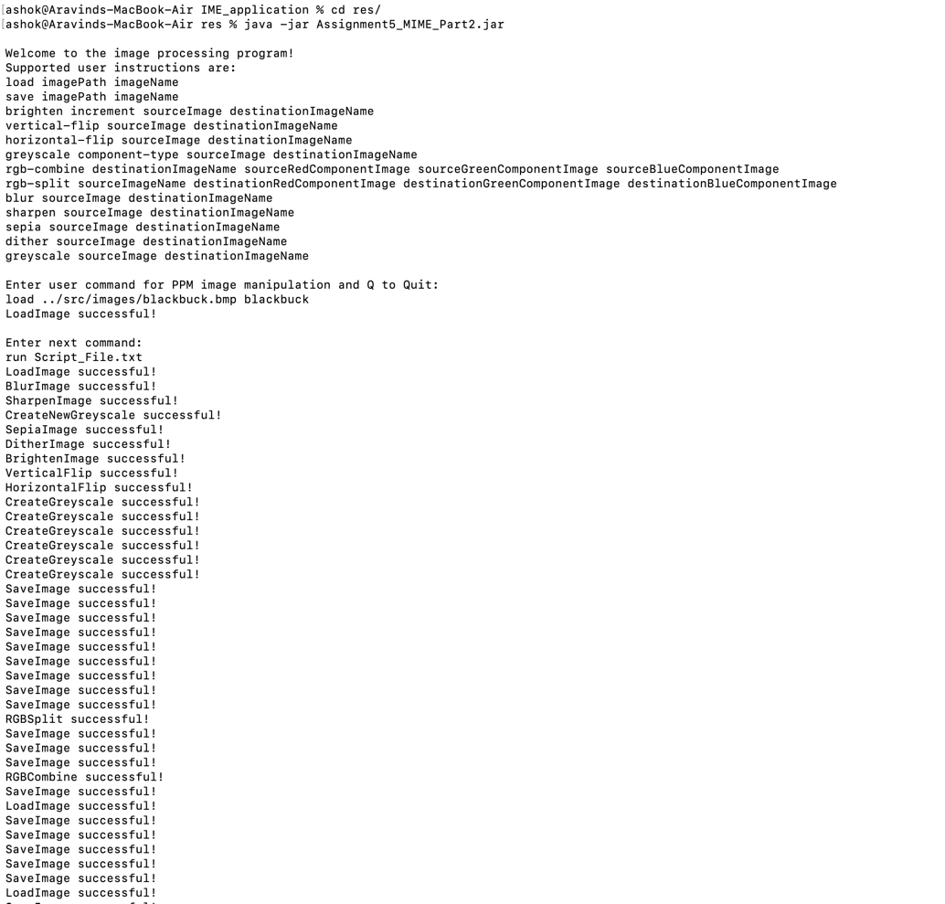

**Points to be noted:**

1. All commands are supported by all the mentioned file formats till assignment 5 which includes Jpg/Jpeg, PNG, BMP and PPM.
2. Apart from load command, all other image processing commands **must**

have load command executed first for the respective image before executing any other commands.

1. Cross saving of files are also supported in our application which means that any of the above mentioned file formats can be loaded in one format and saved in another file format.

Example:

#load blackbuck.bmp

load ../src/images/blackbuck.bmp blackbuck

#save bmp to jpg

save ../res/bmp_to_jpg.jpg blackbuck

1. Kindly, make sure to enter the correct paths of the images/scripts while executing the main class or from the JAR in the command line. Snips are provided above for reference.