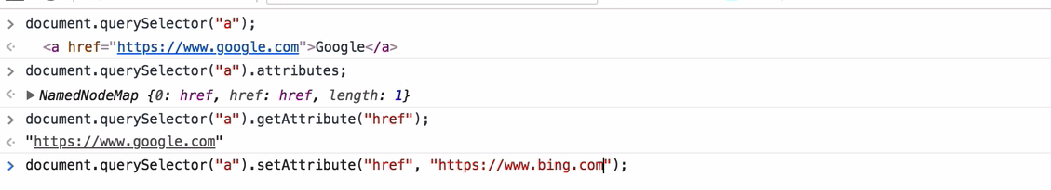

The href is an attribute for anchor tag.

Class is an attribute for any element that has it.

**jQuery:**

In jquery we need not worry about having to loop through an array. It wil do for us naturally

So the following JS code can be replaced with a minimal JQ code. (Note the non-existence of [i] in the JQ code)

JS:

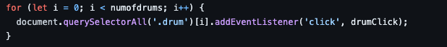

JQ:



**Command Line**

ctrl + U ---Clears the current line of command to type a new one

Holding down Alt or option gives us a plus sign which can be placed anywhere in the command line and used for editing

ctrl _+ A - Beginning of the command line

ctrl + E - End of command line

Backend:

NODE:

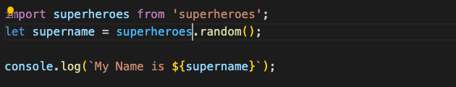

The superheroes object should exist in the superheroes package.

Then we have to use the object created to store a name in our local…the second line of the above code.

Middleware:

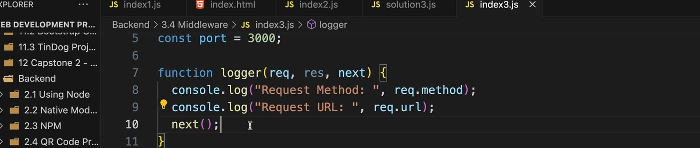

The next function is important. If we don’t specify it, the code will never to the route handlers and will remain in a constant loop insde the middleware

The bodyparser module is used to parse the incoming request. This is specifically used for the req.body method used.