**Reshape**

1. **Prepare data in Table 1 and convert to Table 2 using melt.**

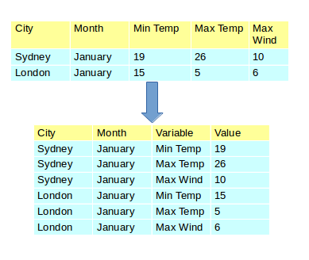

1. **Convert the data back to Table1 format using dcast.**
2. **Create 100 random numbers between 1 and 20. (hint:use sample with replace=TRUE ). Using table() function show the count of each number generated**
3. **Prepare the mpg Vs gear table from mtcars data using table() function**

**Use Group Manipulation Functions in the following**

1. Consider the student data in the marks.csv file. Read it into an R variable, Attach additional columns in it to keep student wise and subjectwise totals .
2. Let list1 <- list(observationA = c(1:5, 7:3), observationB=matrix(1:6,nrow=2))
3. Using lapply(), find the length of list1‘s observations.
4. Using lapply(), find the sums of list1‘s observations.
5. Find the classes of list1‘s sub-variables, with lapply().
6. Let a user defined function f1 <- function(x) { log10(x) + 1 } Apply f1 to list1 and obtain the results
7. Find the unique values in list1. (hint: Use function unique)
8. Find the range of list1 . (hint: Use function range)
9. Let x<-list(A=matrix(1:9,3),B=1.4,C=matrix(1:10,2),D=21)

Apply the function mean on x using lapply and sapply