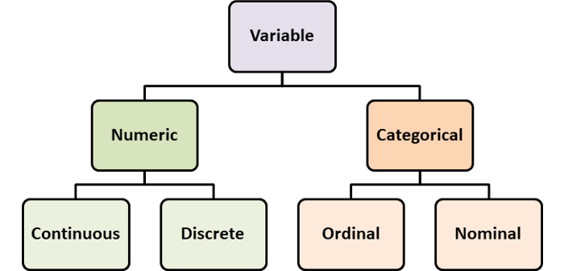The data can be both quantitative and qualitative in nature. Quantitative data is in numeric form , which can be discrete that includes finite numerical values or continuous which also takes fractional values apart from finite values.

Qualitative data is not-numerical which can be based on methods such as interviews, grades given in an exam etc. It can be nominal and ordinal,

where nominal data does not contains any order such as the gender, marital status,

while ordinal data has a particular order such as ratings of a movie, sizes of a shirt.