**WIFI-DIRECT**

**Introduction:**

Wi-Fi technology needs to evolve and embrace a larger set of use cases. Given the wide adoption of Wi-Fi in many kinds of devices, a natural way for the technology to progress is to target device to device connectivity, i.e. without requiring the presence of an Access Point (AP), traditionally provided by other technologies. This is the purpose of the Wi-Fi Direct technology that has been recently developed by the Wi-Fi Alliance.

Wi-Fi Direct has some minimal requirements like the use of 802.11g, RSN (WPA2) with AES-CCMP((**AES**-**C**ounter Mode **C**BC-**M**AC **P**rotocol) encryption, Wi-Fi Protected Setup (WPS), WME (WMM) quality of service, and OFDM data rates for management frames.***P2P devices use their global MAC address as Device ID during discovery and negotiation, and a temporary local MAC address for all frames within a group.***Action frames and additional Information Elements (IE) are used to transport the details of the protocol.

***Note: The only information provided by GroupListener/PeerListener is the mac address. IP address will not exchange between GroupListener and PeerListener.***

* Direct device to device connectivity was already possible in the original IEEE 802.11 standard by means of the ad-hoc or wireless ad-hoc network(WANET) mode of operation.

**What is WANET?**

A wireless ad hoc network (WANET) is a decentralized type of wireless network. The network is ad hoc because it does not rely on a pre existing infrastructure, such as routers in wired networks or access points in managed (infrastructure) wireless networks. Instead, each node participates in routing by forwarding data for other nodes, so the determination of which nodes forward data is made dynamically on the basis of network connectivity. In addition to the classic routing, ad hoc networks can use flooding for forwarding data.

* However this never became widely deployed in the market and hence presents several drawbacks when facing nowadays requirements, e.g. Lack of efficient power saving support or extended QoS capabilities.
* Another relevant technology in the Wi-Fi device to device communications space is 802.11z, also known as Tunneled Direct Link Setup (TDLS), which enables direct device to device communication but requires stations to be associated with the same AP. Unlike the previous technologies, the Wi-Fi Direct technology takes a different approach to enhance device to device connectivity.
* Instead of leveraging the ad-hoc mode of operation, Wi-Fi Direct builds upon the successful IEEE 802.11 infrastructure mode and lets devices negotiate who will take over the AP-like functionalities. Thus, legacy Wi-Fi devices may seamlessly connect to Wi-Fi Direct devices . By taking this decision, Wi-Fi Direct immediately inherits all the enhanced QoS, power saving, and security mechanisms.

**What is Infrastructure Mode in Wireless Network?**

An 802.11 networking framework in which devices communicate with each other by first going through an Access Point (AP). In infrastructure mode, wireless devices can communicate with each other or can communicate with a wired network. When one AP is connected to wired network and a set of wireless stations it is referred to as a Basic Service Set (BSS). An Extended Service Set (ESS) is a set of two or more BSSs that form a single subnetwork. Most corporate wireless LANs operate in infrastructure mode because they require access to the wired LAN in order to use services such as file servers or printers.

* In a typical Wi-Fi network, clients discover and associate to WLANs, which are created and announced by Access Points (APs). In this way, a device unambiguously behaves either as an AP or as a client, each of these roles involving a different set of functionality.
* A major novelty of Wi-Fi Direct is that these roles are specified as dynamic, and hence a Wi-Fi Direct device has to implement both the role of a client and the role of an AP (sometimes referred to as Soft-AP).
* These roles are therefore logical roles that could even be executed simultaneously by the same device, for instance by using different frequencies (if the device has multiple physical radios) or time-sharing the channel through virtualization techniques. In order to establish a communication, then, P2P devices have to agree on the role that each device will assume.

**Architecture:**

* Wi-Fi Direct devices, formally known as P2P Devices, communicate by establishing P2P Groups, which are functionally equivalent to traditional Wi-Fi infrastructure networks.
* The device implementing AP-like functionality in the P2P Group is referred to as the P2P Group Owner (P2P GO), and devices acting as clients are known as P2P Clients.
* Given that these roles are not static, when two P2P devices discover each other they negotiate their roles (P2P Client and P2P GO) to establish a P2P Group. Once the P2P Group is established, other P2P Clients can join the group as in a traditional Wi-Fi network.
* Legacy clients can also communicate with the P2P GO, as long as they are not 802.11b-only devices and support the required security mechanisms. In this way, legacy devices do not formally belong to the P2P Group and do not support the enhanced functionalities defined in Wi-Fi Direct, but they simply “see” the P2P GO as a traditional AP.

Below Figure explains the connection between P2P devices in P2P group circle, WLAN-STA and AP connection explained in WLAN BSS. Here one P2P device acts as a Group owner (P2P GO) and another P2P device acts as a client.

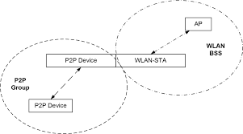

Sometimes P2P devices acts as both P2P Client and P2P GO. This is when there will be a group of devices to connect.

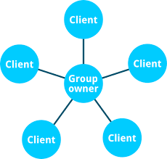

wpa_cli and wpa_supplicant are the standard application to handle whole the 802.11 station mode connection. Hostapd and hostapd_cli are also the standard application to handle whole the 802.11 AP mode connections.

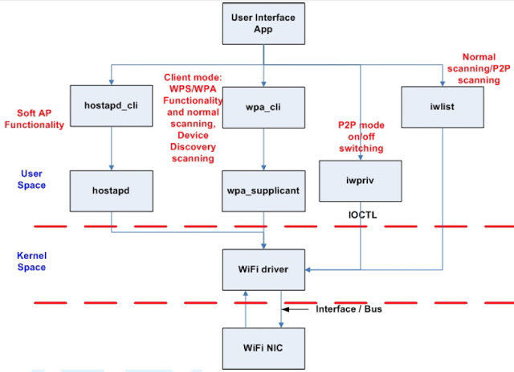

Note: WiFi Direct is one of the functionality of WiFi Technology which uses same protocol(CSMA/CA), which works based on station and access point(Soft AP) concept only.