**Instructions:**

1. migrate the project to create the database and Run the webapi before running the Angular project. Swagger will be running and can working using swagger if required to perform the actions.

2. After running the Api, Change the port number which was displayed in the swagger

3. Run the Angular project using ng serve .

Project is created using Angular for client side and .Net core for webapi.All the fields are verified and validation is done.When the data is entered correctly and click on submit. It saves the contact data in the database. As requested in the requirement document when user enters the details in the form and submitted, it should be displayed in the database. the data will be displayed at the right side of the form. When operations are performed list will also be updated dynamically. To edit the data , click on the data, it will display in the form and u can edit and submit it, it will be updated and updated list will be displayed. Bootstrap is used adapting for mobile view

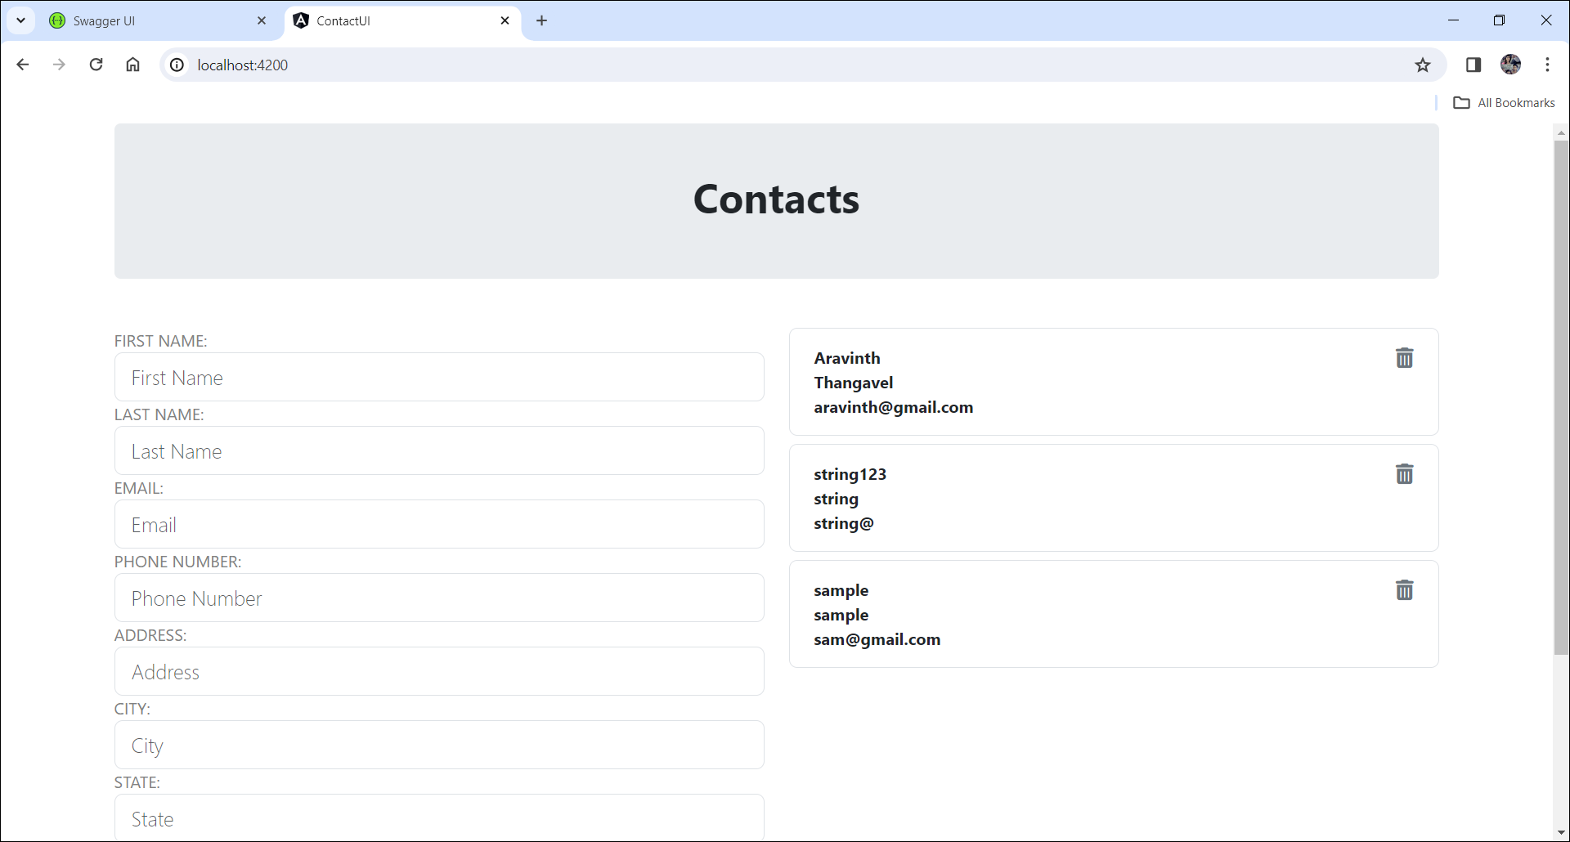

**Test data:**

FirstName – Test (character between 3 to 50)

LastName – TestLast (character between 3 to 50)

Email – [test@gmail.com](mailto:test@gmail.com) (character between 3 to 50 should be in email format)

Phone – 8745856547 (10digit numbers only )

Address – Coimbatore (character between 3 to 100)

City – Coimbator (character between 3 to 50)

State – TamilNadu (character between 3 to 50)

Country – India (character between 3 to 50)

Postal Code – 657856 (character between 3 to 7 should be numbers )