Task – 3: Sensors
Arav Toshniwal

Hall Effect Sensor:
A Hall-effect sensor, also known as a Hall sensor, monitors magnetic fields with high accuracy, consistency and reliability.
The concept behind the Hall Effect Sensor is the Hall Effect. The Hall effect is the production of a voltage (Hall voltage) across an electrical conductor or semiconductor when a magnetic field is applied perpendicular to an electric current flowing through it.
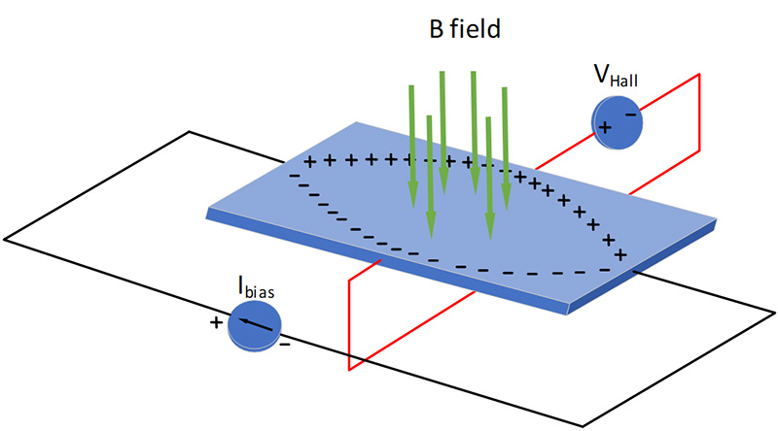
So, as shown in the figure, when a magnetic field is applied across such a ‘Hall Element’, the moving electrons tend to deflect to one side of the conductor causing a potential difference across the conductor. This deflection is due to the Lorentz force which is given by –
F = q(E + (v × B))
Here, we are only concerned with the Magnetic Force (qv × B). This force depends on the charge's velocity and the magnetic field strength.
Direction: The magnetic force is always perpendicular to both the direction of the particle's velocity (v) and the direction of the magnetic field (B). The direction can be found using the right-hand rule.
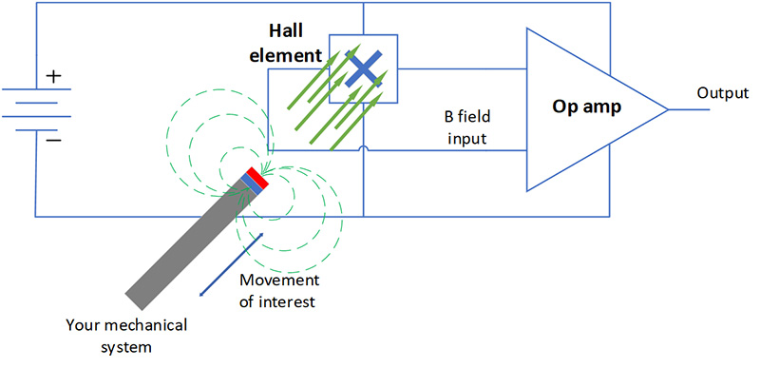
So, if we amplify the small voltage developed using a high gain op-amp (as shown in figure) we can obtain a voltage signaling the presence and strength of the magnetic field.
There are three types of position Hall-effect sensors available today:
- A Hall-effect switch: It is a digital output device that switches states based on the magnetic field it senses. As the magnet draws closer to the sensor, the magnetic field it senses becomes stronger and will switch into an active state called the B_{OP}. As the magnetic field it senses weakens (as the magnet pulls farther away), the device switches back to its inactive state at a threshold called B_{RP}.
- A Hall-effect latch is almost identical in operation to a switch, except that it has a B_{RP} point that is opposite in magnetic polarity. In other words, it requires an alternating magnetic field polarity to switch its output voltage state.
- A Hall-effect linear sensor, also known as a linear, is an analog device that varies its output voltage proportional to the magnetic field it is sensing. With no magnetic field present, the device will produce an output voltage equal to half the power-supply voltage (V_{Q}). As the magnetic field strengthens, the output voltage will either start pulling it closer to ground (magnetic north) or closer to the power-supply voltage (magnetic south) until it reaches a saturation point. The sensor will not measure magnetic fields stronger than those reached at saturation because of the unchanging voltage output. Switches and linear devices come in unipolar versions (that can only sense north or south fields) or omni polar switches and bipolar linears (that sense both north and south fields).
Switches are commonly used in laptops, refrigerator doors, and end-of-line switches to detect when a magnet approaches the sensor.
Latches are common in rotary encoding and motor commutation applications because the rotational nature of the application allows for constant monitoring of the location of the revolving shaft.
Linear sensors can precisely monitor the movement of an item, making them ideal for linear actuators, variable speed triggers, and acceleration pedals.
Proximity Sensors:
A proximity sensor is a component which is designed to detect the absence or presence of an object without the need for physical contact. They are non-contact devices, highly useful for working with delicate or unstable objects which could be damaged by physical sensors.
There are these types of sensors:
- Capacitive
- Inductive
- Magnetic
- Ultrasonic
Capacitive proximity sensors feature a pair of parallel plates, like a standard capacitor. They work when an object produces changes in capacitance, triggering the sensor. Capacitive sensors are designed for use with non-ferrous materials and are ideal for close-range applications such as level detection and monitoring.
Inductive proximity sensors feature a wound iron core. As an object enters the sensing range, the inductance of the coil changes, activating the sensor. These components are used with ferrous materials, typically at close-range, and some types may also be found in hazardous environments.
Magnetic sensors are designed to measure the presence or absence of an object. They achieve this by using an external magnetic field, and as the name suggests, they only work with ferromagnetic objects. These components are typically high-speed, making them suitable for measuring fast rotational velocity.
Ultrasonic sensors employ the use of sound waves which are either reflected or absorbed by any objects within the sensing range. They are versatile and can be used with a wide range of materials and object types. Ultrasonic sensors are also relatively high-speed so can be used for detection over longer distances than alternative types. They are also ideal for detecting objects with varying surface properties. Just a few example applications include continuous level control and industrial automation systems.
Applications:
Manufacturing and Automation
Proximity sensors are extensively used in manufacturing and industrial automation. They can detect the presence and position of objects on conveyor belts, ensuring smooth production lines and providing additional safety in case of something unintended ending up on the conveyor belt. These sensors can also play a critical role in ensuring quality by verifying the presence and alignment of components in the assembly process.
Security and Access Control
Security systems rely on proximity sensors, such as PIR sensors, for intrusion detection. Access control systems use these sensors to grant or deny access based on a person’s proximity or identification card and they are also employed in automatic door systems, where they can detect the approach of individuals and open the door accordingly.
Manufacturing and Automation
Proximity sensors are extensively used in manufacturing and industrial automation. They can detect the presence and position of objects on conveyor belts, ensuring smooth production lines and providing additional safety in case of something unintended ending up on the conveyor belt. These sensors can also play a critical role in ensuring quality by verifying the presence and alignment of components in the assembly process.
LDR sensor:
LDR stands for light dependent resistor, it is a type of passive electronic component that changes its resistance in response to the intensity of incident light. They are made of semiconductor materials that exhibit a decrease in resistance as the light level increases. This property makes them highly useful in various applications, such as light-sensitive switches, ambient light sensors in electronic devices, and even in photography equipment to control exposure settings. They are an integral part of many circuits where the response to changing light conditions is required for automatic control or monitoring.
A light sensor, such as an LDR (Light Dependent Resistor), works based on the principle of photoconductivity. Here's a brief explanation of how it works:
- Photoconductivity Principle: When light falls on the surface of the light sensor, it absorbs photons. This absorption leads to an increase in the energy levels of the electrons in the sensor's material.
- Change in Resistance: In an LDR, this increase in energy allows more electrons to move freely, reducing the material's resistance to the flow of electric current. Essentially, the brighter the light, the lower the resistance.
- Variation with Light Intensity: In dark conditions, an LDR has high resistance as fewer photons are available to energize the electrons. As the light intensity increases, more photons hit the sensor, decreasing its resistance significantly.
- Output Signal: This change in resistance can be measured and used as a signal. For example, in a circuit, the varying resistance of the LDR can be used to control the flow of current, which can then be translated into a measurable voltage change. This voltage change is often used as an input signal for various electronic systems, such as turning lights on at dusk or adjusting the brightness of a display based on ambient light.
LDRs find applications in a wide range of devices and systems. One common use is in streetlights, where they detect the ambient light level and automatically turn on the lights when it gets dark, and turn them off when daylight returns, thereby conserving energy. In cameras, LDRs help adjust the aperture and shutter speed to achieve proper exposure. Additionally, they are employed in burglar alarm systems to trigger alerts when a sudden change in light is detected, and in outdoor weather stations for measuring light levels. LDRs play a crucial role in simplifying and automating tasks in various fields, thanks to their ability to sense and respond to changes in light intensity.
Color Sensor:
A color sensor detects the color of the material. This sensor usually detects color in RBG scale. This sensor can categorize the color as red, blue or green.
To detect the color of material three main types of equipment are required. A light source to illuminate the material surface, a surface whose color has to be detected and the receivers which can measure the reflected wavelengths.
Another way of detecting color is by illuminating the material surface by Red, Blue and Green LED’s one at a time. Here the sensor contains no filters but light to voltage converter. The highest amount of light reflected by the material surface while illuminated with the red, blue and green light is calculated to detect the color.
There are two types of color sensors are RGB (Red, Green, Blue) sensors and XYZ (CIE XYZ) sensors, differentiated by their approach to color detection and the color space they use. RGB sensors measure the relative intensity of red, green, and blue light, requiring mathematical transformation to be standardized, while XYZ sensors measure colors in a standardized color space, offering higher accuracy for accurate color measurement.
Color sensors are applied to measure, detect the color of the surfaces. These sensors have a wide range of applications in industrial, medical and security systems.
IMU Sensor:
An Inertial Measurement Unit (IMU) is an electronic device that measures and reports a body's specific force, angular rate, and sometimes the magnetic field surrounding the body, using a combination of accelerometers, gyroscopes, and sometimes magnetometers.
IMUs are typically composed of three different types of sensors. The first type of sensor is an accelerometer which measures acceleration or the rate at which things speed up or slow down. While there are many different sensor technologies for accelerometers, the most common by far for wearable applications is MEMS (Micro-electromechanical systems). MEMS are sensor systems composed of electrical and mechanical parts usually etched out of silicon at the micrometer scale.
Whenever a MEMS accelerometer experiences an acceleration, a proof mass experiences this acceleration too. Sets of etched springs resist this acceleration. Using Hooke's Law (spring force is proportional to spring compression distance) and Newton's 2nd law (force is proportional to acceleration), the distance that the proof mass moves is proportional to the acceleration that it experiences (see figure below). This movement is sensed using the electrical property of capacitance which is related to the distance between two conductors. A set of electronics is then able to measure the change in capacitance, calibrate the signals, and further process it to give the acceleration.
The second type of sensor in an IMU is a gyroscope which measures angular velocity or how fast and in what direction something is spinning or rotating. Gyroscopes typically also use MEMS technology, although it is more complicated than MEMS accelerometers. The main physics phenomenon that is used for gyroscopes is the Coriolis effect which describes the forces involved when an object moves in a rotating frame of reference.
The last sensor that is commonly found in IMUs is the magnetometer which measures magnetic field strength and acts somewhat like a digital compass. Most magnetometers take advantage of the Hall Effect to measure magnetic field strength. The basic premise of magnetometers is that moving electrons in a conductor are deflected by magnetic fields that the conductor is exposed to. As charge travels through a conducting plate in a magnetic field, the magnetic fields deflect the electrons to one side of the conducting plate. With more negative charges building up on one side of the plate and more positive charge building up on the other side of the plate, there is a measurable voltage between the sides of the plates that is proportional to the magnetic field strength.
IMUs are used in smartphones, drones and cars to track movement autonomously.

Encoder Sensor:
Encoder sensors are a type of mechanical motion sensor that creates a digital signal from a motion. It is an electro-mechanical device that provides users (commonly those in a motion control capacity) with information on position, velocity and direction.
Basically, they detect mechanical change in their environment and give a signal as an output.
These sensors can be classified based on –
- What they detect
- How they detect (Sensing Technology)
- Output Signal
Based on what they detect they can be classified into linear and rotational categories.
Linear: These are encoders which detect linear displacement. They are used in machine tools that require positioning accuracy such as milling machines and drilling machines.
They consist of a scale that serves as a ruler and a head that detects movement by detecting the changes in the magnetism or light blocked.
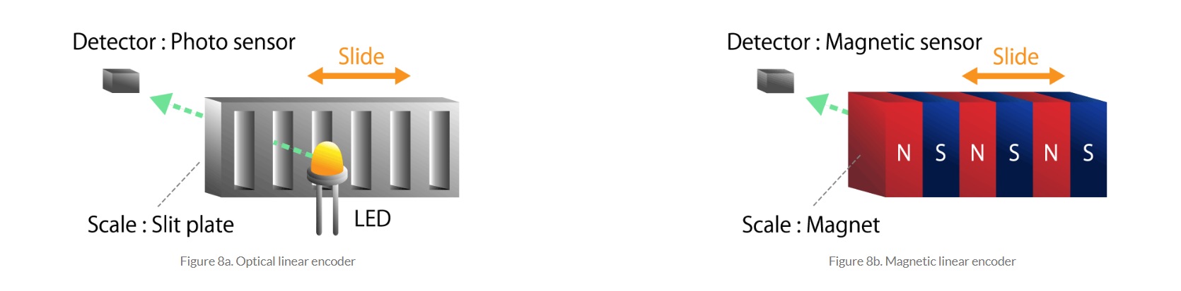

Similarly, rotation encoders detect rotatory motion and are used in machine tools, measuring instruments, copiers, and printers because they can achieve high positioning accuracy.
As we know how to detect linear movement, we try to convert the rotatory motion into linear motion and then detect that. The mechanism that converts the rotational movement of the screw into the linear movement of the nut is called the screw feed mechanism. A typical one is a ball screw. When a steel ball is inserted between the screw shaft and the nut and the screw shaft is rotated, the nut moves on a straight line due to the rolling motion of the ball. The linear displacement of the ball screw can be detected using information on the rotational position of the screw shaft and the rotation count.
The sensing technologies used in an encoder are –
- Mechanical
- Optical
- Magnetic
Mechanical: This approach detects rotational position using a variable resistor whose electrical resistance varies in proportion to the mechanical movement. A mechanical encoder is commonly referred to as a potentiometer. When the slider moves between resistors, the resistance value of the potentiometer varies according to the slider's moving distance.
Optical: This technology employs a plate or disc with slits and a light sensor to determine whether light passes through a slit in the radial direction of a revolving disk or moving plate.
The light pulse signal varies as it travels through the slit, and measuring the number of pulses allows you to determine how much the disc rotates or plate moves.
Magnetic: This technology uses a magnetic sensor and a permanent magnet attached to a rotating shaft or a moving part. As the shaft rotates or the part moves in a straight line, the magnetic field created by the magnet changes. A magnetic sensor detects these changes in the magnetic field. By measuring how the magnetic field changes, you can determine how much the shaft has rotated or how far the part has moved in a straight line (linear movement).
Based on the output signal we can categorize the encoder into incremental and absolute,
The main difference between is that incremental signals do not indicate specific position, only that the position has changed. Absolute encoders, on the other hand, use a different “word” for each position, meaning that an absolute encoder provides both the indication that the position has changed and an indication of the absolute position of the encoder.
Uses: Cut-to-length systems, Conveyors and material handling, Robotics and AGVs, Packaging and labeling machines and plotters and printers.

Pressure Sensors: A pressure sensor is a device that senses and measures pressure. In this case, pressure is defined as the amount of force exerted over an area. When categorized by operating principles there are three types of pressure sensors –
- Piezoresistive
- Capacitive
- Piezoelectric
Piezoresistive: The basic principle of the piezoresistive pressure sensor is to use a strain gauge made from a conductive material that changes its electrical resistance when it is stretched. The strain gauge can be attached to a diaphragm that recognizes a change in resistance when the sensor element is deformed. The change in resistance is converted to an output signal
There are three separate effects that contribute to the change in resistance of a conductor. These are:
- The resistance of a conductor is proportional to its length so stretching increases the resistance
- As the conductor is stretched, its cross-sectional area is reduced, which also increases the resistance
- The inherent resistivity of some materials increases when it is stretched
The last of these, the piezoresistive effect, varies greatly between materials. The sensitivity is specified by the gauge factor, which is defined as the relative resistance change divided by the strain:
GF = (R-R’/R)/e
Where strain is defined as the relative change in length:
e = (L-L’/L)
Capacitive: The capacitance of a capacitor changes when the difference between the two plates changes, changes in that distance. The distance between the two plates determines the capacitance values, which vary with the surrounding pressure. Thus, it can detect changes in pressure.
Piezoelectric: Piezoelectric sensors work by employing the piezoelectric effect. The piezoelectric effect describes the generation of an electric charge as a response to physical changes to material. This effect is more evident in certain materials to a degree that can be measured. The charge created is proportional to the applied force. The sensor can measure and calibrate changes in the charge and display a corresponding pressure measurement.
Piezoelectric sensors can come in very small sizes – making it a good choice for applications with space constraints. They also generally allow high frequencies when taking in data. This is an advantage for readings that require dynamic measurements taken between data points with short intervals.

Humidity Sensors:
A humidity sensor is a device that detects and measures the amount of humidity, or water, in the surrounding air. They're available in many sizes and forms, ranging from handheld sensors to small components built into air quality systems. The readings from these sensors allow you to adjust if the air becomes too dry or humid.
There are three types of humidity sensors:
- Capacitive
- Resistive
- Thermal
Capacitive: As we know, the capacitance of any capacitor changes with the medium. So as the humidity changes, the capacitance changes Aswell. In a sensor a thin metal oxide strip is placed between the two electrodes. The metal oxide’s electrical capacity changes with the atmosphere’s relative humidity. The capacitive type sensors are linear and can measure relative humidity from 0% to 100%.
Resistive: Resistive humidity sensors utilize ions in salts to measure the electrical impedance of atoms. As humidity changes, so do the resistance of the electrodes on either side of the salt medium.
Thermal: Two thermal sensors conduct electricity based upon the humidity of the surrounding air. One sensor is encased in dry nitrogen while the other measures ambient air. The difference between the two measures the humidity.
Humidity sensors are used for comfort and efficiency in HVAC systems, to monitor and protect products in industries like food, pharmaceuticals, and agriculture, and to preserve items in museums and archives. They are also utilized in smart homes, weather stations, medical equipment, data centers, and various other industrial processes where controlling moisture is essential for safety, product quality, or operational integrity.

Gas Sensor:
A gas sensor detects the presence and concentration of specific gases in the atmosphere by converting chemical reactions into electrical signals that can be measured and analyzed.
A few types of gas sensors are:
- Semiconductor
- Electrochemical
- Magnetic
A semiconductor gas sensor is a device that uses a semiconductor element as a measuring unit.
When the gas undergoes a redox reaction on the semiconductor, which causes the resistance value to change. As the gas passes through the measuring cell, it absorbs on its surface and reacts. Gas levels are measured by causing a change in conductivity or potential characterized by carrier motion. For example, when methane gas passes through the measuring cell, a reaction occurs that consumes oxygen. The pinned electrons are released, and the electrons are returned to the semiconductor, increasing the conductivity. When the electrons are fixed by oxygen, the resistance increases; when the methane reacts with oxygen, and the electrons return to the semiconductor, the resistance decreases. The resistance change is related to the presence, absence and amount of methane, and the methane content can be known by measuring the resistance change.
Electrochemical: They react with the measured gas and generate an electrical signal proportional to the gas concentration. Most electrochemical gas sensors are current sensors, producing a current that is linearly proportional to gas concentration. The electrochemical gas sensors working principle: the gas passes through a diaphragm that prevents condensation, and this diaphragm also has a dust-proof effect. The gas molecules then diffuse through the filter and reach the working electrode. Here, the gas is oxidized or reduced, and this electrochemical reaction causes a change in the current flowing through the external circuit.
Magnetic: After the magnetic gas sensor senses heat, light, radiation and pressure in the environment, its magnetic properties will also change accordingly. Using this feature, various reliable and high-sensitivity sensors can be made. Magnetic gas detectors are mostly magnetic probes with relatively strong measurement capabilities. When measuring gases, it is common to use the high magnetic properties of oxygen to measure the oxygen concentration. Because oxygen in the air can be attracted by strong magnetic fields. Commonly used are thermal magnetic convection oxygen analysis sensors and magneto-mechanical oxygen analysis sensors.

NTC Thermal Resistor:
NTC stands for "Negative Temperature Coefficient". NTC thermistors are resistors with a negative temperature coefficient, which means that the resistance decreases with increasing temperature. They are primarily used as resistive temperature sensors and current-limiting devices.
The working principle of the NTC thermistor is mainly dependent on the ambient temperature. Once the thermistor’s temperature enhances then its resistance will decrease. For every 1-degree centigrade rise of temperature, 5% resistance will be decreased.
There are two factors that affect a material’s resistance to electrical flow: the number of free electrons in the material and the ease with which they can move through it. The latter is affected by the crystal structure of the material, which will have more or fewer “free-electron paths” for the current to flow through.
NTC thermistors are made from ceramics containing metal oxides, including Mn-Ni-Co oxide, Ni-Cr oxide and Cu-Ni oxide with additives. When these metals are combined with oxygen, they form bonds that limit the number of free-electron paths in the crystal structure, increasing resistance.
At higher temperatures, however, collisions between atoms cause the crystal structure to break down slightly, releasing some electrons and creating free-electron paths where they didn’t exist before. The more free-electron paths there are, the less resistance there is to electrical flow. That’s how NTC thermistors exhibit a drop in resistance as temperature increases.
Thermocouple:
A thermocouple is a type of temperature sensor made from two different metals joined together at one end. It’s used to measure temperature by producing a small voltage that changes with temperature. Thermocouples are simple, durable, and can measure a wide range of temperatures. It works based on the Seebeck effect. When the joined end of the two metals (called the "hot junction") is heated, and the other ends (the "cold junction") are kept at a different temperature, a small voltage is created. This voltage is directly related to the temperature difference between the two ends. By measuring the voltage, we can calculate the temperature at the hot junction. Thermocouples are widely used in industries like manufacturing, power plants, and aerospace to monitor high temperatures. They’re also used in household appliances like gas ovens, water heaters, and furnaces to control temperature. Because they are rugged and reliable, thermocouples are ideal for harsh environments where other sensors might fail.

