Arav Toshniwal

Task 4
Ultrasonic Sensor –
https://www.tinkercad.com/things/l7zDmJBwJeG-ultrasonicsensor?sharecode=hevGfJ1yJSfLzwMizUJa9dy-qZskmEAUtUcXoCRhtuE

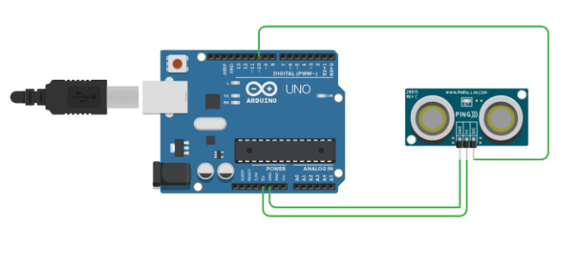
LDR –
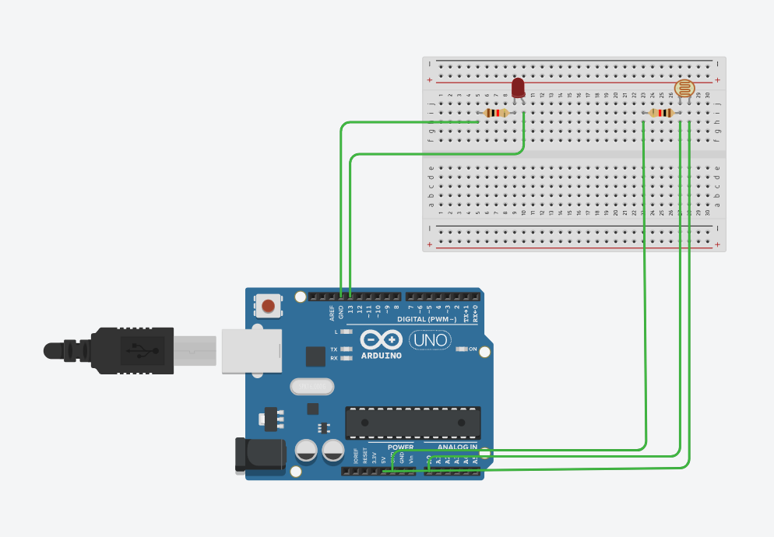
https://www.tinkercad.com/things/1lu2Lg8Stf7-ldr?sharecode=xU8GFtwSgZyYaB2QGzGrDu9jEdMkfYavoDHBTwO7_1U
Traffic Light –
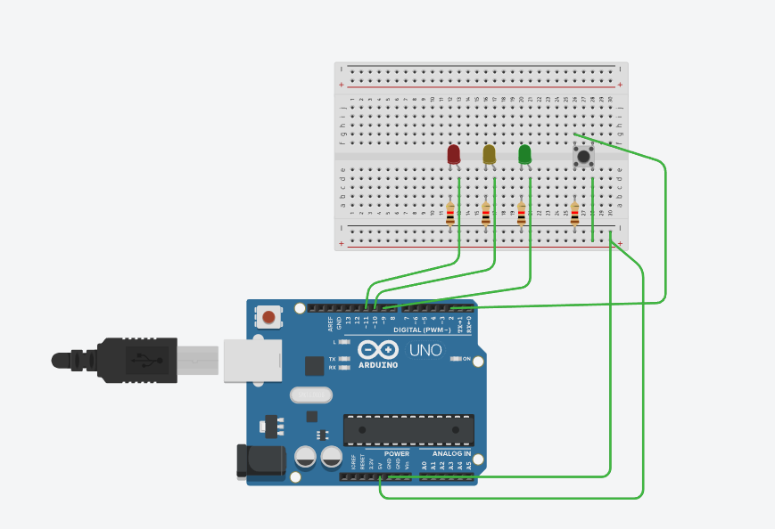
https://www.tinkercad.com/things/d1QNwPrtaXZ-trafficlight?sharecode=HqdH0XAuchEiOlIwxCTjPeCbRaZdiFtlBJCXZd0NyyU
Logic Gates –
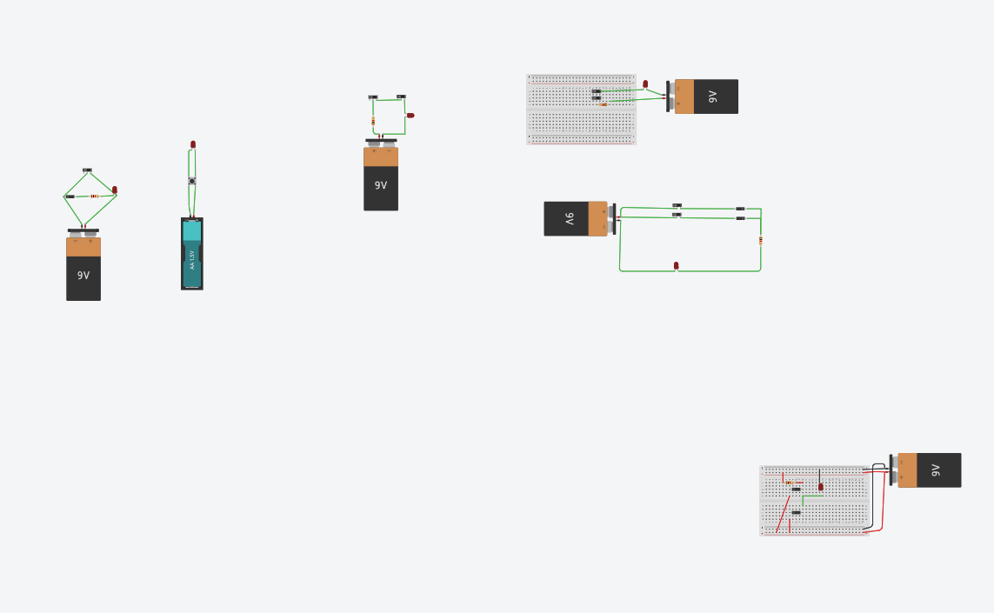
https://www.tinkercad.com/things/eA2Ft6saQaq-gates?sharecode=undefined

