SCSE3040 – MLOps

Practical 06: Experiment Tracking with MLflow

Student Details
Name: Arav Wahi
Roll Number: S24CSEU1949
Batch: 50

Repository
GitHub Repository:
https://github.com/aravwahi13/scse3040-mlops

1. MLflow Experiment Runs
The following three Random Forest runs were compared under the delivery-time experiment in MLflow:
- rf-n50-d4
- rf-n100-d6
- rf-n150-d8
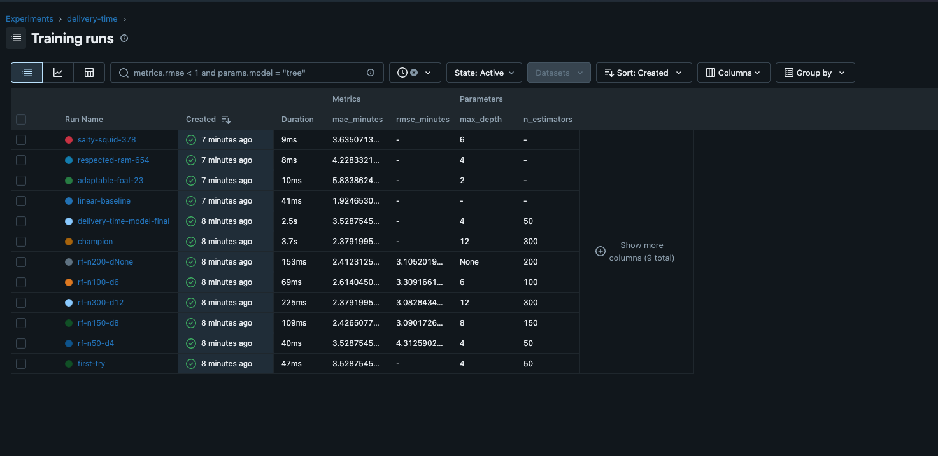

2. Selected Best Run
The best-performing run was selected based on the Mean Absolute Error (MAE), where a lower value indicates better prediction performance.
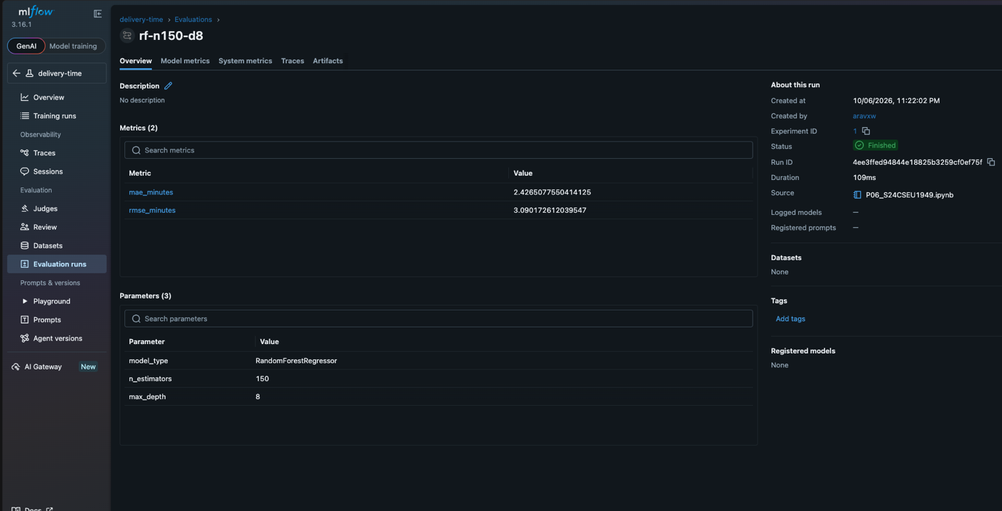

3. Best Run Details
Run Name: rf-n150-d8
Run ID: 4ee3ffed94844e18825b3259cf0ef75f
Model Type: RandomForestRegressor
Parameters:
- n_estimators = 150
- max_depth = 8
Metrics:
- mae_minutes = 2.4265077550414125
- rmse_minutes = 3.090172612039547
Reason for Selection:
I selected this run because it achieved the lowest MAE among the three compared Random Forest runs, indicating the smallest average absolute prediction error.

