Azerra Architecture

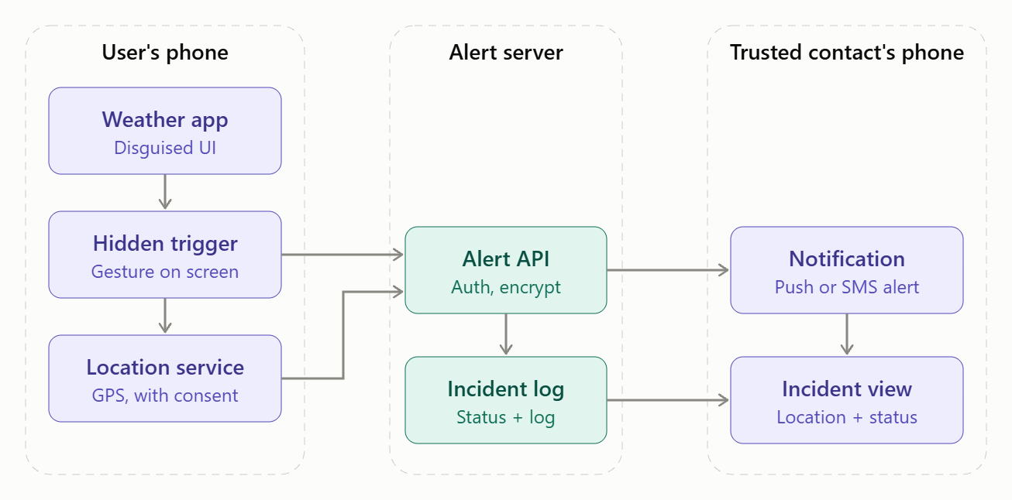

Detailed version :
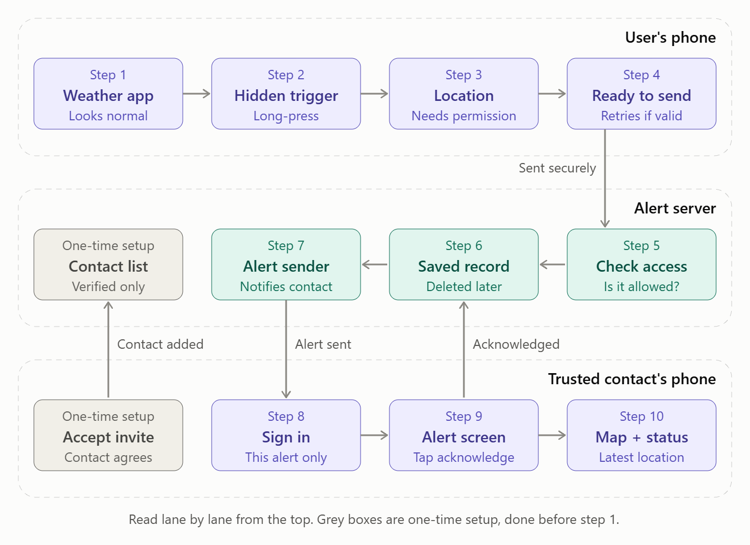
How an alert and location travel through the system
- Setup (one time). The user invites a trusted contact. The contact reviews what an incident may share, verifies their identity and accepts. The contact registry marks them as Verified, and only then can they receive alerts. If no contact is verified, live alerts cannot be enabled.
- Normal use. The user opens what looks like an ordinary weather app. Ordinary taps do nothing, and nothing on screen suggests a safety feature.
- Hidden trigger. The user performs the agreed long-press on the weather element. The app recognises it on the device and nothing is sent yet.
- Cancellation window. A short, discreet window lets the user cancel. If they do, the app returns to the weather screen, no alert is sent and anything queued for that activation is discarded.
- Incident starts. If the window passes, the app creates an incident record with a unique ID, the user’s ID, the approved contacts and a timestamp.
- Location is requested. The app asks the phone’s location service for coordinates. This only works if the user has granted permission. If it is denied, the app shows “Location unavailable” and never substitutes an old position.
- Send queue. The incident goes into the send queue. If the phone is offline, the app shows “Alert not sent” and retries, but only while the incident is still active and the contact is still approved. Cancelled or ended incidents are never retried.
- Alert is sent. The app sends the incident over an encrypted connection (HTTPS/TLS). The access check on the server confirms the user is authenticated and the recipient is an approved contact for this specific incident.
- Server stores and forwards. The alert service saves the incident in the incident store, then sends a push notification or SMS to the contact. The user sees a delivery state: Sending, Delivery unconfirmed or Delivered.
- Contact authenticates and views. The contact signs in, and the server grants access only to this incident. They see the status, a map and the latest location with its timestamp and accuracy. Stale locations are labelled “Last known” and never shown as live.
- Acknowledgement. The contact taps “Acknowledge alert”. This is recorded separately from delivery, because a delivered alert does not prove a person has seen it.
- Live updates. While the incident is active, the phone keeps sending location updates and the server passes each one on. Sharing happens only during the incident.
- Ending the incident. The user selects End and confirms. Location sharing stops on the phone immediately, even offline. The app shows “Sharing stopped” and, if the contact can’t be told yet, “End update pending”. Once the server receives it, the contact sees Ended.
- Retention. Location points, incident records and delivery logs are deleted after a defined retention period, and the user can request deletion earlier.

