Contents
Project Overview 2
Hardware Components 2
System Architecture 3
ERD Diagram 5
Authentication and user Management 6
User Authentication 6
Users Roles 6
Subscription based Access control 6
PubNub Communications 7
PubNub Access Manager 8
Purpose of Access manager 8
Token based permissions 8
Token expiry handling 9
Input Validations and Error Handling 10
Audit Logging and Accountability 10
Sensor data handling 11
Real time sensor updates 11
Sensor Logs 11
Deployment and server Configuration 11
Server setup 11
Domain and HTTPS 12
Database Configurations 12
Security considerations 12
Securing the IoT Device 12
Securing Communication Channel 12
Securing The Web Server 12
Data at Rest and in Transit 13
Pictures of hardware 13
Use of AI Tools 15
Conclusion 15

Project Overview
Smart Room Automation is a secure IoT based web application designed to monitor environmental sensor data and allow authorised users to control room devices such as lighting. The system integrates a web interface, a backend server, a database and IoT messaging infrastructure to provide a real time monitoring and controlled device interaction.
Smart Room Automation is based on security role based access and controlled permissions were central design goals. The system ensures that only authorized users with valid subscription can perform sensitive actions such as turning light on or off.
www.autosmart.live
website link ^

Hardware Components
Component | Description
Raspberry Pi | IoT controller for Smart Room system. It reads sensor data process automation logic, publish sensor to PubNub and listens for remote control commands such as turning light on or off
PIR Motion | Detects movement within the room. The sensor triggers automation logic and immediate data publishing when motion is detected and security awareness.
LDR light sensor | Measures light levels in the room. Used to determine whether the environment is dark or bright.
DHT Temperature and Humidity sensor | Collects environmental data including temperature and humidity in real time.
Relay Module | Acts as an actuator interface between the Raspberry Pi and the light. It allows safe switching of high voltage device using low voltage control signals from the Pi.
Ultra Bright LED | Represents the light were switched on or off automatically based on sensor data or manually via the web interface and button.
Physical Push Button | Intended as a manual actuator input allowing local control of the light.
Resistors | Resistors are used with the LDR and DHT sensors.

System Architecture
The system follows a client server IoT architecture consisting of:
- Web Browser – User interface for login, dashboard and admin features
- Flask Backend server – Manages authentication, authorization, database access and PubNub token generation.
- MariaDB database – stores users, sensor logs, audit logs and subscription states
- PubNub Access Manger – Manges secure, real time communication between server, users and IoT devices.
- IoT Devices – the system uses Raspberry pi which publishes sensor data and listens for control commands.
All communications between components are restricted using PubNub tokens and server side access checks.
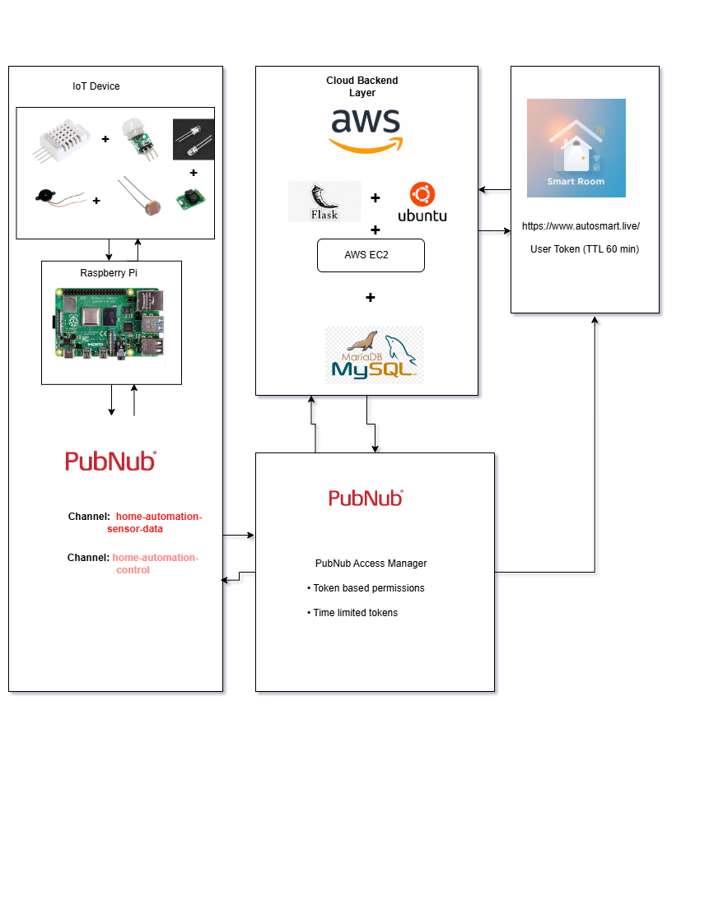

ERD Diagram
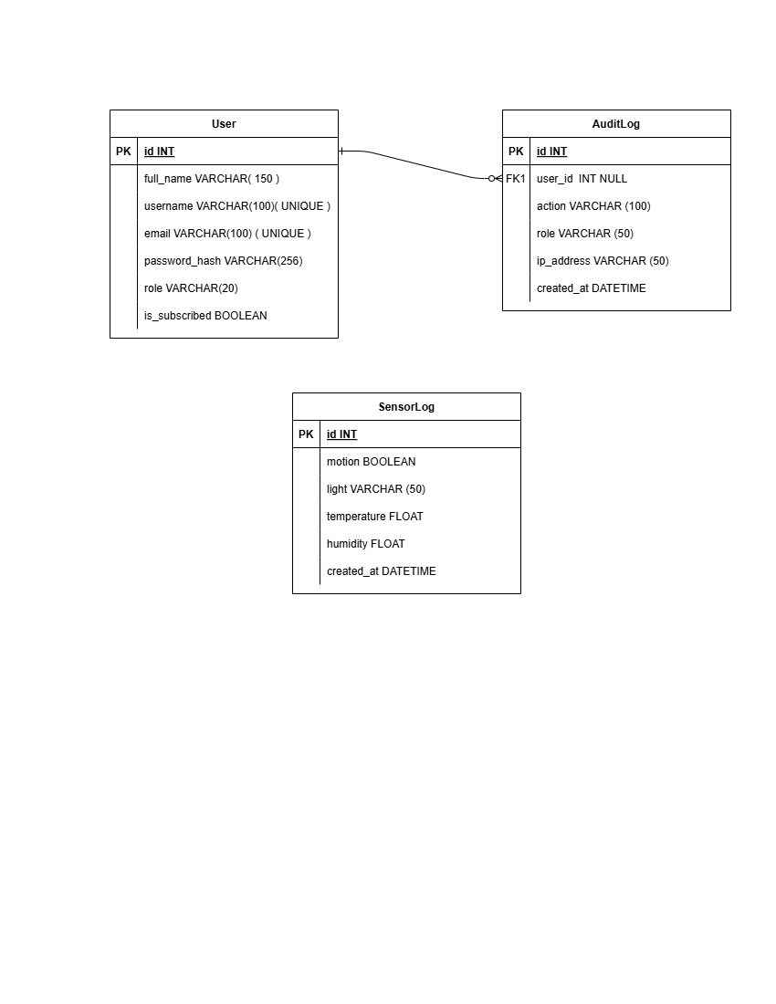

Authentication and user Management

User Authentication
The system uses Flask Logi to mange authentication. Users must log in using an email and password before accessing protected routes.
Key features:
- Secure password hashing
- Session based login.
- Automatic redirection to login page for unauthorized users
- Logout logging for security tracking
- Google login

Users Roles
Two roles are implemented Admin and User:
Admin
- Full access to the system
- Can view audit logs and sensor logs.
- Can mage user subscriptions.
- Can always control IoT devices.
- Can delete and add new users.
Users
- Can view dashboards and sensor data.
- can only control devices if subscribed.
- can update profile details.

Subscription based Access control
A subscription model was implemented to restrict advanced features.
- Users without a subscription cannot control IoT devices.
- Subscriptions status is stored in the database (is_subscribed)
- Admins can enable or disable subscriptions via admin panel.
- Subscriptions changes are recorded in the audit log.
This approach allows controlled features access without changing application logic.

PubNub Communications
PubNub is used as the real time messaging infrastructure that enables secure communication between the IoT devices, backend server and web clients. Sensor data published by the Raspberry pi is transmitted to the server through PubNub channels while control commands are securely sent from authorised users to the IoT device. PubNub Access manager is used to issue time limited tokens with permission ensuring that each entity can only access the channels required for its role.
Below is an example of actual PubNub message used:
For home-automation-sensor-data
{
"channel": "home-automation-sensor-data",
"timetoken": "17680850163025483",
"publisher": "raspberry-pi-01",
"message": {
"motion": true,
"light": "bright",
"temperature": 26.2,
"humidity": 36.6
},
"actualChannel": null,
"subscribedChannel": "home-automation-sensor-data"
}
For home-automation-control
{
"channel": "home-automation-control",
"timetoken": "17680847057390317",
"publisher": "6",
"message": "TURN_LIGHT_ON",
"actualChannel": null,
"subscribedChannel": "home-automation-control"
}
{
"channel": "home-automation-control",
"timetoken": "17680832983487161",
"publisher": "1",
"message": "TURN_LIGHT_OFF",
"actualChannel": null,
"subscribedChannel": "home-automation-control"
}

PubNub Access Manager

Purpose of Access manager
PubNub Access Manager is used to secure real time communications channels between:
- Web users
- Backend server
- IoT devices
Instead of exposing permanent keys the system issues time limited, permission scoped tokens.

Token based permissions
Different tokens are generated depending on entity type.
User Tokens
- Issued on login
- Time limited (TTL = 60 minutes)
- Permissions depend on role and subscriptions status.
Channels:
- Sensor data: Read
- Control channel: Read + Write (admin or subscribed users only)

Server Token
- Long lived
- Can read sensors data.
- Can send control messages.

IoT Device Token
- Can publish sensor data.
- Can read control commands.

Token expiry handling
When tokens expire:
- PubNub rejects the request.
- The server catches the exceptions.
- User receives a flash notification subscription expired error message.
- User must re login to receive a new token.
This ensures that no permanent access automatic security refresh and minimal attack surface.
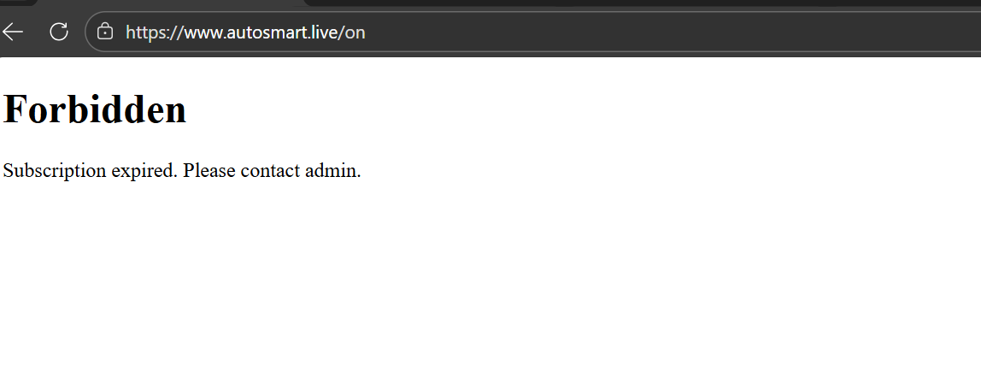
When subscriptions expired

Input Validations and Error Handling
Input validations are enforced on both client and server sides to prevent invalid or unnecessary data entry. Email formats are validated, password must meet defined complexity rules.
User friendly error messages are provided using Flask flash notifications while sensitive error details are not exposed to end users. This improves useability while maintaining security.

Audit Logging and Accountability
An audit logging system was implemented to track sensitive actions. Logged events include:
- User login and logout
- Device control actions
- Subscriptions changes
- User registration
- Administration actions
Each audit log entry stores:
- User ID
- Role
- Action description
- Ip address
- Timestamp
Admins can view logs in paginated interface, filter logs and export to CSV.

Sensor data handling

Real time sensor updates
Sensor data is received from IoT devices via PubNub and includes:
- Motion
- Light
- Temperature
- Humidity

The server updates the dashboard, stores in the database and maintains the most recent sensor state.

Sensor Logs
Admin can view historical sensor data, navigate paginated logs and export sensor data as CSV.

Deployment and server Configuration

Server setup
The application was deployed on an AWS Ubuntu instance using:
- Apache with mod_wsgi to serve the Flask applications. Once configured the site was enabled and Apache was reloaded to apply the changes.
- Python virtual environment was created to project dependencies and ensure consistency between development and production environments.
- MariaDB running on the same instance to store all applications data securely
- Environment variables stored securely in .env

Domain and HTTPS
- Custom domain configured to point to the AWS EC2 instance using DNS records.
- HTTPS enabled using let’s Encrypt providing free SSL certificate for secure communications.
- HTTPS traffic redirected to HTTPS ensuring that user always connect securely to the application.

Database Configurations
MariaDB database was configured locally on the EC2 instance and is not exposed to the public internet. A credential was stored securely using environment variables. The database connection was verified through the Flask application to ensure reliable data storage and retrieval.

Security considerations

Securing the IoT Device
The IoT hardware including the raspberry pi connected to environmental sensors is secured using SSH key based authentication. Communication between IoT devices and the cloud infrastructure occurs through PubNub encrypted channels preventing unauthorized interception or modification of sensor data. Sensitive credentials such as PubNub keys are stored in hidden environments files rather than in the source code.

Securing Communication Channel
All communication between the IoT devices, backend server, and web interface is protected using Transport Layer Security (TLS). PubNub automatically encrypts all messages using HTTPS and TLS, ensuring that environmental sensor readings cannot be intercepted or altered during transmission. Similarly, communication between the web browser and the Flask server is encrypted using HTTPS once SSL certificates are installed via Certbot. This guarantees secure data transmission across all system components.

Securing The Web Server
The Flask web application is hosted on an AWS EC2 Ubuntu instance configured with strict security rules. Only essential ports, such as port 22 for SSH and port 443 for HTTPS, are open, while all other ports are blocked using AWS Security Groups. The custom domain is protected by a Let’s Encrypt SSL certificate ensuring that all web traffic is encrypted and users connect securely.

Data at Rest and in Transit
All data stored in the database is protected through local access controls. Data transmitted between IoT devices, the backend server, and client browsers is fully encrypted using HTTPS and PubNub’s TLS enabled channels.

Pictures of hardware
When you turn on the light using the button
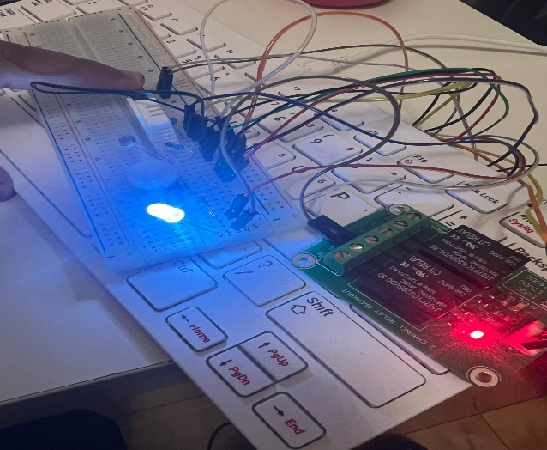
Light turning on when there is a motion during night
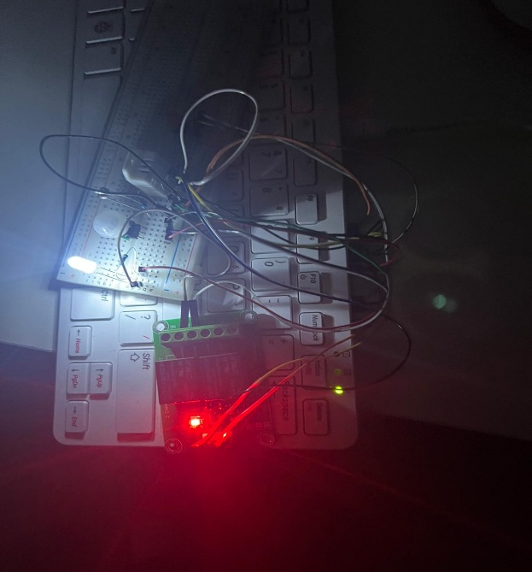

Actual wiring with all sensors
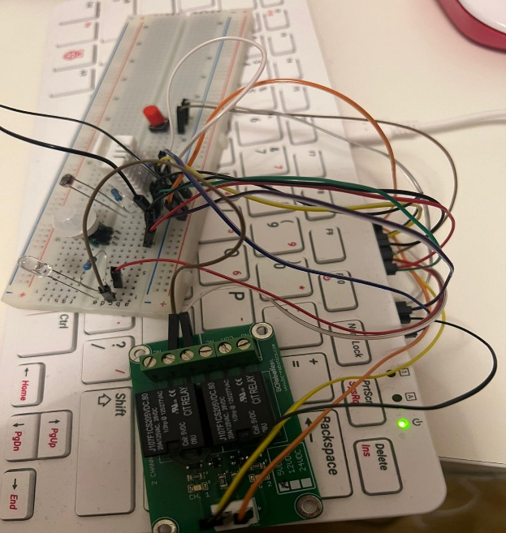

Use of AI Tools
ChatGPT was used during development of this project as a learning and support tool. It assisted in debugging errors and best practice related Access manager and flask development. All final design decisions, implementation, AWS deployment, PubNub and documentation were completed and fully understood by the author. ChatGPT was used as supplementary.

Conclusion
The Smart Automation System demonstrates a strong understanding of IoT systems, secure cloud deployments, real time messaging and access controlled web application design. The system provides a solid foundation that can be expanded into a scalable and production ready smart environment solution.

