We want to choose crystalline silicon nanoparticles (SiNPS) with 100-400 nm diameter because:
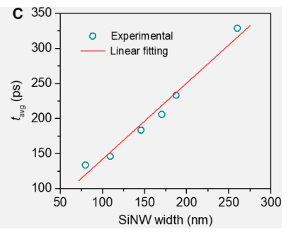
Figure 1 Size dependent average carrier lifetimes for silicon nanowires (Li, 2023)

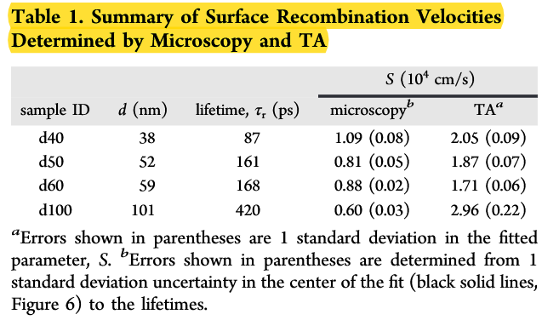
Figure 2 Grumstrup, 2014
We can safely say tau_c>>tau_r condition can be satisfied.
How can we find their \beta and \sigma_fc values?
It is not specifically measured for nanoparticles of this size, because when the dimension of the material bigger than its bohr radius (\approx. 14 nm) we can treat it as bulk material (Brus, 1984). So \beta and \sigma_fc can be directly taken from Boggess, 1986 safely.
Is this particles biocompatible? Used for imaging?
Of course, many works presented. They’re widely used as biosensors or contrast agents, cell imaging, early cancer detection etc. Ivanov, 2021 demonstrated its application in cancer and Zhang, 2012 showed much general picture on use of SiNWs as biosensors.
Grüneisen
Also changes for the silicon nanoparticles, \Gamma \approx 0.8 for our size which r>100 nm (Omar, 2009).
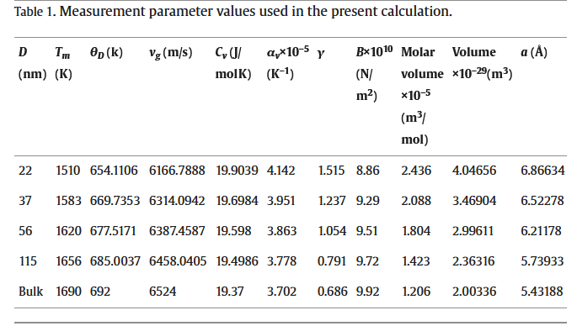

Optical properties
For 1064 nm, have very negligible linear absorption (Brönstrup, 2010). TPA coefficient from Boggess, 1986. Scattering irrelevant.

Medium
Already configured as native grey matter at 1100 nm, no changes. Thermal properties are taken from the medium since dominant PA signal generated via surrounding medium (Chen, 2012).

Nanowire concentration?
I have no idea about this and how this affects the absorption values, never think of this.

