React-Redux Shopping Cart Application

In this Project you will fix a Shopping Cart application with the knowledge of react and redux. Some parts of the code is missing and the page is not working now.
You have folders and files in your src folder like this;

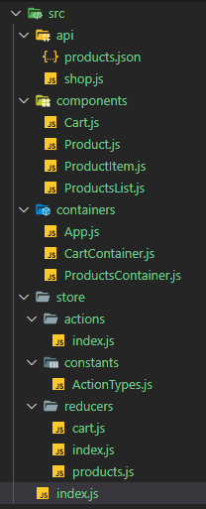

You can make changes, but it is recommended to keep structure.

This is the working path of application; “https://tafatsum.github.io/shopping-cart/”.

You have given some parts of the files, some codes, feel free to make any changes to achive the stories below.

Stories:

1.
As a user, i can see all products as a list on the web page, under each others. Every item should have “name”, “price” and “identity(inventory)” and also should have an “Add to Cart” button.
2.
As a user, i should able to click “Add to Cart” button for every item on the list (if inventory is enough). If item out of stock, “Add to Cart” button got disabled.
3.
As a user, with every click for “Add to Cart” button;
- Inventory of item decrease,
- Item added to cart.
4.
As a user, i sould see “every added item”, “Total Price” and a “Checkout” button inside cart section. If there is no item it should write default text ; “Please add some products to cart.”
5.
As a user, i sould see items with “name”, “price” and “quantity”,
6.
As a user, after every click for “Add to Cart” button, inside cart section;
- Item added to cart.
- If item has alreadey in cart, quantity of item increase,
- Total Price changes according to the added item’s price.
7.
As a user, after clicking for “Checkout” button, cart section become empty. You can start with new shopping with the current (last) inventories of items.
If item sold out, you can not buy it (until refreshing the page).

Good Luck…

