Yummy Yum’s Website Storyboard
Topic: Yummy Yum’s restaurant
Target Audience:
- Young professionals looking for a nice, casual meal
- Adults, age 18-34
Objectives:
- The user should be able to access the information in four clicks or less for easy navigation.
- The user should be able to list at least three items on the Yummy Yum’s menu.
- The user should be able to explain how to make reservations.
- The user should be able to list at least three facts about Yummy Yum’s.
- 95% of Web pages must theoretically download in four seconds or under on a 56k modem.
- 95% of the content must be understandable to an English speaker with a ninth grade reading level.
Navigation: Navigation will be a navigation bar with buttons. Users will be able to access any page from any page.
URL: There will be Natural Language links on the resources page to the following pages:
- http://en.wikipedia.org/wiki/Fast_food_restaurant

Page | Content Summary | Images/Graphics
Index | Home page with links to all pages and a brief introduction of Yummy Yum’s | Picture of Yummy Yum’s logo
Menu | Look at the various food choices | Pictures of many food choices
Order | Order food items | Buttons for ordering methods
Deals | The best price offers | Picture of foods on sale
Reservations | Make reservations for the restaurant | Picture of restaurant interior
Resources | Contact Yummy Yum’s | Picture of phone

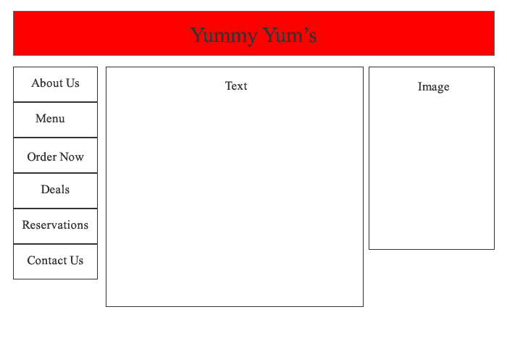
About Us
Menu
Order Now
Deals
Reservations
Contact Us

