

Job Salary Prediction Using Regression

Submitted by:- ARBAAZ AHMED ANSARI
Enrollment:- 24FMUCHH012027

Course Details
Course : Fundamentals of Machine Learning
Programme: BBA | Semester: 4
Faculty Name: Dr. Shubhangi Urkude

Date of Submission: 12/04/2026
Email Submitted To: shubhangini@ibsindia.org

Job Salary Prediction Using Regression

- INTRODUCTION

In today’s data-driven world, predicting employee salaries is crucial for organizations to make informed hiring and compensation decisions. Salary prediction helps companies maintain fair pay structures, attract talent, and optimize workforce costs

The objective of this project is to build a regression model that predicts employee salary based on factors such as experience, education level, skills, industry, and other relevant attributes.

This project aims to:

Analyze the relationship between various job-related factors and salary

Build a predictive model using multiple linear regression

Generate meaningful business insights from the data

- DATASET DESCRIPTION.

The dataset used in this project is a publicly available Job Salary Prediction dataset sourced from an open-source data repository from Kaggle.com. It is a large, structured dataset designed for regression analysis, containing detailed job-market attributes for a substantial number of records.
The dataset consists of 250,000 rows (records) and 10 columns (features). Each row represents a unique job entry, and each column captures a quantitative or categorical attribute that may influence salary. The target variable is 'salary', representing the annual compensation in a standardized format.

The table below summarizes all ten features available in the dataset:
Feature Name | Description
job_title | The designation or role of the employee within the organization
experience_years | Total number of years of professional work experience (primary predictor)
education_level | Highest academic qualification attained by the individual
skills_count | Number of relevant professional skills listed by the employee
industry | The sector or industry in which the organization operates
company_size | Categorical size of the employing organization (small/medium/large)
location | Geographic location of the work (city/region)
remote_work | Binary indicator: 1 = remote work permitted, 0 = office-based
certifications | Number of professional certifications held by the employee
salary | Annual salary of the employee — the target variable (y)

- DATA PREPROCESSING:-
Data preprocessing is an essential step to clean and prepare the dataset for building an accurate machine learning model.

- (Step-1)- Importing Libraries
Python libraries are used for data analysis, visualization, and machine learning. These libraries provide built-in functions that simplify complex operations.

  - Pandas is a powerful library used for data manipulation and analysis.
  - NumPy (Numerical Python) is used for performing mathematical and numerical operations efficiently.
  - Matplotlib is a visualization library used to create basic graphs and plots.
  - Seaborn is an advanced visualization library built on top of Matplotlib.

import pandas as pd
import numpy as np
import matplotlib.pyplot as plt
import seaborn as sns

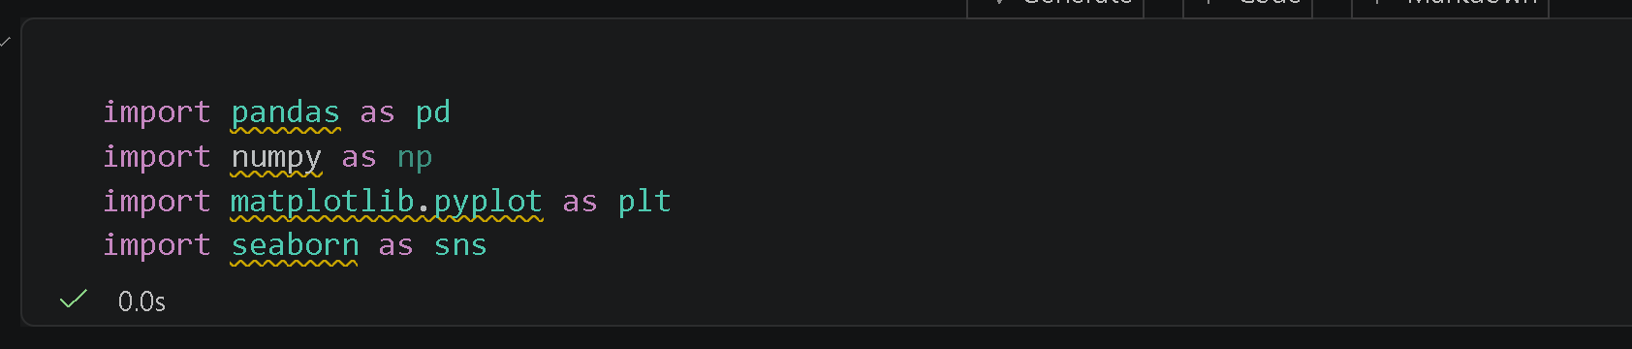

- (Step-2)- Loading the Dataset
The dataset was loaded into the working environment using the Pandas library, which provides efficient data structures for data analysis. The dataset is typically stored in formats such as CSV, Excel, or JSON, and is imported into a DataFrame for easy manipulation.

df = pd.read_csv("job_salary_prediction_dataset.csv")
df.head()
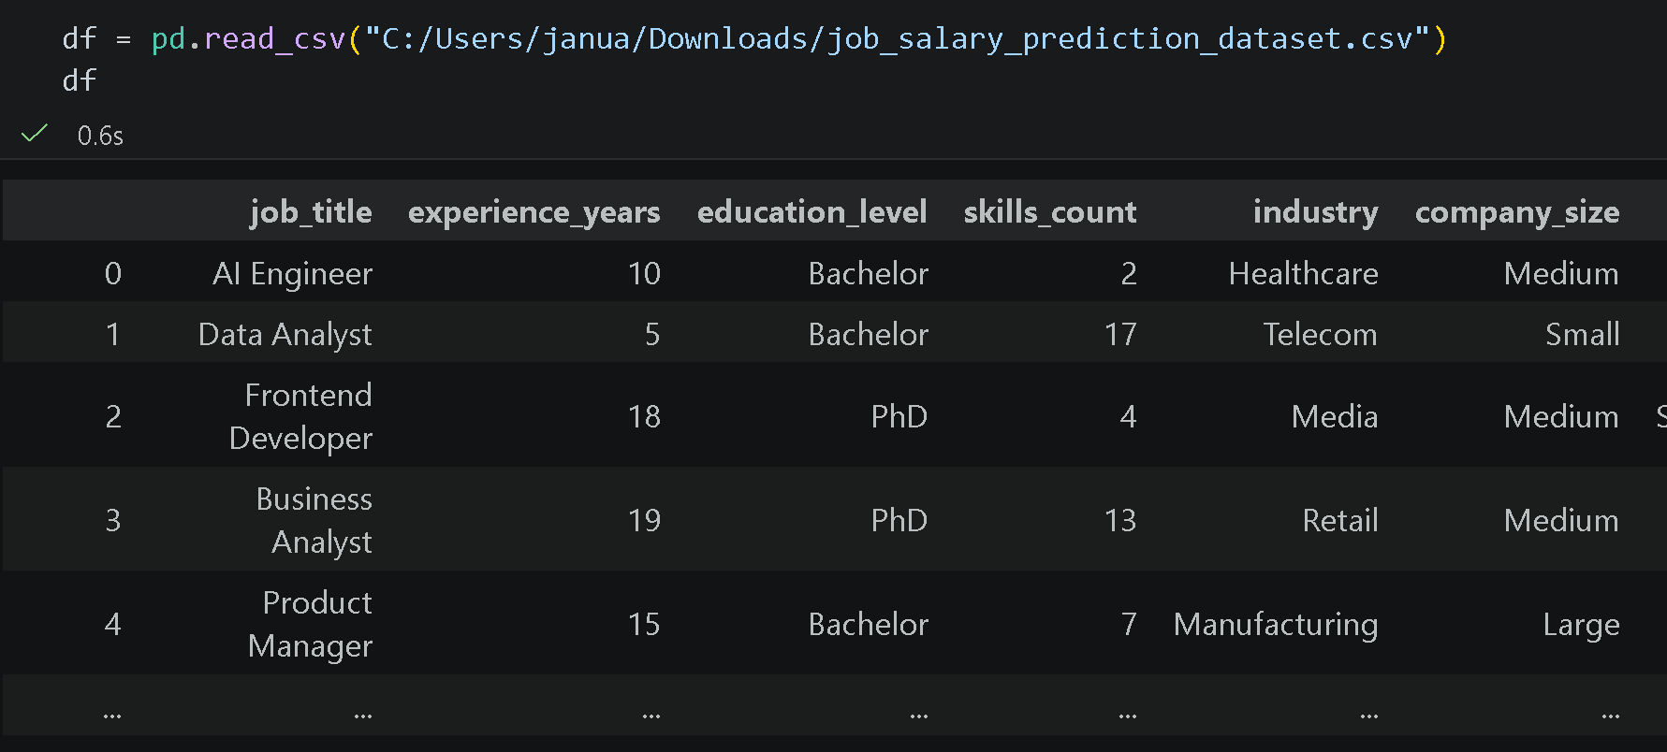
- (Step-3)- Dimension of Dataset
line of code is used to display the dimensions of the dataset. The shape attribute in Pandas returns a tuple representing the number of rows and columns in the DataFrame.
- The first value represents the number of rows (records)
- The second value represents the number of columns (features)

print("Shape:", df.shape)

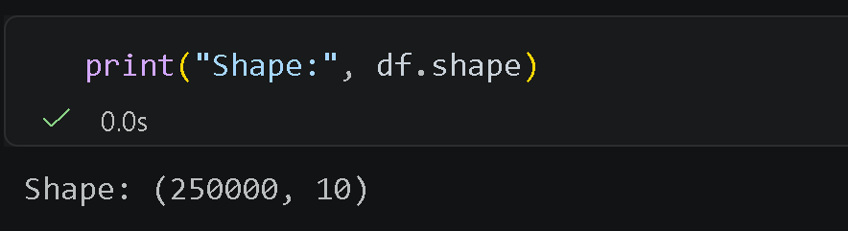
- (Step-4)-Statistical summary
The describe() function in Pandas is used to generate a statistical summary of numerical columns in the dataset. It provides key metrics that help in understanding the distribution and characteristics of the data.

df.describe()

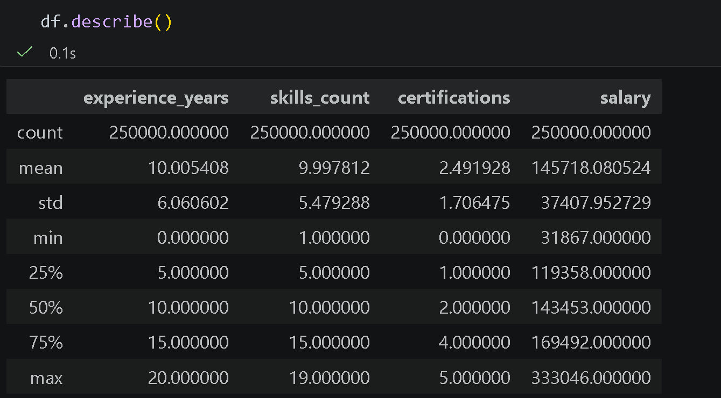

- (Step-5)-Information Summary:- The info() function in Pandas is used to display a concise summary of the dataset. It provides important details about the structure and contents of the DataFrame.

df.info()

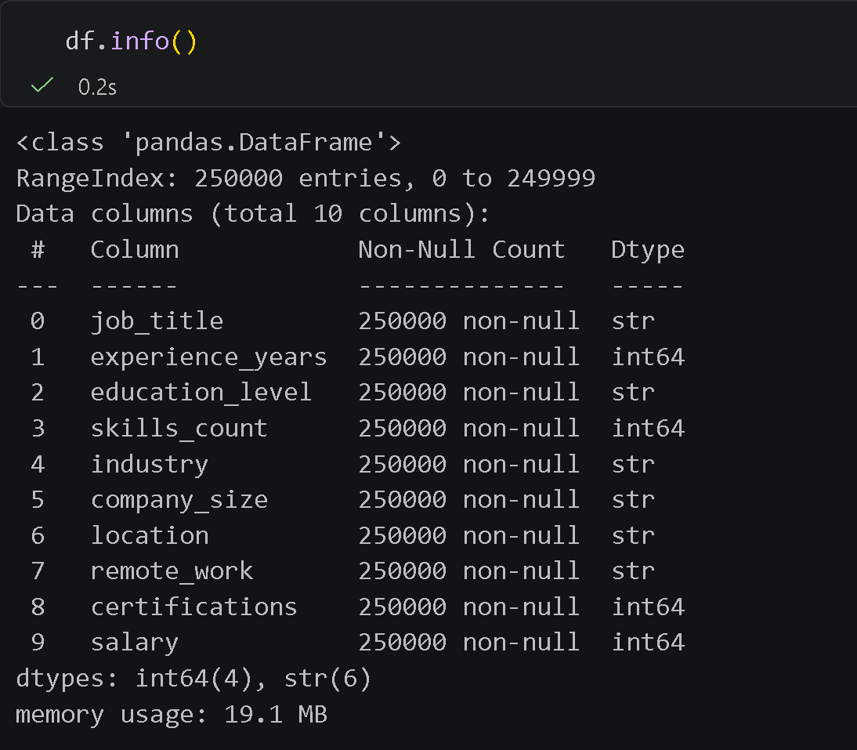

- (Step-6)-Viewing Column Names of Dataset
The columns attribute in Pandas is used to display the list of all column names present in the dataset. It returns an index object containing the names of each feature (column) in the DataFrame.

df.columns

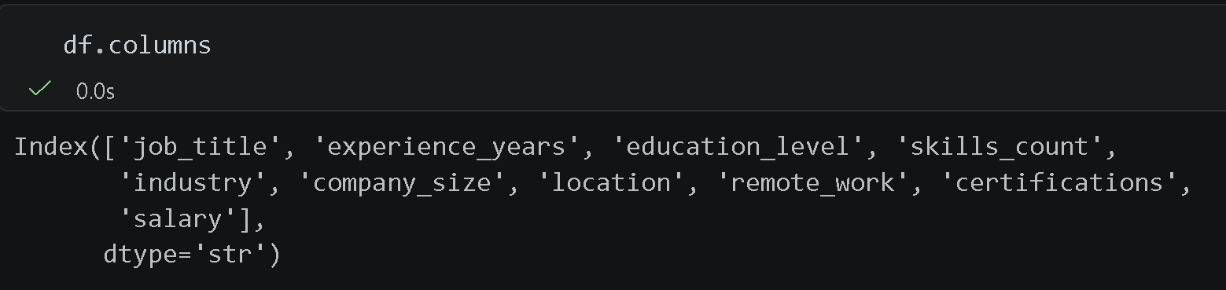

- (Step-7)-Count Duplicate Rows and removing them
This line of code is used to identify and count duplicate rows in the dataset. and other is used to remove duplicate values entries.

df.duplicated().sum()
df.drop_duplicates(inplace=True)

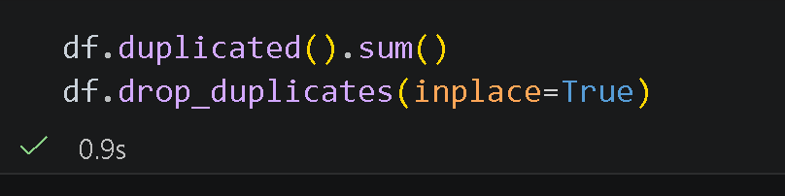

- (Step-8)- Checking Missing Values in Dataset
This line of code is used to identify and count missing (null) values in each column of the dataset.
df.isnull() returns a DataFrame with:
- True → missing value
- False → non-missing value
- .sum() calculates the total number of missing values in each column.

df.isnull().sum()

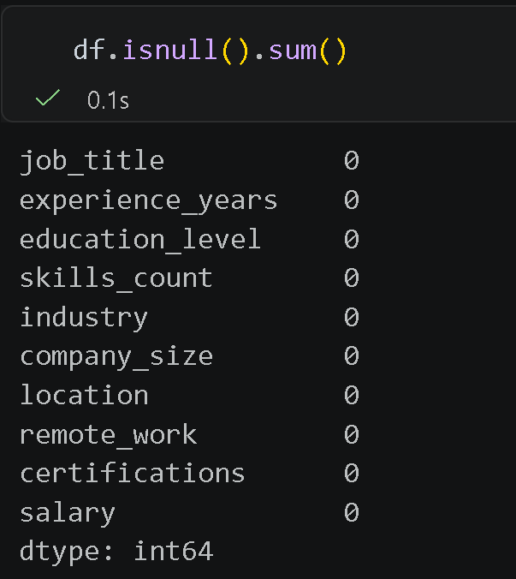

- (Step-9)- Filling missing values (numerical columns) with mean(Avegrage) value. (“there is no missing value” only for knowledge)

df=df.fillna(df.mean(numeric_only=True), inplace=True)-
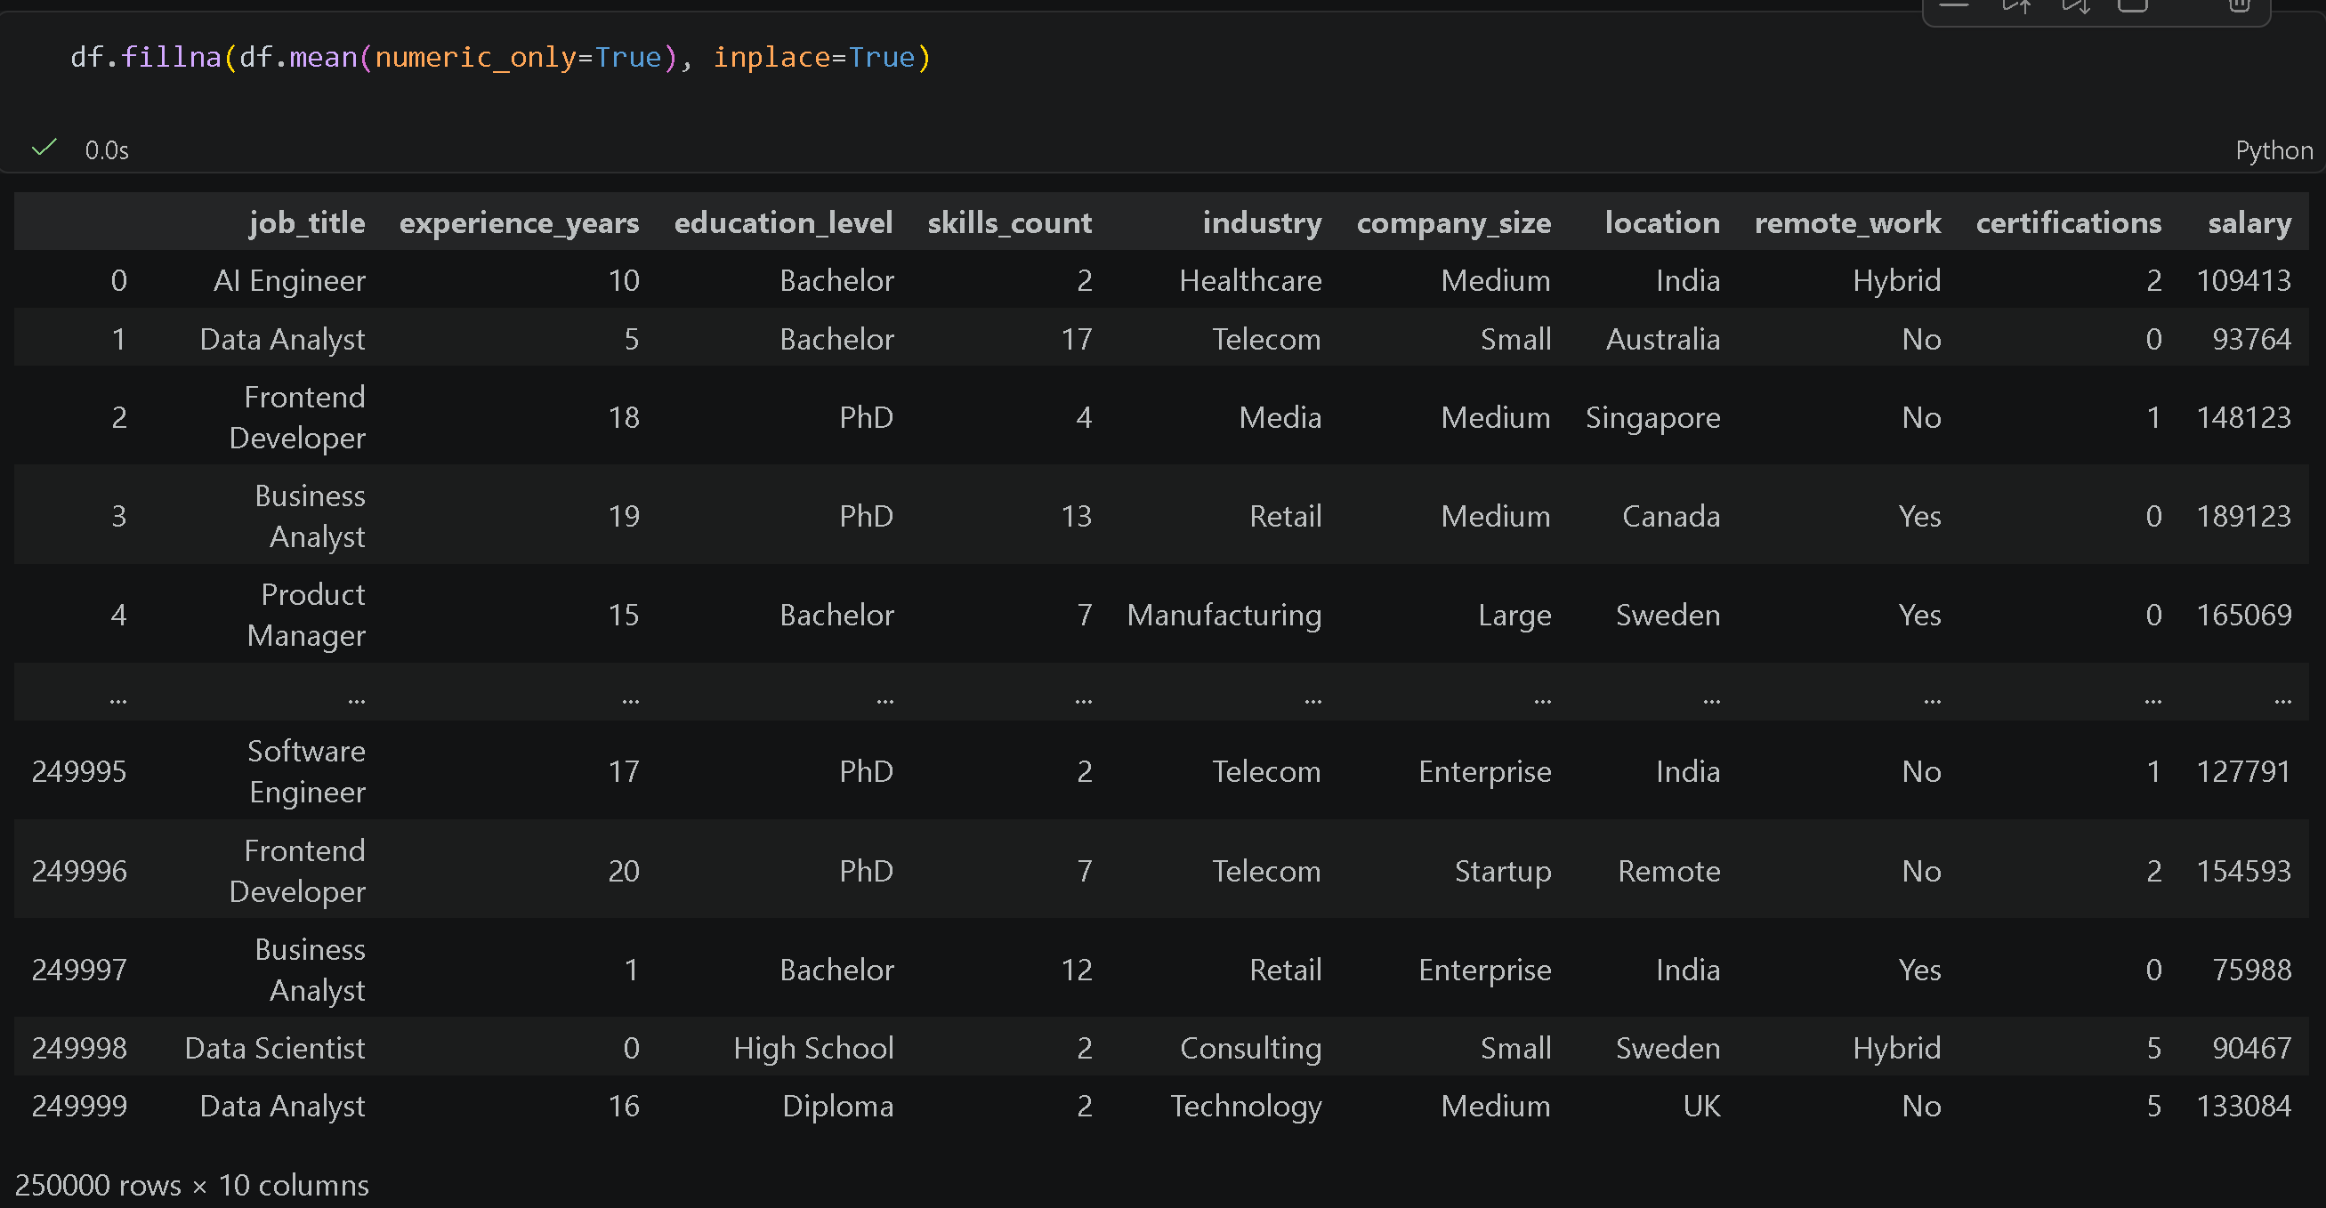
4

LINEAR REGRESSION
- (Step-10)- Define Features (X) and Target (y)
What it does: Separates the independent variable (YearsExperience) and dependent variable (Salary). The reshape(-1, 1) makes x a 2D array as required by scikit-learn.

# Creating X and y
x = df['experience_years']
x =np.array(x)
# Convert to 2D
x = x.reshape(-1, 1)
y = df['salary']

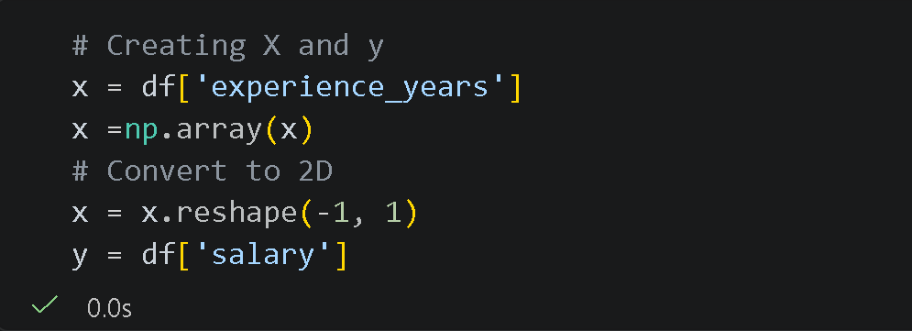

- (Step-11)-Train-Test Split
What it does: Splits data into 70% training and 30% testing sets. random_state=100 ensures the same split every time for reproducibility.

Reproducibility means that you (or someone else) can run the same code on the same data and get the same results again.

from sklearn.model_selection import train_test_split x_train, x_test, y_train, y_test = train_test_split(x, y, train_size=0.7, test_size=0.3, random_state=100)

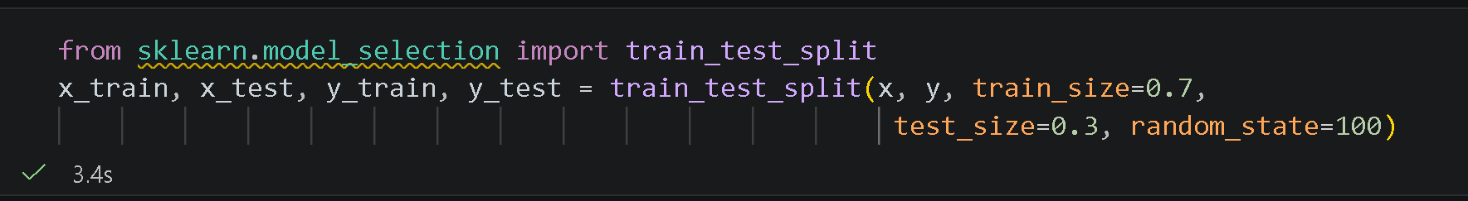
- (Step-12)- Train the Linear Regression Model
What it does: Creates a Linear Regression model and trains it on the training data. Finds the best-fit line: y = b₀ + b₁x.

from sklearn.linear_model import LinearRegression
regressor = LinearRegression()
regressor.fit(x_train, y_train)

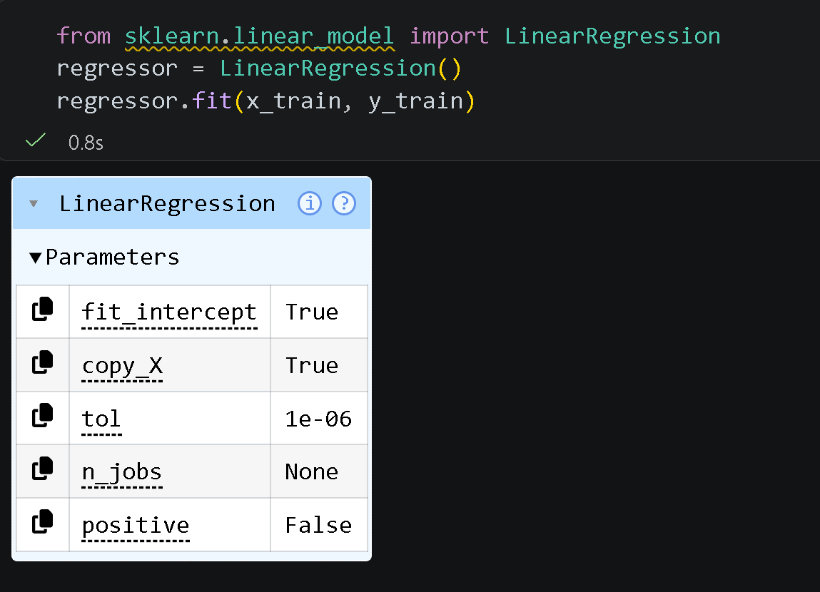

- (Step-13)- Calculating Linear Regression
What it does: Retrieves the equation values. The regression formula is: Salary = 118633.222+ 2703.322× YearsExperience.

Intercept ($b_{0}$)
- The intercept represents the predicted salary when the years of experience is zero.
- In this model, the intercept value is 118633.222.
- This means that even if a person has no experience, the model predicts a base salary of approximately 118,633.
Purpose:
The intercept provides a baseline value from which the salary starts and helps in forming the regression line.

Coefficient ($b_{1}$)
- The coefficient represents the change in salary for each additional year of experience.
- In this model, the coefficient value is 2703.322.
- This means that for every 1-year increase in experience, the salary increases by approximately 2,703.
Purpose:
The coefficient shows the strength and direction of the relationship between experience and salary:
- Positive value → Salary increases with experience
- Negative value → Salary decreases with experience

# To get the intercept value b0
b0=regressor.intercept_
# To get the coefficient value b1
b1=regressor.coef_
print("Intercept:",b0, "Coefficient:",b1)
y=b0+b1*x
y

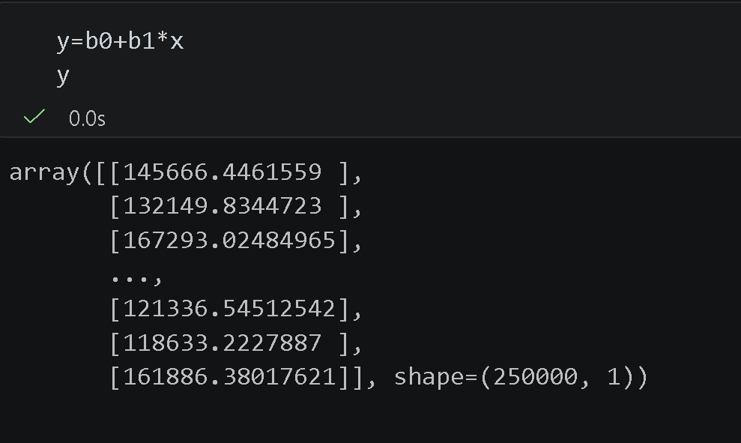

- (Step-14)-Saving the Processed Dataset
This code is used to save the processed dataset into a new CSV file. After completing all preprocessing steps (like cleaning, encoding, and transformation), the updated DataFrame is stored for future use.
- to_csv() → Exports the DataFrame to a CSV file
- 'job_salary_prediction_dataset_saved' → Name of the saved file
- index=False → Prevents saving row index values as an extra column

df.to_csv('job_salary_prediction_dataset_saved', index=False)
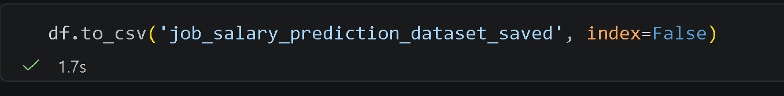

- (Step-15)- Making Predictions.
What it does: Uses the trained model to predict Salary values for the test set. And comparing it using dataFrame.

y_pred = regressor.predict(x_test)
results = pd.DataFrame({
'Actual': y_test[:5].values,
'Predicted': y_pred[:5]
})
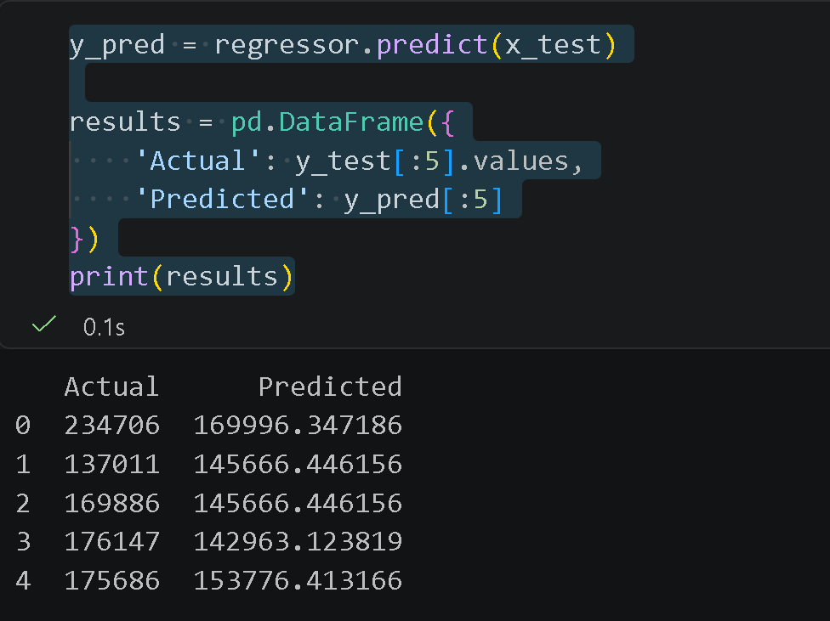
print(results)

- (Step-16)Evaluate the Model
What it does: Measures prediction error. Lower values = better model. MAE is average absolute error, MSE penalizes larger errors, RMSE is in the same unit as y.

from sklearn import metrics
print('Mean Absolute Error:', metrics.mean_absolute_error(y_test, y_pred))
print('Mean Squared Error:', metrics.mean_squared_error(y_test, y_pred))
print('Root Mean Squared Error:', np.sqrt(metrics.mean_squared_error(y_test, y_pred)))

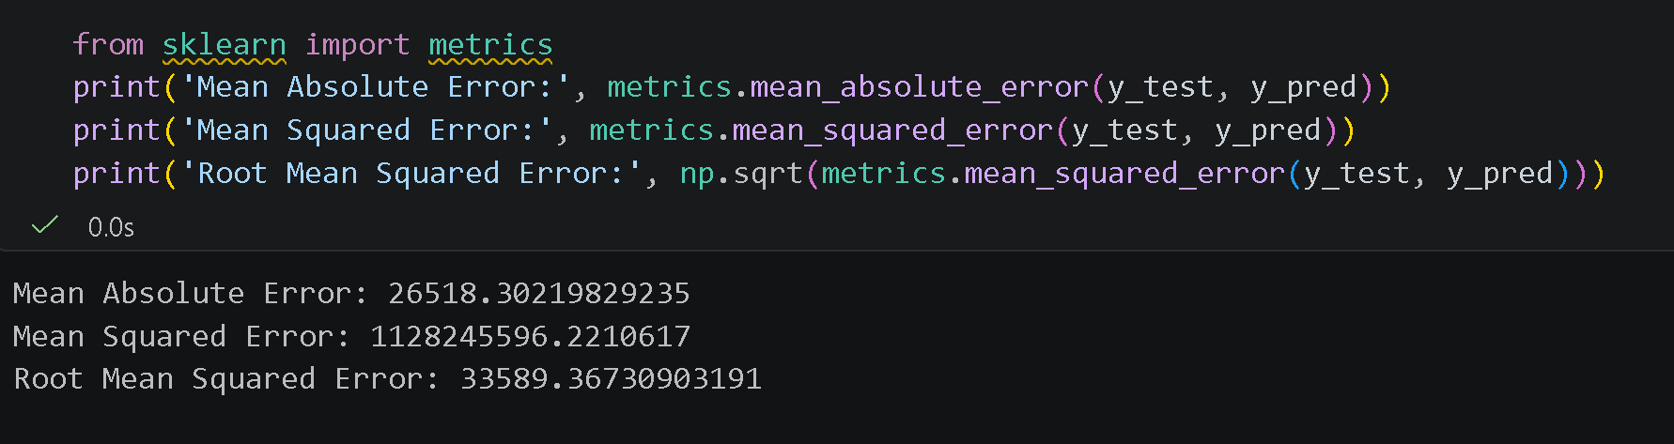

- (Step-17)- Calculating R²
What it does: R² (R-squared) tells how well the model explains variance in the target. Ranges from 0 to 1 — closer to 1 is better. The final model got ~0.1913 (19.13 % accuracy)

from sklearn.metrics import r2_score
r_squared = r2_score(y_test, y_pred)

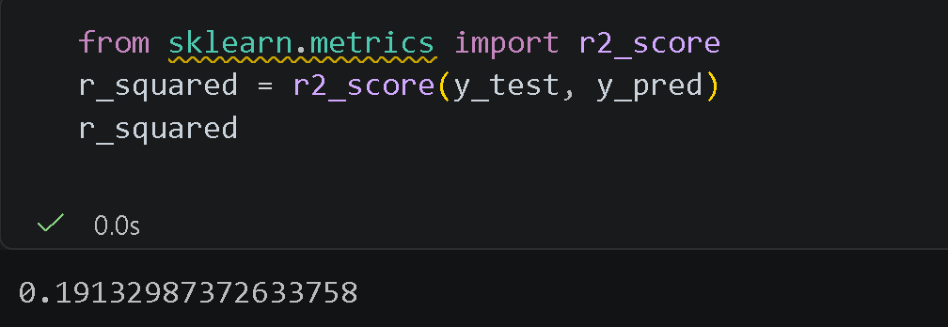

Visualize the Regression Line

- Data Visualization is the process of representing data in a visual format such as charts, graphs, and plots, so that it becomes easier to understand patterns, trends, and relationships.

- (Step-1)-Visualize the Regression Line
What it does: Plots training data points as a scatter plot and draws the red regression line over them.

- plt.scatter(x_train, y_train)
Creates a scatter plot of the training data where:
- X-axis → Years of Experience
- Y-axis → Salary
Each point represents an individual data observation.
- plt.plot(x_train, 118633.222 + 2703.322 * x_train, 'r')
Plots the regression line using the equation:
Salary = 118633.222 + 2703.322 × (YearsExperience)
- 'r' indicates that the line is drawn in red color
- plt.show()
Displays the final graph
plt.scatter(x_train, y_train)
plt.plot(x_train, 118633.222+ 2703.322* x_train, 'r')
plt.show()
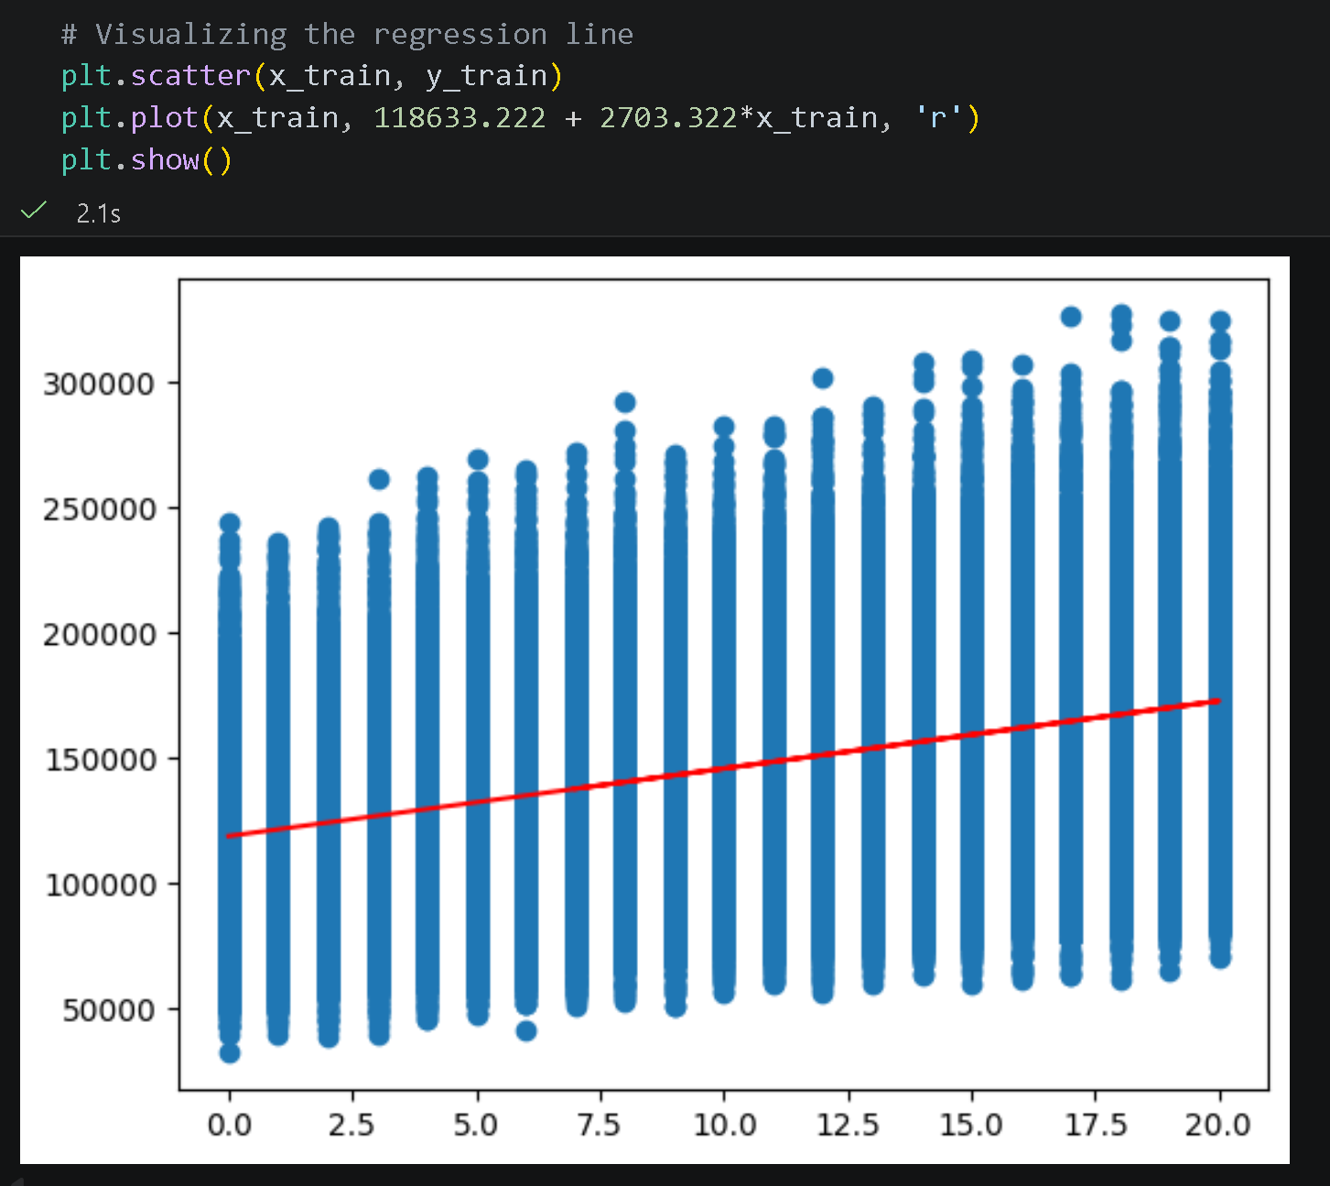

- (Step-2)- Histogram for Data Distribution
This code is used to visualize the distribution of employee salaries in the dataset using a histogram.
- plt.figure()
Initializes a new plotting area for the graph.
- sns.histplot()
Creates a histogram to display how salary values are distributed across the dataset.
- bins=30 → Divides the salary range into 30 intervals
- kde=True → Adds a smooth density curve to better understand the distribution pattern
- color='steelblue' → Sets the color of the histogram
plt.title()
Sets the title of the graph as “Distribution of Salary”.
- plt.xlabel() and plt.ylabel()
Label the axes:
- X-axis → Salary values
- Y-axis → Number of employees
- plt.show()
Displays the final plot.

plt.figure()
sns.histplot(df['salary'], bins=30, kde=True, color='steelblue')
plt.title('Distribution of Salary')
plt.xlabel('Salary')
plt.ylabel('Number of Employees')
plt.show()
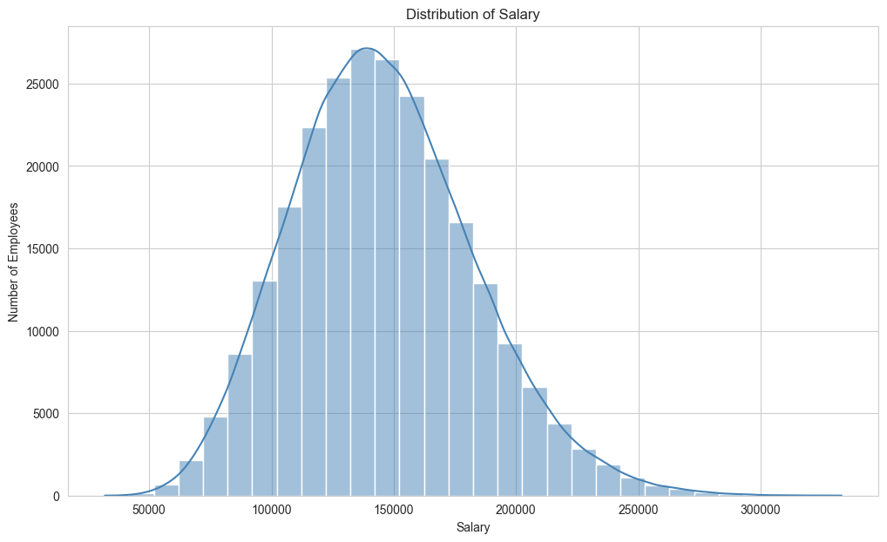

- (Step-3)-Job Title Distribution Visualization
This code is used to analyze and visualize the distribution of different job titles based on the number of employees in each role.

# Most Common Job Titles
job_counts = df['job_title'].value_counts()
sns.barplot(x=job_counts.values, y=job_counts.index, palette='viridis')
plt.title('Job Title Distribution by Employee Count')
plt.xlabel('Number of Employees')
plt.ylabel('Job Title')
plt.show()

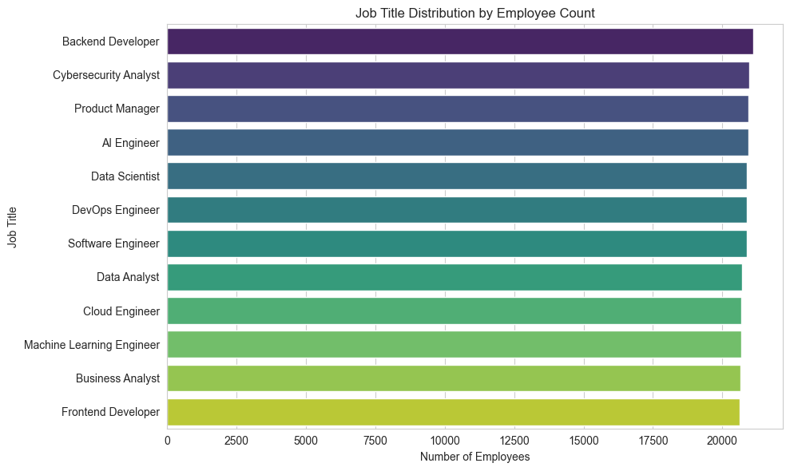

- (Step-4)-Salary Distribution by Job Title
This code is used to visualize how salaries vary across different job titles using a box plot.

job_order = df.groupby('job_title')['salary'].median().sort_values(ascending=False).index
sns.boxplot(x='job_title', y='salary', data=df, order=job_order, palette='Set1')
plt.title('Salary Distribution by Job Title')
plt.xlabel('Job Title')
plt.ylabel('Salary (USD)')
plt.xticks(rotation=45)
plt.show()

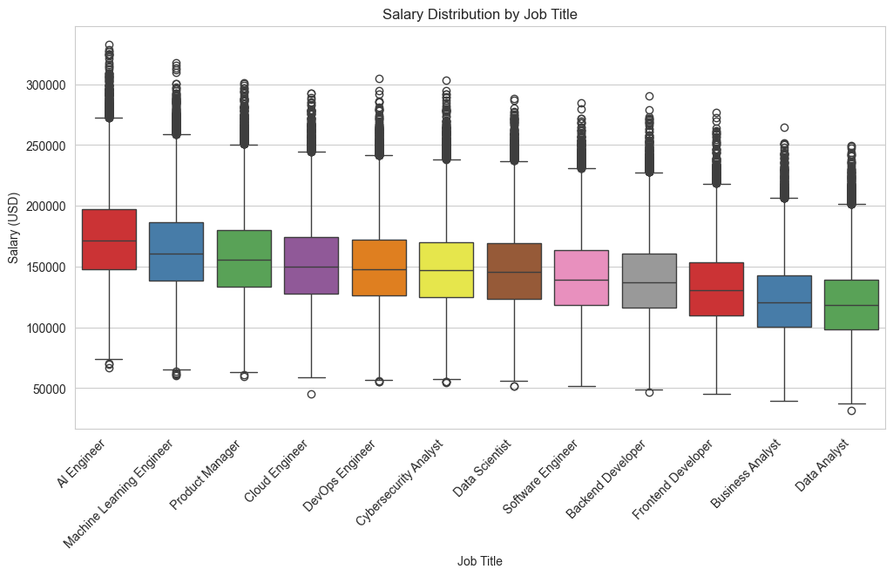

- (Step-5)-Experience vs Salary (Scatter Plot)
This code is used to visualize the relationship between years of experience and salary using a scatter plot.

sns.scatterplot(x='experience_years', y='salary', data=df, alpha=0.4, color='coral')
plt.title('Experience vs Salary')
plt.xlabel('Experience (Years)')
plt.ylabel('Salary (USD)')
plt.show()

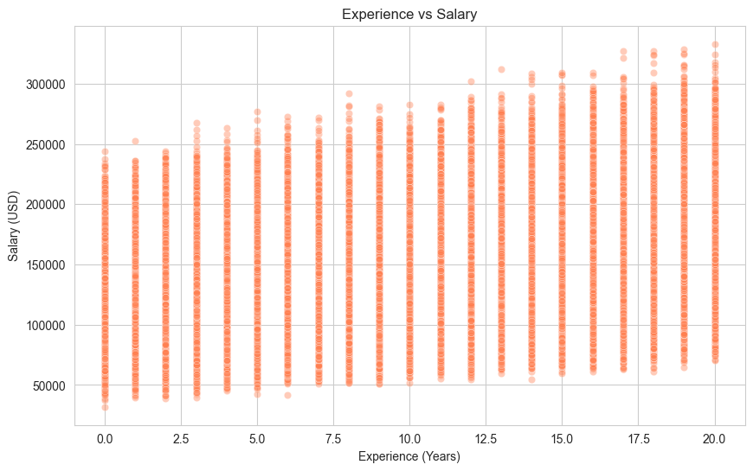

- (Step-6)-Correlation Heatmap
This code is used to visualize the correlation between numerical variables in the dataset using a heatmap.
- +1 → Strong positive correlation
- -1 → Strong negative correlation
- 0 → No correlation
numeric_df = df[['experience_years', 'skills_count', 'certifications', 'salary']]
sns.heatmap(numeric_df.corr(), cmap='coolwarm', annot=True, fmt='.2f', linewidths=0.5)
plt.title('Correlation Heatmap')
plt.show()

- Features Correlated with Salary (barplot)
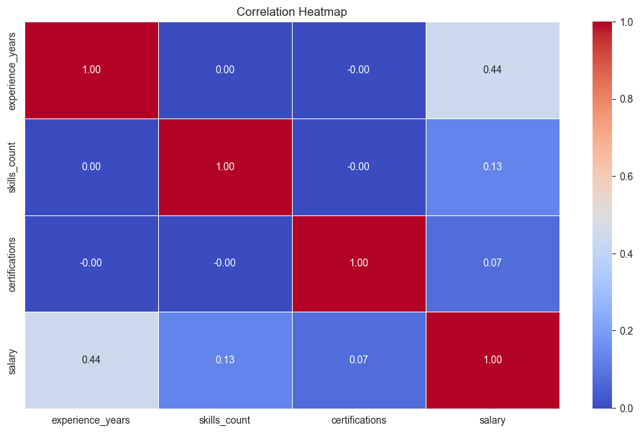
This code is used to identify and visualize the relationship between numerical features and salary using correlation analysis.

# Top Features Correlated with Salary
numeric_df = df.select_dtypes(include='number')
corr=numeric_df.corr()['salary'].drop('salary').sort_values(ascending=False)
sns.barplot(x=corr.index, y=corr.values, palette='Blues_r')
plt.title('Features Correlated with Salary')
plt.xlabel('Correlation')
plt.ylabel('Feature')
plt.show()

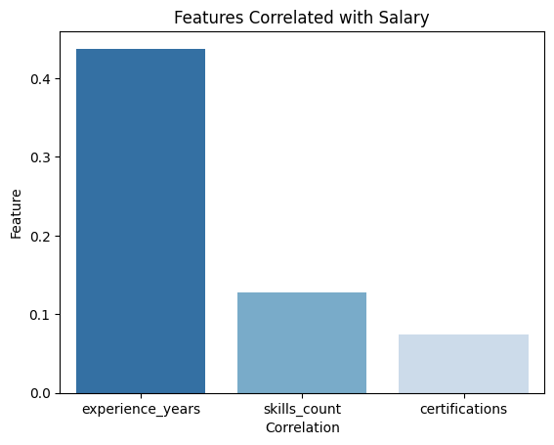

- Importing Machine Learning Libraries
This code is used to import essential modules from the Scikit-learn library required for building and training the machine learning model.

from sklearn.linear_model import LinearRegression
from sklearn.model_selection import train_test_split
from sklearn.preprocessing import LabelEncoder

- Encoding Categorical Variables and Feature Selection
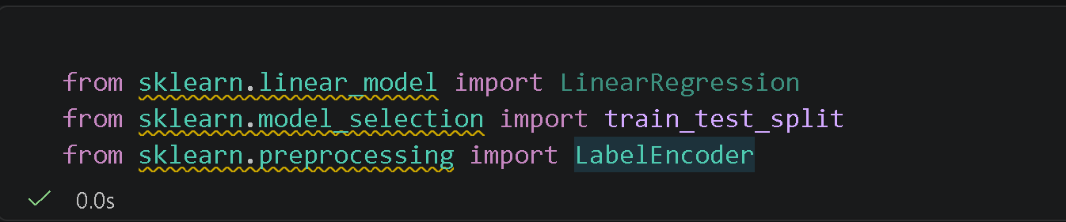
This code is used to convert categorical variables into numerical form and to define the feature set (X) and target variable (y) for the regression model.

# Encode all categorical columns
le = LabelEncoder()

columns = ['job_title', 'education_level', 'industry', 'company_size', 'location', 'remote_work']

for col in columns:
df[col + '_encoded'] = le.fit_transform(df[col])

# Select features (encoded + original numerical columns)
X = df[['experience_years', 'skills_count', 'certifications',
'job_title_encoded', 'education_level_encoded', 'industry_encoded',
'company_size_encoded', 'location_encoded', 'remote_work_encoded']]

y = df['salary']

print("Features:", X.columns.tolist())
print("Shape:", X.shape)
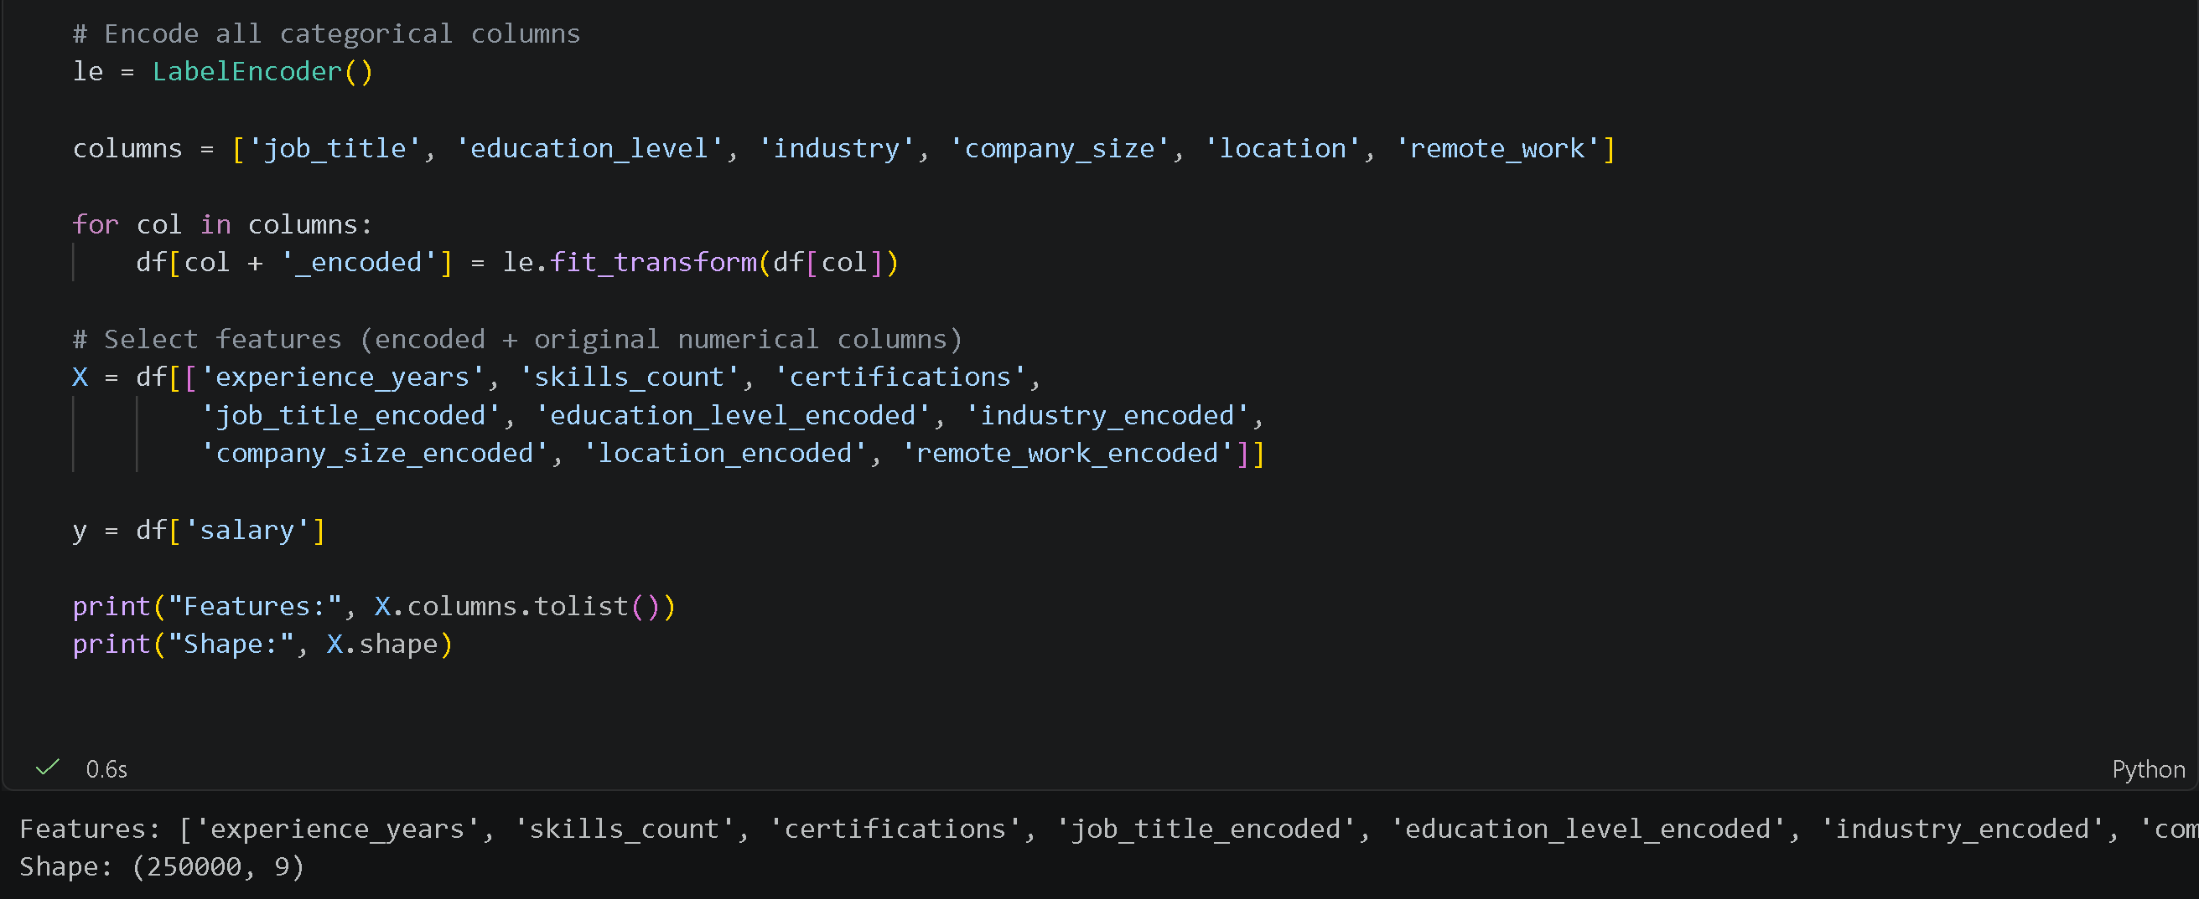
- Splitting Data into Training and Testing Sets
This code is used to divide the dataset into training and testing subsets for building and evaluating the machine learning model.

# Split Data (80% train, 20% test)
X_train, X_test, y_train, y_test = train_test_split(
X, y, test_size=0.2, random_state=42
)

print("Training samples:", X_train.shape[0])
print("Testing samples:", X_test.shape[0])

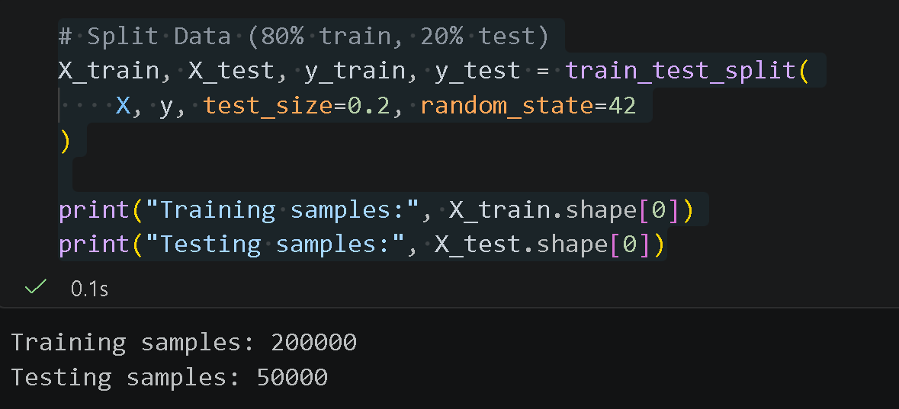

- Training the Linear Regression Model
This code is used to create and train a Linear Regression model using the training dataset.

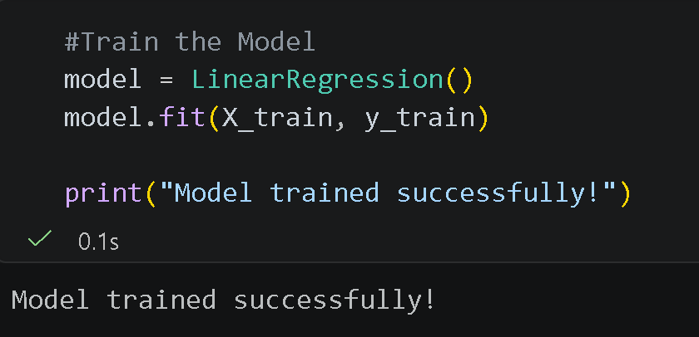
# Train the Model
model = LinearRegression()
model.fit(X_train, y_train)
print("Model trained successfully!")
- Conclusion
This project demonstrated the complete process of a supervised machine learning regression model, including data preprocessing, model building, visualization, and evaluation. The results show a positive relationship between years of experience and salary.

The regression equation provides a basic salary prediction; however, the low R² score (19.13%) indicates that experience alone is not sufficient for accurate predictions. Future improvements can be made by including more features and using advanced models.

Overall, the project highlights the importance of data quality, feature selection, and model choice in improving prediction performance.

- Reference
https://www.kaggle.com/datasets/nalisha/job-salary-prediction-dataset

