**SVC API**

*ARBAAZ KHAN*

*J071*

**SVM**

Support vector machines (SVMs) are a set of supervised learning methods used for [classification](https://scikit-learn.org/stable/modules/svm.html#svm-classification), [regression](https://scikit-learn.org/stable/modules/svm.html#svm-regression) and [outliers detection](https://scikit-learn.org/stable/modules/svm.html#svm-outlier-detection).

Code:

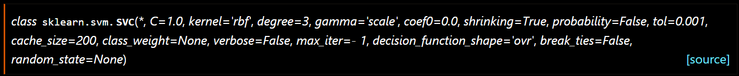

Methods:

|  |  |
| --- | --- |
| [decision_function](https://scikit-learn.org/stable/modules/generated/sklearn.svm.SVC.html#sklearn.svm.SVC.decision_function)(X) | Evaluates the decision function for the samples in X. |
| [fit](https://scikit-learn.org/stable/modules/generated/sklearn.svm.SVC.html#sklearn.svm.SVC.fit)(X, y[, sample_weight]) | Fit the SVM model according to the given training data. |
| [get_params](https://scikit-learn.org/stable/modules/generated/sklearn.svm.SVC.html#sklearn.svm.SVC.get_params)([deep]) | Get parameters for this estimator. |
| [predict](https://scikit-learn.org/stable/modules/generated/sklearn.svm.SVC.html#sklearn.svm.SVC.predict)(X) | Perform classification on samples in X. |
| [score](https://scikit-learn.org/stable/modules/generated/sklearn.svm.SVC.html#sklearn.svm.SVC.score)(X, y[, sample_weight]) | Return the mean accuracy on the given test data and labels. |
| [set_params](https://scikit-learn.org/stable/modules/generated/sklearn.svm.SVC.html#sklearn.svm.SVC.set_params)(**params) | Set the parameters of this estimator. |

Advantages:

* Effective in high dimensional spaces.
* Still effective in cases where number of dimensions is greater than the number of samples.
* Uses a subset of training points in the decision function (called support vectors), so it is also memory efficient.
* Versatile: different [Kernel functions](https://scikit-learn.org/stable/modules/svm.html#svm-kernels) can be specified for the decision function. Common kernels are provided, but it is also possible to specify custom kernels.

Disadvantages:

* If the number of features is much greater than the number of samples, avoid over-fitting in choosing [Kernel functions](https://scikit-learn.org/stable/modules/svm.html#svm-kernels) and regularization term is crucial.
* SVMs do not directly provide probability estimates, these are calculated using an expensive five-fold cross-validation.

In scikit-learn support both dense (numpy.ndarray and convertible to that by numpy.asarray) and sparse (any scipy.sparse) sample vectors as input. However, to use an SVM to make predictions for sparse data, it must have been fit on such data. For optimal performance, use C-ordered numpy.ndarray (dense) or scipy.sparse.csr_matrix (sparse) with dtype=float64.