OOP ARBAB ALI : Document for the Task 1.

ARBAB ALI | 1. assignment/2. task | 15th march 2020
arbabniz123@gmail.com

Task

Implement the X matrix type which contains integers. These are square matrices that
can contain nonzero entries only in their two diagonals. Don't store the zero entries.
Store only the entries that can be nonzero in a sequence. Implement as methods:
getting the entry located at index (i, j), adding and multiplying two matrices, and
printing the matrix (in a square shape).

X matrix type

Set of values
Xmat(n) = { a ℤn×n i,j [1..n]: i≠j or (i+j) ≠ (n-1) → a[i,j]=0 }

Operations

1. Getting an entry
Getting the entry of the ith column and jth row (i,j [1..n]): e:=a[i,j].
Formally: A : Xmat(n) × ℤ × ℤ × ℤ
a i j e
Q : ( a=a’ i=i’ j=j’ i,j [1..n] )

- : ( Q e=a[i,j] )

This operation needs any action only if i=j or (i+j=n-1), otherwise the output is zero.

2. Setting an entry

Setting the entry of the ith column and jth row (i,j [1..n]): a[i,j]:=e. Entries outside the diagonal cannot be modified (i=j).
Formally: A : Xmat(n) × ℤ × ℤ × ℤ
a i j e
Q : ( e=e’ a=a’ i=i’ j=j’ i,j [1..n] i=j )
R : (e=e’ i=i’ j=j’ a[i,j]=e k,l [1..n]: (k≠i l≠j)→ a[k,l]=a’[k,l] )

This operation needs any action only i=j or (i+j=n-1), otherwise it gives an error if we want to modify a zero entry.

3. Sum
Sum of two matrices: c:=a+b. The matrices have the same size.

Formally:

A : Xmat (n) × Xmat (n) × Xmat (n)
a b c

Q : ( a=a’ b=b’)

R = ( Q i,j [1..n]: c[i,j]= a[i,j] + b[i,j] )

OOP ARBAB ALI : Document for the Task 2.

In case of X matrices there is an easier version:
I,j [1..n]: c[i,j]= a[i,j] + b[i,j] and i,j [1..n]: i≠j or (i+j) ≠ (n-1) → c[i,j]=0.

4. Multiplication
Multiplication of two matrices: c:=a*b. The matrices have the same size.

Formally:

A : Xmat (n) × Xmat (n) × Xmat (n)
a b c

Q : ( a=a’ b=b’)

- : ( Qi,j [1..n]: c[i,j]= k=1..n a[i,k] * b[k,j])

In case of diagonal matrices there is an easier version:
I,j [1..n]: c[i,i]= a[i,i]*b[i,i] & i,j [1..n]: i≠j or (i+j) ≠ (n-1) → c[i,j]=0.

Representation

Only the diagonal of the n×n matrix has to be strored.

a11 | 0 | 0 | … a1n
0 | a22 | a23 | … 0 | v =< a11…a1n a22 .. a 2n a 32… a 3n a n1.. a nn >
a = 0 | a32 | a33 … 0 |  | v =< a11…a1n a22 .. a 2n a 32… a 3n a n1.. a nn >
an1 | 0 | 0 | … ann

Only a one-dimension array (v) is needed, with the help of which any entry of the double diagonal matrix or X matrix can be get:

OOP ARBAB ALI Document for the Task 3.

Implementation¹

1. Getting an entry

Getting the entry of the ith column and jth row (i,j [1..n]) e:=a[i,j] where the matrix is represented by v,1 i n, and n stands for the size of the matrix can be implemented as

i=j (i+j=n-1) i!=j
e:=v[i-1] | e:=v[n-i-1] | e:=0

2. Setting an entry

Setting the entry of the ith column and jth row (i,j [1..n]) a[i,j]:=e where the matrix is represented by v,1 i n, and n stands for the size of the matrix can be implemented as

i=j (i+j=n-1) i!=j
v[i-1]:=e | V[n-i-1]:=e | SKIP

3. Sum

The sum of matrices a and b (represented by arrays t and u) goes to matrix c (represented by array u), where all of the arrays have to have the same size.

i [0..n-1]: u[i]:= v[i] + t[i]

4. Multiplication

The product of matrices a and b (represented by arrays t and u) goes to matrix c (represented by array u), where all of the arrays have to have the same size.

i,j [0..n-1]: u[i,j]:= v[i,j] * t[i,j]

- 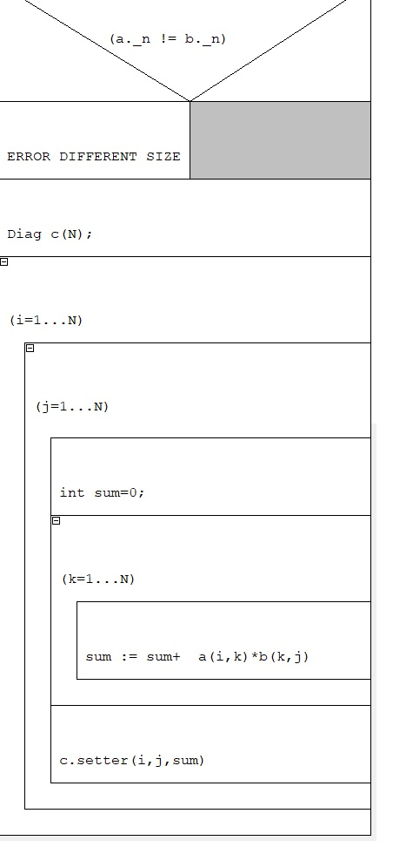
- To implement an operation, a program has to be given (not necessarily structogram).

OOP ARBAB ALI : Document for the Task 4.

Class

The X matrix type is worked out as a class. The size of the matrix can be set through the constructor. At the operations, the matrices have to have the same size, otherwise the program should throw an exception.
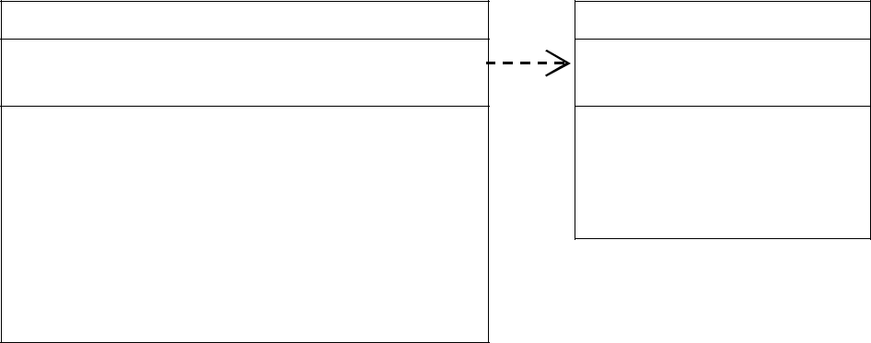

Xmat

- v : int[0 .. n-1]
- n : int

+ Xmat(int)
+ get(int, int) : int { query }
- set(int, int, int) : void
- add (Xmat, Xmat) : Xmat
- mul (Xmat, Xmat) : Xmat

+ write() : void { query }
+ read() : void

Exceptions

- OVERINDEXED
- NULLPART
- DIFFERENT

The entries in the diagonal can be represented as a vector<int> or as a dynamic array. In the latter case the constructor allocates the dynamic array and the destructor frees the memory (a copy constructor and an assignment operator is needed, too).

To override the getter and the setter of an entry, operator () is overridden in two ways. Operators sum and product are created as friend functions.

The class is extended by read and write methods, worked out via operators.

For error handling, three exceptions are defined. OVERINDEXED is thrown when wrong indexes are given as inputs in the getter and the setter. NULLPART is raised when an entry outside the diagonal should be overwritten. DIFFERENT exception is given in case of operation (sum, product) with matrices of different size.

OOP ARBAB ALI: Document for the Task 5.

Testing

Testing the operations (black box testing)

- Creating, reading, and writing matrices of different size.
  - 0, 1, 2, 3-size matrix
- Getting and setting an entry
  - Getting and setting an entry in the primary diagonal and in the secondary diagonal
  - Getting and setting an entry outside the primary diagonal and the secondary diagonal
  - Illegal index, indexing a 0-size matrix
- Copy constructor

  - Creating matrix b based on matrix a, comparing the entries of the two matrices. Then, changing one of the matrices and comparing the entries of the two matrices.

- Assignment operator

  - Executing command b=a for matrices a and b (with and without same size), comparing the entries of the two matrices. Then, changing one of the matrices and comparing the entries of the two matrices.

  - Executing command c=b=a for matrices a, b, and c (with and without same size), comparing the entries of the three matrices. Then, changing one of the matrices and comparing the entries of the three matrices.

  - Executing command a=a for matrix a.
- Sum of two matrices, command c:=a+b.
  - With matrices of different size (size of a and b differs, size of c and a differs)
  - Checking the commutativity (a + b == b + a)
  - Checking the associativity (a + b + c == (a + b) + c == a + (b + c))
  - Checking the neutral element (a + 0 == a, where 0 is the null matrix)
- Multiplication of two matrices, command c:=a*b.
  - With matrices of different size (size of a and b differs, size of c and a differs)
  - Checking the commutativity (a * b == b * a) (X TYPE matrix is not commutative )
  - Checking the associativity (a * b * c == (a * b) * c == a * (b * c))
  - Checking the neutral element (a * 0 == 0, where 0 is the null matrix)
  - Checking the identity element (a * 1 == a, where 1 is the identity matrix)

Testing based on the code (white box testing)
- Creating an extreme-size matrix (-1, 0, 1, 1000).
- Generating and catching exceptions.

