Lab 5: Minimax and Alpha-Beta Pruning

1. Task1
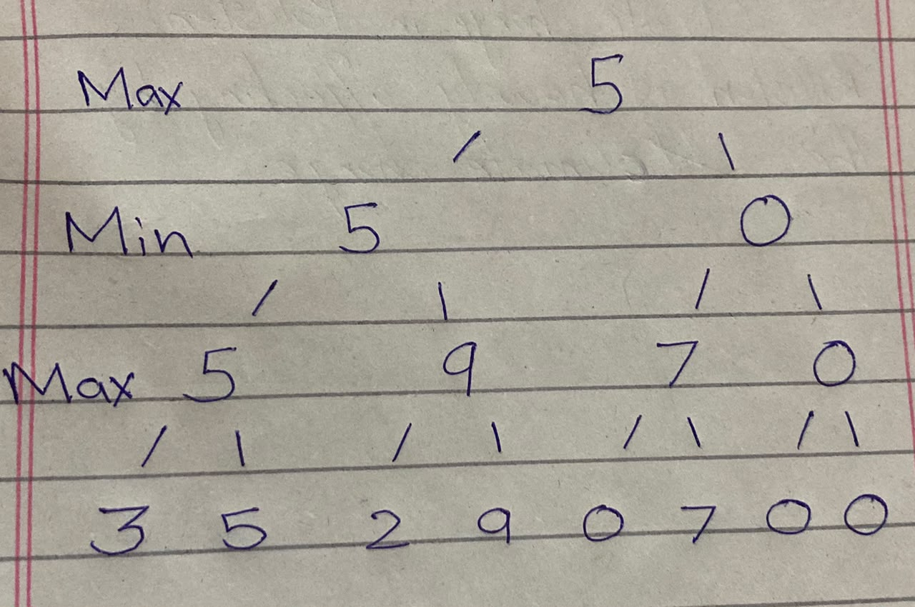
Leaves: 3, 5, 2, 9, 0, 7, 0, 0
MAX level: max(3, 5) = 5; max(2, 9) = 9; max(0, 7) = 7; max(0, 0) = 0.
MIN level: min(5, 9) = 5; min(7, 0) = 0.
Root MAX: max(5, 0) = 5. Optimal value = 5.

2. Task2
A) Minimax
import math
minimax_count = 0
def minimax(curDepth, nodeIndex, maxTurn, scores, targetDepth):
global minimax_count
# Base case: targetDepth reached
if curDepth == targetDepth:
minimax_count += 1
return scores[nodeIndex]
if maxTurn:
return max(
minimax(curDepth + 1, nodeIndex * 2, False, scores, targetDepth),
minimax(curDepth + 1, nodeIndex * 2 + 1, False, scores, targetDepth)
)
else:
return min(
minimax(curDepth + 1, nodeIndex * 2, True, scores, targetDepth),
minimax(curDepth + 1, nodeIndex * 2 + 1, True, scores, targetDepth)
)
scores = [3, 5, 2, 9, 0, 7]
treeDepth = math.ceil(math.log2(len(scores)))
scores += [0] * (2**treeDepth - len(scores))
print("Minimax optimal value:", minimax(0, 0, True, scores, treeDepth))
print("Minimax leaves evaluated:", minimax_count)

Minimax optimal value: 5
Minimax leaves evaluated: 8

B) Alpha beta
import math
alphabeta_count = 0

def alphabeta(depth, index, maxTurn, scores, target, alpha, beta):
global alphabeta_count

if depth == target:
alphabeta_count += 1
return scores[index]

if maxTurn:
value = float('-inf')
for i in range(2):
value = max(value, alphabeta(depth+1, index*2+i, False, scores, target, alpha, beta))
alpha = max(alpha, value)
if alpha >= beta:
break
return value
else:
value = float('inf')
for i in range(2):
value = min(value, alphabeta(depth+1, index*2+i, True, scores, target, alpha, beta))
beta = min(beta, value)
if alpha >= beta:
break
return value

ab_scores = [3, 5, 2, 9, 3, 5, 2, 9]
depth = int(math.log2(len(ab_scores)))

print("Alpha-beta optimal value:", alphabeta(0, 0, True, ab_scores, depth, float('-inf'), float('inf')))
print("Alpha-beta leaves evaluated:", alphabeta_count)
Alpha-beta optimal value: 5
Alpha-beta leaves evaluated: 6

3.Task3

- Minimax

import math

minimax_count = 0

def minimax(curDepth, nodeIndex, maxTurn, scores, targetDepth):
global minimax_count

# Base case: targetDepth reached
if curDepth == targetDepth:
minimax_count += 1
return scores[nodeIndex]

if maxTurn:
return max(
minimax(curDepth + 1, nodeIndex * 2, False, scores, targetDepth),
minimax(curDepth + 1, nodeIndex * 2 + 1, False, scores, targetDepth)
)
else:
return min(
minimax(curDepth + 1, nodeIndex * 2, True, scores, targetDepth),
minimax(curDepth + 1, nodeIndex * 2 + 1, True, scores, targetDepth)
)

scores_re = [3, 9, 0, 5, 0, 2,7,0]
treeDepth = math.ceil(math.log2(len(scores_re)))

print("Reordered Minimax optimal value:", minimax(0, 0, True, scores_re, treeDepth))
print("Reordered Minimax leaves evaluated:", minimax_count)

Reordered Minimax optimal value: 5
Reordered Minimax leaves evaluated:: 6

- Alphabeta

import math
reordered_count = 0

def alphabeta_reordered(depth, index, maxTurn, scores, target, alpha, beta):
global reordered_count

if depth == target:
reordered_count += 1
return scores[index]

if maxTurn:
value = float('-inf')
for i in range(2):
value = max(value, alphabeta_reordered(depth+1, index*2+i, False, scores, target, alpha, beta))
alpha = max(alpha, value)
if alpha >= beta:
break
return value
else:
value = float('inf')
for i in range(2):
value = min(value, alphabeta_reordered(depth+1, index*2+i, True, scores, target, alpha, beta))
beta = min(beta, value)
if alpha >= beta:
break
return value
reordered_scores = [3, 9, 0, 5, 0, 2,7,0]
depth_re = int(math.log2(len(reordered_scores)))
print("Reordered alpha-beta value:", alphabeta_reordered(0, 0, True, reordered_scores, depth_re, float('-inf'), float('inf')))
print("Reordered alpha-beta leaves evaluated:", reordered_count)

Reordered alpha-beta value: 5
Reordered alpha-beta leaves evaluated: 6

4. Comparison
Algorithms give same root values of their tree. The counter tells each algorithms score calculated. Changing the score keeps the minimax leaves evaluated same but alpha beta pruning changes

5. Conclusion
Alpha-beta pruning visits less leaves then minimax that’s why it is fast.

