**Name of Business:** Metro

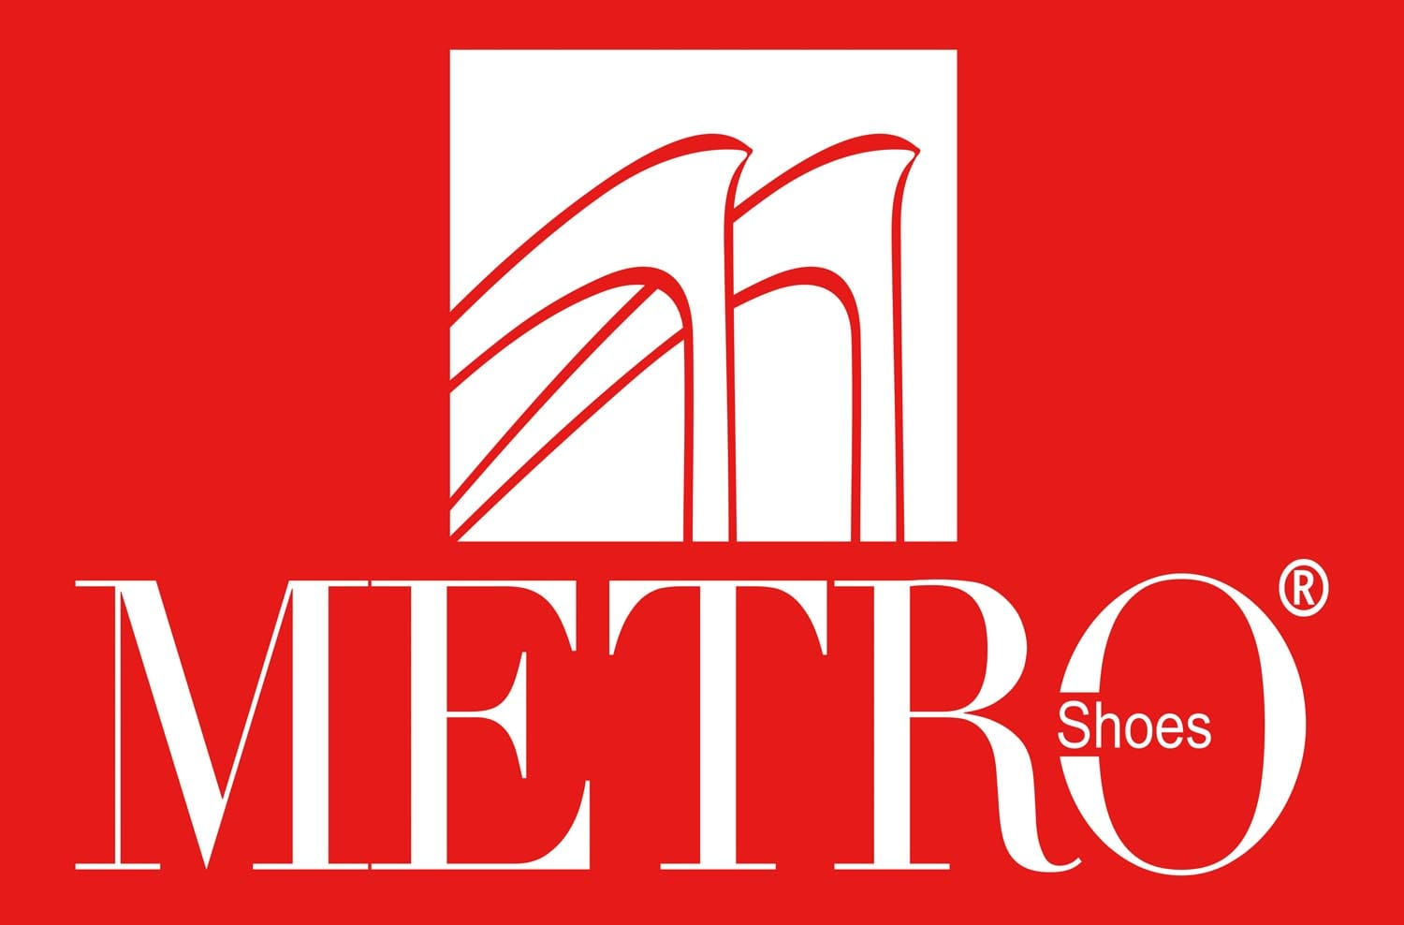

Founded in **1986,** Metro Shoes is an indigenous Pakistani brand. It is ISO certified and has a clear vision of catering to the footwear needs of the community. Metro Shoes has become one of the first shoe brands that women could turn to for feminine style they coveted and comfort they thought was impossible to attain. With rich leathers and unique details, Metro Shoes has captured the essence of modern femininity… whether that means taking a leisurely walk or running a board meeting. Metro Shoes pampers your feet with the cushioned, contoured foot bed and experience all-day comfort!

**Founder:**

Nadeem Younis

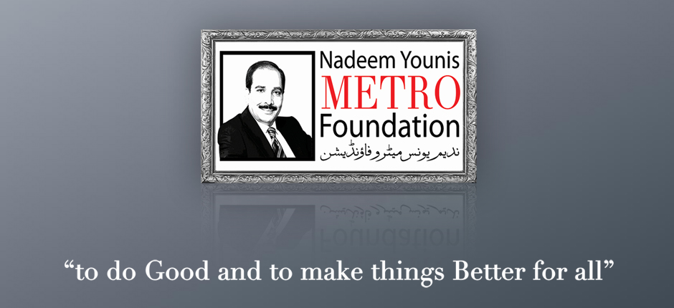

**Origin:** Pakistan

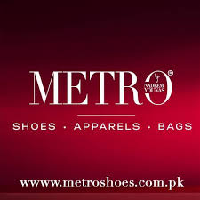

**Region of Operation:**

### Rawalpindi

* Islamabad
* Jehulm
* Kasoor
* Mandi Bahauddin
* Okara
* Chakwal
* Swat
* Lahore
* Peshawar
* Sargodha
* Gujranwala
* Multan
* Mardan
* Mansehra
* Bahawalpur
* Jhang
* Karachi
* Hyderabad

**Products:**

Footwear, Apparel, Jewelry and Accessories Clutches and Hand Bags

Metro Shoes over the years, has established its reputation as one of the finest brands in fashion footwear and accessories all across the country and beyond borders, showcasing a large variety of casual, seasonal, formal, fancy and bridal collections in ladies shoes, clutches, handbags and men’s shoes, keeping in perspective the varied communal likes, interests and aspirations.

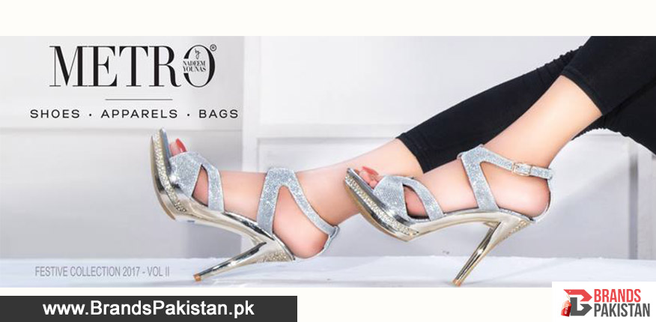

# **Mission Statement:**

Our mission is to be the biggest and the best leader in Pakistan’s footwear industry by offering trendy, elegant and sophisticated shoes with tremendous quality, superior customer services and highly modern techniques.

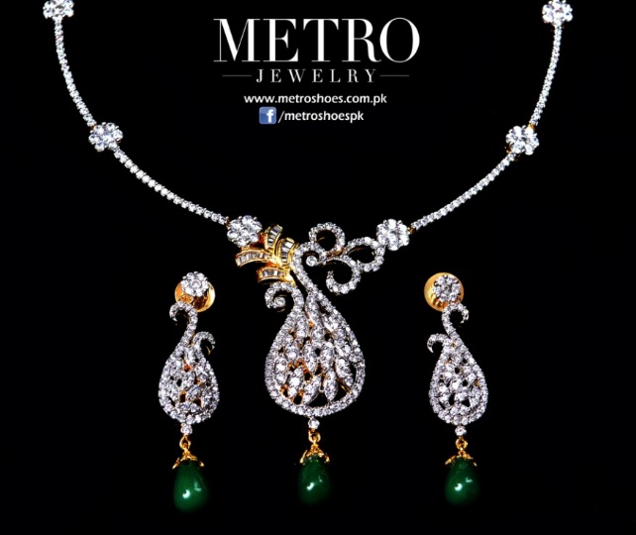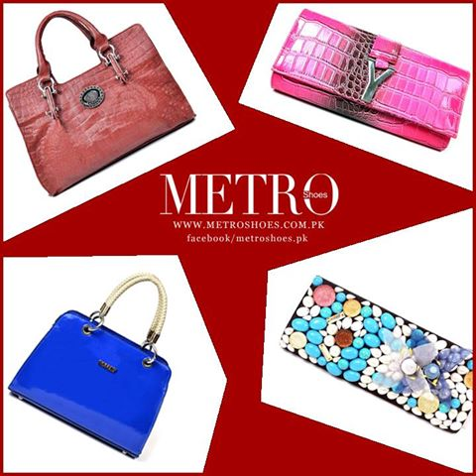

# **Core Values:**

# **Excellence**

# **Creativity**

# **Quality**

# **Integrity**

# **Teamwork**

# **Unique Store Concepts**

# **References:**

# <http://www.metroshoes.com.pk/about-us>

<http://www.metroshoes.com.pk/>

<https://en.wikipedia.org/wiki/Metro_Shoes>

<https://pk.linkedin.com/in/muhammad-younas-81064522>