

Business Requirements Document (BRD)

Smart Attendance System

February 2018

Version 1.00

# Document Revisions

|  |  |  |
| --- | --- | --- |
| Date | Version Number | Document Changes |
| 05/02/2018 | 0.1 | Initial Draft |
| 06/02/2018 | 0.2 | Approvals from stake holders |
| 08/02/2018 | 0.3 | Modified Functionality chart for detailed purpose |
|  |  |  |
|  |  |  |
|  |  |  |
|  |  |  |
|  |  |  |
|  |  |  |

# Approvals

|  |  |  |  |  |
| --- | --- | --- | --- | --- |
| **Role** | **Name** | **Title** | **Signature** | **Date** |
| Project Sponsor | Syed Shah | Shareholder at ASH Solutions |  |  |
| Business Owner | Arsalan Khan | Owner at ASH Solutions |  |  |
| Project Manager | M. Hammad | Project Manager at ASH Solutions |  |  |
| System Architect | Shazz Wayne | Lead Architect at ASH Solutions |  |  |
| Development Lead | Arbab Ahmed | Lead Developer at ASH Solutions |  |  |
| User Experience Lead | Hamza Khan | Lead Designer at ASH Solutions |  |  |
| Quality Lead | Imad | QA lead at ASH solutions |  |  |
| Content Lead | Misbah | Content writer at ASH Solutions |  |  |

Introduction

## Project Summary

### Objectives

* Deliver a high-quality system for business owners to gather the information of their employees about their attendance and checkout times.
* Avoid duplication of attendance.
* Searching facility for owners to locate their offices or sites.
* Provide log for employees to track their attendance and checkouts times.

### Background

Smart attendance system with full functionality will reduce the effort of business owners to maintain the attendance of their employees.

## Project Scope

### In Scope Functionality

* Add geo-fence functionality for owners.
* Login functionality using the above credentials for business owners and users.
* Add user functionality for owners.
* User can claim their logs of attendance and checkouts.
* Automatic attendance marking.
* Automatic checkout marking.

## System Perspective

### Assumptions

* Owners don’t use this sort of application already as it is not so popular.

### Constraints

* Once attendance is marked no changes allowed.
* Owner has allotted very little time for completion of the project

### Risks

* Previously approved development projects may limit availability of development and QA resources, necessitating outsourcing or additional budget requisitions to meet the anticipated timeline.

### Issues

* N/A

# Business Process Overview

## Current Business Process (As-Is)

At any point during or after deployment of web apps or web sites (internal or external) to support business activities, development/support teams.

1. Manual attendance and checkouts based on register/paper.

.

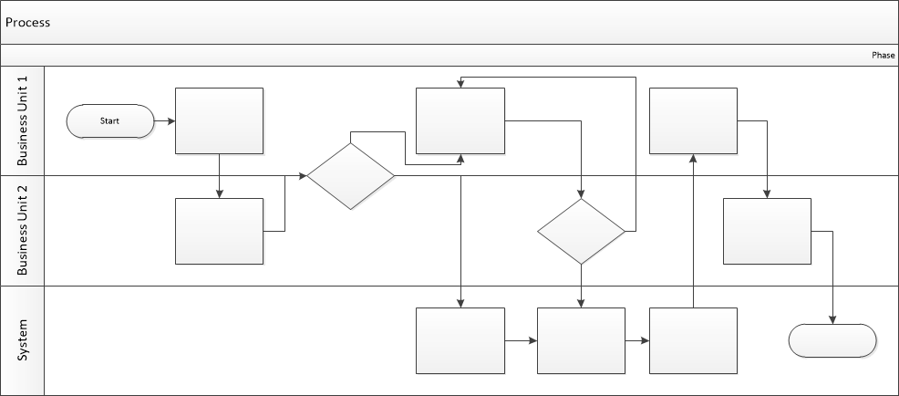

## Proposed Business Process (To-Be)

1. User and admins Logins.
2. If the person/user in the selected radius (assigned by the owner) the attendance will marked.
3. If the person/user leaves the selected radius (assigned by the owner) the attendance will marked.
4. User/ Employee will review and claim their timings of attendance and checkouts.



# Business Requirements

The requirements in this document are prioritized as follows:

|  |  |  |
| --- | --- | --- |
| **Value** | **Rating** | **Description** |
| 1 | Critical | This requirement is critical to the success of the project. The project will not be possible without this requirement. |
| 2 | High | This requirement is high priority, but the project can be implemented at a bare minimum without this requirement. |
| 3 | Medium | This requirement is somewhat important, as it provides some value but the project can proceed without it. |
| 4 | Low | This is a low priority requirement, or a “nice to have” feature, if time and cost allow it. |
| 5 | Future | This requirement is out of scope for this project, and has been included here for a possible future release. |

## Functional Requirements

| **Req#** | **Priority** | **Description** | **Rationale** | **Use Case Reference** | **Impacted Stakeholders** |
| --- | --- | --- | --- | --- | --- |
| **General / Base Functionality** | | | | | |
| FR-G-001 | 1 | A new user database shall be created with their records and password secured. |  |  | Development team  Data base Team |
| FR-G-002 | 1 | A user shall be identified with a unique identifier name combination |  |  | Back end team Data Base Team |
| **Security Requirements** | | | | | |
| FR-S-001 | 1 | User creation shall be limited to users with unique mobile IP | This will lead to only one account per mobile |  | Development Team |
| **Reporting Requirements** | | | | | |
| FR-R-001 | 2 | The system shall generate a weekly, Daily, Monthly Report of attendance and checkouts | Owner will have more control |  | Development  Team |
|  |  |  |  |  |  |

## Non-Functional Requirements

|  |  |
| --- | --- |
| **ID** | **Requirement** |
| NFR-001 | The Smart Attendance System application shall accommodate up to 100 users concurrently at this point in time. |
| NFR-002 | The Smart Attendance System application shall be available on demand of the business and sites owners. |
| NFR-003 | Geo-locations captured by GPS accurately. |
| NFR-004 |  |
| NFR-005 |  |

# Appendices

## List of Acronyms

N/A

## Glossary of Terms

N/A

## Related Documents

N/A