

Mini Project Report: 04
Master of Computer Application – Data Science
Semester I

Subject: Front-End Frameworks and Technologies

Topic Sementic Website
By
Name: Arbab Suhail
Registration No: PROV/ASAC/MCA/7/26/082
Faculty Name: VEERA RAGHAV K
Faculty Signature:________________

Department of Computer Application
Alliance University
Chandapura – Anekal Main Road, Anekal
Bengaluru – 562 106

August 2026

INDEX
SL NO | NAME OF THE CONTENT | PAGE NO
1 | INTRODCUTION | 3
2 | INPUT CODE | 4
3 | CODE OUTPUT | 9
4 | CONCLUSION | 10

INTRODUCTION

A Semantic Website is a website created using semantic HTML elements that clearly describe the meaning and purpose of each section. Elements such as "<header>", "<nav>", "<main>", "<section>", "<article>", and "<footer>" help organize the webpage in a meaningful structure. This project demonstrates how semantic HTML can be used to create a clean, well-structured, and user-friendly website. It also improves accessibility, readability, and search engine optimization.

INPUT CODE
<html>
<head>
<title>Department of Computer Science</title>
<style>
*{margin:0;padding:0;box-sizing:border-box;scroll-behavior:smooth} body{ font-family:Arial, sans-serif; background:#f5f8fc;
color:#263238; line-height:1.6; } header{ background:white; padding:18px 7%; display:flex; justify-content:space-between; align-items:center; position:sticky; top:0; z-index:10; box-shadow:0 2px 10px #00000012;
} header h1{ font-size:24px; color:#1769aa; } nav{ display:flex; gap:22px;
}

nav a{ text-decoration:none; color:#444; font-weight:bold;
} nav a:hover{ color:#1769aa; } section{ padding:65px 7%;
} h2{ text-align:center; color:#1769aa; font-size:30px; margin-bottom:30px;
}
#home{ min-height:75vh; display:flex; align-items:center; justify-content:center; text-align:center; background:linear-gradient(120deg,#eaf4ff,#ffffff);
}
.hero{ max-width:750px;
} .hero h2{ font-size:45px; color:#174a73; margin-bottom:15px;
} .hero p{ color:#555; font-size:18px; margin-bottom:25px;
} .btn{ display:inline-block; padding:12px 25px; background:#1769aa; color:white; text-decoration:none; border-radius:6px;
}

.btn:hover{ background:#0d4f82;
}
#about,#courses,#events{ background:white;
}
.content{ max-width:850px; margin:auto; text-align:center; color:#555;
}
.about-box{ padding:30px; background:#f5f9fd; border-left:4px solid #1769aa;
}
.grid{ max-width:1050px; margin:auto; display:grid; grid-template-columns:repeat(auto-fit,minmax(210px,1fr)); gap:20px;
}
.card{ background:white; padding:25px 20px; text-align:center; border-radius:8px; border:1px solid #e1e8ef; box-shadow:0 4px 12px #0000000d;
transition:.3s; } .card:hover{ transform:translateY(-5px); box-shadow:0 8px 18px #00000015;
}
.card h3{
color:#1769aa; margin:8px 0;
} .card p{ color:#666; font-size:15px;
}

.icon{ font-size:32px; } #faculty{ background:#f5f8fc;
}
.table-wrap{ max-width:1000px; margin:auto; overflow-x:auto; } table{ width:100%; border-collapse:collapse; background:white; box-shadow:0 4px 15px #00000010;
} th,td{ padding:13px; text-align:center; border:1px solid #e2e7ec;
}

th{ background:#1769aa; color:white; } tr:nth-child(even){ background:#f5f9fd; } tr:hover{ background:#eaf4ff;
}
.contact{ max-width:600px; margin:auto; text-align:center; padding:30px; background:white; border-radius:8px; box-shadow:0 4px 15px #00000010;
}
.contact p{ margin:8px; color:#555; }
footer{ background:#174a73; color:white; text-align:center; padding:20px; font-size:14px; }
@media(max-width:750px){ header{ flex-direction:column; gap:12px; } nav{ flex-wrap:wrap; justify-content:center; gap:12px;
} .hero h2{ font-size:35px; } section{ padding:50px 5%;
}
}
</style>
</head>
<body>
<header>
<h1>Computer Science</h1>
<nav>
<a href="#home">Home</a>
<a href="#about">About</a>
<a href="#faculty">Faculty</a>
<a href="#courses">Courses</a>
<a href="#timetable">Timetable</a>
<a href="#events">Events</a>
<a href="#contact">Contact</a>
</nav>
</header>
<section id="home">
<div class="hero">
<h2>Department of Computer Science</h2>
<p>
Welcome to our department. Learn programming, explore technology and develop skills for the future.
</p>
<a href="#courses" class="btn">View Courses</a>
</div>
</section>
<section id="about">
<h2>About Us</h2>
<div class="content about-box">
<p>
Our department provides strong foundations in programming, databases, networking, Artificial Intelligence and Data Science. Students develop practical skills through projects, workshops and competitions.
</p>
</div>
</section>
<section id="faculty">
<h2>Our Faculty</h2>
<div class="grid">
<div class="card">
<div class="icon">👨‍💻</div>
<h3>Arjun Mehta</h3>
<p>Professor – Python Programming</p>
</div>
<div class="card">
<div class="icon">👨‍🏫</div>
<h3>Durga Sir</h3>
<p>Associate Professor – Data Science</p>
</div>
<div class="card">
<div class="icon">💻</div>
<h3>Veera Raghav Kathula</h3>
<p>Assistant Professor – Frontend Frameworks</p>
</div>
<div class="card">
<div class="icon">👩‍💻</div>
<h3>Ananya Nair</h3>
<p>Assistant Professor – Communication</p>
</div>
</div>
</section>
<section id="courses">
<h2>Courses Offered</h2>
<div class="grid">
<div class="card">
<div class="icon">🎓</div>
<h3>BCA</h3>
<p>Duration: 3 Years</p>
<p>Undergraduate</p>
</div>
<div class="card">
<div class="icon">💻</div>
<h3>B.Tech Computer Science</h3>
<p>Duration: 4 Years</p>
<p>Undergraduate</p>
</div>
<div class="card">
<div class="icon">🎓</div>
<h3>MCA</h3>
<p>Duration: 2 Years</p>
<p>Postgraduate</p>
</div>
<div class="card">
<div class="icon">📚</div>
<h3>M.Sc. Computer Science</h3> <p>Duration: 2 Years</p>
<p>Postgraduate</p>
</div>
<div class="card">
<div class="icon">📊</div>
<h3>M.Sc. Data Science</h3>
<p>Duration: 2 Years</p>
<p>Postgraduate</p>
</div>
</div>
</section>
<section id="timetable">
<h2>Weekly Timetable</h2>
<div class="table-wrap">
<table>
<tr>
<th>Day</th>
<th>9-10</th>
<th>10-11</th>
<th>11-12</th>
<th>1-2</th>
</tr>
<tr>
<td>Monday</td><td>HTML</td><td>CSS</td><td>Python</td><td>AI</td>
</tr>

<tr> <td>Tuesday</td><td>Python</td><td>Database</td><td>AI</td><td>Networking</td>
</tr>
<tr>
<td>Wednesday</td><td>CSS</td><td>HTML</td><td>Python</td><td>Project</td>
</tr>
<tr>
<td>Thursday</td><td>Database</td><td>AI</td><td>Networking</td><td>Project</td>
</tr>
<tr>
<td>Friday</td><td>AI</td><td>Python</td><td>Database</td><td>Activity</td>
</tr>
<tr>
<td>Saturday</td><td>Data Science</td><td>Cyber
Security</td><td>Lab</td><td>Project</td>
</tr>
</table>
</div>
</section>
<section id="events">
<h2>Upcoming Events</h2>

<div class="grid">
<div class="card">
<div class="icon">💻</div>
<h3>Tech Fest</h3>
<p>Coding, robotics and innovative projects.</p>
</div>
<div class="card">
<div class="icon">💡</div>
<h3>Hackathon</h3>
<p>Build creative solutions to real-world problems.</p>
</div>
<div class="card">
<div class="icon">🤖</div>
<h3>AI Workshop</h3>
<p>Learn Artificial Intelligence and Machine Learning.</p>
</div>

</div>
</section>

<section id="contact">
<h2>Contact Us</h2>

<div class="contact">
<p>📍 Department of Computer Science</p>
<p>📧 computer.science@example.com</p>
<p>📞 +91 98765 43210</p>
<p>🌐 www.computerscience.edu</p>
</div>
</section>
<footer>
<p>© 2026 Department of Computer Science. All Rights Reserved.</p> </footer>
</body>
</html>

OUTPUT

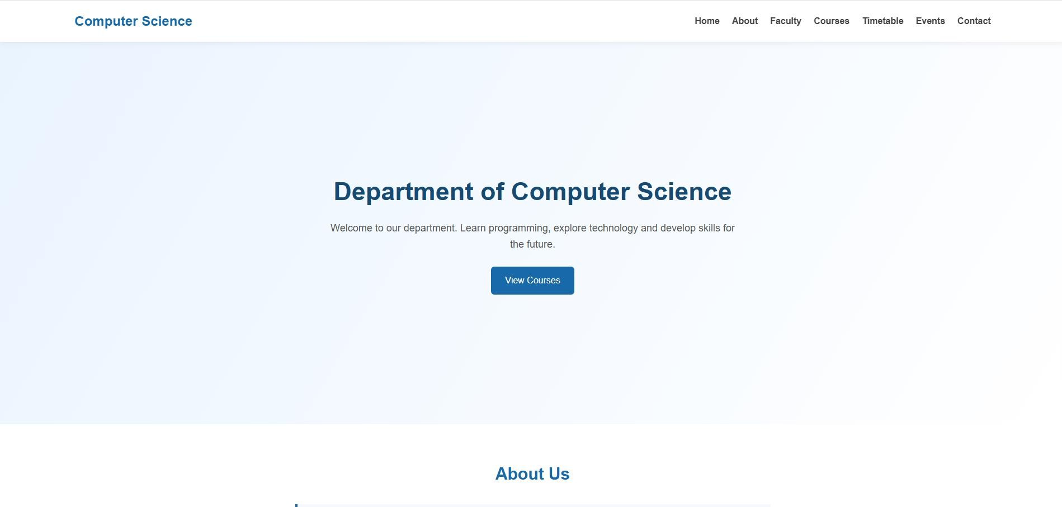

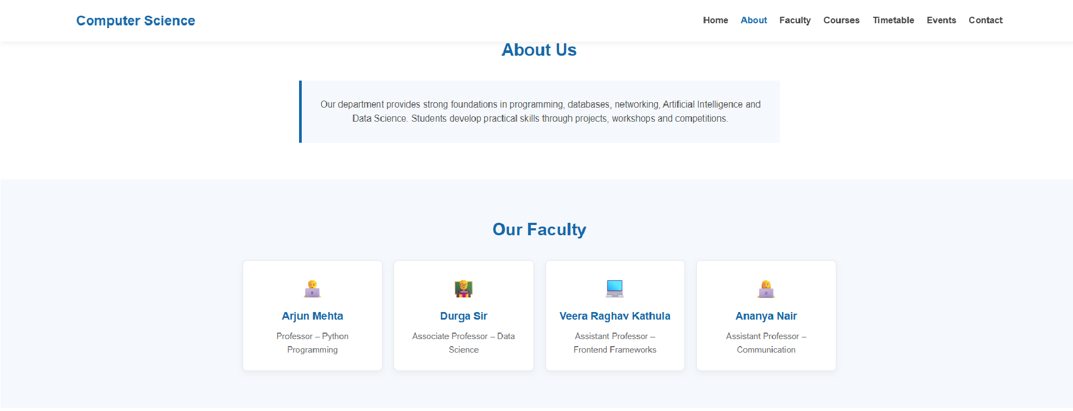

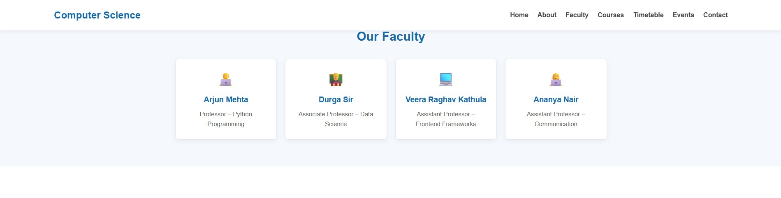

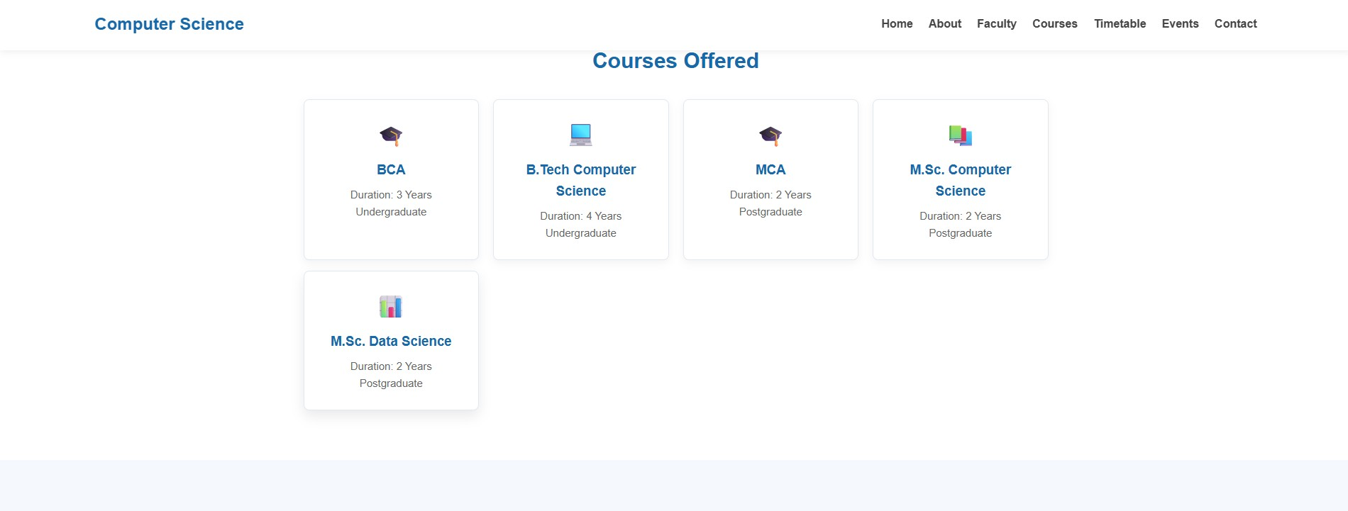

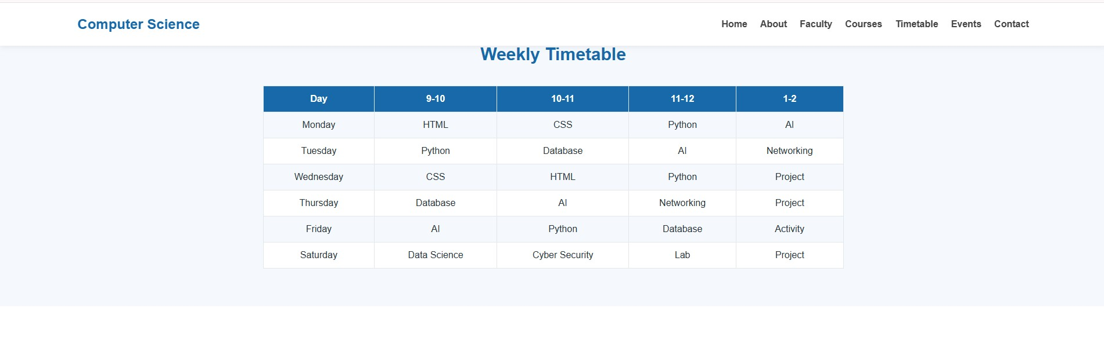

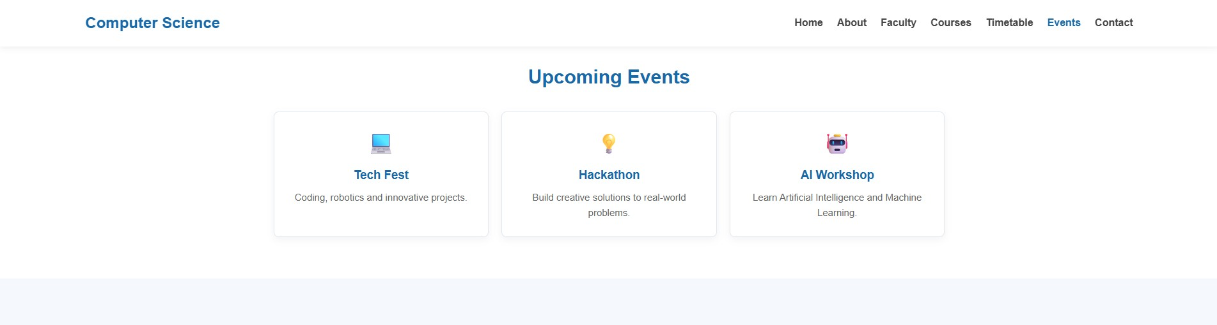

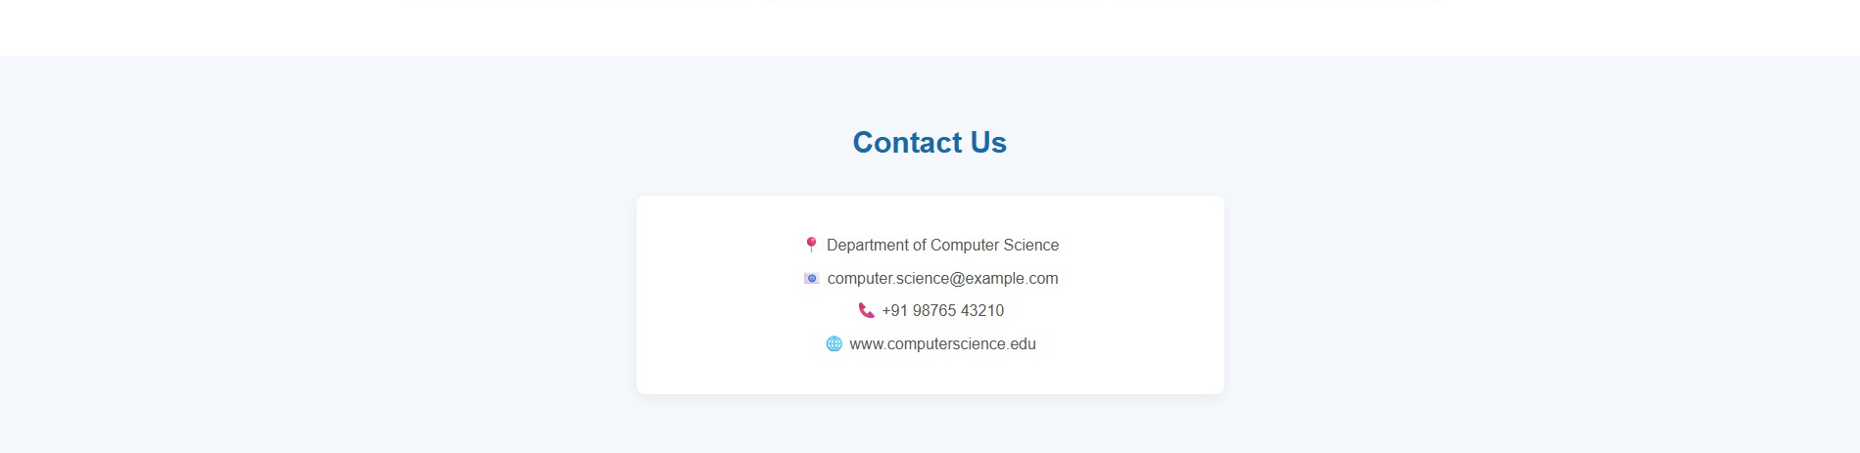

CONCLUSION

The Semantic Website project helped in understanding how semantic HTML elements can be used to structure a webpage properly. By using elements such as header, navigation, main content, sections, articles, and footer, the website becomes easier to understand and maintain. Semantic HTML also improves accessibility and helps search engines understand the content of the webpage. Overall, this project provided practical knowledge of creating a clear and meaningful website structure using HTML.

