



Arbalet LED table
Lava variant
Assembly guidelines for DIY building
Beta version, last edit: 29 April 2016
Preliminary notes

This document describes how to build an Arbalet LED table licensed under an Open Hardware CC-BY-SA licence. It is then permitted and formally encouraged to take inspiration from this work to build new Open Hardware items and publish them to the community.
Lava is the Laser-cut variant, designed to be easily reproducible with standard equipment of fablabs.

Bill of Material (BOM)

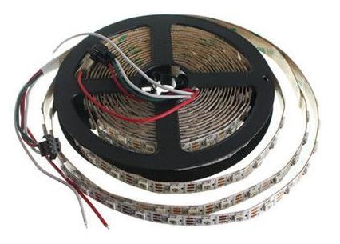
5 meters of WS2812B strip
It is possible to use non-WS2812B LEDs, however this might require software changes. Unless you know what you do, choose a strip that matches these requirements:
- 150 LEDs
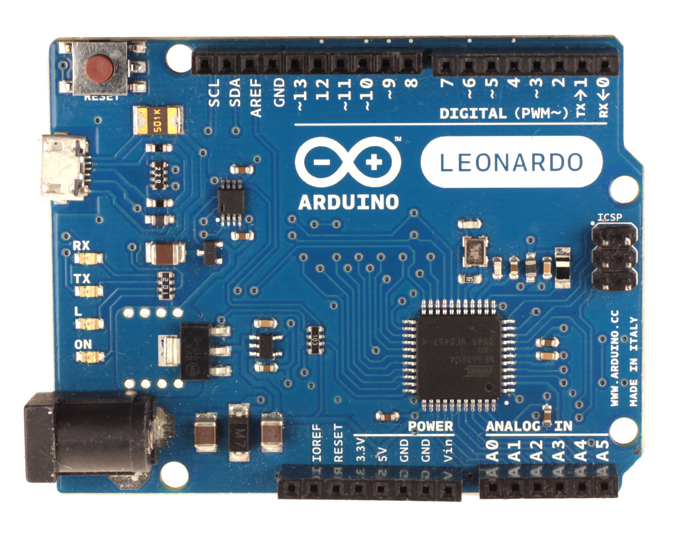
- Density 30 LED/meter (33.3mm between each LED)

Arduino Leonardo microcontroller
Other Arduino board are also usable, however Uno's serial connection is not much stable. Do not forget its USB cable.

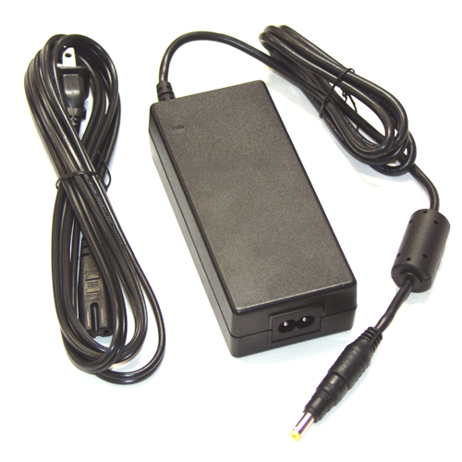
A 5V AC → DC wall adapter >5A
Use a regulated power supply of at least 5 amps.

A bunch of electrical wires
The wires will be used to connect the cut sections of the LED strip. We will need to connect 3 wires: Power + (red), Power - (black) and Data (green, or any other color).
The 2 power wires will drive up to 5A and might melt if they are too thin. The strip is sold with a 20 AWG cable, meaning that its copper inner wire is 0.8 mm thick. You should keep this section for the 2 power wires for safety purposes. For the Data line, you might use a very thin wire as it drives very few current. If you want to calculate precisely the section of power wires, refer to the standard.

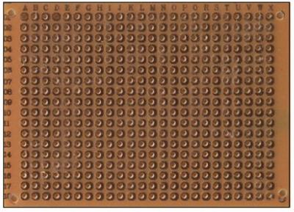
A credit card sized soldering board
This card will go right above the Arduino, fastened to the microcontroller thanks to pin headers. You can also use soldering boards dedicated to Arduino, already mounted with PIN headers and screw connectors if you're not familiar with soldering.

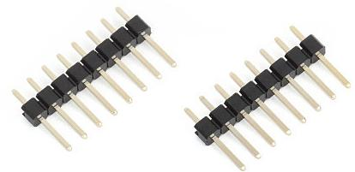
Some male pin header

A 100 to 200 µF capacitor (optional)
If your power supply is shoddy, this capacitor can help it to provide enough energy to the LED strip in case of peaks of current, for instance when all pixels are suddenly lit from black to full brightness.

600x600mm of 5 or 6 mm-thick MDF wood (medium)
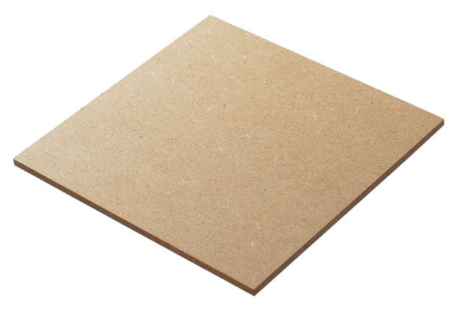
This thick board will be used to build the external host box of the table. Online plans are made for both 5mm or 6mm thicknesses.
Make sure you can cut these boards precisely thanks to a laser-cutting machine (most fablabs have one) and that it's actually able to handle pieces of wood of that size from SVG files.

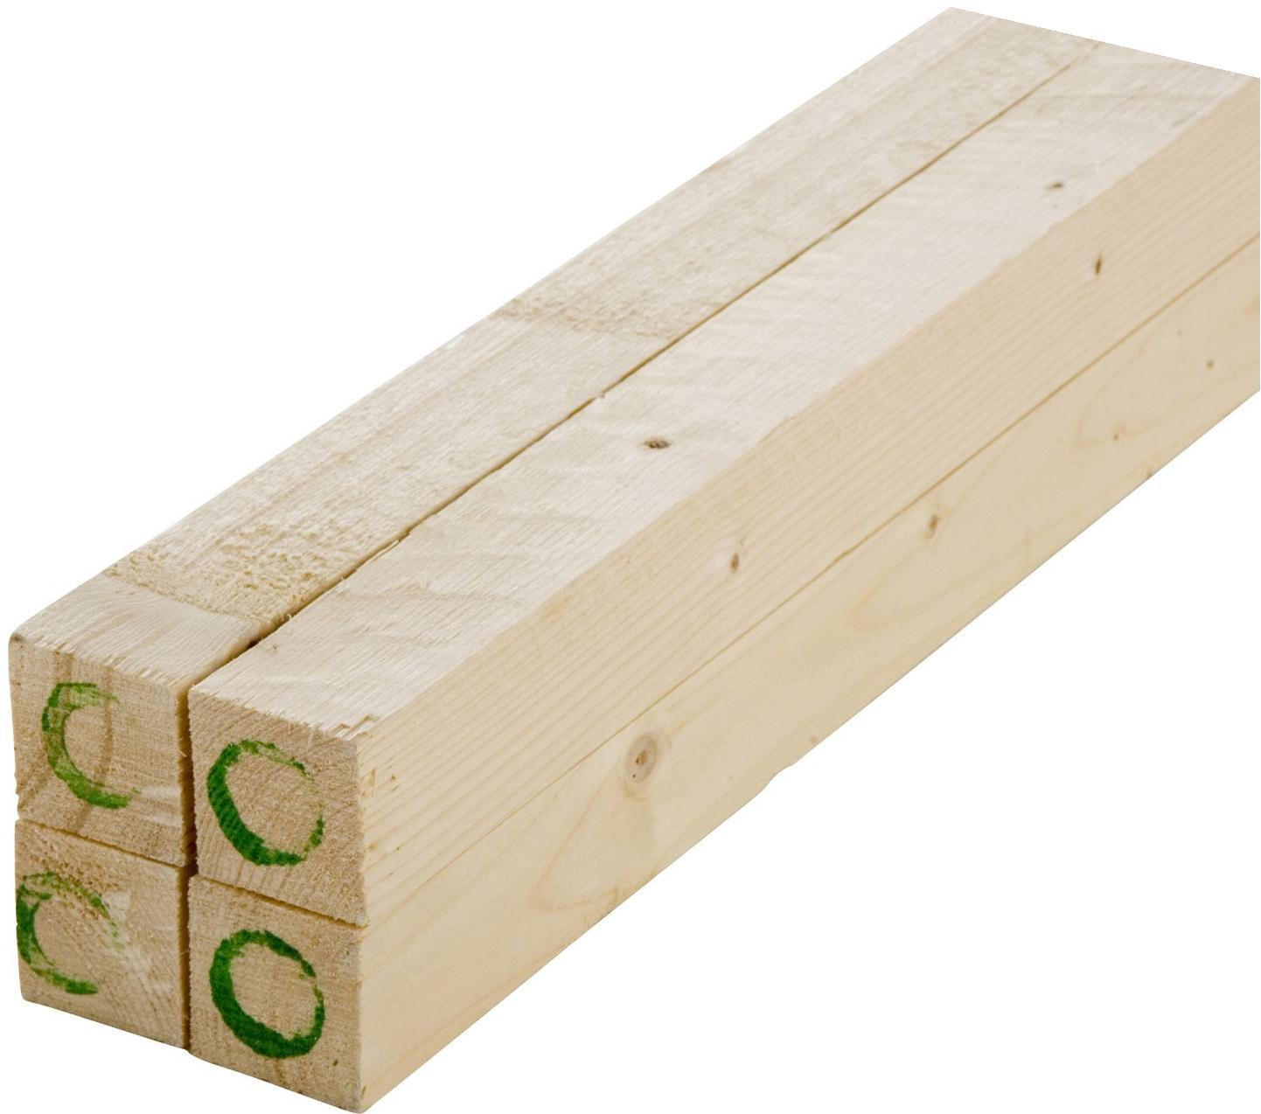
800x600mm of 3mm-thick MDF wood (medium)
This thin board will be used to build the internal grid delimitating pixels.

4 battens of 50x50mm, 400mm-long
These battens will be used are table legs.

4 Double-threaded bolts, washers and butterfly nuts
These will allow to assembly the legs. One side of each bolt must be screwed into the battens here above, the nuts will be screwed on the other side. The first side must be suitable to screw into wood. Choose the biggest diameter possible up to 10mm. High diameter will allow more stability.
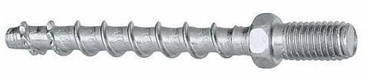
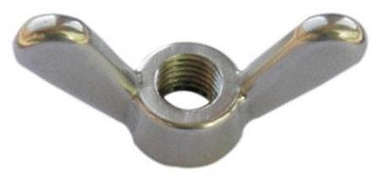
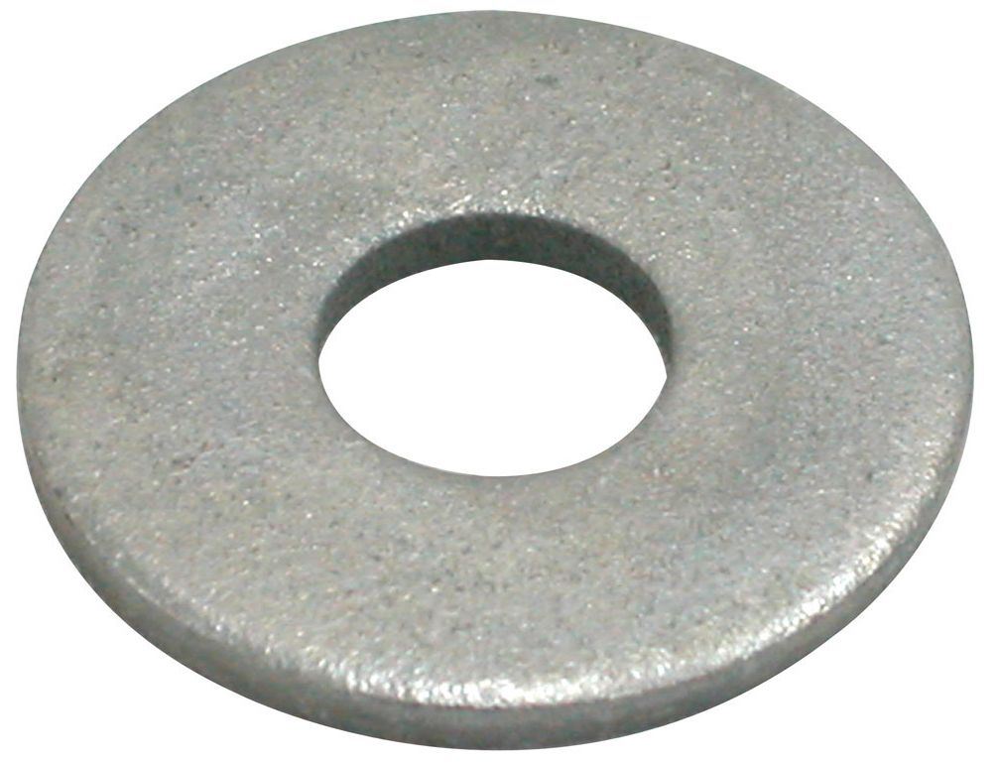

498x498mm of 4mm-thick glass or plexiglass
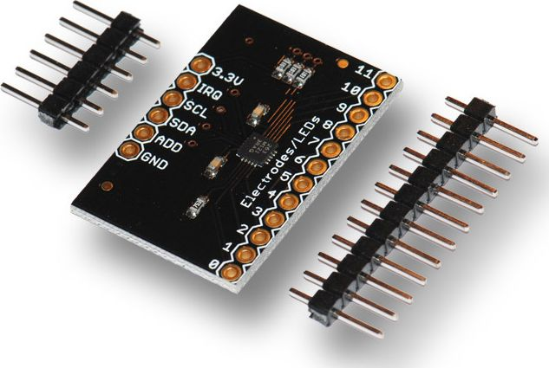
This will be the upper tray of the table. This glass will support your bottles, glasses and remote controls after building ;-)

A MPR 121 sensor with I2C (optional, for touch)
This cheap capacitive sensor will provide 12 touch keys to your Arbalet.

ITO (Indium Tin Oxide) plastic (optional, for touch)
ITO is a conductive liquid. When painted on a flexible plastic sheet it allows to make it conductive by keeping its transparency. A piece of ~200x100 mm of ITO transparent plastic will make you able to create several touch keys for your Arbalet.

Preliminary advices
You definitely not have to be expert in computer science or electronics expert to build your Arbalet table. Everything is made to simplify as much as possible the setup. You are then free to bring your own touch by customizing it through new software development, better aesthetic furniture integration or new features. You might want to get in touch with a fablab (fabrication laboratory) where people will be happy to help you.
Before mounting your table, check out the timelapse of assembly that will give you a good overview of the different assembly steps. The overall assembly presented in the video lasts only 2 hours but it assumes that all spare parts are ready and the wooden boards cut.

Laser cutting
Pick your medium density fiber boards (MDF) and go to the closest fablab. A fablab manager there will help you using a laser-cutting machine to cut the pieces of wood.
SVG files are online for 3, and 5 or 6mm boards. You need only one thickness among 5 and 6, depending of the material you find more easily in your local retail store.
Download the SVG files and make sure the software is able to load them properly before cutting. The 150 tiny holes in the host box (5 or 6mm) are made to pass wires for future touch detection via capacitive sensors, the 4 rectangles are hatches for microcontrollers. The bottom-right side of 12 vertical strips (over 14) is also slightly cut to pass wires of the LED strip.
If necessary you might regenerate the SVGs from CAD files using FreeCAD.
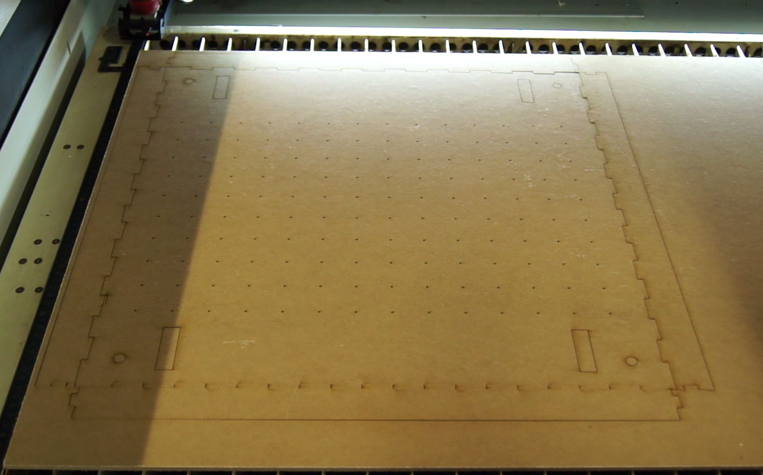
After cutting you might consider painting one side of the 5mm/6mm parts using a spray-paint can or a brush, that will be the outer side. The other side (inner) can be painted in white for a better light reflection.

Touch wires passings (x150, ⌀ 1.5mm)
Leg holes (x4, ⌀ 10mm)
Cable passings/Technical hatches (x4)

Legs preparation and assembly
According to the diameter of your bolts, pre-pierce the battens by choosing the drill bit right smaller than the bolt diameter ; e.g. 7mm for a bot of 8mm.
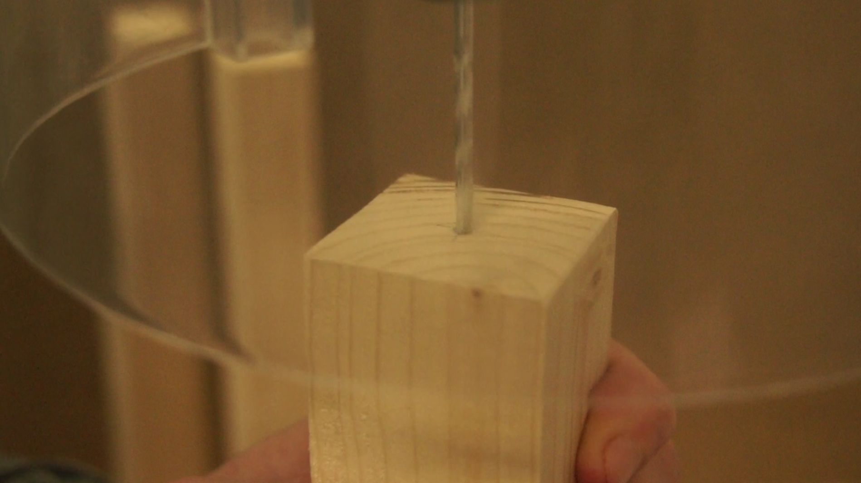
Then screw the 4 bolts into the 4 legs. You can use the nuts to force.
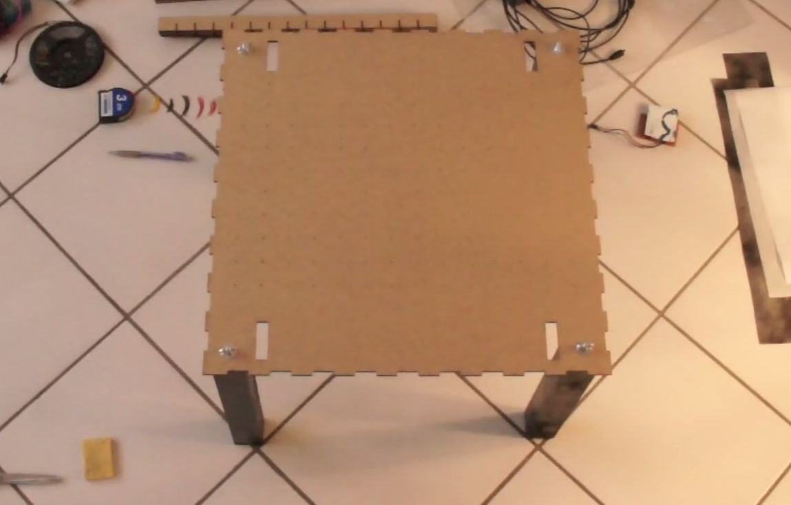
Finally, assemble the 4 legs to the main part of the host box using washers and nuts.

LED strip cutting
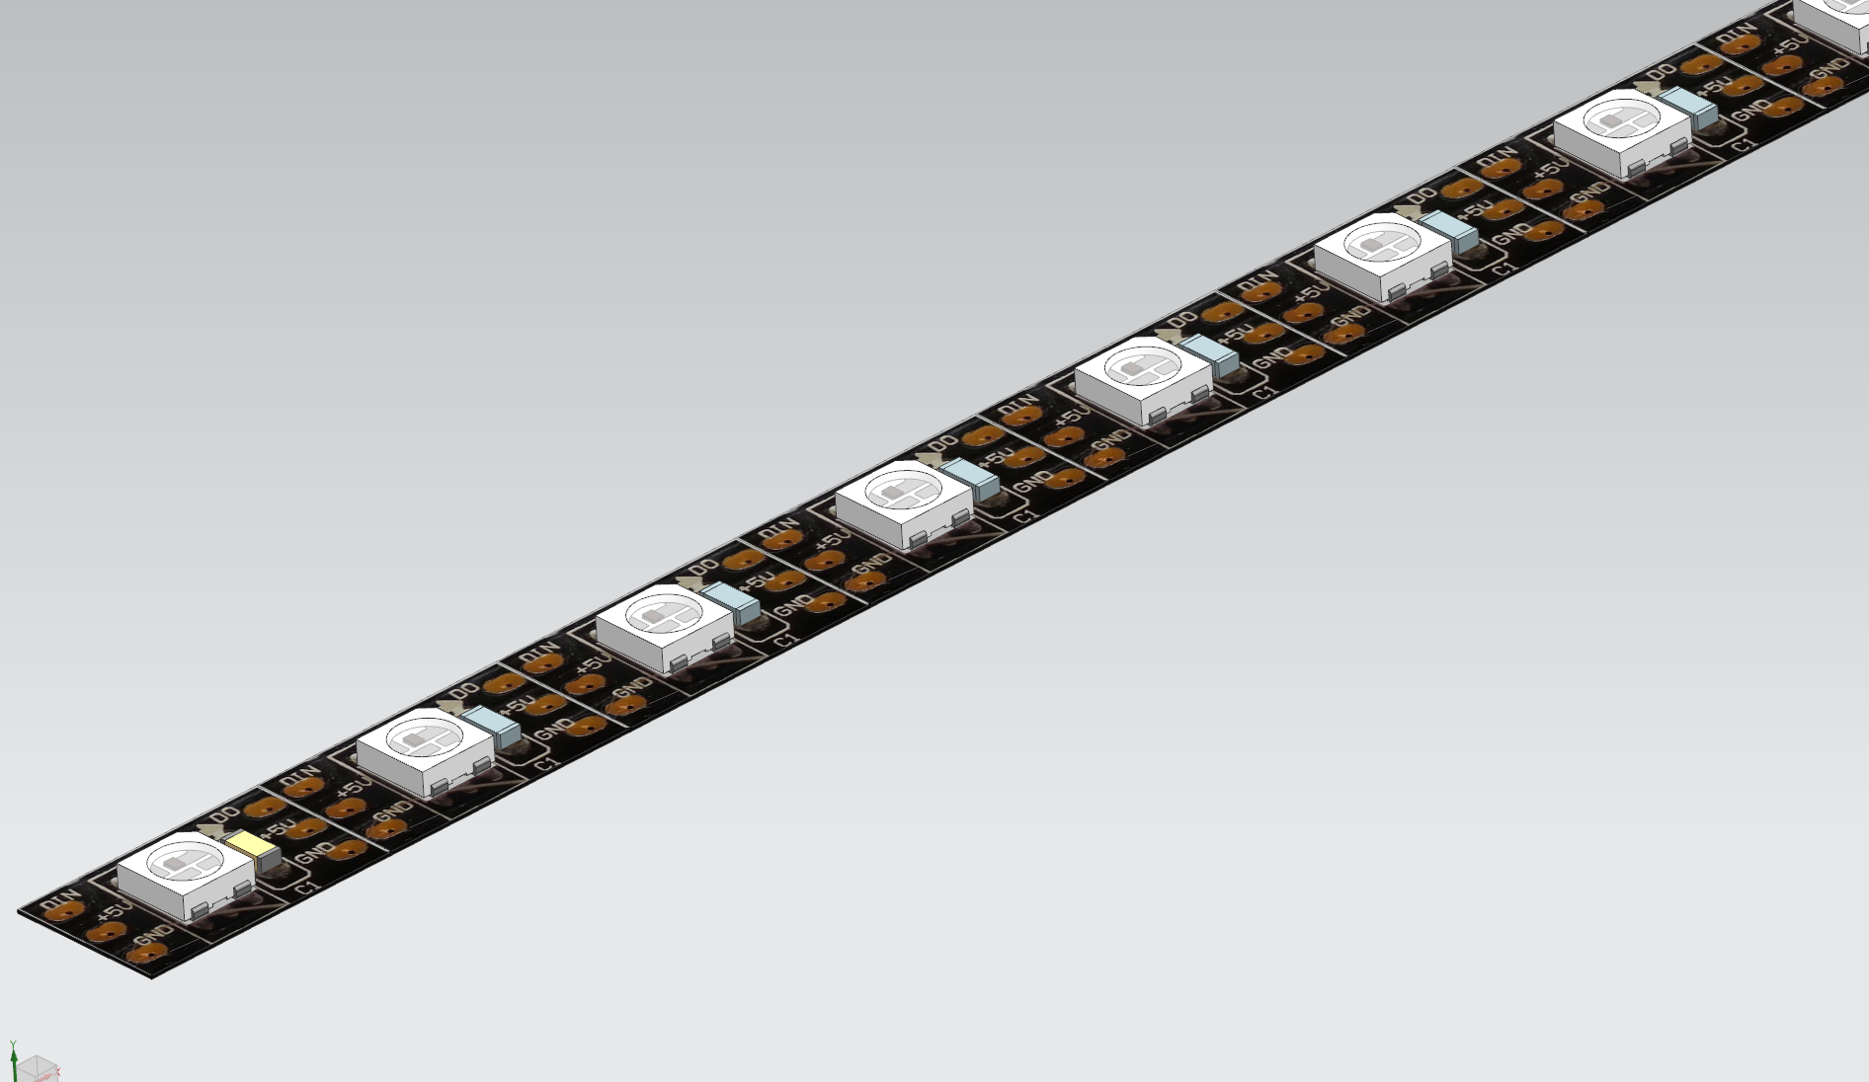
Unroll the LED strip, observe the arrows noticing the data signal. These LEDs are soldered on a serial bus: each DOUT pin (aka DO, for data out) is connected to a DIN (data IN). Thus the strip has an input and an output.
You LED strip comes with connectors factory-soldered 3-pin JST SM at both ends. The male connector is soldered to the input, the female to the output. Unsolder the output (female) connector but keep the input one.
Data signal


Using scissors cut the strip every 500mm = 15 LEDs. Make sure you cut in the middle of a coppered connection. This area is often marked by a sign
You must end up with 10 strips of 15 LEDs, whose one has a male connector.

LED strips gluing
Using a pencil, trace the lines where you will glue the pieces of strips. They are 10 lines horizontally centred. The host box is not symmetric, make sure you trace them in the vertical direction (see picture).
The first column must be traced 83.3mm from the edge, then each line is 33.3mm from the previous one. The distance between the first and the last (10th) line is 333.3mm.
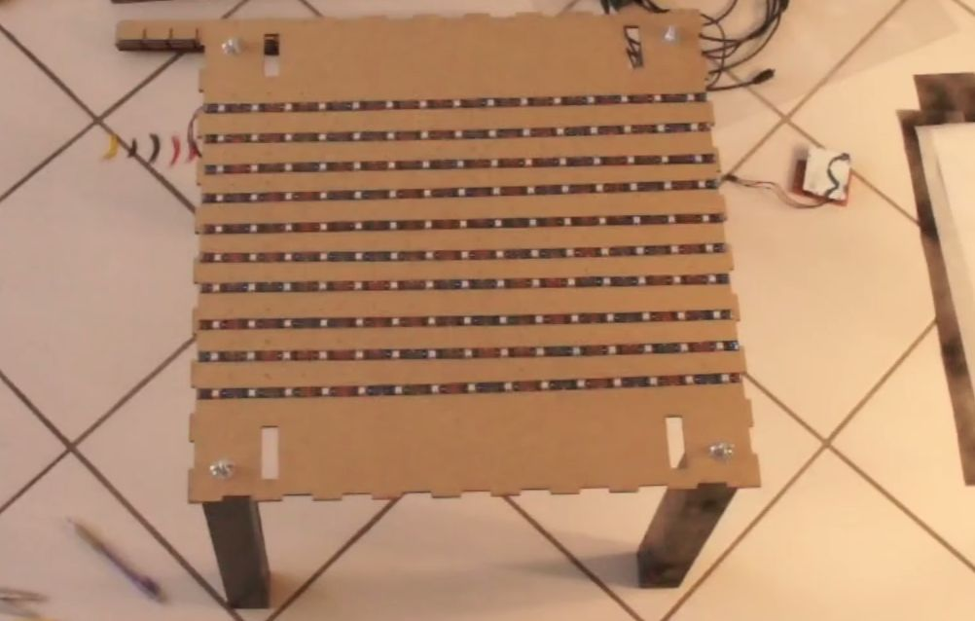
Then pre-place the 10 pieces of strips according to diagram next page. Only focus on the connections between LED strips now, the rest of electronics will be explained later on. It is primordial that you alternate each piece of strip. For this you can rely on their arrows whose direction must change each column: → ← → ← and so on… ; or you can also rely on DIN and DOUT pins.

Vertical direction
Horizontal direction

connector
Rectangle cable-passing in the main tray
WARNING: Recall that the Data line is ordered. Alternate DIN and DOUT pins to form a coil. The coil is a succession of DIN to DOUT connections. Connect all 5V (red) together, all GND (black) together, and all DATA (often green or yellow) together. Double check that you're always connecting DOUT to the next DIN. Never connect DIN to DIN nor DOUT to DOUT.
Glue the pieces of strips on your pencil lines once you are sure that the Data line forms a coil.
Cut and strip 9x3 = 27 pieces of wires to reconnect the data and power lines between each piece of strip.
Connect also the power supply of both extremities (GND to GND and 5V to 5V) via 2 direct wires. It allows to better dispatch the power to avoid a difference of colour at extremities.
TODO: CAD drawing of wooden parts here
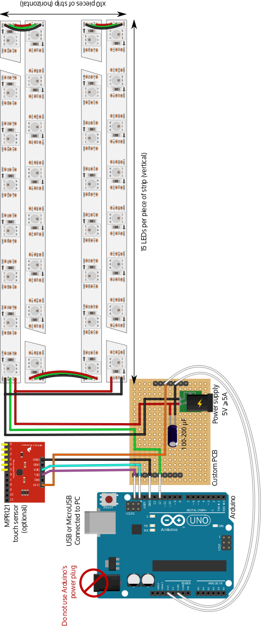

Solder the circuit board
Arbalet's electronics, illustrated on the previous diagram, is composed by:
- An Arduino board (in blue), connected to a computer through USB
- A custom PCB (in brown), connected to a 5V power supply
- An optional touch sensor MPR121 (in red) connected to 6 active surfaces (yellow pins)
The custom board will be mounted right above the Arduino board, with its male PIN headers directly plugged in Arduino's female headers, ensuring its fastening as well as its data connection.
Solder the components and connections on the custom board as shown on the diagram previous page. White wires on the diagram are not actual wires but direct male-female connections of PIN headers.
Components will be wedged between both boards, so make sure that there are not too big to avoid the boards being plugged together. The capacitor and the DC power plug are the big components that could prevent connection of boards.
If you are planning to plug a touch sensor, we will detail this later on, however at this step you must make sure it will be easy to solder the 4 wires of the sensor (orange, black, cyan, purple).
Then follow the Hardware and Software preliminaries until Arbalet firmware is uploaded before continuing. If something went wrong during soldering you will figure it out during these tests before it becomes less easy to fix the hardware problems.
Place your electronics on the side and jump to step 8 only after having successfully run at least the colour demonstrator on your new hardware using the -w flag to enable hardware. Ensure that all pixels are driven and able to light. If you meet troubles, find help in the troubleshooting section.

Assemble the inner grid
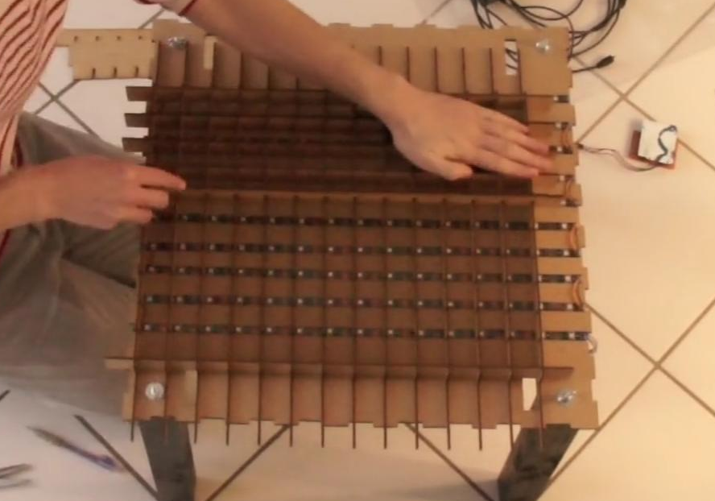
The 3mm medium board has been cut into 11 vertical and 14 horizontal strips. The horizontal ones have side rods creating two side cavities that will host electronics and support the upper tray.
Side rods
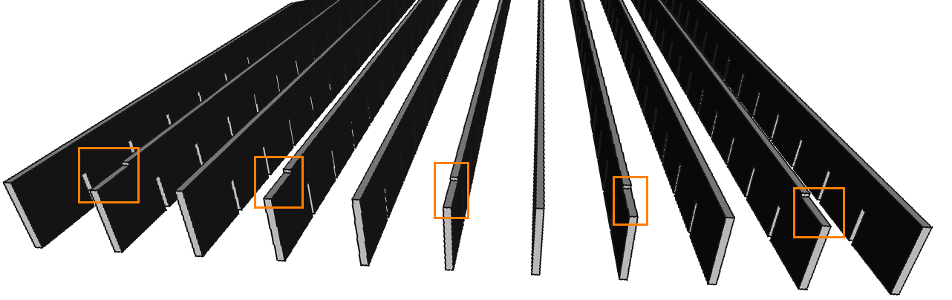
Notice that 9 vertical strips have wire passings. They are made for the data line you have soldered at step 6. Make sure you alternate them as shown on the drawing hereafter. Orange areas emphasis the alternation of wire passings on one side. The two strips with no wire passing go at the extremities.

Assemble the whole grid made of vertical and horizontal strips by sliding strips into each other as shown on the next drawing.
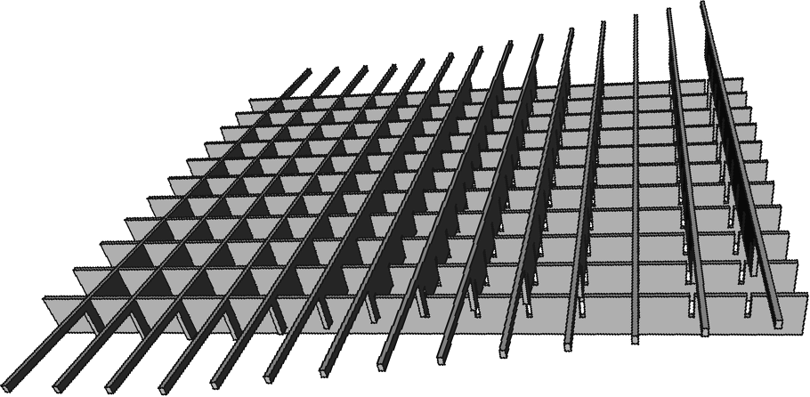
Then eventually rotate the final construction upside down so that side roads are at the top (only the last illustration respects this orientation). Finally move the grids on the table tray so that each pixel the structures has created matches a LED.

Close the table
Position and glue the 4 laser-cut sides of the tray. Cut pieces of cooking paper covering the pixels area that will help diffuse the light, as well as two side covers to hide the side cavities hosting electronics.
Finally, cut a piece of glass or plexiglass of 498x498mm, keeping a degree of freedom of 2mm on each side to ensure an easy placing and removing of the glass. The online plans are more suited for 4mm-thick glasses but other thickness will be fine as well.
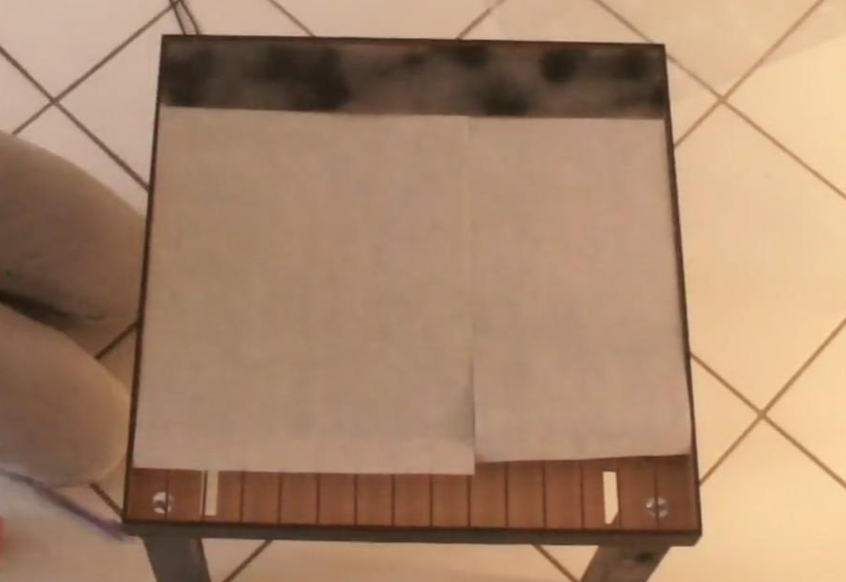

Extension: touch keys
This step is not required but is an extension if you would like your table to be touch-sensitive. Although they are different and may return different types of output, touch feature can be provided by many kinds of sensors, including infra-red, barycentre of weight, vibration sensing, ... The method proposed here involves capacitive sensor connected to pieces of ITO plastic.

Hardware
This plastic is covered with a thin conductive layer that makes it discrete underneath your glass as well as sensitive to capacitive changes. Only 1 side if generally conductive, identify which one thanks to an ohmmeter. Cut 6 pieces of ITO plastic slightly smaller than the size of two pixels i.e. 30x63mm.
The MPR121 sensor can have up to 12 keys. Connect its capacitive inputs 0 to 5 to wires going through Arbalet's pixels from the bottom of the table.

Software activation of touch
By default the online SDK has touch features disabled. You can activate them by adding parameter -c config150touch.json when executing an app. Use the file default.cfg and reinstall the SDK to make this change permanent. This parameter loads a config file enabling 6 touch keys. For each app, activated touch keys will backlight in light white switching to strong white when they are pressed.
TODO: Better documentation, CAD drawing and pictures here

Hack and share!
Recall that Arbalet is a hackable device, try and play the existing applications in the arbapps repository.
Do not hesitate to share pictures of your build status with us, keep in touch and tell us your news on twitter:

