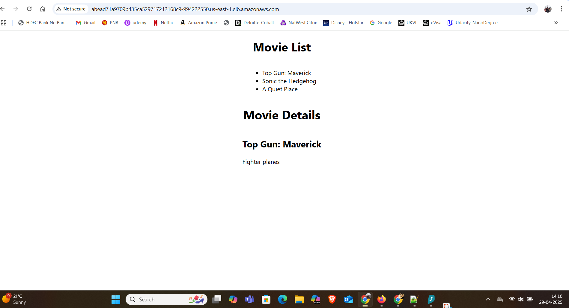

**Frontend and Backend service URLs**

* Frontend service URL: <http://abead71a9709b435ca529717212168c9-994222550.us-east-1.elb.amazonaws.com/>
* Backend service URL: [http://aeb9614cc4f1c4751adc97420a70524b-784435929.us-east-1.elb.amazonaws.com](http://aeb9614cc4f1c4751adc97420a70524b-784435929.us-east-1.elb.amazonaws.com/)

LB

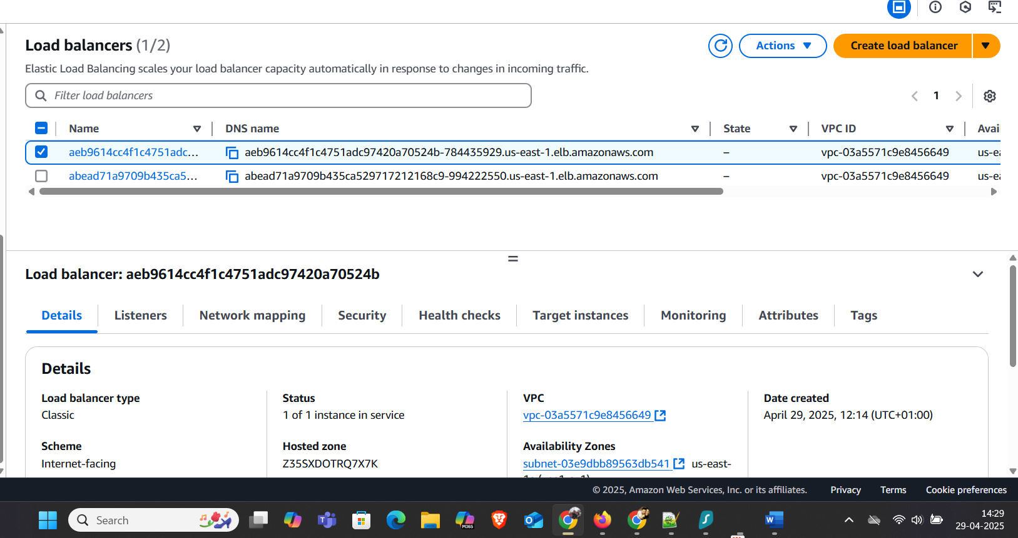

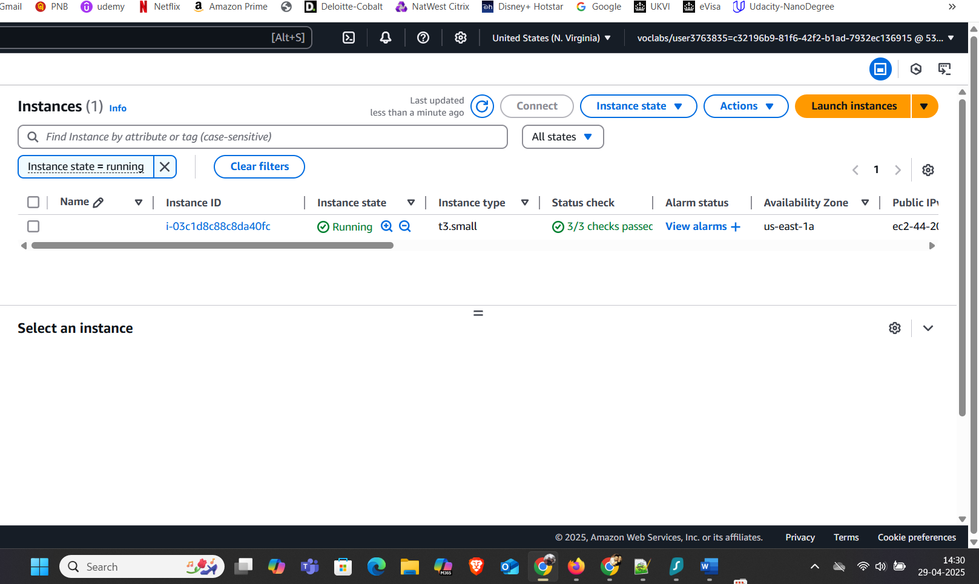

EKS

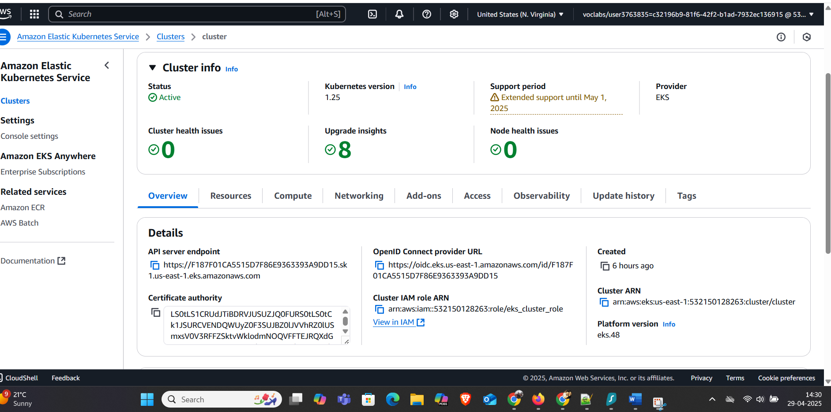

GitHub Actions

