Steps to setup the tool in local environment:
(Document Still in Progress)
Pre-requisites:
Step 1) Checkout the project from git and import it in a Eclipse IDE
Step 2) Setup MS Access DB and Mailing Script:
- Copy the sample db from “InvoiceApp/src/resource/sample_db.accdb” and mail script from “InvoiceApp/src/resource/ mail.vbs” and paste it in your “Desktop/Invoice” folder
- You can configure the path to paste these stuffs, DB Name, DB Password etc. in applications “config.properties” file
*Note: If you are planning to distribute this application across multiple users then make sure to place these files in common location (like share path) where everybody can access it.
Step 3) if you are planning to use the application as it is then export this project as “Runnable jar” from eclipse and you are all set to go.
------------------------------------------------------------------------------------------------------------------------------------------Open the exported Runnable jar file:
Description: The above step will execute the invoicing java application, see the below screen shot for reference
Login Screen:
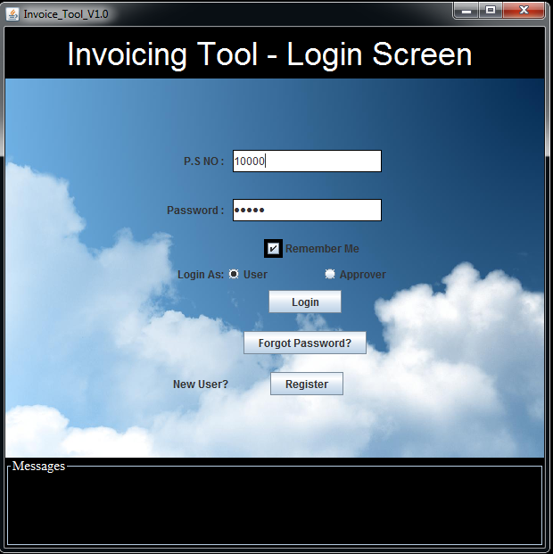
Registration: Click on “Register” button (If existing user then skip this step)
Description: New user need to register in order to access this tool, clicking Register button will display Registration page. See below screen shot for reference.
Registration Screen:
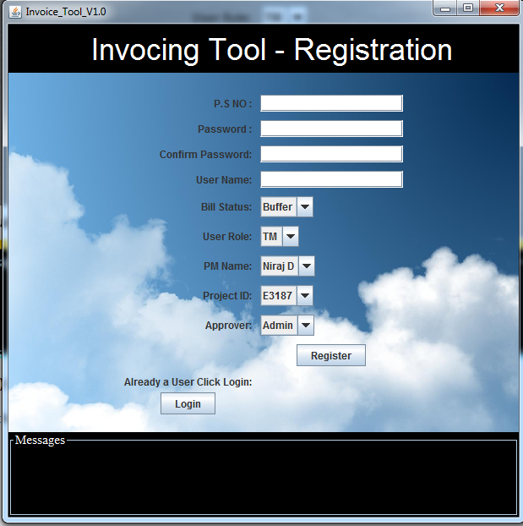
- Click “Register”
If everything went successful then Login screen will be displayed, with Registration success message
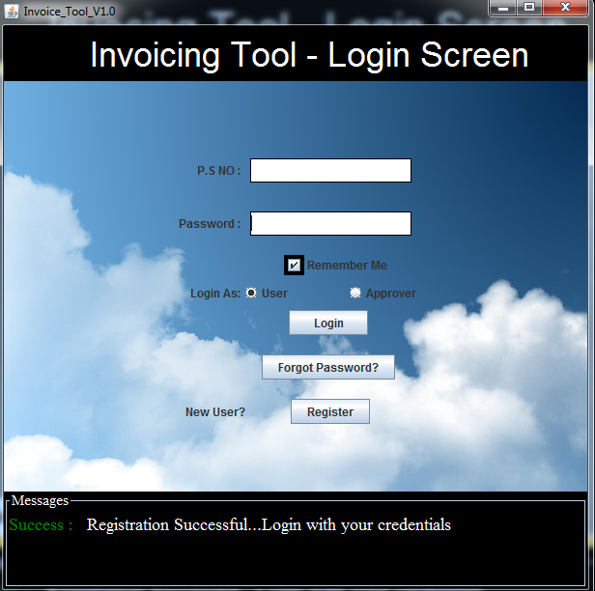
If outlook is setup, then a mail would have been triggered to the Admin / Approver. The new user should be approved before accessing invoice tool
Sample Approver Login details:
Approver PS.NO: 1000
Password: admin
Note: Right know there are no UI to create Approvers, additional project names and PM names. You can do this by directly editing the sample db.
- Please refer PM_NAMES_TABLE to add Project manager names
- Please refer APPROVER_NAME TABLE and REGISTER table to add approvers, you can give approver access to all the user just update approving_access column of a user in REGISTER table to “-1”
- Please refer PROJECT_NAMES_TABLE to add project names
Enter the required fields in login page and click “Login” button.
Note: The user needs to be approved by approver (Selected while registration in Registration page) prior to access this tool. If user is not approved “Error Message User yet to be approved will be displayed”
If the user is approved by approver then below screen will be displayed based on User Role:
- For TM
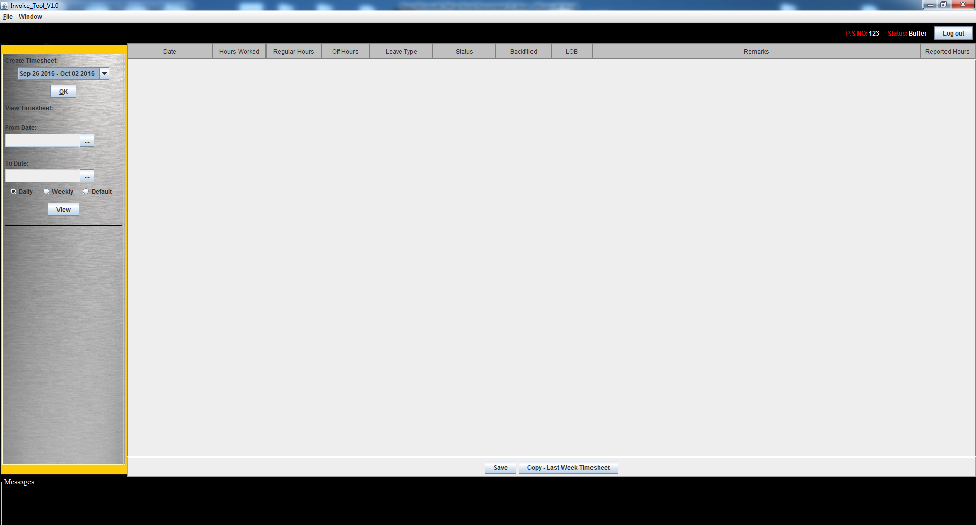
- For PL and PM
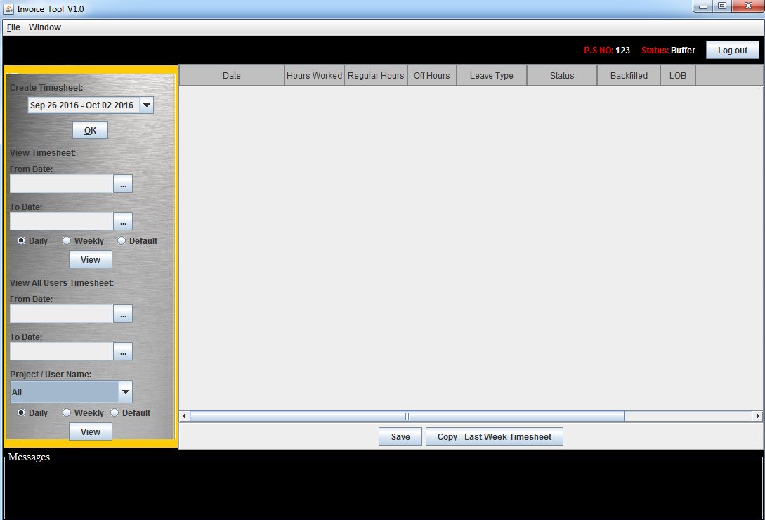
Create Time Sheet:
For TM roles below functionalities are applicable:
1) Create Time Sheet
2) View Timesheet:

- Create Time Sheet
- Select the dates (week) and click ok.
If no timesheet data exist for the selected week, then new timesheet will be created and same will be displayed, if not then previously saved timesheet will be displayed. See the below screen shot for reference
New Timesheet created for the week Sep 26 2016 to Oct 02 2016:
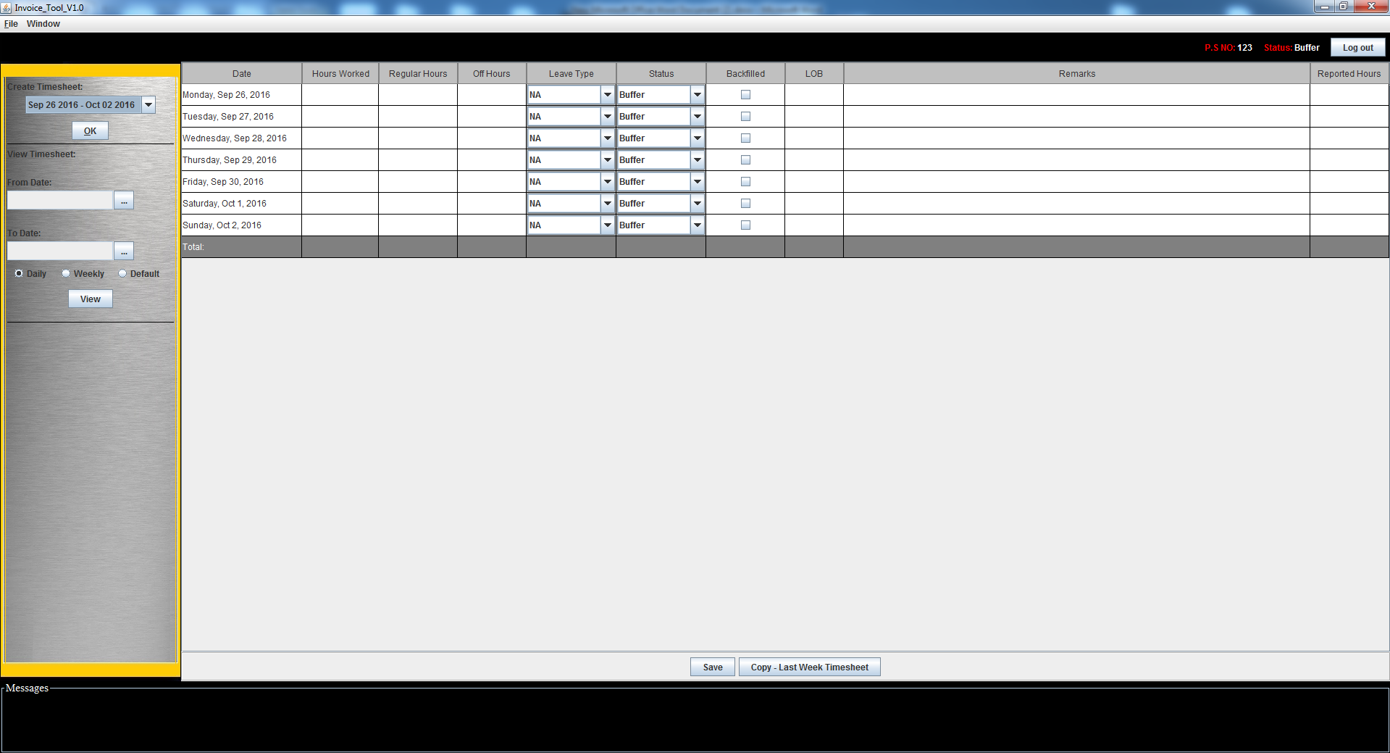
- Book the timesheet and Click “Save” Button, if save is successful then a message stating same will be displayed in Message panel.
Below are fields, where user inputs are required:
- Hours Worked
- Regular Hours
- Off Hours
- Leave Type (leave this as empty if it’s not applicable)
- Status (Default is what the user entered in registration page)
- Coverage Provided (check the checkbox to indicate whether coverage provide for your leaves)
- LOB (LOB hrs will show 8 hrs by default if leave is taken and coverage is not provided, user can edit it though)
- Remarks
Sample screen shot:
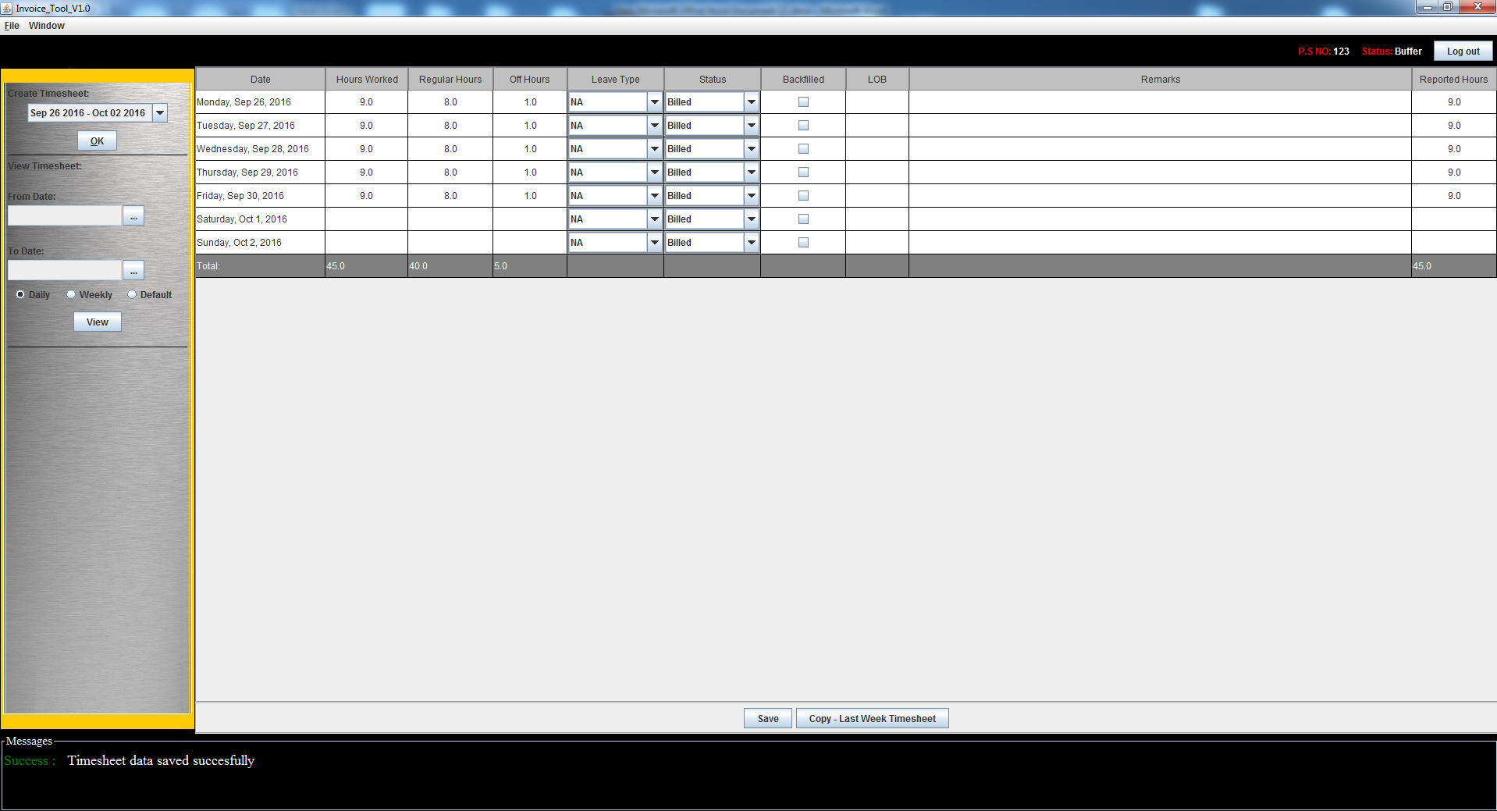
- View Timesheet:
User can view (no edit) the timesheet booked within a particular time frame.
Below are fields, where user inputs are required:
- From Date (Select from the calendar widget)
- To Date (Select from the calendar widget)

Calendar Widget Screen Shot:
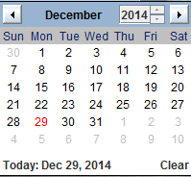

- Daily or Weekly (Radio Buttons)
Daily – If daily is selected, the timesheet data present within the selected time frame will be displayed in day basis.
Weekly – If weekly is selected, then total of weeks will be displayed.
Screen shot Daily view:
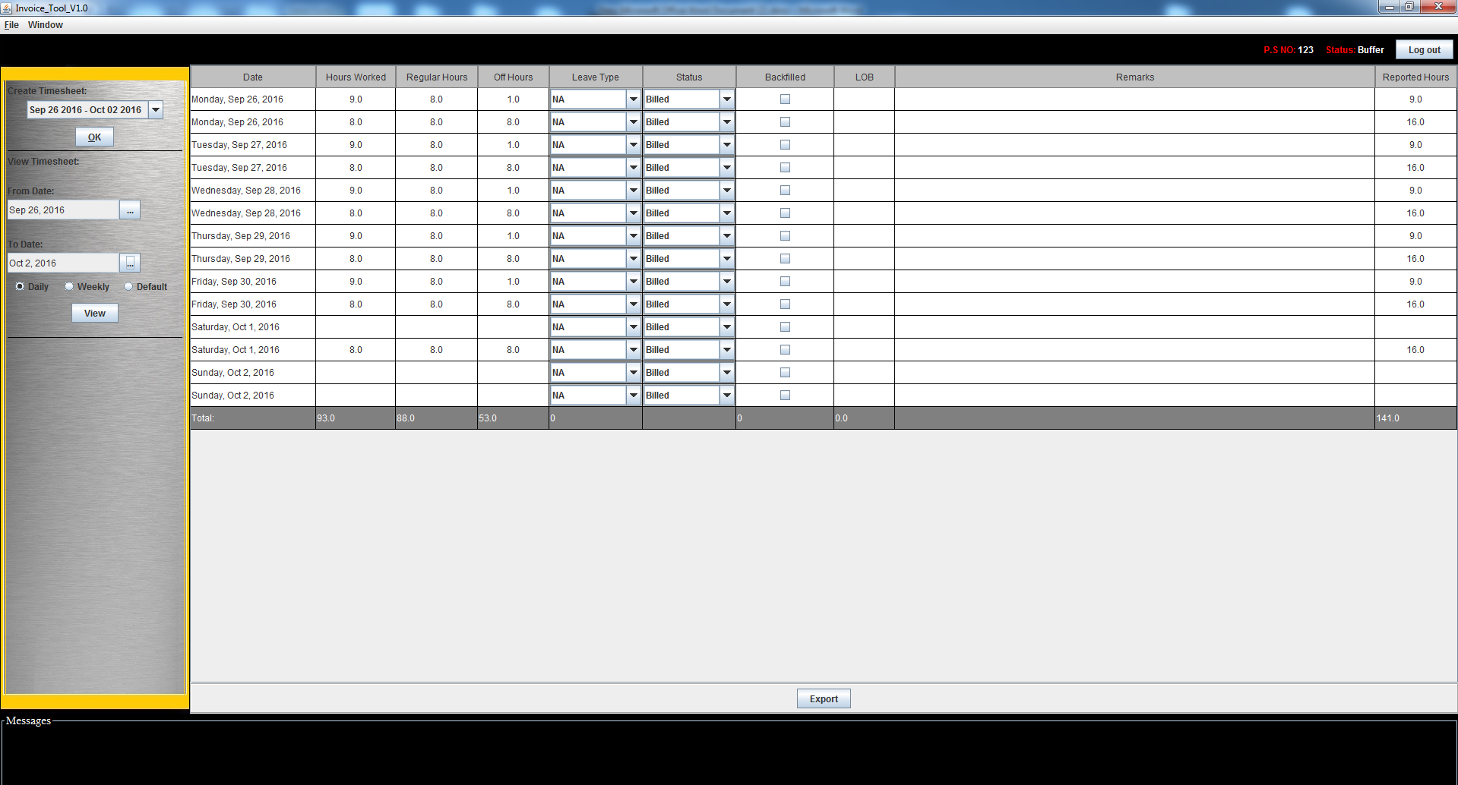
Screen Shot Weekly view:
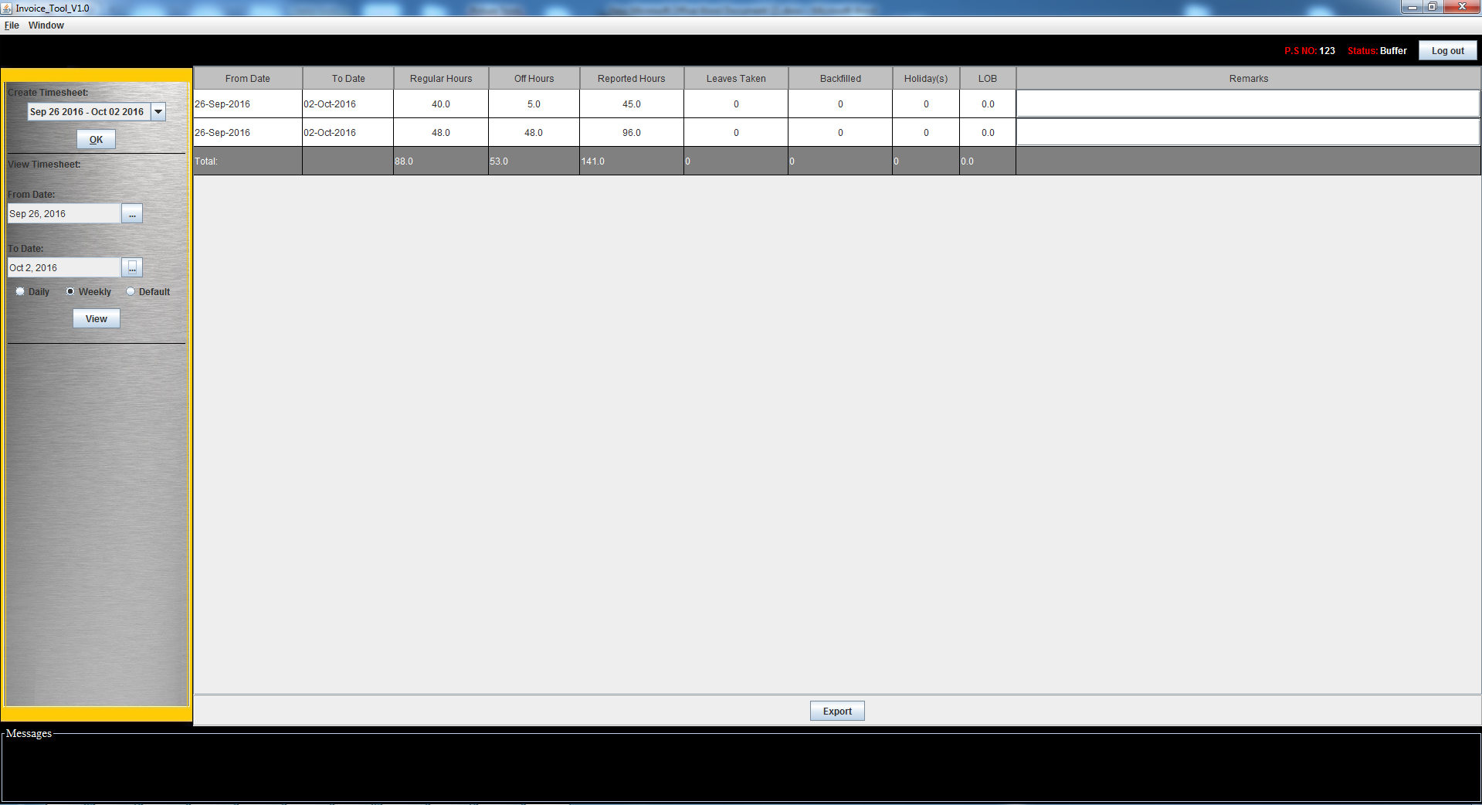
Note: User can hide the Timesheet Panel by below steps:
Window → Show → Uncheck “My Timesheet” checkbox
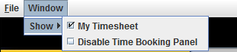
Screen shot – Timesheet Panel hidden.
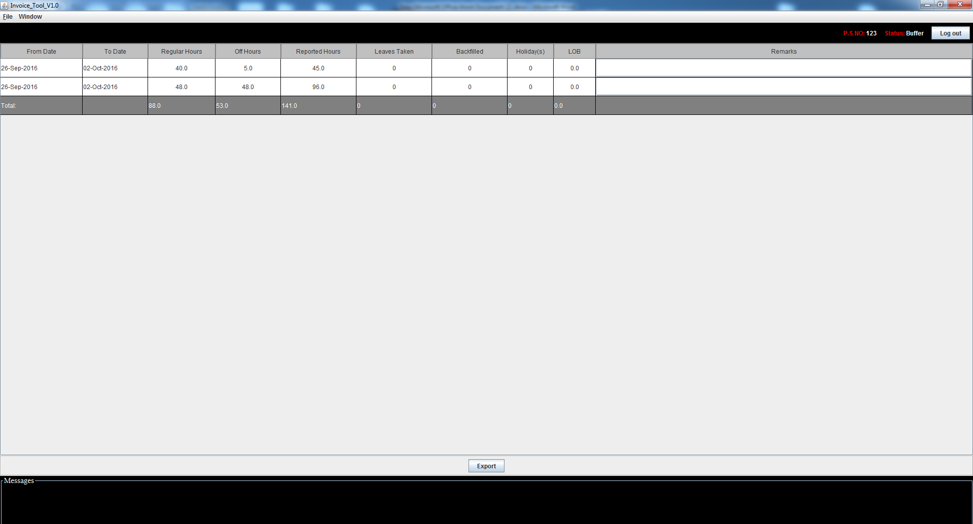
- PM and PL will be having extra three options
- To see the timesheet of the entire registered user.
- To Enable, Disable Registered user time booking (Editing option to be precise) for a time frame.
- To get the defaulter list
To see the timesheet of the entire registered user:
Below are fields, where user inputs are required:
- From Date (Select from the calendar widget)
- To Date (Select from the calendar widget)
- Daily or Weekly (Radio Buttons) – same description mentioned in previous step applies here as well.
- Project / User Name (The List will contain all the registered users, Projects)

- All – If this option is selected in the list then entire user timesheet data of selected time frame will be displayed. If this option is selected then all other options selected (if any) will be ignored
- Project IDs –This will list all the users timesheet data under the selected project will be displayed.
Note: Multiple project Ids can be selected from the list (Hold Ctrl and select the options)
If projects IDs are selected then user name selected (if any) will be ignored.
- User Names – Multiple user names can be selected and selected user name timesheet data will be displayed when user clicks view.
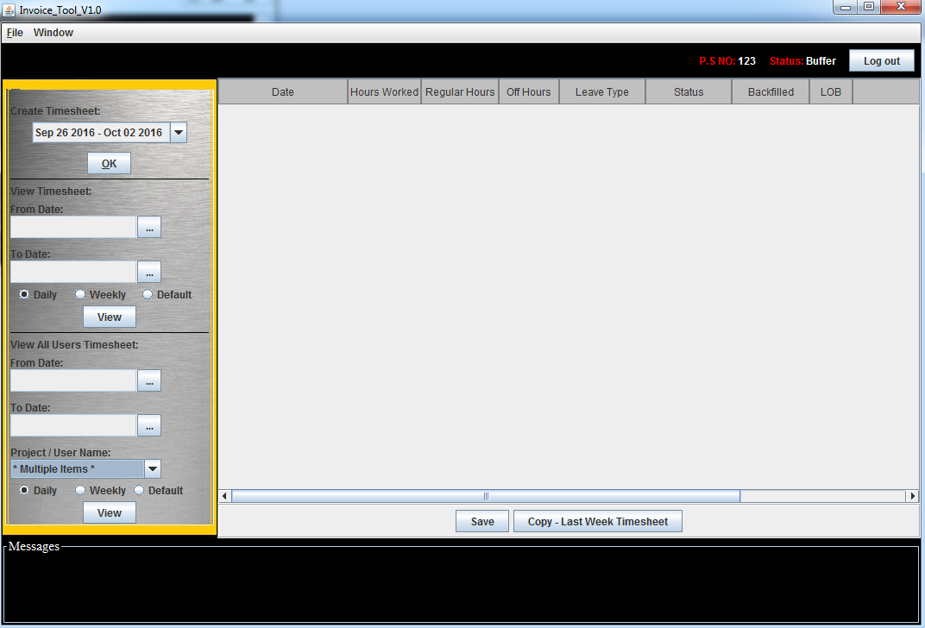
- To Enable, Disable registered user time booking:
Initially PM and PL role people will not see Enable / Disable timesheet panel, to make this show up below steps need to be done, see below screen shots for reference.
Step 6.1) Window → Show → Utilities panel

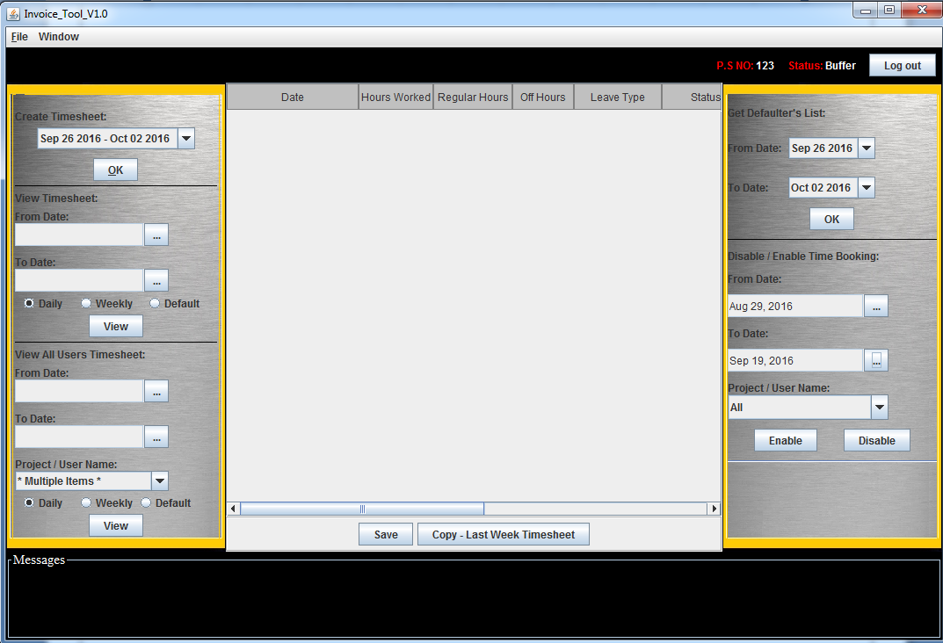
Fill up the fields from date, To Date and project/User Names. And click Enable or Disable
Enable will make the Users Timesheet editable and Disable will make it non editable.

