TASK 01

WEB DEVELOPMENT

Submitted by : Arbaz

[Arbazmohammad117@gmail.com](mailto:Arbazmohammad117@gmail.com)

+91 6302809697

|  |
| --- |
| **Table Booking Form - User Guide and Documentation** |

Form Usage:

The Table Booking Form is designed to allow customers to make reservations for tables at the restaurant. To use the form, customers need to fill in the required information and submit the form by clicking the "Book Table" button. The form includes the following fields:

* Name: Customers should enter their name.
* Email: Customers should enter their email address.
* Phone: Customers should enter their phone number.
* Date: Customers should select the desired date for the reservation.
* Time: Customers should select the desired time for the reservation.
* Party Size: Customers should enter the number of guests in their party.
* Special Requests: Customers can enter any special requests or notes.

Form Submission:

Once all the required information is filled in, customers can click the "Book Table" button to submit the form. The form data will be sent to the server for processing. It's important to note that this form is a front-end example only and does not include backend functionality to handle form submission. Appropriate server-side scripting or backend code will need to be implemented separately to process form data and make the actual reservation.

**Special Features:**

* Form Validation: The form includes HTML5 form validation attributes such as required, type, and min/max attributes to ensure that the required fields are filled in and that data is entered in the correct format.
* Responsive Design: The form has been designed to be responsive, meaning it will adapt and display properly on different screen sizes, including desktops, tablets, and mobile devices.
* Customizable Styling: The form's styling can be easily customized by modifying the CSS code in the provided style.css file to match the restaurant's brand colors and overall design theme.

Considerations for Restaurant Management Team:

* Backend Implementation: The form is a front-end example and does not include backend functionality to handle form submission. The restaurant management team will need to implement appropriate server-side scripting or backend code to process form data and make actual reservations based on the submitted data.
* Data Privacy: The form collects sensitive information such as name, email, and phone number. It's important for the restaurant management team to handle and store this data securely and in compliance with relevant data privacy laws and regulations.

User Experience: It's crucial to regularly test and optimize the form for usability and user experience. This includes ensuring that the form is easy to fill out, displays properly on different devices, and provides clear instructions for form submission.

Accessibility: The form should be designed and coded with accessibility considerations in mind, ensuring that it is usable by people with disabilities, including those who use screen readers or have other accessibility needs.

Screenshots:

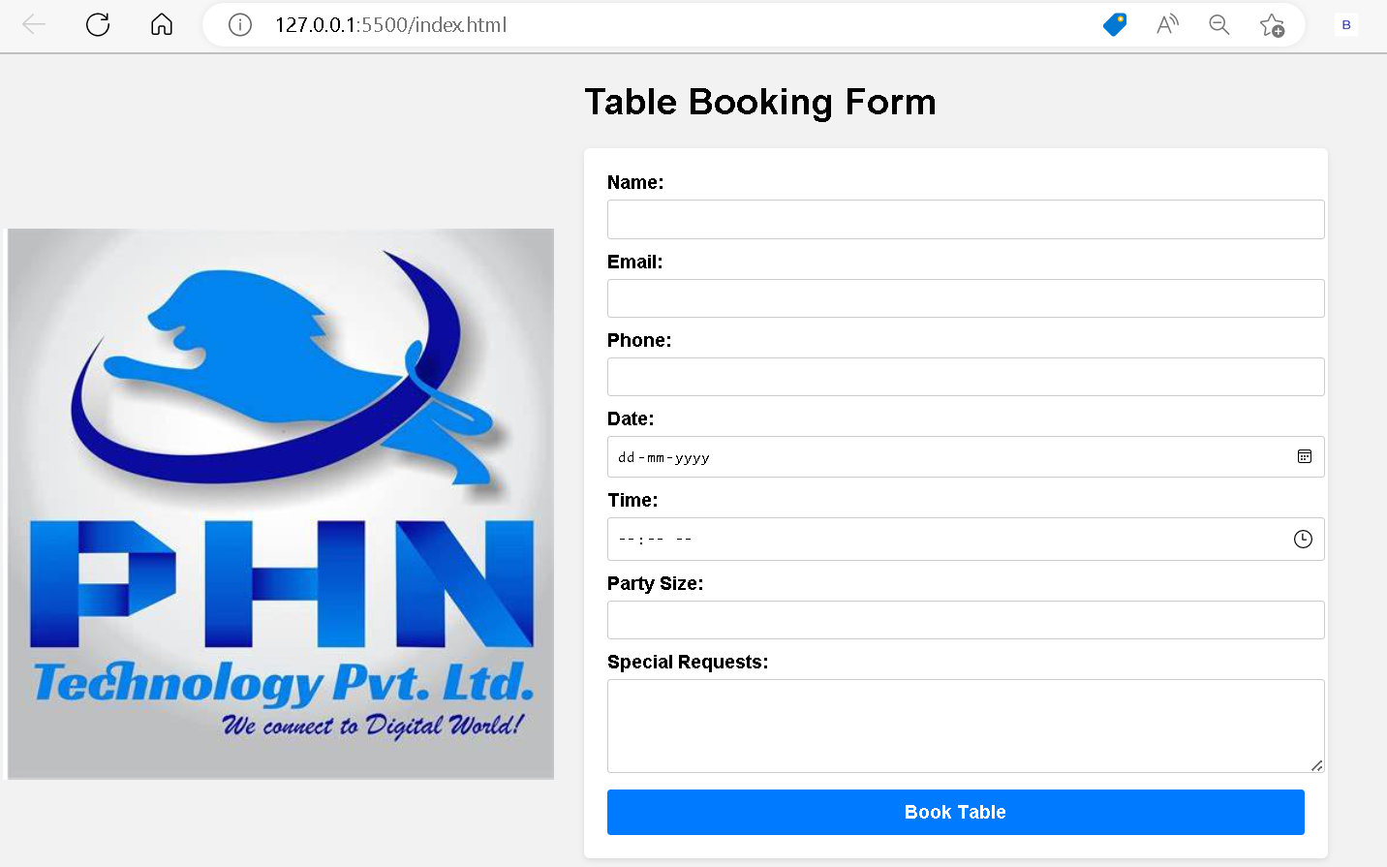

**Conclusion:**

The Table Booking Form is a user-friendly and visually appealing way for customers to make reservations at the restaurant. The restaurant management team should ensure proper implementation of backend functionality for form submission, handle data privacy securely, regularly test and optimize the form for usability and accessibility, and customize the form's styling to match the restaurant's brand theme.