EXPERIENCE-CENTRED DESIGN IN HCI AND ITS APPLICATION IN A COOPERATIVE USABILITY EVALUATION OF THE AIRBNB MOBILE APPLICATION

TABLE OF CONTENTS
PART 1: A Critical Summary of the Development of Experience-Centred Design in HCI and its Importance to Interactive Technology 3
1. Introduction 3
2. Early HCI and the Foundations of Usability 3
3. The Emergence of User Experience (UX) 4
4. Experience-Centred Design: Core Principles 4
5. Critical Evaluation 5
6. Importance for Contemporary Interactive Technology 5
7. Conclusion 6
PART 2: COOPERATIVE EVALUATION: USABILITY REPORT 7
USABILITY Evaluation and User Requirements for: Airbnb (Mobile Application) 7
Executive Summary 7
Product Details 8
User Test Details 9
Evaluation Results 11
Incident Log [1] 11
Incident Log [2] 12
Incident Log [3] 13
Incident Log [4] 14
Summary of Findings 14
Reference List 16

PART 1: A Critical Summary of the Development of Experience-Centred Design in HCI and its Importance to Interactive Technology

Student ID: 250471247

1. Introduction
Human Computer Interaction (HCI) became a field of study that aimed on enhancing the usability of interactive systems. At the initial stage of its evolution, the main attention was paid to the fact that users should be able to perform the work effectively and correctly. Nevertheless, with the introduction of digital technologies into the fabric of every-day life HCI has grown beyond task performance and considered emotional, social and contextual interaction. This movement brought about the experience-centred design. The essay reviews critically the development of HCI in response to the usability-based models, to experience-based approaches and measures the importance of this change in developing interactive technologies with modern technologies.

2. Early HCI and the Foundations of Usability
Cognitive psychology and human factors engineering played an important role in HCI in the 1970s-1990s (Mirabdolah et al., 2023). The main goal was to maximise interaction through user error and cognitive load minimisation. Usability has become the prevailing framework, which is determined by the standards including ISO 9241-11 as the degree to which a particular product is applicable, easy to use, and satisfying to the specific context or use of a particular product (Zhang et al., 2024). This method was more of looking at users as information processors carrying out specific tasks. Increased learnability through improvements to the interface like the graphical user interfaces (GUIs) and lessened dependency on the complex command-line systems. The measurement of usability occurred due to the completion rates of tasks, duration of tasks, and the rate of errors. Although this model made systems much clearer and reliable, it was still to a great extent devoted to workplace productivity and instrumental application.

3. The Emergence of User Experience (UX)
With the introduction of computing technologies into homes, leisure spaces and social life, usability was no longer enough. The internet, mobile technology and multimedia platforms altered the digital systems into communication, entertainment and self-expression tools (Sun et al., 2024). Interaction was not necessarily functional. User Experience (UX) brought the concept of emotion response, aesthetics, interaction interfaces, and subjective meaning within the scope of evaluations provided by HCI (Yang and Wang, 2024). The system might work but ineffective, annoying or unreliable. This movement was an expression of what can be termed as the third-wave HCI, which held greater focus on lived experience as opposed to only cognitive performance. Designers were now thinking about how users can feel of the systems and how interactions determine identity and relationships.

4. Experience-Centred Design: Core Principles
Experience centred design extends the knowledge of UX by directly predicting the context, emotion, and the sense creation (Lu et al., 2025). It acknowledges that interaction exists within physical, social and cultural settings. Instead of paying attention to the ability of the user to execute tasks only, it inquires about experiencing interactions and meanings.
This approach is based on a number of principles:
- Contextual awareness: Interaction is a factor of the environment and social surroundings.
- User diversity: The users come with different motivations, expectations and values.
- Participatory design: Designing with users rather than for them.
- Ethical and societal consideration: Technologies have an effect on the trust, autonomy, and long-term behaviour.
The experience-centred design recognizes the fact that the interaction is not just mechanical, but interpretative and relational.

5. Critical Evaluation
Experience-based design has important advantages. It is specifically applicable to the modern systems including AI-based platforms, social media, and sharing-economy services when the elements of trust, transparency, and emotional engagement matter (Nguyen et al., 2024). These technologies influence behaviour and the social interaction, i.e. the efficiency can not define the quality of the design alone (Ntoa, 2025). Nonetheless, experience-centred design is also problematic. Experience is a subjective area and cannot be easily measured and thus it is not as accurate as the traditional usability measures. The possibility of prioritisation of aesthetic qualities (or engagement rates) over ethical clarity and transparency also exists. Experience-centred methods can be weak in terms of analytical rigour without an underpinning in usability principles. Thus, the combination of usability measures and experiential awareness should be incorporated balanced to achieve healthy and responsible interaction design.

6. Importance for Contemporary Interactive Technology
The present interactive systems are pervasive and are integrated into daily life. AI assistants, reservation services, wearables, and smart environments are affecting the decision-making process and social interactions among individuals (Deshmukh and Chalmeta, 2024). The fact that such systems are being designed to be efficient alone would overlook the overall societal and emotional effects of such systems. The experience-centred design concept guarantees that the interaction design considers trust, inclusiveness as well as long-term consequences. It corresponds to the necessity of responsible innovation in the age of data-oriented systems and the algorithmic approach to decision. In addition, experience-based design has the potential to stimulate designers to consider systems that are not just about short-term success and how interactions effects build up user perception, autonomy and behaviour patterns (over time). The problem of transparency, fairness, and explainability becomes a concern of the user experience as the role of algorithmic systems continues to grow in the mediation of access to services, information and opportunities. Experience views in design facilitates ethical responsibility and sustainable digital ecosystems that put human values as key in development with technology.

7. Conclusion
The experience-centred design is a product of the trend where HCI was viewed as a discipline that fits more into a task-oriented approach than into an approach that is concerned with the overall human experience. The models developed in the early days of usability developed very basic fundamentals, which were not enough to take care of the intricate digital settings. Experience-based design transforms HCI to both emotional and contextual and societal levels. Although it presents measurement and conceptual-definition problems, it is needed to make the ability of creating meaningful and responsible interactive technologies in modern society. In a world being defined by AI, pervasive computing, and platform-mediated interaction, designing experience is no longer a choice it is an imperative to responsible and meaningful interactive technology.

PART 2: COOPERATIVE EVALUATION: USABILITY REPORT

USABILITY Evaluation and User Requirements for: Airbnb (Mobile Application)
Evaluation Prepared by: [250471247]
Date Test Conducted: [19-02-2026]

Executive Summary
This usability test analyzed Airbnb mobile application through Cooperative Evaluation (Think-Aloud Protocol) technique. Three respondents were invited to perform several realistic tasks involving booking procedures, such as intake search, results filtering, property description and property booking. The assessment indicated that usability had a number of problems that influenced the efficiency and satisfaction. As much as the app was of high aesthetic standard and displayed good information presentation, issues arose concerning filter transparency, clarity of price and navigations between property details and search results.
Two significant usability problems had been recognized:
- Confusion of overall pricing during checkout.
- Confusion around filter persistence and search state.
The results indicate that despite the overall excellent user experience, Airbnb still needs to work on the areas where it has not succeeded at the time of making a decision, i.e., transparency and a low-cognitive load.

Product Details
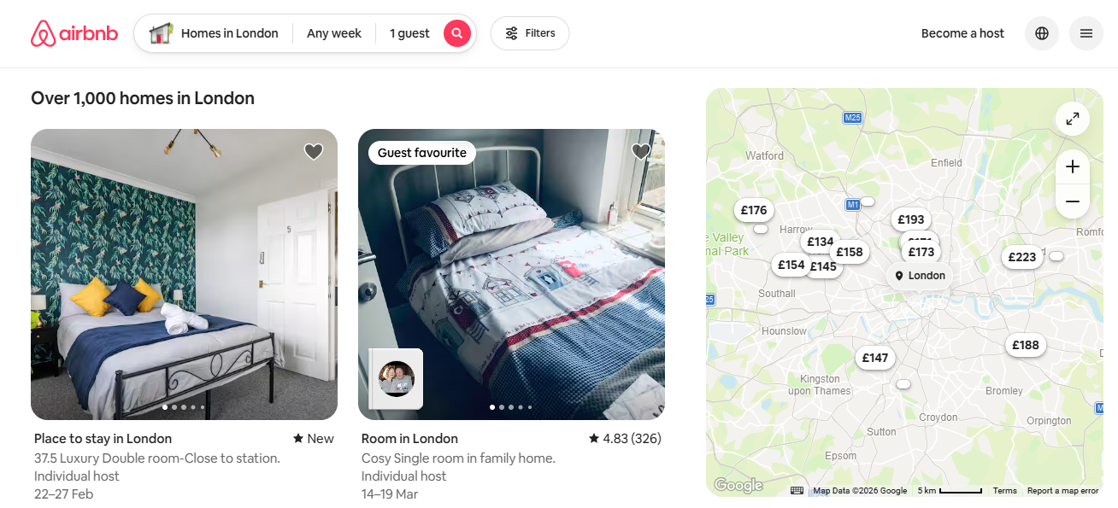
Figure 1: Airbnb Website UK
(Source: www.airbnb.co.uk)
Product Name: Airbnb Mobile Application
Version: Current public release (2026 version)
Elements Evaluated:
- Search function
- Filters (price, dates, amenities)
- Property detail page
- Booking initiation process
- Map integration
Intended User Groups:
- Leisure travellers
- Business travellers
- Students
- Families
Training Required: No formal training will be needed.
Purpose of Product:
To allow users to make comparisons, searches and bookings of short-term accommodation.
Designed Context of Use:
Mobile use in varied contexts (home, commuting, travel planning settings).

User Test Details
Number of Users Tested: 3
Participant Details:
- Participant 1: 21-year old university student, middle level of experience.
- Participant 2: 29-years old working professional, frequent Airbnb user
- Participant 3: 45 years old, occasionally travelling, low familiarity
Length of Test Session (per user): ~20 minutes
Location of Test: Quiet indoor environment
Method Used: Cooperative Evaluation (Think Aloud Protocol)
Data Collected:
- Observational notes
- Incident log
- Verbal comments during interaction

User Tasks Conducted
Find accommodation in London 2-night stay next month on a £120 per night budget.
- Apply filters for “Entire place” and “Wi-Fi included”.
- Compare two entries, make a total cost identification.
- Initiate booking procedure but do not make payment confirmation.

Evaluation Results

Incident Log [1]
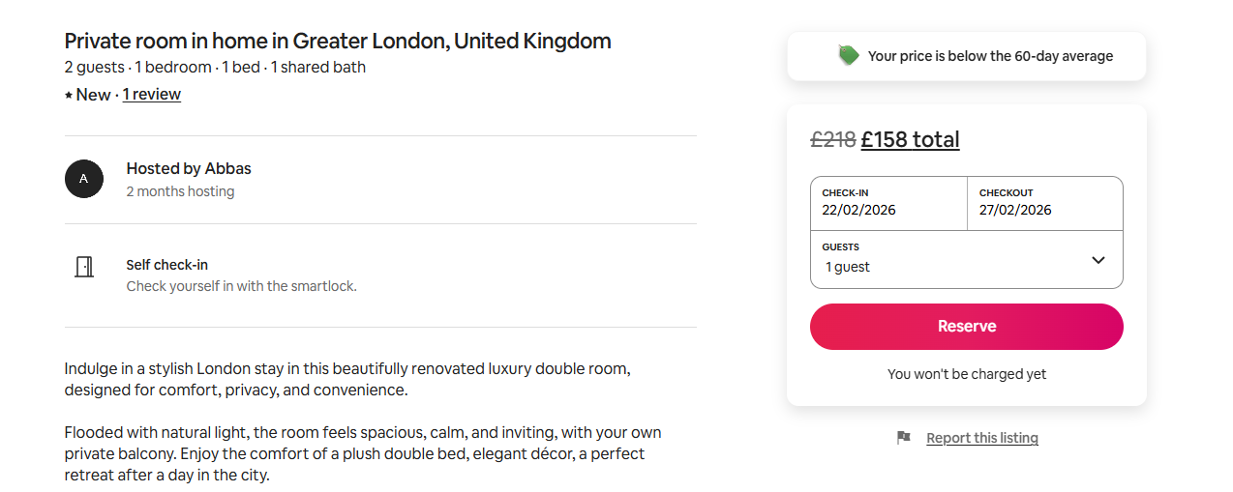
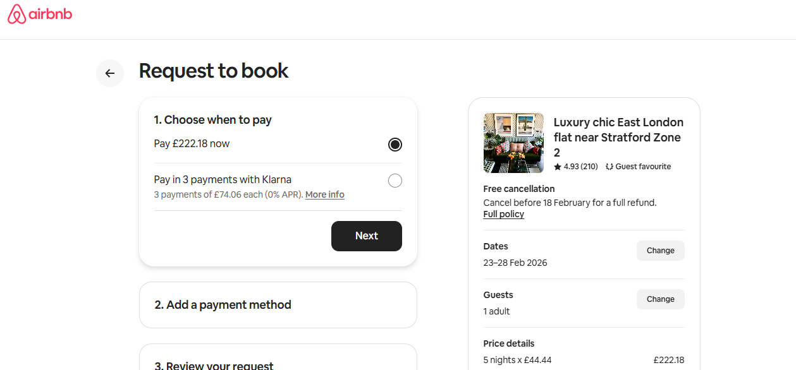
Figure 2: Airbnb Price Comparison
(Source: www.airbnb.co.uk)
Incident Description:
Participant 1 was confused about the overall price that is presented at the first search results. The price was prominently displayed in the form of a per-night fee, but included other service fees and cleaning costs could only be seen after scrolling further into the reservation process. This brought about a mismatch between the expectation of the user and the total shown thus the end result. The hidden nature of the total cost took more navigation and cognitive processing to offset the differences. The interviewee added that the pricing was misleading which means that there would be a case of absence of match-up in expectations. It has been demonstrated that such pricing models affect the perceived transparency and satisfaction of digital booking platforms (Hwang et al., 2024). This problem adversely affects efficiency and confidence of users in the initial decision-making phases.
User comment:
“I thought it was £110 per night, but now it’s much more that’s misleading.”
Usability Impact:
- Affects Efficiency (additional navigation required)
- Affects Satisfaction (perceived lack of transparency)
- Creates mismatch in expectation (Gulf of Evaluation)
Severity Rating:
Major usability problem (3)
Important to fix due to financial implications.

Incident Log [2]
Incident Description:
Participant 3 used several search filters, such as price range and the type of the property, but forgot about them not being inactive. The participant thought that there was no accommodation available when the search results were not satisfactory and did not recognize that the search was being limited by the use of filters. This implies lack of system status that is visible enough and poor feedback of running filters. This absence of a consistent or salient indicators of the filters augmented thought loads and resulted in faulty identification of search outcomes. The participant also took more time to revisit filter settings to trouble-shoot. It indicates that users can more accurately understand and are confident in the decisions made in digital platforms with a transparent interface constraint (Shin et al., 2025). This is a problem that affects efficiency and match-making of expectations mainly.

User comment:
“Why are there so few options? Is everything booked?”
Filter status visibility was insufficient.
Usability Impact:
- Affects Effectiveness (incorrect interpretation of results)
- Affects Efficiency (extra time spent re-evaluating search)
Severity Rating:
Major usability problem (3)

Incident Log [3]
Incident Description:
Participant 2 had a challenge in navigating on search result back after visiting a property detail page and keeping up with their previous scroll point diversion. When the list returned, it was in the same order leading to the participant losing count of already read listings. This obstructed the process of comparison and had to scroll further to move properties of interest. The problem made the cognitive activity more difficult and inefficient as well as disturbed the process of making the decision as a whole, which had adverse impact on the efficiency and the general user experiences.
User comment:
“I lost the place I was looking at before.”
Usability Impact:
- Reduces Efficiency
- Increases cognitive load
- Interrupts comparison workflow

Severity Rating:
Minor usability problem (2)

Incident Log [4]
Incident Description:
Favorable feedback concerning map-based search interface.
User comment:
“I like that I can see where everything is visually.”
Usability Impact:
- Supports Satisfaction
- Enhances mental model of spatial layout
Severity Rating:
Cosmetic / Positive observation

Summary of Findings
Airbnb exhibits high aesthetic design and experience, which unfolds positively to the satisfaction of the user. The interface shows the property information in a sound organized and attractive format, has clear images, clear descriptions and easy navigation routes. These features contribute to the interaction of the users and lessen the cognitive load of the browsing. The map integration and filtering options also lead to the further intensification of the exploratory interaction whereby users enhance the search refining option and visualising spatial options. Nonetheless, there were major usability issues found when it comes to transparency of prices and transparency of filters. The fact that the price of the base is not presented as a whole with added prices at later stages of booking process builds up expectation discrepancy and frustrations among the users and diminishes trust. On the same note, poor active filter visibility may lead to confusion and this will influence the interpretation of search results and even lead to unnecessary navigation.
From an ISO usability perspective:
- Effectiveness: Generally high
- Efficiency: Fairly subject to the flow of navigation and pricing.
- Satisfaction: Mixed because of the financial transparency issues.

Reference List
Deshmukh, A.M. and Chalmeta, R., 2024. User experience and usability of voice user interfaces: A systematic literature review. Information, 15(9), p.579. https://www.mdpi.com/2078-2489/15/9/579
Hwang, Y., Shin, S. and Kim, T., 2024. The emergence of virtual experiences in the sharing economy. Journal of Hospitality & Tourism Research, 48(8), pp.1439-1452. https://ira.lib.polyu.edu.hk/bitstream/10397/113748/1/Hwang_Emergence_Virtual_Experiences.pdf
Lu, J., Schmidt, M. and Shin, J., 2025. Beyond technological usability: exploratory factor analysis of the comprehensive assessment of usability scale for learning technologies (CAUSLT). arXiv preprint arXiv:2501.18754. https://arxiv.org/pdf/2501.18754
Mirabdolah, A., Alaeifard, M. and Marandi, A., 2023. User-centered design in HCl: enhancing usability and interaction in complex systems. International Journal of Advanced Human Computer Interaction, 1(1), pp.16-33. https://www.ijahci.com/index.php/ijahci/article/download/16/12
Nguyen, T., Canossa, A. and Zhu, J., 2024. How human-centered explainable ai interface are designed and evaluated: A systematic survey. arXiv preprint arXiv:2403.14496. https://arxiv.org/pdf/2403.14496
Ntoa, S., 2025. Usability and user experience evaluation in intelligent environments: A review and reappraisal. International Journal of Human–Computer Interaction, 41(5), pp.2829-2858. https://www.tandfonline.com/doi/pdf/10.1080/10447318.2024.2394724
Shin, S., Hwang, Y. and Kim, T., 2025. Attributes of satisfaction and dissatisfaction with online travel experiences in peer-to-peer platforms. International journal of hospitality management, 124, p.103972. https://www.sciencedirect.com/science/article/pii/S0278431924002846
Sun, Q., Xue, Y. and Song, Z., 2024. Adaptive user interface generation through reinforcement learning. arXiv preprint arXiv:2412.16837. https://ieeexplore.ieee.org/abstract/document/10913228/
Yang, J. and Wang, Y., 2024. Research on User Experience and Human-Computer Interface in the Process of Innovative Design. Frontiers in Art Research, 6(1). https://francis-press.com/uploads/papers/Fv6MuMoqPPtnPxLE9NMYGFO2yaaAgs4HIHIzLWcp.pdf
Zhang, R., Wang, S., Xie, T., Duan, S. and Chen, M., 2024, December. Dynamic user interface generation for enhanced human-computer interaction using variational autoencoders. In 2024 4th International Conference on Communication Technology and Information Technology (ICCTIT) (pp. 260-265). IEEE. https://arxiv.org/pdf/2412.14521

