**COMSATS University Islamabad,   
Park Road, Chak Shahzad, Islamabad Pakistan**

Project Proposal  
(SCOPE DOCUMENT)

for

**DARTS**

Detection And Recognition with Tracking of Suspects  
Version 1.0

***By***

**Arbaz Ajaz CIIT/FA16-BCS-001/ISB**

**Kanwal Shariq CIIT/FA16-BCS-005 /ISB**

***Supervisor*Mr. Tahir Mustafa Madni**

***Bachelor of Science in Computer Science (2016-2020)***

|  |  |  |
| --- | --- | --- |
| **No.** | **Comment** | **Action** |
|  |  |  |
|  |  |  |
|  |  |  |
|  |  |  |
|  |  |  |
|  |  |  |

**SCOPE DOCUMENT REVSION HISTORY**

**Supervisor Signature**

**Date:**

**Table of Contents**

Abstract 5

1. Introduction 6

2. Problem Statement 6

3. Problem Solution for Proposed System 6

4. Related System Analysis/Literature Review 6

5. Advantages/Benefits of Proposed System 7

6. Scope 7

7. Modules 7

7.1 Module 1: Cameras Manager 7

7.2 Module 2: Tier 1 Servers handling system 8

7.3 Module 3: Preprocessing video feed 9

7.4 Module 4: Video analysis 9

7.5 Module 5: Face Recognition 10

7.6 Module 6: Location tracker 10

7.7 Module 7: Alert System 11

7.8 Module 8: User Management 11

7.9 Module 9: QR forces communication system 12

7.10 Module 10: Suspect Information Management 12

8. System Limitations/Constraints 13

9. Software Process Methodology 13

**9.1** **Software Process Methodology** 13

**9.2** **Software Design Methodology** 13

10. Tools and Technologies 13

11. Project Stakeholders and Roles 14

12. Team Members Individual Tasks/Work Division 14

13. Data Gathering Approach 14

14. Concepts 15

15. Gantt chart 15

16. Mockups 16

17. Conclusion 20

18. References 20

19. Plagiarism Report 21

**Project Category:**

**A** Web Application/Web Application based Information System

**B** Problem Solving and Artificial Intelligence

**C** Smartphone Application

**D** Image Processing

# Abstract

There exists no such system in Pakistan yet that tracks person of interest when they enter an area. Though terrorism has gone down, Pakistan needs top security systems to make sure it never happens again especially when tourism is reaching its peak. Our system is offering an intelligent surveillance and tracking system that will consist of a web application through which the authorized personnel can monitor the camera feeds and will use available installed cameras to detect and recognize the person of interest through computer vision algorithms even if the face is occluded, detect objects it is carrying, track movements in real-time on the server and in addition to this, it will also notify the nearest quick response units through a mobile application, catalyzing the process of capture.

# Introduction

Pakistan is one of the countries, worst hit by the terrorism that erupted in the aftermath of the 9/11 incident. Since 2009, till 2017, Pakistan has lost more than 60,000 of its citizens to terrorism, not to mention the direct economic cost of terrorism. Automated systems that would minimize human intervention in the monitoring system would enable the LEAs to work in cohesion with the system but due to the complicated internal and external security situation, some of these have been on-hold due to interaction of the public and private sector. Though terrorism, thanks to our army, has been minimized drastically, there is still a need to provide efficient security and safety measures especially as tourism is reaching a peak and one accident can ruin this country’s future forever

This project presents a web and mobile application for the use of LEAs, and any other security related organizations, through which they will be able to monitor the movements of a person of interest who would be detected and recognized through computer vision algorithms. They will be able to observe the movements of the person in real-time which would not only enable them to capture the person but would also help them in monitoring his movements and interpreting his intentions. It would also make it easier to capture the groups working in collaboration with minimum hassle

# Problem Statement

Peace and harmony are imperative for economic growth and progress; it ensures foreign investment and unhindered economic activities. Pakistan is still behind in the use of technology to for the maintenance of law and order across the country as there is no such system yet that recognizes and tracks a suspect as they enter an area that has surveillance cameras. Intelligence agencies still make use of physically surveilling the area which as largely inefficient and leads to human errors.

# Problem Solution for Proposed System

This project is introducing a fully automated system that will detect and recognize a suspect even if it is occluded and the last saved picture of him is of his childhood. It will also detect the objects it is carrying, track movement of the person of interest in real time and predict its next location. Based on the severity of the threat, it will alert the quick response forces through a mobile application that will also provide them with a communication interface. The designated authoritative figure will be able to monitor the movement through the web platform. The application is designed to assist the LEAs in quickly responding to the imminent threats that an individual pose and to also trace the initiation of his movements and apprehend the culprits before they get a chance to act.

# Related System Analysis/Literature Review

**Table 1 Related System Analysis with proposed project solution**

|  |  |  |
| --- | --- | --- |
| **Application Name** | **Weakness** | **Proposed Project Solution** |
| Smart tracker FRS | It is only a facial recognition software and offers no tracking system | Our proposed project will include facial recognition as well as tracking and alerting system |
| Face recognition-based real-time system for surveillance (Research paper)[1] | This paper only explores the real time surveillance based on facial recognition techniques without any location based tracking or alerting system | Our proposed project is a full product that not only has facial recognition, but also location based tracking and alerting system. |

# Advantages/Benefits of Proposed System

* Assist LEAs in reacting quickly for apprehending suspects
* Enable remote and automated monitoring of suspects
* Monitoring of movements, and prediction of movement in different directions is enabled
* Curb on terrorist and street crime activities through a 24/7 monitored system

# Scope

Our proposed system will work in tier architecture. Firstly, it will use the available installed cameras whose location will be added to the system by the Admin. The admin can then view the feed of the cameras as per will. The feed will be distributed over the servers attached evenly to avoid bottleneck. The feed will then be analyzed and preprocessed and will then be applied with human detection, object detection, activity recognition, face detection and facial recognition algorithms.

If the suspect is matched or a suspicious behavior is detected, the server will send the location, time and feed to the main server, which will be the web application, where it will visualize the path of the suspect based on the locations he was spotted on and the map that was generated by the user. It will also predict the next location he might go to using machine learning algorithm. Based on the suspect’s location, it will be tracked accordingly. The teams will be registered beforehand through QR code and after they have pressed ‘engaging,’ their location will be viewable to the designated authority for monitoring. The teams will also be able to communicate with other teams in case they need a backup through text messages, calls and even pinging their location on map to other units close by.

# Modules

## Module 1: Cameras Manager

This module will be in charge of keeping track of all the cameras connected to the system by their geo locations. It will allow the admin to view the video feed of each camera and also to send it to the servers for further processing. The system will also allow the admin to delete or add a camera to the system which will be useful for the scalability of the system.

### Stores camera’s locations

This will allow the admin to enter camera’s geo-location for it to be displayed on the map as well as to know where the target was observed.

### Set the activity detection algorithms that have to applied to the specific camera feed

This will allow the admin to choose the activity detection algorithms that have to be applied on the specific camera feed.

### Allows Admin to view camera’s feed

This will allow the admin to view the camera’s feed in real-time as per his/her liking to monitor and report the issues to the development team.

### Allows Admin to add, remove or change the location of the camera

This will allow the system to be dynamic and scalable as cameras can be added and removed at will.

## Module 2: Tier 1 Servers handling system

To be safe from overload and bottleneck, this module will distribute the incoming camera feeds to the servers attached to the system through camera connections. It will check which server is free and will keep the video frames to be processed without interruption. If a suspect is recognized, it will send the required data to the main server. The system will also handle the addition and removal of servers.

### Adds or removes camera connections

The admin will manually assign tier 1 servers the cameras they will be fetching live video feeds from to perform further operations.

### Adds or removes servers

This will allow the system to be dynamic and scalable as it will allow the number of servers to increase as the number of cameras start creating a bottleneck.

### Distributes cameras evenly to the servers and avoids bottlenecks

This will allow the system to automatically assign tier 1 servers the right about of cameras for optimal system efficiency.

### Stores and sends the feed to the main server if a suspect is recognized or detected along with other necessary information such as location, time, picture etc.

### In case if a person of interest is recognized or a suspicious behavior is detected by the tier 1 server, it will send the detected face, the geo-location of the camera, the captured frame, time and the person of interest’s information (if recognized) to the main server.

## Module 3: Preprocessing video feed

### Due to various factors, the facial detection or algorithm does not always work because of the quality of the video, glare, and brightness. In this module, the system will try to increase the accuracy of the algorithms by enhancing the images in any way it can.

### Adjusts brightness

This will automatically adjust the brightness of the captured frame based on the time of day, and computer vision algorithms to increase the efficiency of detection and recognition modules.

### Removes noise

This will automatically decrease the noise in a captured frame through machine learning algorithms.

### Adjusts contrast

This will automatically adjust the contrast the image to sharpen the image with histogram equalization to increase the efficiency of detection and recognition modules.

## Module 4: Video analysis

This module will run facial detection algorithm on the video feed and extract faces from it. If the face is covered up, it will run an algorithm to recreate the face. If successful, these faces will be sent to facial recognition module. This module will also run the object detection algorithms on the camera feed to detect suspicious objects and an abandoned object detection algorithm to keep track of the object left behind and the person who left it.

### Detects face in all possible positions and points

This will detect the face in the human entity image.

### Save all the unique faces for future uses

This will extract the faces to be sent to the face recognition module

### Object detection

This will detect the object on the face of the human entity extracted and if it is carrying a weapon or any other suspicious object.

### Occluded faces recreation

If the face is covered up, it will run an algorithm to .the face without the cover and then pass it to the facial recognition algorithm.

### Abandoned object detection

This will analyze the video feed and will detect if an object is left abandoned somewhere. It will send the feed to the servers to track the person who left the object.

## Module 5: Face Recognition

### This module will use latest and the most innovative facial recognition algorithms to compare the faces against the suspect’s pictures that are in the database and will alert the main server if the face is a match.

### Runs facial recognition algorithm

This will run the facial recognition algorithm on the faces sent by the previous module against the pictures of the people of interest.

### Sends alert and necessary information to the main server if the suspect is found

If the module recognizes the person, it will send the mandatory details to the main server for further steps.

## Module 6: Location tracker

This module is in charge of map and location data. It will ask the user if it wants to use the city map or design a map of the specific area himself. If latter, it will provide the user with an interface to link the chosen area with a self-designed map. As our system uses multiple cameras, this module will keep track of the suspect’s movement on the map by pinning locations on the map wherever the cameras catch the suspect. It will then draw a probable path the suspect took. It will also use network location of users around the area of its path and using machine learning algorithms, predict the places the suspect is most likely to visit next.

### Create map

This will allow the user to design a map through our interface of the chosen area on the city map.

### Pins locations on the map

This will display all cameras on the map based on their geo-location and will pin the location and details of the person of interest on the map.

### Draws probable path between locations

Based on the locations where the person of interest is observed, the system will draw a probable path to provide a visual interpretation of person of interest’s movement.

### Using machine learning algorithms, it will predict the next probable location he might go to and send an alert to increase the security there.

This will predict the next probable place the person of interest will be based on the path the said person is using.

## Module 7: Alert System

### This module determines severity of the threat by checking its path and the locations near it. It will then send alerts to the respective quick response teams around the area through the registered application. On the application side, the teams can set their status to ‘engaging’ so the designated authority can monitor them.

### Determines severity of the threat

Based on the person of interest’s location, where he/she was observed on camera and the activity recognized, the system will determine the severity of the threat.

### Sends alerts to the respective quick response units

This will alert nearby quick response units about the suspect, its location, the severity of the threat, video feed of the captured scene and other mandatory details for quick action.

### Provides monitoring system of the active teams by showing their live location

This will allow the admin to manage the active operation by being able to view quick response units’ live locations.

## Module 8: User Management

The system has three registered actors. One is the designated authority figure who can use the system to monitor the teams, the other is the admin that manages the system through its admin privileges, and the last is the quick response team which will be registered by scanning the QR code on the system. Each team will have the application to receive alerts and communicate with other teams.

### Provides login system for the admin and authority

This will provide the admins and the authority the ability to access the functionalities of the system and prevent unauthorized access.

### Provides registration system for the quick response teams by scanning the QR code

This will allow the admins to register new quick response teams and generate a one-time login QR code for the quick response team’s mobile device assigned by the organization so they can only register and never logout.

### Provides options for deleting a team and adding authoritative figure

This will allow the admin to unregister or delete a team, logging them out of their devices remotely

## Module 9: QR forces communication system

To provide a single and safe interface, our project will include a communication system for the quick response teams so they could be safe and can call for backup in need of emergency. This will be a mobile application that the QR forces will use that would include all their information and the a map to show locations of all other QR teams and suspects.

### Provides text and calls interface

This will allow the quick response teams to communicate with each other by providing them a platform to text and call to devise strategies.

### Provides a pinging mechanism for quick one-tap assist call.

This will allow the quick response teams to quickly request other quick response teams for assistance by pinging their own location.

### Will automatically call for backup if the team does not check in after 30 minutes

The system will automatically assign other nearby quick response teams if the units in operations do not check in after 30 minutes.

### Will provide a secure way of sharing their location with other teams

This will allow other quick response units to be able to look for other nearby teams in case of assistance.

## Module 10: Suspect Information Management

All the information regarding an already identified suspect will be stored in the database along with their latest pictures. This module will provide the admin with a front end through which they can manage the suspect’s information, view their tracking history, add or remove suspects.

### View and edit suspect’s information

This will allow the admin to view and edit the suspect’s information that is stored in the database and will also allow the admin to search for suspect in the database.

### Add or remove suspects

This will allow the admin to add or remove new and old suspects.

### Transform pictures

This will perform a transformation algorithm to transform pictures of suspect from his childhood to adult and then to elder.

# System Limitations/Constraints

* The alert functionality requires constant network access to receive real-time push notifications.
* If a tier 1 server crashes, the system will temporarily lose access to the cameras managed by the said server until it restarts.
* The system depends on the availability of the cameras and if the system loses access to them, the system will be blind for the area.
* Environmental factors such as rain, fog, brightness levels may affect the performance of the system.
* As the system uses geo-locations, it cannot be yet implemented inside buildings that have multiple floors.

# Software Process Methodology

### **Software Process Methodology**

For this project, we will be using iterative and incremental development. We will be producing deliverables after a specific period of time; these deliverables will then be integrated together on the basis of their completion.

### **Software Design Methodology**

We will be using Object Oriented Methodology, for the development of the proposed system as this will ensure encapsulation, modularization and refactoring of the code.

# Tools and Technologies

**Table 2: Tools and Technologies**

|  |  |  |  |
| --- | --- | --- | --- |
| **Tools**  **And**  **Technologies** | **Tools** | **Version** | **Rationale** |
| Spyder | 3.3.4 | IDE |
| Adobe Illustrator | CSC 6 | Design Work |
| MS Word | 2015 | Documentation |
| MS Power Point | 2015 | Presentation |
| Pencil | 2.0.5 | Mockups Creation |
| Google Collaborator | 2019 | To run and test our deep learning models |
| Firebase | 16.0.6 | DB |
| Android Studio | 3.2 | IDE |
| Node JS | 12.12.0 | Platform |
| Express JS | 5.0 | Framework |
| MongoDB | 4.2.0 | DB |
| **Technology** | **Version** | **Rationale** |
| Python | 3.7 | Programming language |
| Java | 8.0 | Programming language |
| Javascript | 1.7 | Programming language |
| Keras | 2.2.5 | Machine Learning Library |
| OpenCV | 2013 | Image processing |

# Project Stakeholders and Roles

**Table 3: Project Stakeholders for Proposed Project**

|  |  |
| --- | --- |
| **Project Sponsor** | COMSATS University, Islamabad |
| **Stakeholder** | * Team Members: Kanwal Shariq, Arbaz Ajaz. * Project Supervisor Name: Mr. Tahir Mustafa Madni |

# Team Members Individual Tasks/Work Division

**Table 4: Team Member Work Division for Proposed Project**

|  |  |  |
| --- | --- | --- |
| **Student Name** | **Student Registration Number** | **Responsibility/ Modules** |
| Arbaz Ajaz | FA16-BCS-001 | Modules 1,2,3,5,6 and 8 |
| Kanwal Shariq | FA16-BCS-005 | Modules 4,5,6,7,9 and 10 |

# Data Gathering Approach

We will gather location information from SyntecX software company in order to train our location prediction system. Research papers will be studied for facial detection, facial recognition and activity recognition functionalities. We will be using already installed and publicly available CCTV cameras to fetch surveillance footage from for our proposed system.

# Concepts

**Concept-1: Location mapping**: We will be learning and using TPL maps to plot the movement of the recognized intruder

**Concept-2**: **Facial Recognition:** We will use latest facial recognition algorithms to recognize the suspect in surveillance cameras. A facial recognition system is a technology capable of identifying or verifying a person from a digital image or a video frame from a video source.

**Concept**-**3: Machine Learning:** We will use machine learning to train on our location data to predict possible future locations. Machine learning is the scientific study of algorithms and statistical models that computer systems use to perform a specific task without using explicit instructions, relying on patterns and inference instead. It is seen as a subset of artificial intelligence

**Concept-4: Object detection:** We will useobject detection algorithms to detect suspicious objects, objects on human’s face and object left abandoned. It aims to recognize the actions and goals of one or more agents from a series of observations on the agents' actions and the environmental conditions.

**Concept**-**5:** Transformation algorithms: We will use image transformation algorithms to convert images from the childhood of a person of interest to adult and elderly. An image transformation can be applied to an image to convert it from one domain to another. We will also use it to convert occluded faces to bare ones.

# Gantt chart

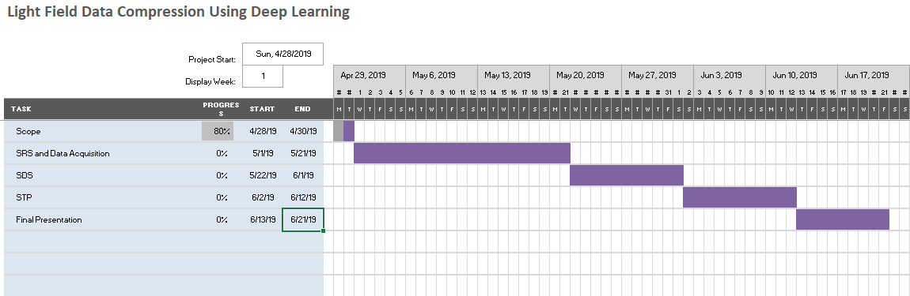

Figure 1: Gantt chart

# Mockups

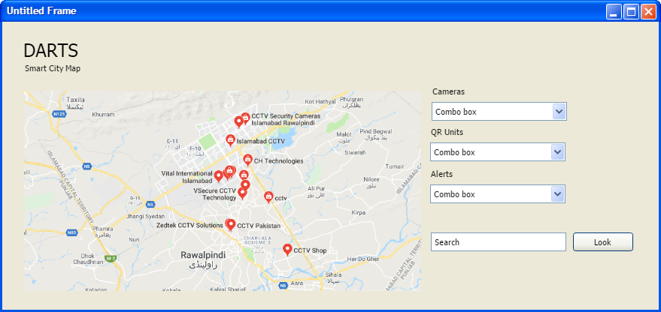

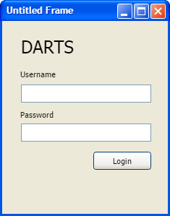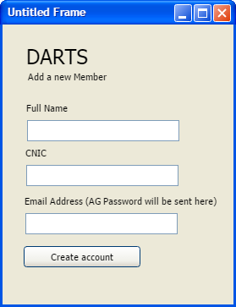

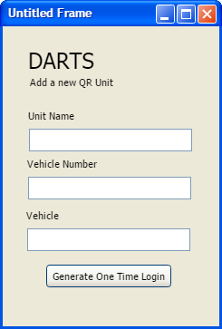

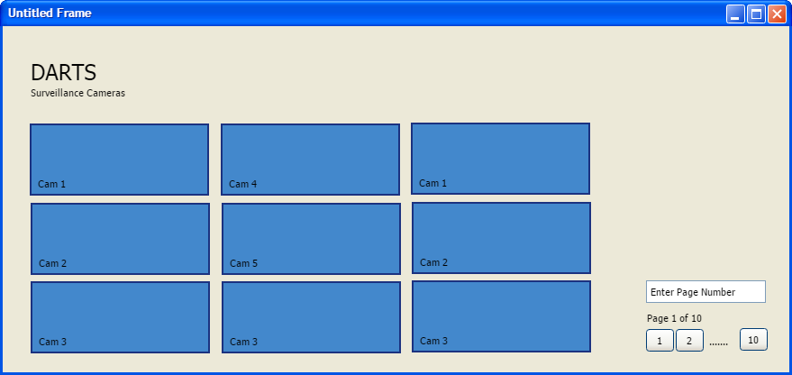

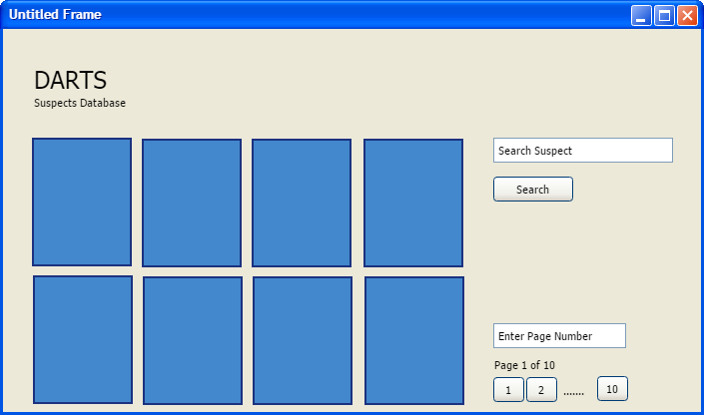

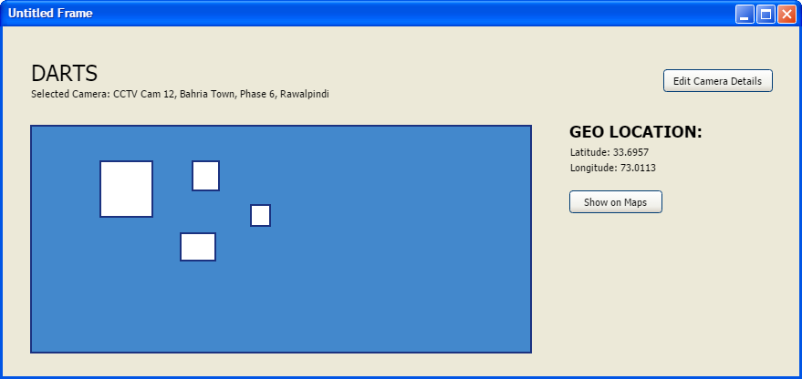

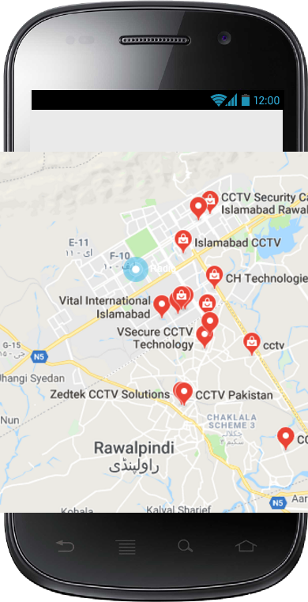

# Conclusion

Essentially, this project aims at catalyzing the security system through an automated assistance application for the quick response units. There is not just a research gap in this regard but also a high need to ensure that the latest technologies are utilized in order to track and apprehend high priority suspects. With the implementation of this application, the quick response units will have an edge over the criminal elements, and they will be able to triumph over them more easily.

# References

Publications:

* <https://www.researchgate.net/publication/308387275_Face_recognition-based_real-time_system_for_surveillance>

Similar product descriptions:

* <https://speechpro.com/product/facial-recognition/smart-tracker-frs#tab1>
* <https://analyticsindiamag.com/run-but-you-cant-hide-ai-based-facial-recognition-systems-are-now-tracking-down-criminals/>
* <https://www.mathworks.com/discovery/image-enhancement.html>

Blogs:

* <https://medium.com/@madhawavidanapathirana/https-medium-com-madhawavidanapathirana-real-time-human-detection-in-computer-vision-part-1-2acb851f4e55>

Websites:

* <https://us.norton.com/internetsecurity-iot-how-facial-recognition-software-works.html>

# Plagiarism Report

1.