Student All Document

 Student Name :

Aadhar/Pan:

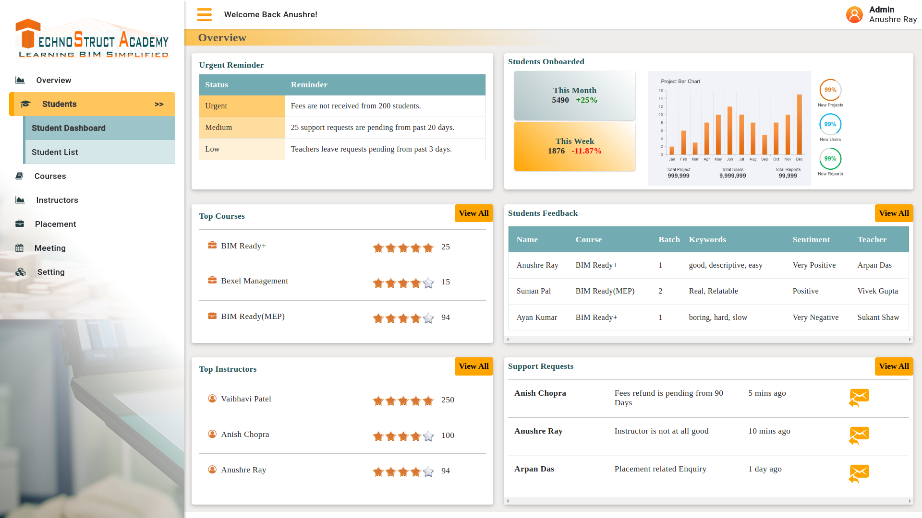

Photo :

Graduation Certificate :

Certificate of 10+2:

Certificate of 10Th: