Student All Document

 Student Name : Arpan Das

Aadhar/Pan:

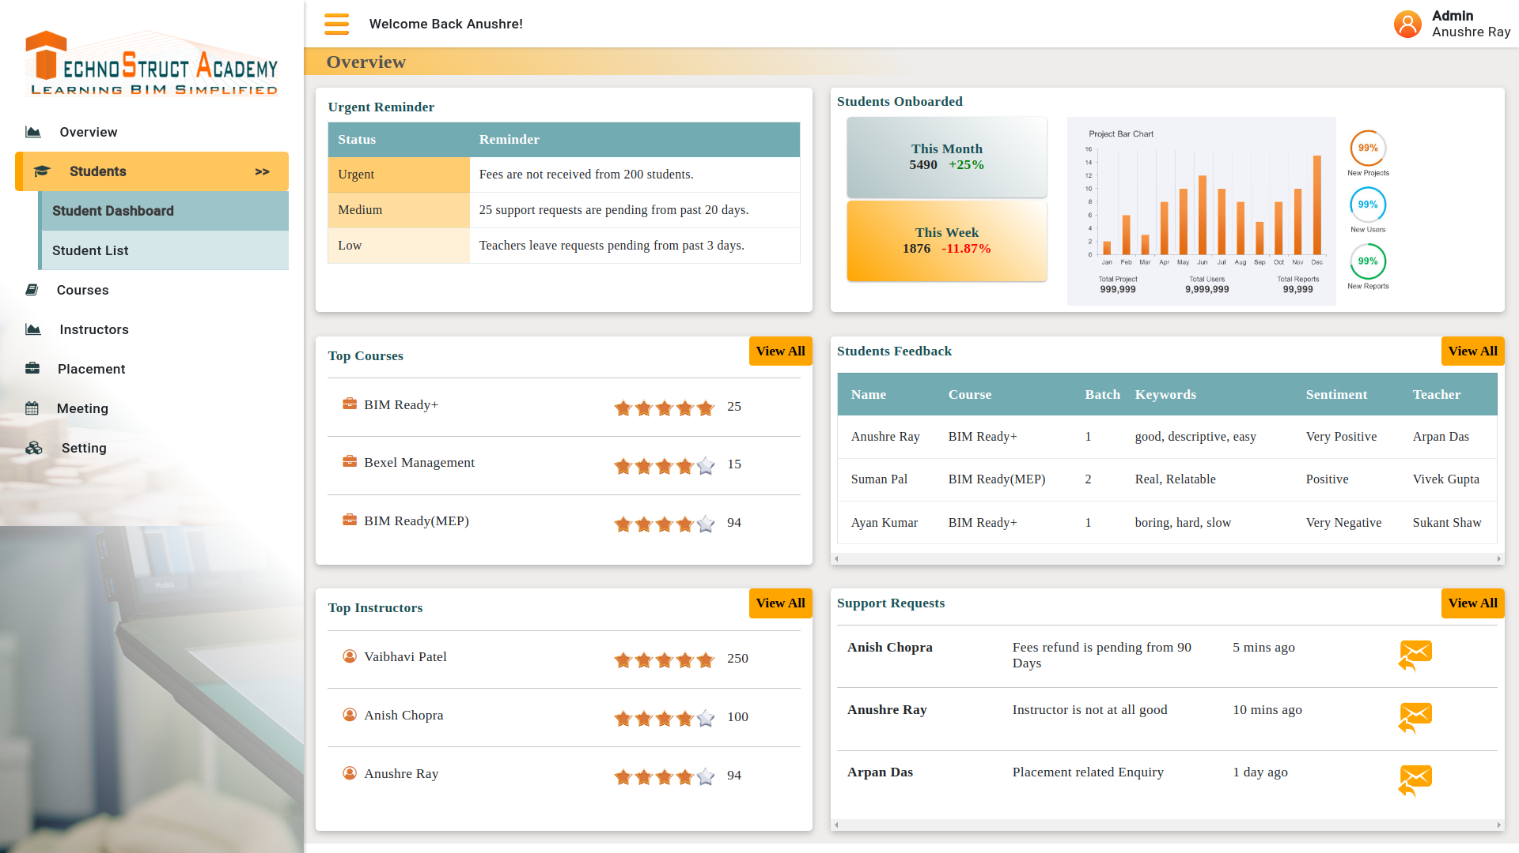

Photo :



Graduation Certificate :

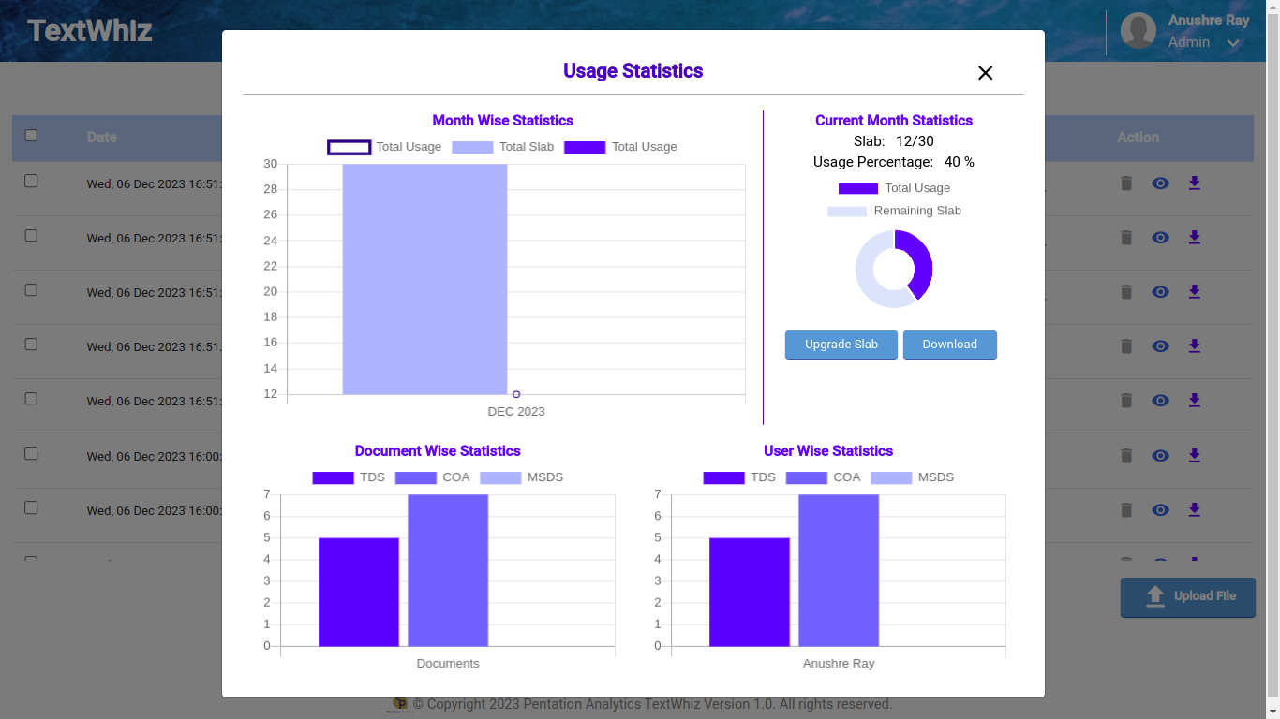

Certificate of 10+2:



Certificate of 10Th:

