14. Use Case Diagrams Creation
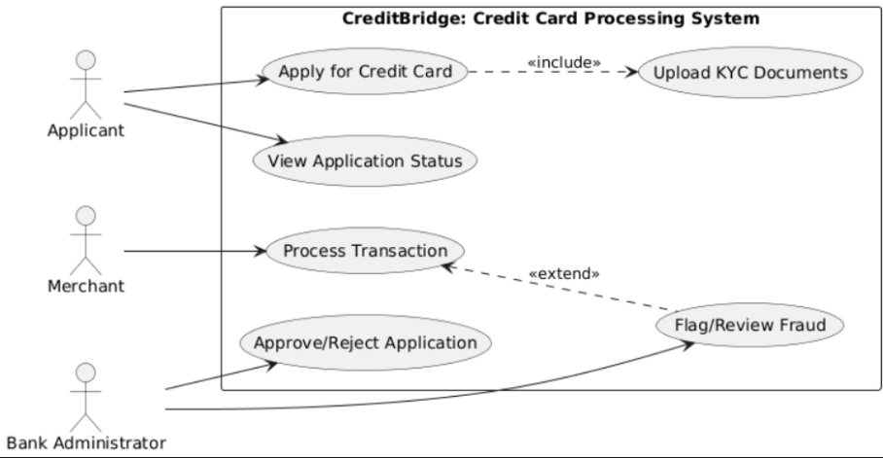
The use case diagram illustrates interactions between Applicants, Bank Admins, and Merchants with the CreditBridge System. It defines system boundaries and shows how each actor accesses specific functionalities.

