31. Object Interactions Documentation
Sequence Diagram 1: Transaction Processing 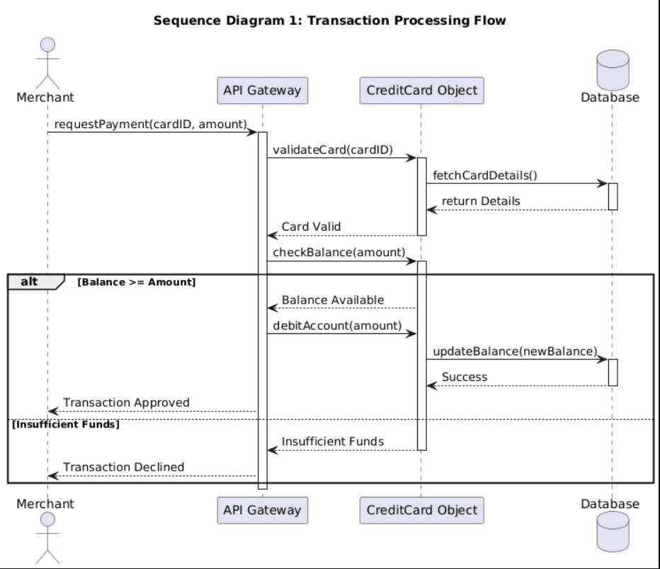
Detailed Interaction Flow:
- The Merchant initiates a charge() request.
- The System validates the card details.
- The CreditCard object checks balance >= amount.
- If valid, the Transaction object is created.
- The Database is updated, and "Success" is returned to the Merchant.\
- \

