35. Component Diagram Creation
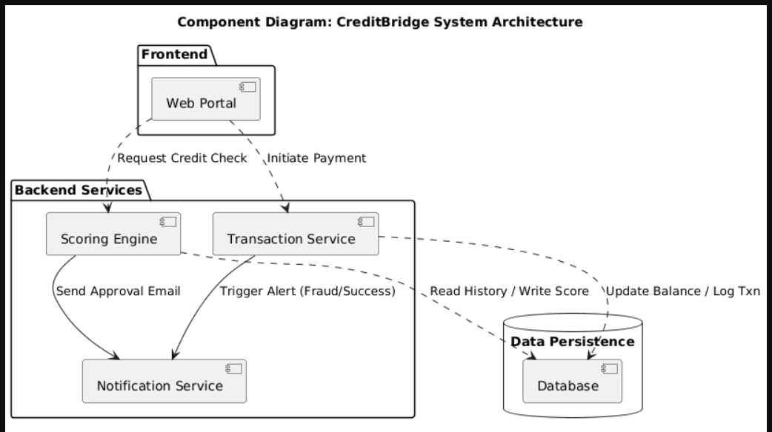
Identified Components:
- Web Portal: User Interface.
- Scoring Engine: Logic for calculating risk.
- Transaction Service: Handles payments.
- Database: Stores all records.
- Notification Service: Sends emails/SMS.

