36. Deployment Diagram Creation
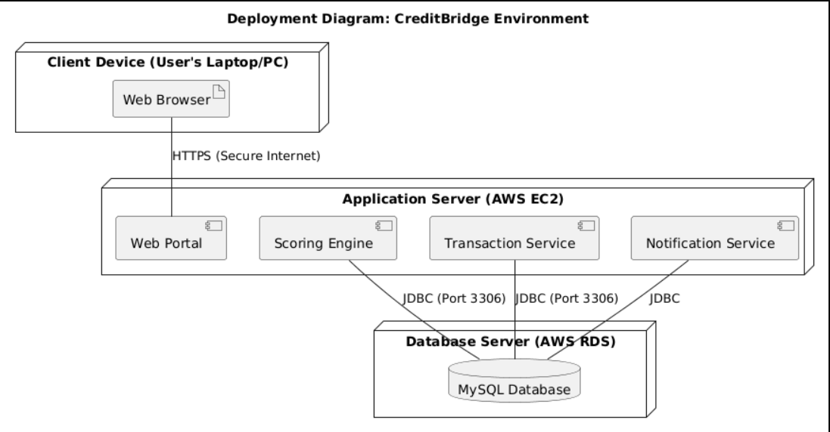
Deployment Environment:
- Client Node: User's Browser accessing the portal.
- Application Server: Hosts the Logic and API.
- Database Server: Securely stores encrypted data.
- Connection: HTTPS for security.

37. Design Document Creation
Design Decisions:
- Modular Architecture: The Scoring Engine is decoupled from the Transaction Service to allow updating risk logic without stopping payments.
- Security First: AES encryption used for storing Card Numbers in the Database.
Assumptions:
- Users have stable internet access.
- The Mock Credit Bureau API is available for testing.
Limitations:
- System does not handle real currency.
- Physical logistics are not handled.
Scalability:
- The architecture supports adding more "Merchant" nodes easily.
- Database can be scaled vertically to handle more transactions.
This design ensures CreditBridge is secure, robust, and meets the academic requirements for Software Engineering.

