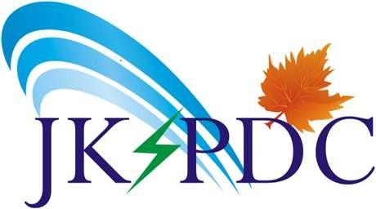

No: JKPDC/Tech/IT/
Dated: 03-09-2026

To
The DA Admin, NIC,
Civil Secretariat, Jammu & Kashmir.
Subject: Official Request for MAF codes / Password Reset for Government Email ID (agmmech1-jkspdc@jk.gov.in).
Reference: Email communication from DA Admin dated Jul 29, 2026.
Sir/Madam,
Apropos to the subject and reference cited above, this is to officially forward the request of Sh. Waseem Ahmad Wani, Assistant Executive Engineer, Mechanical Division, BHEP.
The officer has lost access to his official government email ID (agmmech1-jkspdc@jk.gov.in). The original password is not working, and he is unable to reset it because the "Gov one auth" mobile application is not functioning as expected.
As per the advisory from the helpdesk, the officer requires MAF codes or a complete reset of the authentication settings from the DA Admin to regain access.
The verified details of the officer are as follows:
- Name: Waseem Ahmad Wani
- Designation: Assistant Executive Engineer, Mechanical Division, BHEP
- Official Email ID: agmmech1-jkspdc@jk.gov.in
- Registered Mobile Number: 7006072843
It is a kind request to provide the necessary MAF codes or restore access at the earliest so that important government work is not hampered.
Yours faithfully

Deputy General Manager (E/IT)
Corporate Office, JKSPDC

Copy to the following for information:
1. PS to ED (E) for information of Executive Director (E) JKSPDC
2. PS to MD for information of Managing Director JKSPDC

JAMMU AND KASHMIR STATE POWER DEVELOPMENT CORPORATION LIMITED

(A Government of J&K Enterprises)
Reg. Office: Exhibition Ground, Srinagar, Kashmir J&K-190009. Phone.: 0194-2458005. Fax: 0194-2451665, 2483578.
Ashok Nagar, Satwari, Jammu J&K-180004. Phone.:0191-2430548, Fax: 0191-2435403
E-mail: md@jkspdcl.com
Website: www.jkspdc.co.in
CIN: U40101JK1995SGC001418

