Python Minor Project

**Problem Statement- Create A Countdown Timer Using Python**

**Features To Include**

**Reset/ Stop**

**Pause /Resume**

I Arbaz Hasan Roll no. 2004260 of ETC Branch KIIT University I have completed my ML Project ( Create A Countdown Timer Using Python ) Using Tkinter Library in Python with features Reset/Stop and Pause/Resume.

**Software required-**

Python 3.9

Visual studio

**Outputs-**

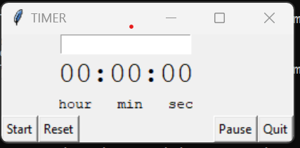

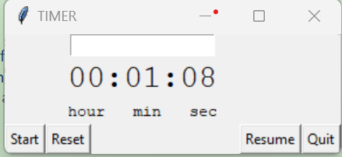

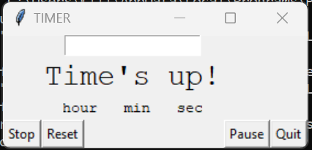

**Codes-**

import tkinter as tk

import tkinter.messagebox

import time

class Application(tk.Frame):

def __init__(self, master, *args, **kwargs):

tk.Frame.__init__(self, master, *args, **kwargs)

self.master = master

self.running = False

self.time = 0

self.hours = 0

self.mins = 0

self.secs = 0

self.build_interface()

def build_interface(self):

self.time_entry = tk.Entry(self)

self.time_entry.grid(row=0, column=1)

self.clock = tk.Label(self, text="00:00:00", font=("Courier", 20), width=10)

self.clock.grid(row=1, column=1, stick="S")

self.time_label = tk.Label(self, text="hour min sec", font=("Courier", 10), width=15)

self.time_label.grid(row=2, column=1, sticky="N")

self.power_button = tk.Button(self, text="Start", command=lambda: self.start())

self.power_button.grid(row=3, column=0, sticky="NE")

self.reset_button = tk.Button(self, text="Reset", command=lambda: self.reset())

self.reset_button.grid(row=3, column=1, sticky="NW")

self.quit_button = tk.Button(self, text="Quit", command=lambda: self.quit())

self.quit_button.grid(row=3, column=3, sticky="NE")

self.pause_button = tk.Button(self, text="Pause", command=lambda: self.pause())

self.pause_button.grid(row = 3,column=2, sticky = "NW")

self.master.bind("<Return>", lambda x: self.start())

self.time_entry.bind("<Key>", lambda v: self.update())

def calculate(self):

"""time calculation"""

self.hours = self.time // 3600

self.mins = (self.time // 60) % 60

self.secs = self.time % 60

return "{:02d}:{:02d}:{:02d}".format(self.hours, self.mins, self.secs)

def update(self):

"""validation"""

self.time = int(self.time_entry.get())

try:

self.clock.configure(text=self.calculate())

except:

self.clock.configure(text="00:00:00")

def timer(self):

"""display time"""

if self.running:

if self.time <= 0:

self.clock.configure(text="Time's up!")

else:

self.clock.configure(text=self.calculate())

self.time -= 1

self.after(1000, self.timer)

def start(self):

"""start timer"""

try:

self.time = int(self.time_entry.get())

self.time_entry.delete(0, 'end')

except:

self.time = self.time

self.power_button.configure(text="Stop", command=lambda: self.stop())

self.master.bind("<Return>", lambda x: self.stop())

self.running = True

self.timer()

def stop(self):

"""Stop timer"""

self.power_button.configure(text="Start", command=lambda: self.start())

self.master.bind("<Return>", lambda x: self.start())

self.running = False

def reset(self):

"""Resets the timer to 0."""

self.power_button.configure(text="Start", command=lambda: self.start())

self.master.bind("<Return>", lambda x: self.start())

self.running = False

self.time = 0

self.clock["text"] = "00:00:00"

def quit(self):

"""quit the window"""

if tk.messagebox.askokcancel("Quit", "Do you want to quit?"):

root.destroy()

def pause(self):

"""Pause timer"""

self.pause_button.configure(text="Resume", command=lambda: self.resume())

self.master.bind("<Return>", lambda x: self.resume())

if self.running == True:

self.running = False

self.timer()

def resume(self):

"""Resume timer"""

self.pause_button.configure(text="Pause", command=lambda: self.pause())

self.master.bind("<Return>", lambda x: self.pause())

if self.running == False:

self.running = True

self.timer()

if __name__ == "__main__":

"""Main loop of timer"""

root = tk.Tk()

root.title("TIMER")

Application(root).pack(side="top", fill="both", expand=True)

root.mainloop()

**Conclusion-**

Using Tkinter Library in Python with features Reset/Stop and Pause/Resume completed this project

**Signature-**

