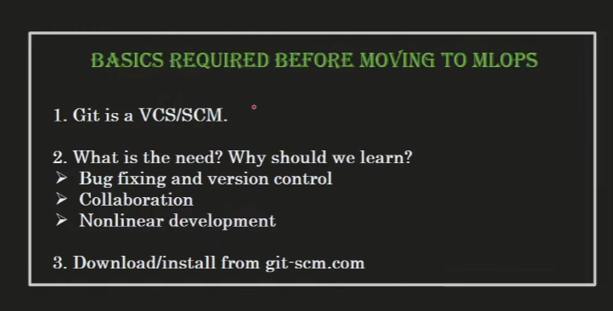

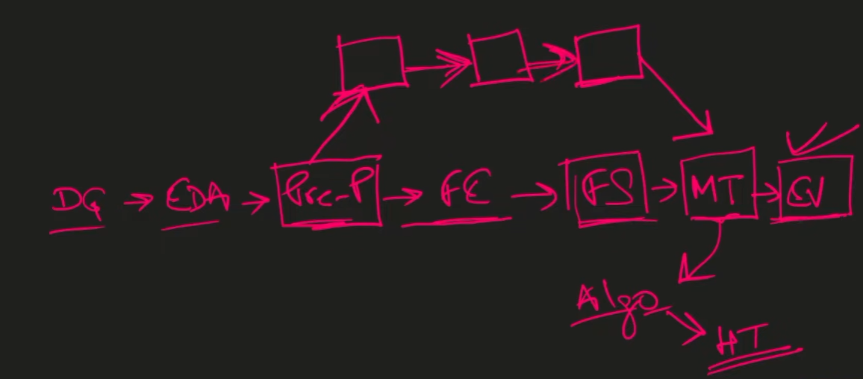
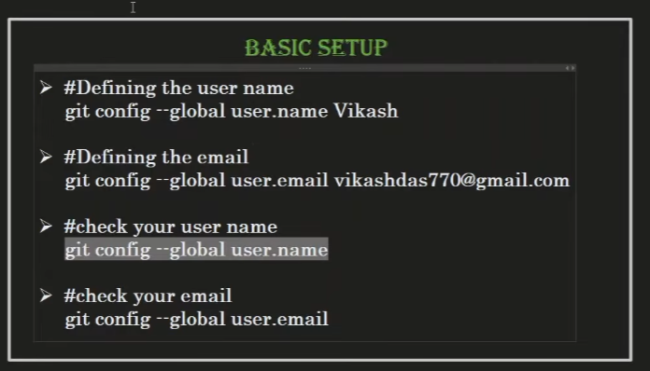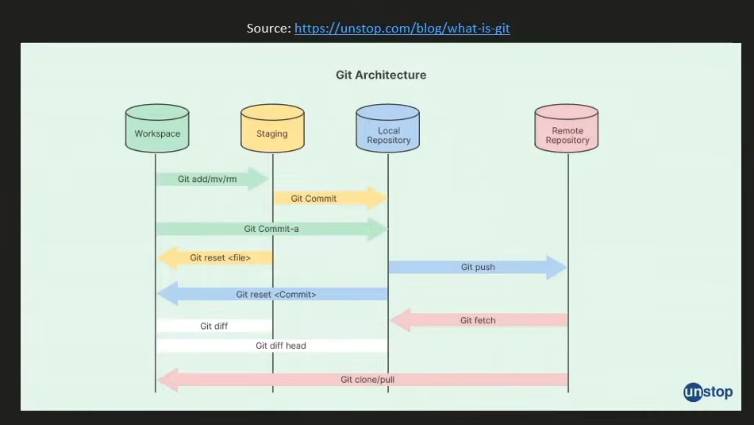
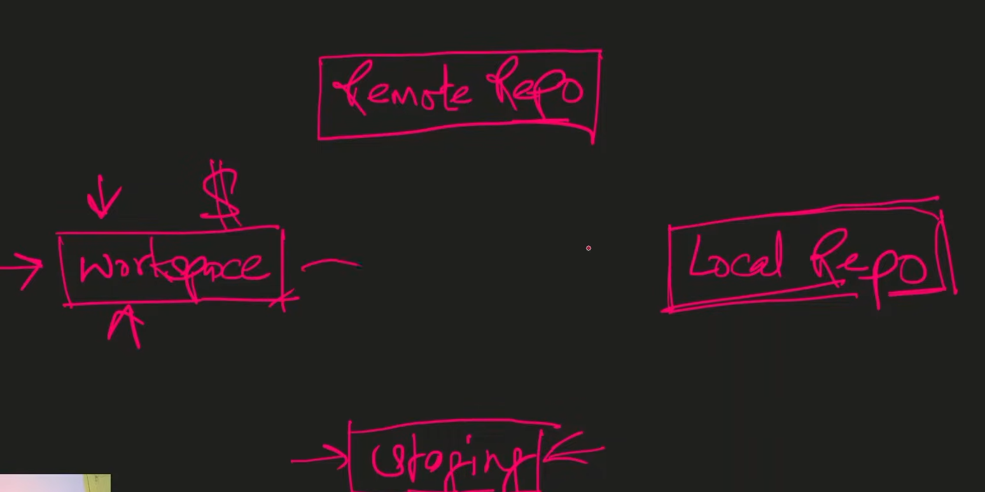
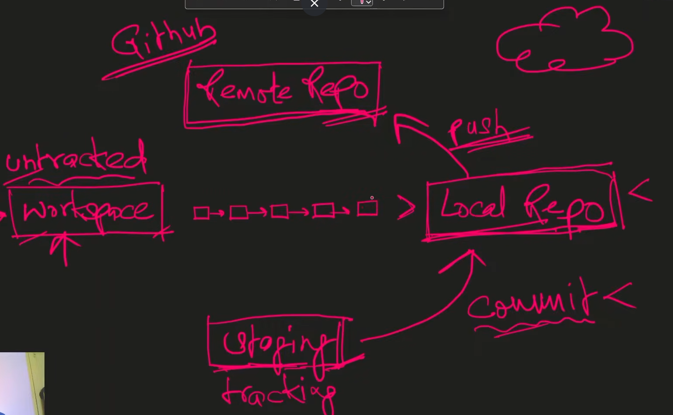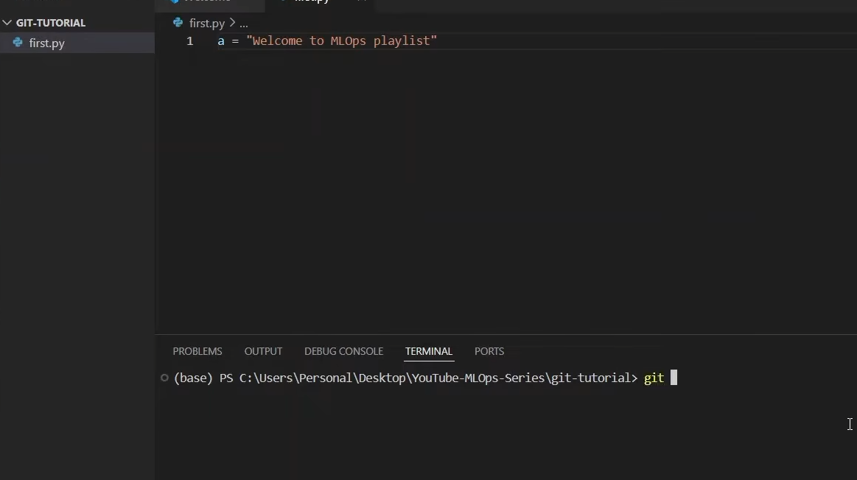

1.folder create
2. and open foolder in vs code
--> path location --> code .
CMD
git --version
git config --global user.name "John Doe"
git config --global user.email "john@example.com"
git clone url -->

git init (one time)
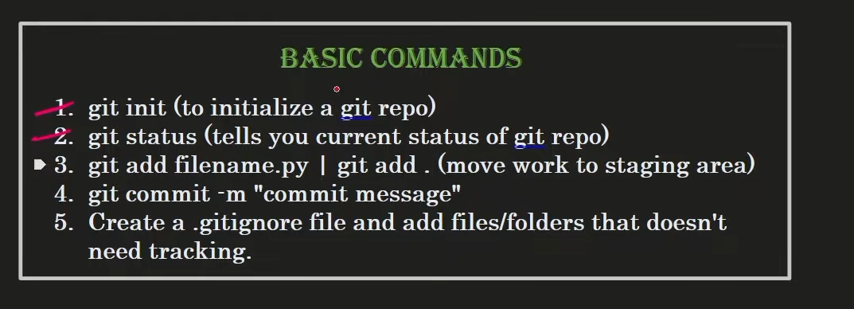
git status --> check for stageinig are
(red color -->not add)
git add * --> add all file in signle command
git add filename

git commit -m "add new file in 1st commit "

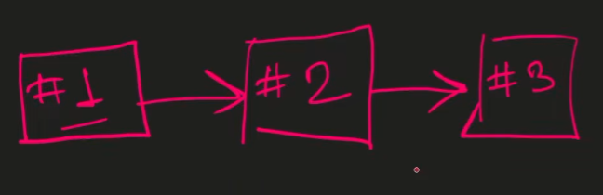create a 3 commits

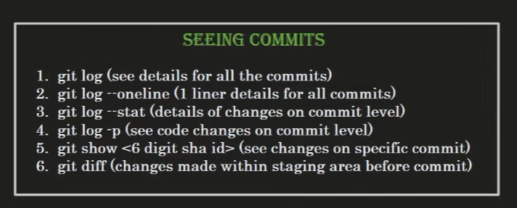

==============================

To switch or "roll back" to a previous commit ID in your current branch, you use the git checkout command followed by the specific commit hash (SHA ID).
Here is the process shown
- Find the Commit ID: Run git log --oneline to identify the hash of the version you want to move to
- Checkout the Commit: Execute git checkout
  - This will update your files to match the state of the project exactly as it was at that specific point in history.
- Return to the Branch: To go back to your most recent work on that branch, you can simply run git checkout (e.g., git checkout master) .
Note: When you checkout a specific commit ID, you enter a "detached HEAD" state. This allows you to inspect the code at that point in time without immediately modifying your current branch structure.

=================================
git log --> for show the all git commit
git log --oneline --> same as log in short form

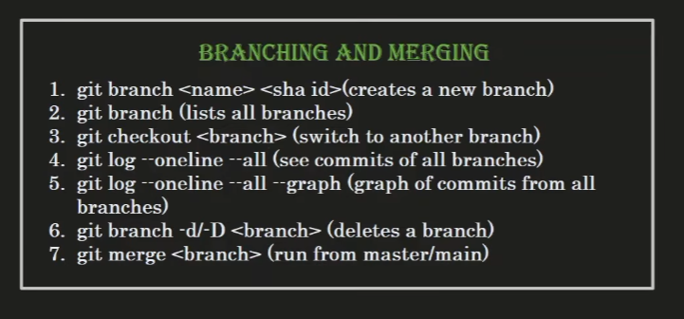

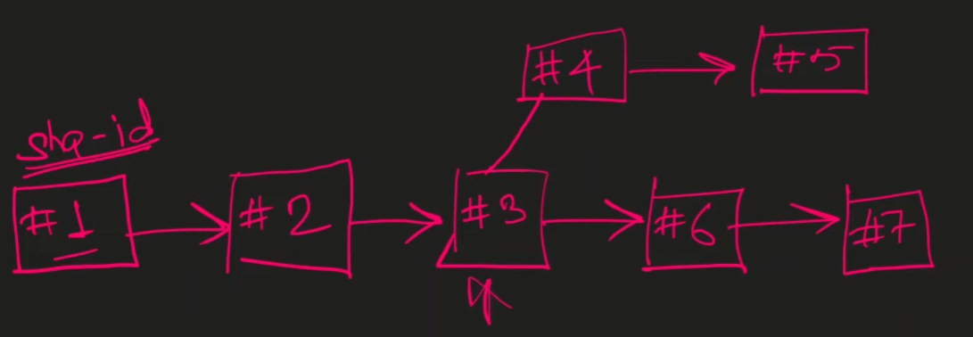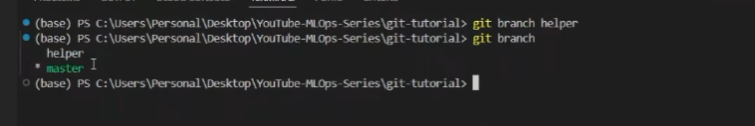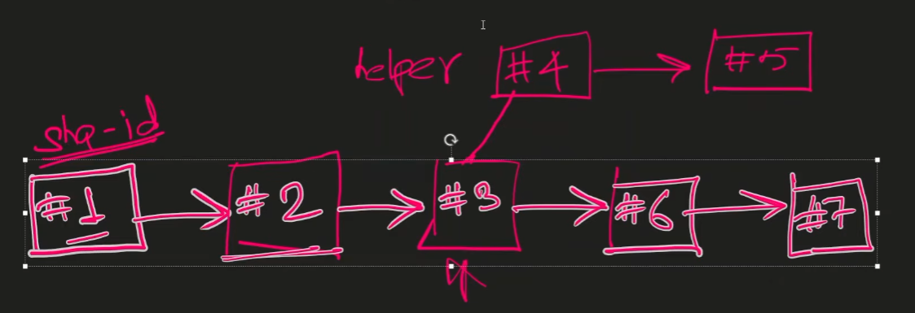

Merge
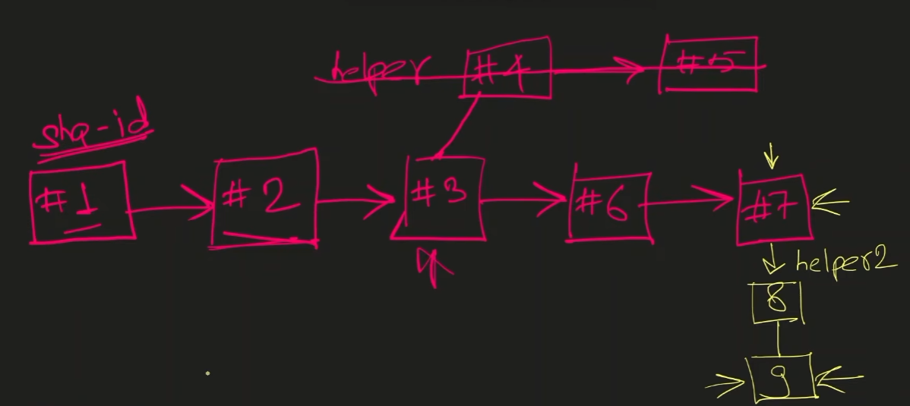
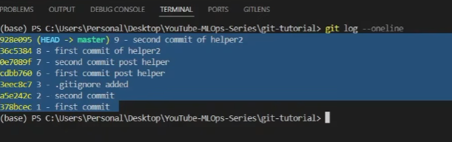

Complex conflit resolving
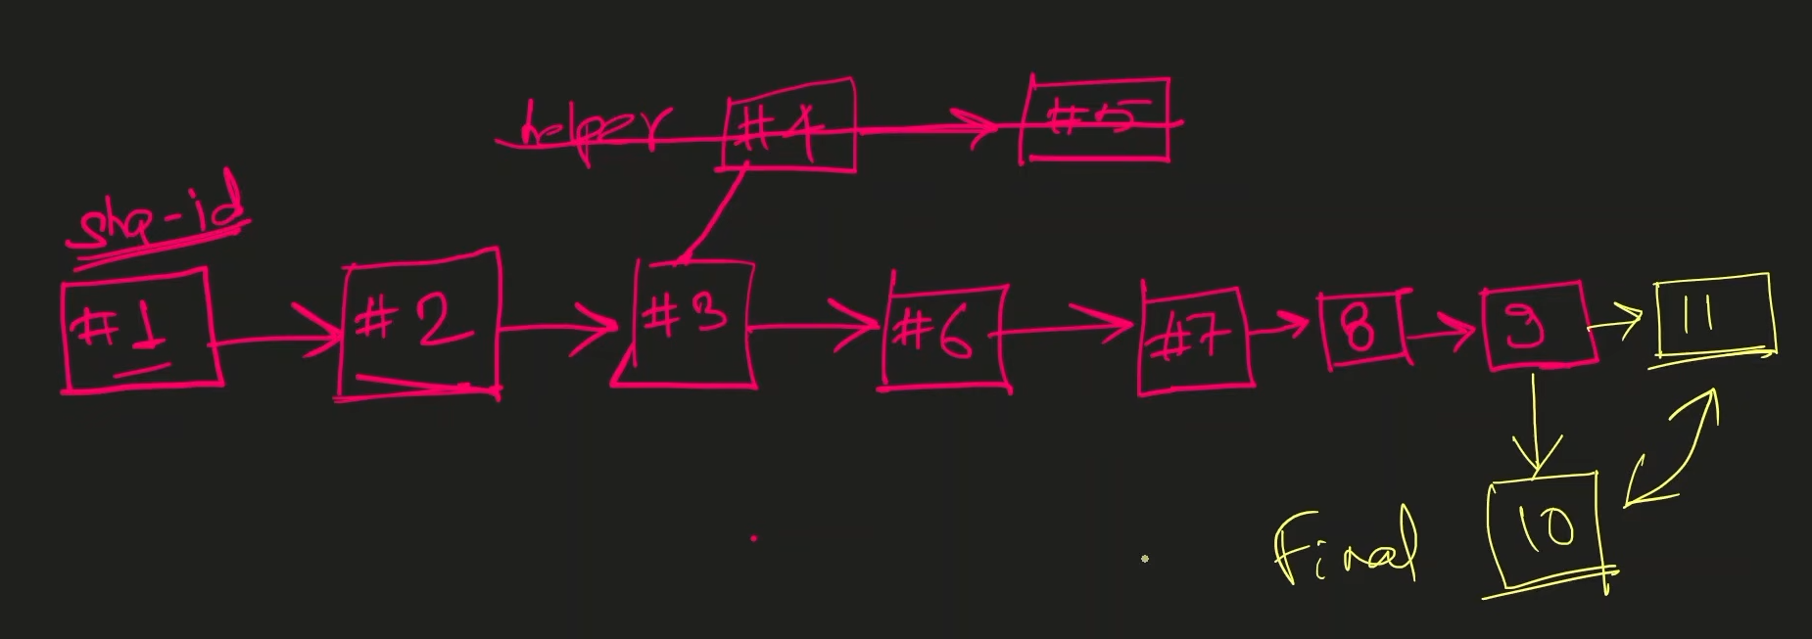

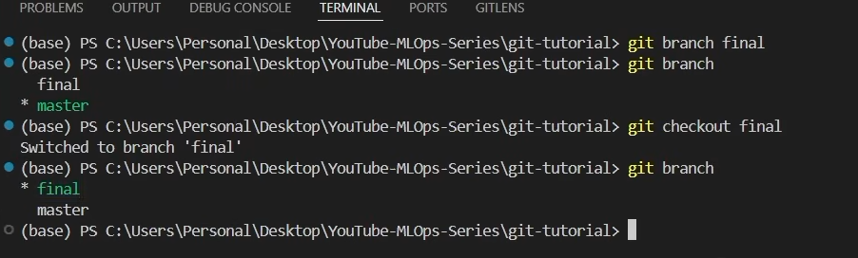
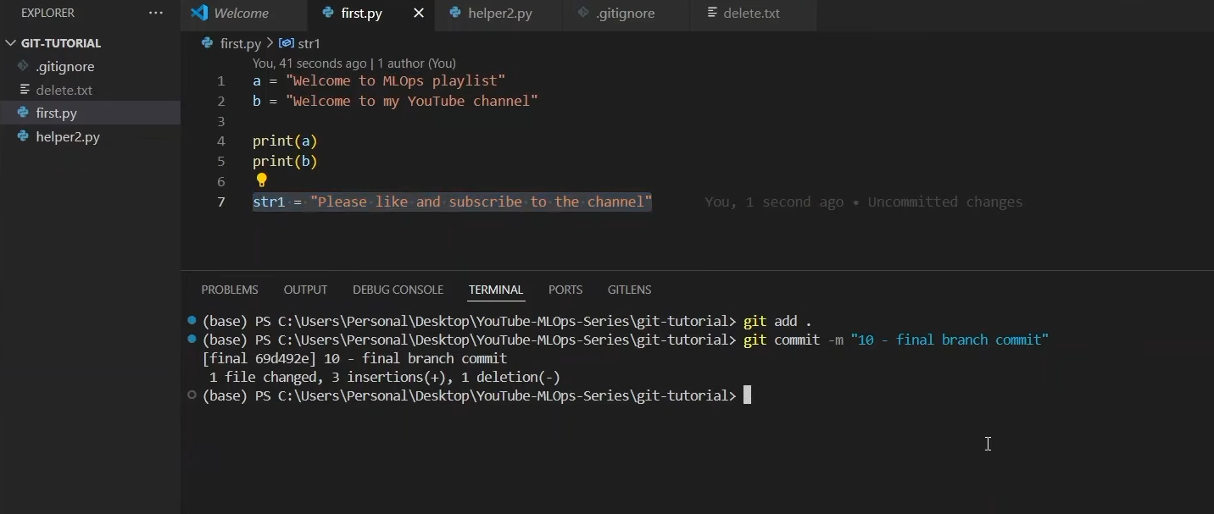
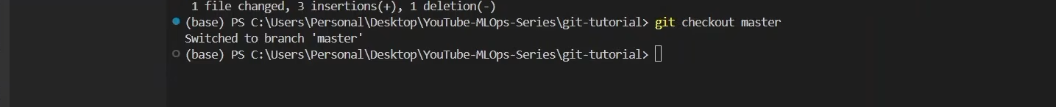
Change same str
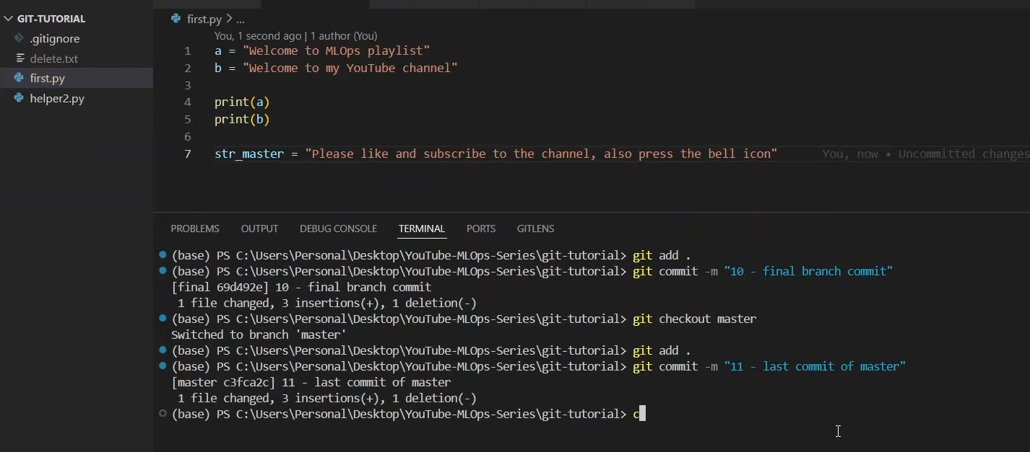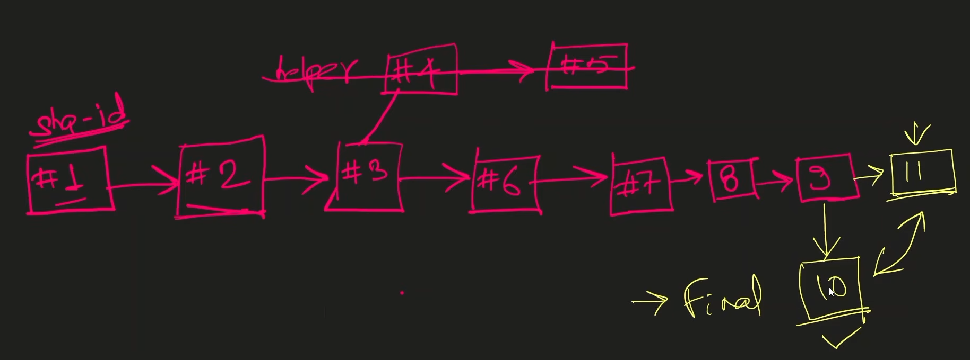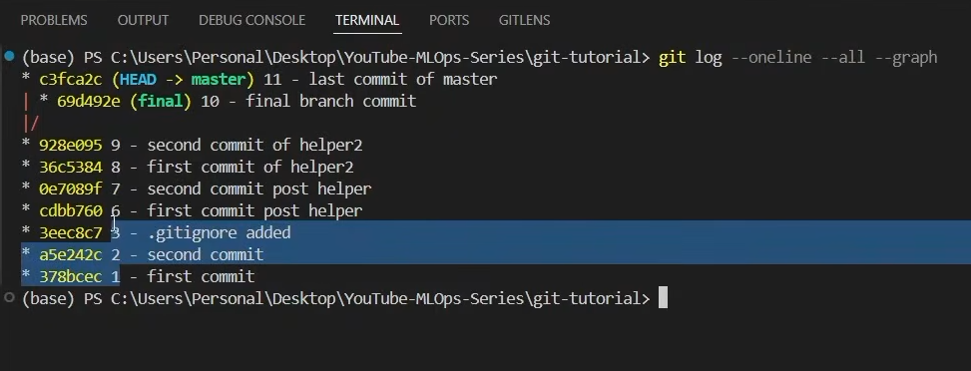
MERGE THEN SHOW THE CONFLIT
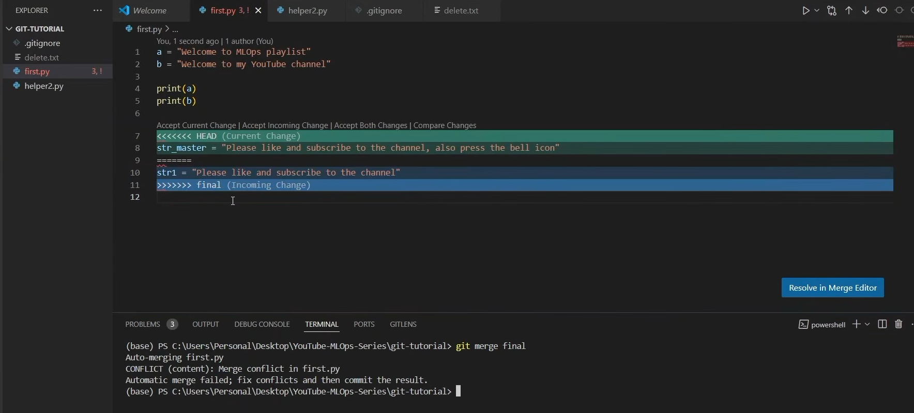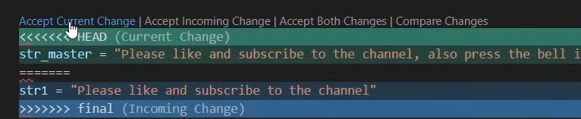
Ctrl+z 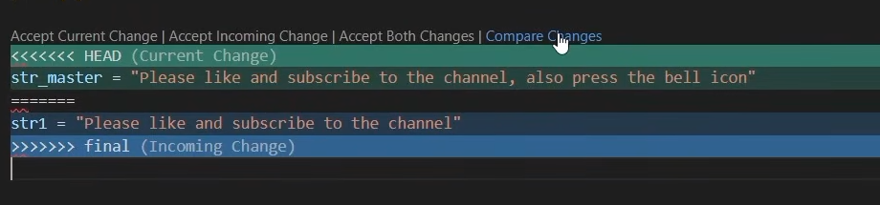
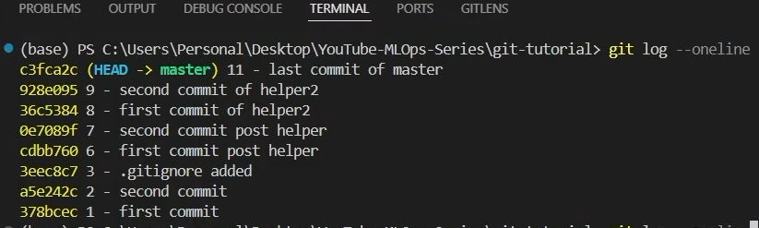

Resolve the conflit and delete commit 10 automatically

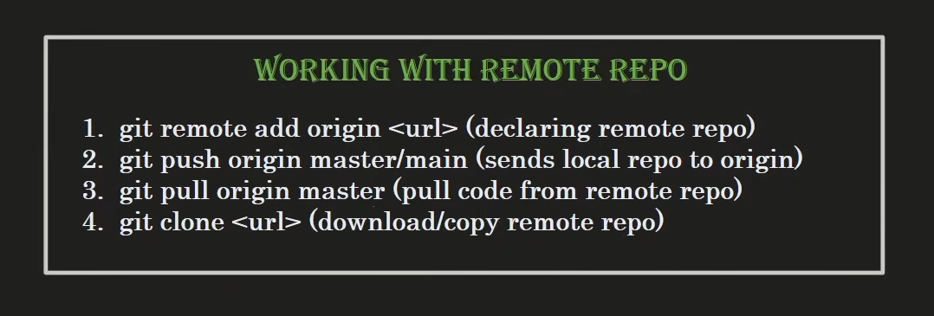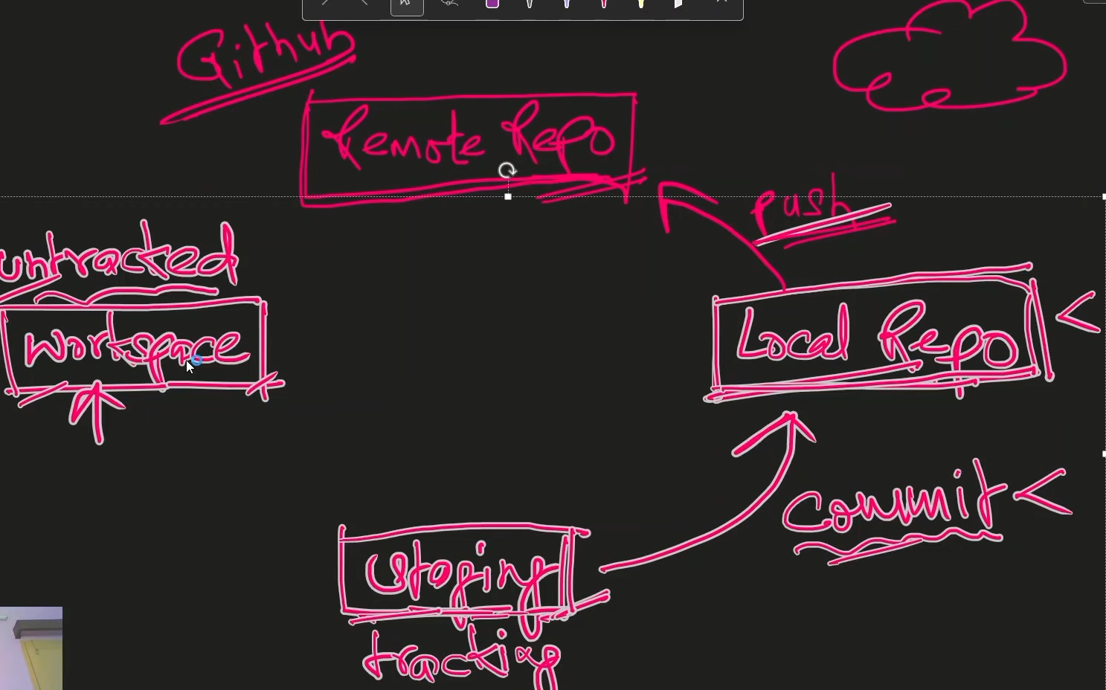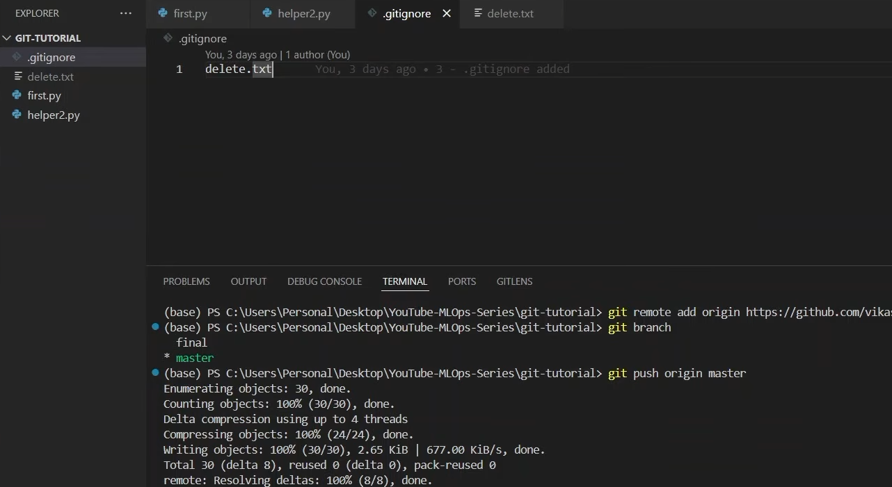
git remote add origin https://github.com/shahil04/devops_git_class.git
(one time add)

git push -u origin master

===============================
================================
Push the Other branch to GitHub Like backend branch:
bash
git push -u origin your-new-branch-name

The -u (upstream) flag ensures that future git push or git pull commands run smoothly while you are on this branch



