**20.GIVING THE FOLLOWING DATABASE WITH 5 TRANSACTIONS AND A MINIMUM SUPPORT THRESHOLD OF 60% AND A MINIMUM CONFIDENCE THRESHOLD OF 80%, FIND ALL FREQUENT ITEMSETS USING (A) APRIORI AND (B) FP-GROWTH.**

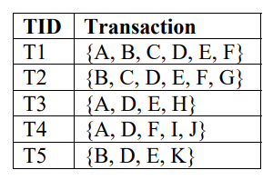

**Output:**

