**21.THE 'DATABASE' BELOW HAS NINE TRANSACTIONS. WHAT ASSOCIATION RULES CAN BE FOUND IN THIS SET, IF THE**

**MINIMUM SUPPORT (I.E COVERAGE) IS 60% AND THE MINIMUM CONFIDENCE (I.E. ACCURACY) IS 80% ?**

**TRANS_ID ITEMLIST**

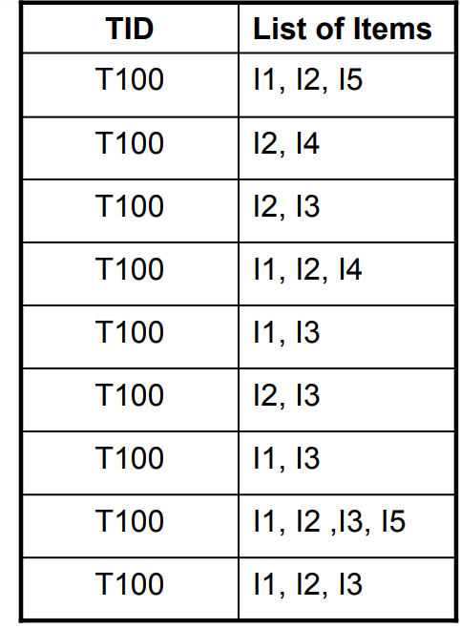

**OUTPUT:**

