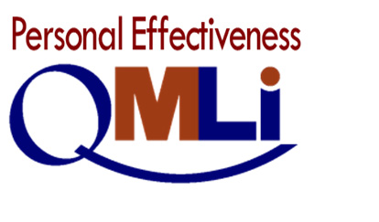

1

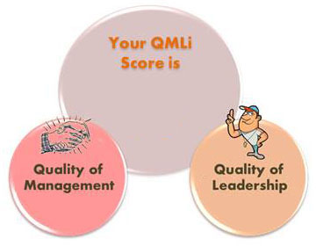

90

75

85

Prepared for: hasan

Out-of-class Survey

In-class Survey Through

QMLi Best Practices Survey Taken on: 2022-11-25

QMLi Personal Effectiveness Report Code: 4e987

From the Online Registrar, AndrewTani Research The Personal Effectiveness Report uses the results of the Orbex Quality of Management & Leadership Survey SELF to produce Quality of Management and Quality of Leadership scores that pinpoint levels of individual compliance with each of the 10 PCDCA Key Management Processes to impact order and 5 PCDCA Leadership Objectives to impact the effort that people exert to achieve organizational goals.

hasan

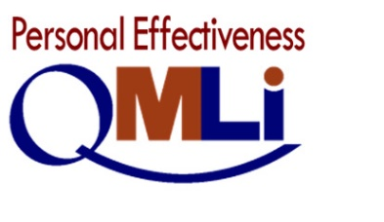

90

91-100

76-90

61-75

40-60

0-39

RATING

SCALE

Excellent

Very good

Good

Fair

Poor

2

85

75

2022-12-06

Dear hasan,

Skor QMLi secara keseluruhan berdasarkan umpan balik yang diolah berdasarkan survei, menurut persepsi:

anggota team anda

QMLi Quality of Quality of

Management Leadership

Good Fair Fair



diri anda sendiri

QMLi Quality of Quality of

Management Leadership

Good Good Good



3

Dalam gaya *manage by head*, Best Practice yang **paling penting** menurut anggota team Anda adalah:

|  |  |  |  |
| --- | --- | --- | --- |
| Key Management Process | Best Practice | | Skor | Peringkat |
|  |  | ${skor_head_tim1} | ${rank_ head_tim1} |
|  |  | ${skor_ head_tim2} | ${rank_ head_tim2} |
|  |  | ${skor_ head_tim3} | ${rank_ head_tim3} |
|  |  | ${skor_ head_tim4} | ${rank_ head_tim4} |
|  |  | ${skor_ head_tim5} | ${rank_ head_tim5} |

Dalam gaya *lead by heart*, Best Practice yang **paling penting** menurut anggota team Anda adalah:

|  |  |  |  |
| --- | --- | --- | --- |
| Key Management Process | Best Practice | | Skor | Peringkat |
|  |  | ${skor_ heart_tim1} | ${rank_heart_tim1} |
|  |  | ${skor_ heart_tim2} | ${rank_tim2} |
|  |  | ${skor_ heart_tim3} | ${rank_ heart_tim3} |
|  |  | ${skor_ heart_tim4} | ${rank_ heart_tim4} |
|  |  | ${skor_ heart_tim5} | ${rank_ heart_tim5} |

hasan

42

hasan

42

hasan

5

hasan

6

hasan

7

hasan

hasan