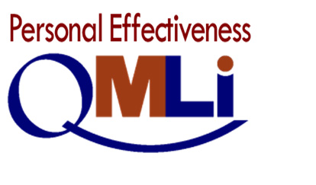

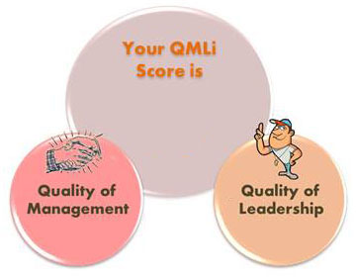

Prepared for: arbi

Out-of-class Survey

In-class Survey Through

QMLi Best Practices Survey Taken on: ${date}

QMLi Personal Effectiveness Report Code: ${report_code}

From the Online Registrar, AndrewTani Research The Personal Effectiveness Report uses the results of the Orbex Quality of Management & Leadership Survey SELF to produce Quality of Management and Quality of Leadership scores that pinpoint levels of individual compliance with each of the 10 PCDCA Key Management Processes to impact order and 5 PCDCA Leadership Objectives to impact the effort that people exert to achieve organizational goals.