# **Design and Implementation of IS: Assignment Bonus**

# **UML**

**System Name:** 

Perfect Trip System

**Semester:** A 2024

Askevich

**Submitted by Group:** 

208642868_316495126

# **Assumptions:**

This is an optional section for essential assumptions; Please provide concise information aimed at clarifying key aspects for the exercise evaluator; Ensure that the content does not replicate details already presented in the system description narrative.

# **We are using the solutions use case, class and state chart diagrams and not our original one to make it closer to the wanted implementation.**

# **In order to show the exporting we put it in the vp of content panel although it happens automatically.**

# **In ex 3 the updated instructions were to export to a word file, we did in this ex the same.**

# **We will assume that a trip creator can invite to the trip only members of the "perfect trip system" because we cant send an email throw the current system.**

# **1.1.a. The Final Use Case Diagram:**

Verify readability of the figure.

Our original use case diagram:

**1.1.b. The Final Descriptions of the Use Cases:**

Make sure the descriptions are short and concisely describe the responsibilities of the various use cases.

a. Retrieve distances between places: This use case is responsible for retrieving the distances between different places from Google Maps.

b. Import places: This use case is responsible for importing places from the MZ system into the Perfect Trip system.

c. Manage kitchen styles: This use case is responsible for maintaining the list of kitchen styles and associating them with restaurants.

d. Invite friends: This use case is responsible for sending invitations to friends to join the Perfect Trip system.

e. Add/Update a review: This use case is responsible for adding or updating a review for a place.

f. Generate recommendations: This use case is responsible for generating personalized recommendations for places to visit based on a user's preferences.

g. Trip management: This use case is responsible for managing a trip's itinerary, including adding and removing places, and tracking the trip's progress.

h. Receiving the registration confirmation email: This use case is responsible for sending a registration confirmation email to new users once their account has been created.

i. Registration: This use case is responsible for creating a new user account and storing the user's information in the system.

j. Browse places and recommendations: This use case displays a list of places and recommendations to users, along with their details and ratings.

k. Search for places: This use case is responsible for searching for places based on a user's query and returning a list of matching results.

# **1.1.c. UML Class Diagram:**

This section will not be checked again and is intended to understand the context.

**2.1 The Final Statechart Diagram:**

Verify readability of the figure.

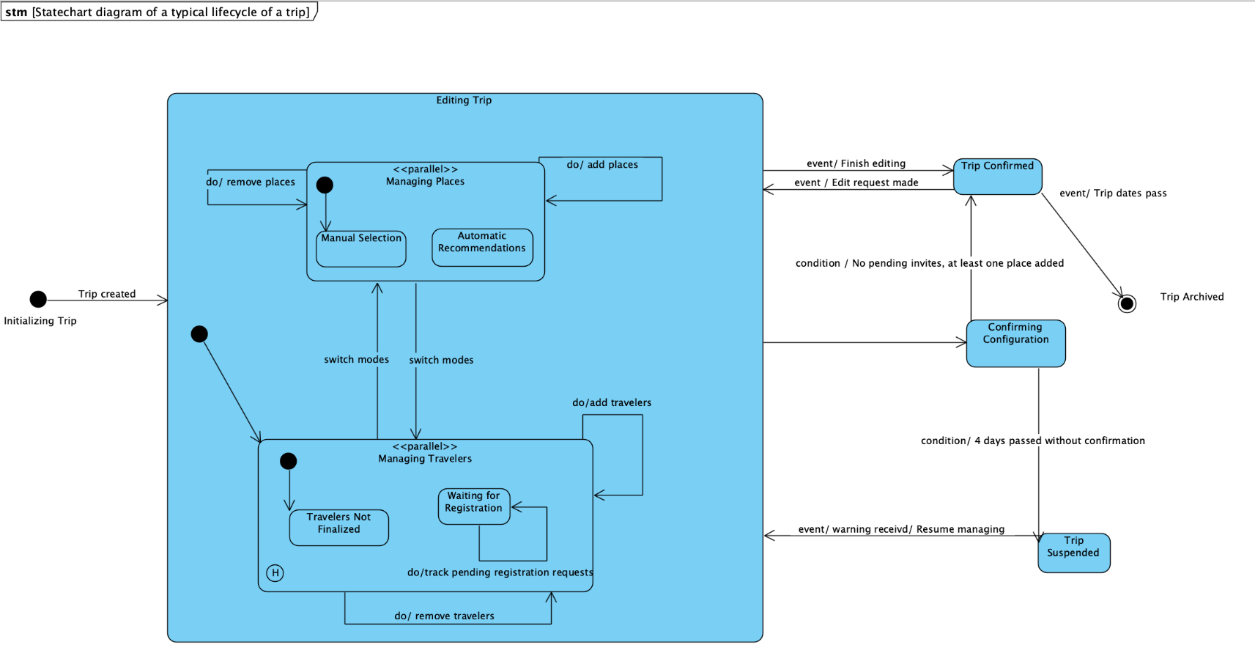**Model:**

The formal solution:

**Description of the final model:**

|  |  |
| --- | --- |
| **Event / Variable** | **Description** |
| **Trip created (Initializing Trip)** | A trip is initiated; unique ID and dates are set. |
| **Managing Travelers** | The creator invites members, handles registration, and tracks requests. |
| **Waiting for Registration** | Awaiting confirmation of invited travelers' registration. |
| **Managing Places (Manual Selection)** | Creator adds or removes places manually. |
| **Automatic Recommendations** | System suggests places. |
| **Add Places** | Places are added to the trip by the creator. |
| **Remove Places** | Unwanted places are removed from the trip plan. |
| **Switch Modes** | Toggling between manual selection and automatic recommendations. |
| **Add Travelers** | New travelers are added to the trip. |
| **Remove Travelers** | Travelers are removed from the trip by the creator. |
| **Editing Trip** | Changes made to travelers or places before trip confirmation. |
| **Trip Confirmed** | Finalized state when all travelers are registered, and places are chosen. |
| **Trip Suspended** | Temporary state if trip is not confirmed within four days. |
| **Trip Archived** | After trip dates pass, the trip is archived for review. |
| **Trip Canceled** | The trip is canceled by the user at any point before confirmation. |
| **Resume Managing** | Trip managing is resumed following a suspension or edit request. |

**2.2 Design Class Diagram of** search for the next place

Verify readability of the figure. For each diagram, the relevant screenshots must be presented (the titles can be reproduced if needed).

**3.1.a Design Class Diagram of** Generation of the place recommendation report

Verify readability of the figure. For each diagram, the relevant screenshots must be presented (the titles can be reproduced if needed).

**Screenshot:**

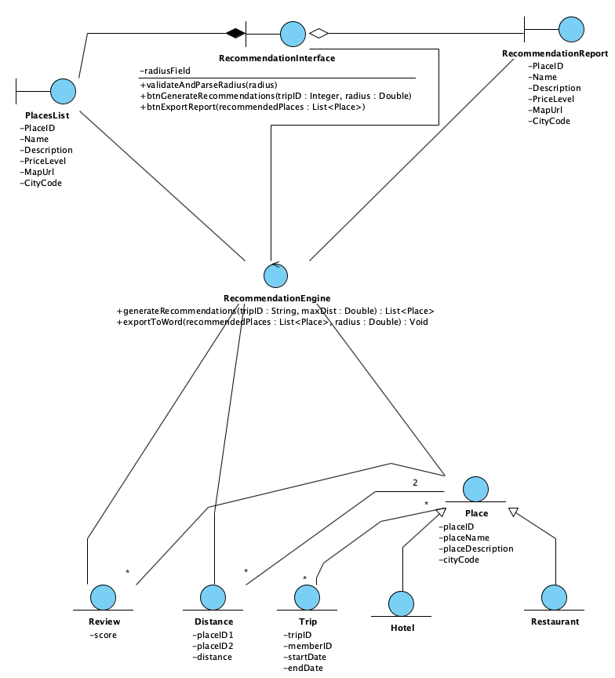

**3.1.b Sequence Diagram of :**

Generation of the place recommendation report

Verify readability of the figure.

