- Explain regression
Improved prompt: Explain regression in simple terms for a beginner in data analytics. Include a real-life example
Why it’s stronger: it asks for a clear explanation and an example to make learning easier.
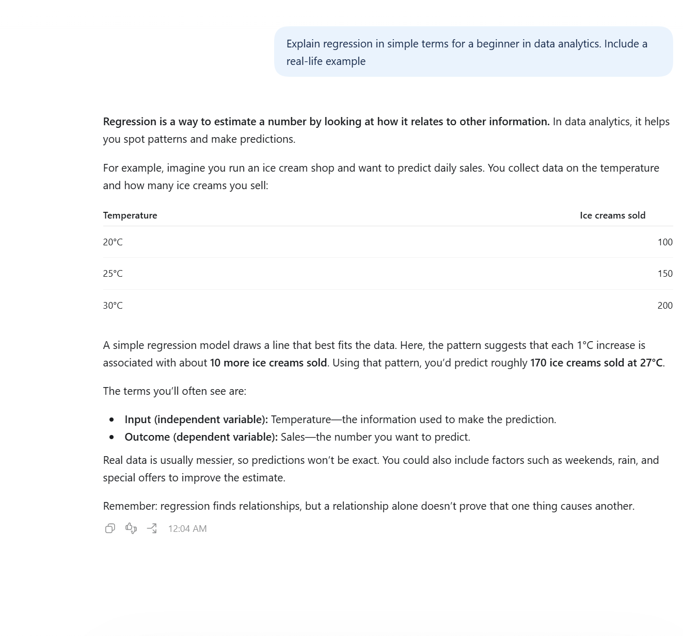
- Help me understand SQL
Improved prompt: Explain SQL for a beginner and show three basic SQL commands with examples.
Why it’s stronger: It gives specific instructions and asks for useful examples.
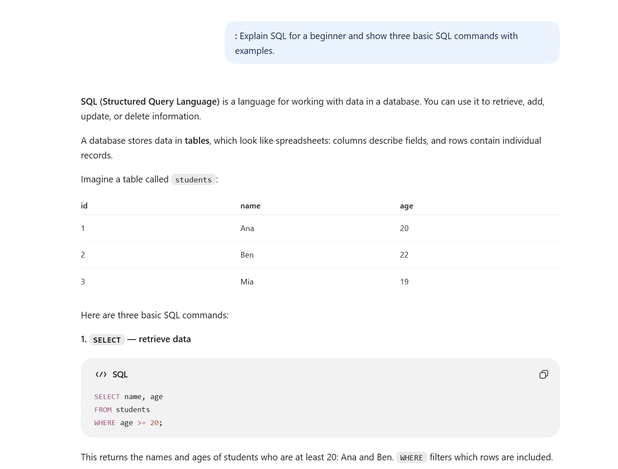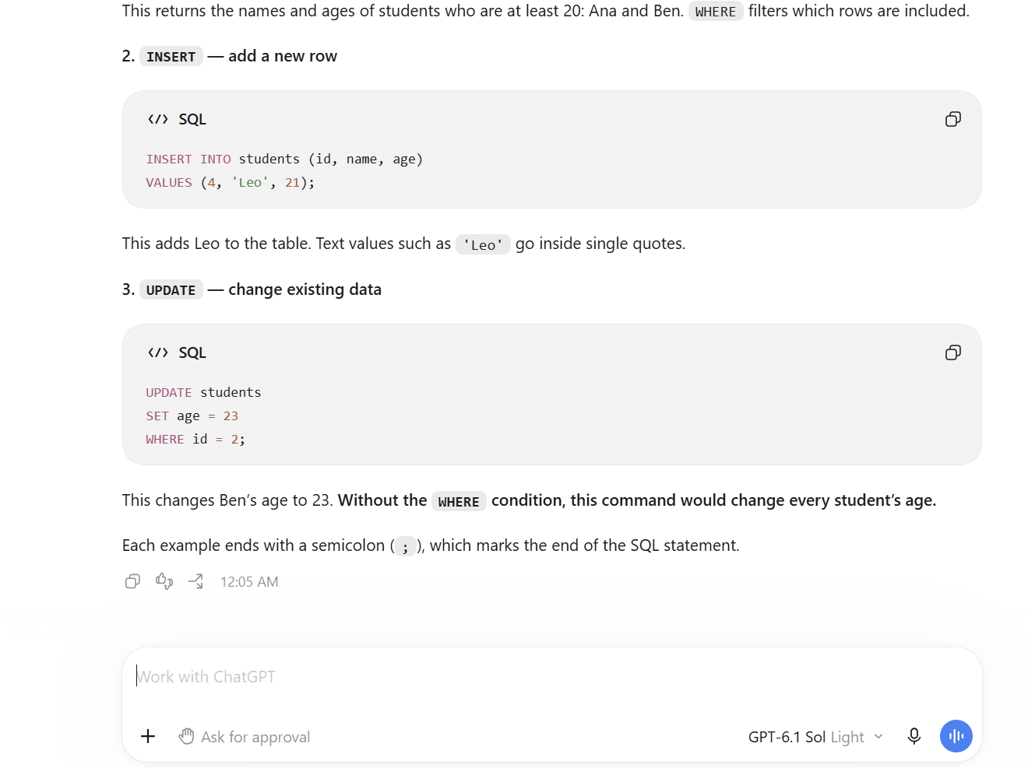
- Create a dataset
Improved prompt: Create a table of 10 employees with their names, ages, departments, and salaries.
Why it’s stronger: It clearly explains what information the dataset should include.
