Weekly Progress Report
  - Date: March 24, 2026
  - Author: Arbi Golemi

Hill Climbing Analysis

Introduction
The problem of protein structure prediction, even within simplified abstract frameworks such as the 2D Hydrophobic-Polar (HP) lattice model, is known to be computationally intractable (NP-hard). As the length of an amino acid sequence increases, the number of possible valid spatial conformations explodes exponentially, making absolute exhaustive search methods impossible. To navigate this combinatorial complexity effectively, heuristic local search algorithms such as Hill Climbing are widely employed.

Hill Climbing is an iterative optimization algorithm that continuously seeks to improve a given solution. It begins with an initial valid state—in this case, an unfolded or stretched protein sequence on a 2D grid. At each iteration, the algorithm generates a new "neighboring" state by applying a discrete modification to the current configuration. In the context of the lattice HP model, this is achieved through random "pivot moves," where a segment of the protein chain is rotated (e.g., by 90°, -90°, or 180°) while strictly ensuring the resulting conformation remains self-avoiding without any overlapping amino acids.

To avoid getting permanently trapped in immediate local optimal, a common limitation of classical Steepest Ascent Hill Climbing; a Stochastic Hill Climbing approach with plateau-walking capabilities is utilized for this project. Instead of generating all possible neighbors, the algorithm evaluates a single, randomly generated valid pivot move at each step. If the new conformational state presents a lower or equal energy level compared to the current state, the move is accepted. Allowing the algorithm to accept moves that yield equal energy (plateaus) is a critical feature for lattice-based protein folding; it grants the structure the flexibility to shift laterally across flat areas of the energy landscape until it organically discovers a deeper energetic well. Through thousands of rapid, iterative steps, this stochastic refinement process effectively mirrors the natural folding trajectory, actively pushing the structure toward its lowest energy, natively folded state.

The Algorithm

Algorithm: Stochastic Hill Climbing with Pivot Moves
Input:
S: Amino acid sequence in HP format (e.g., "HPHHP...")
N: Maximum number of iterations
Output:
Best_State: The 2D self-avoiding conformation with lowest free energy
Best_Energy: The lowest energy achieved

Initialize Current_State as a straight, unfolded line on a 2D lattice.

- Current_Energy ← Calculate_Energy(Current_State)
- Best_State ← Current_State
- Best_Energy ← Current_Energy

- For iteration = 1 to N do:
- Pivot_Index ← Random integer between 1 and length(S) - 2
- Rotation_Angle ← Random choice from {90°, -90°, 180°}

- New_State ← Apply_Rotation(Current_State, Pivot_Index, Rotation_Angle)

- If Is_Self_Avoiding(New_State) is False then:
- Continue to next iteration

- New_Energy ← Calculate_Energy(New_State)

- If New_Energy <= Current_Energy then:
- Current_State ← New_State
- Current_Energy ← New_Energy

- If Current_Energy < Best_Energy then:
- Best_State ← Current_State
- Best_Energy ← Current_Energy

- Return Best_State, Best_Energy

This algorithm is a stochastic optimization method used to find a low-energy 2D conformation of a protein sequence represented in the HP (Hydrophobic-Polar) model. The goal is to minimize the free energy of the structure while ensuring that the conformation remains self-avoiding (i.e., no two amino acids occupy the same position).

The algorithm begins by constructing an initial solution and the Current_State is initialized as a straight, unfolded chain placed on a 2D lattice. The energy of this configuration is computed using a function Calculate Energy that will be shown after.
This initial configuration is also stored as the Best_State, and its energy is saved as Best_Energy.

The algorithm then performs a loop for a maximum of N iterations. At each iteration:

- Random Pivot Selection
A random position in the sequence (excluding the endpoints) is selected as the pivot point.

- Random Rotation.
A random rotation angle is chosen from the set {90°, -90°, 180°}. This rotation will be applied to one part of the chain around the pivot.

- Generate New State
A new conformation (New_State) is generated by applying the rotation to the current structure.

- Validity Check (Self-Avoidance)
The algorithm verifies whether the new conformation is valid:
- If the structure is not self-avoiding (i.e., overlaps occur), it is discarded and the algorithm proceeds to the next iteration.

- Energy Evaluation
If the new conformation is valid, its energy (New_Energy) is computed.

- Acceptance Criterion (Hill Climbing Rule)
The new state is accepted only if it does not worsen the energy:
- If New_Energy ≤ Current_Energy, the new state replaces the current one.

- Update Best Solution
If the accepted state has a strictly lower energy than the best found so far:
- Update Best_State and Best_Energy accordingly.

And it terminates after completing all the iterations and returns Best_State the best conformation found (lowest energy) and Best_Energy the corresponding minimum energy value

For calculating the energy:
Algorithm: Calculate_Energy
Input:
State: A sequence of 2D grid coordinates [(x1,y1), (x2,y2), ..., (xn,yn)]
S: Amino acid sequence in HP format (e.g., "HPHHP...")
Output:
E: The thermodynamic free energy of the given conformation

- E_Contacts ← 0
- Create a hash map Pos_Map linking each coordinate in State to its sequence index i
- For i = 1 to length(State) do:
- If S[i] is 'H' (Hydrophobic) then:
- Current_Position ← State[i]

- // Define the 4 von Neumann lattice directions (Up, Right, Down, Left)
- Directions ← { (0,1), (1,0), (0,-1), (-1,0) }

- For each (dx, dy) in Directions do:
- Adjacent_Position ← Current_Position + (dx, dy)

- If Adjacent_Position exists in Pos_Map then:
- j ← Pos_Map[Adjacent_Position]

- If absolute_value(i - j) > 1 and S[j] is 'H' then:
- E_Contacts ← E_Contacts + 1
- E ← -(E_Contacts / 2)
- Return E

The Calculate_Energy function calculates the stability of the protein structure on the 2D grid. Its goal is to count the total number of valid Hydrophobic-Hydrophobic (H-H) contacts to determine the final free energy.

- Mapping the Grid (Lines 1-2): First, the algorithm creates a map (Pos_Map) that connects every X,Y coordinate on the grid to its specific amino acid index i in the sequence. This makes it very fast to check if a grid cell is occupied or empty.

- Checking for Neighbors (Lines 3-11): The algorithm loops through the entire protein. When it finds a Hydrophobic amino acid ('H' at Line 4), it looks at the 4 adjacent cells around it (Up, Right, Down, Left). If it finds another part of the protein in one of those cells, it notes down its sequence index j (Line 11).

- Identifying Valid Contacts (Lines 12-13): To be considered a true H-H interaction, two rules must be met at Line 12:
- absolute_value(i - j) > 1: The two interacting amino acids must not be directly connected in the main sequence (they cannot be neighbors in the chain).
- S[j] is 'H': The second amino acid must also be Hydrophobic. If both conditions are true, the contact counter goes up by 1 (Line 13).

- The Final Formula -(E_Contacts / 2) (Line 14): Because the algorithm checks every single amino acid one by one, every contact is accidentally counted twice (for example, it counts the contact from amino acid 3 looking at 8, and later counts it again from 8 looking at 3). We divide by 2 to fix this and get the real number of unique contacts.

Finally, we apply a negative sign because protein folding is fundamentally an energy minimization problem. In physics, a more stable protein has a lower (negative) free energy. Therefore, maximizing the H-H contacts directly results in a lower, more negative energy score for the algorithm to find.

Test and Results
To evaluate the practical effectiveness and performance of the implemented Stochastic Hill Climbing algorithm, a comprehensive testing framework was designed. The algorithm was tested against a custom dataset of 10 different protein sequences of progressively increasing lengths, ranging from a minimal chain of 6 amino acids to a more complex structure of 42 amino acids. For each protein, the sequence was first translated into its corresponding Hydrophobic-Polar (HP) string. To assess how the computational budget affects the folding accuracy and execution speed, the algorithm was executed over four distinct iteration thresholds for every sequence:
- 1,000 iterations (Quick superficial search)
- 10,000 iterations
- 50,000 iterations
- 100,000 iterations (Deep prolonged search)

During each test run, two primary metrics were recorded:

- Computational Time (Seconds): To measure the algorithmic efficiency and scalability as the chain length and iteration count restrict the temporal budget.
- Best Energy: To evaluate the thermodynamic success of the simulation, strictly counting the non-covalent H-H contacts achieved (where a more negative value indicates a more stable, natively folded structure).

As expected, the computational time scales predictably in relation to both the chain length and the number of iterations, yet remains highly efficient (peaking at merely ~0.69 seconds for 100,000 iterations on a 42-AA chain).

More importantly, the energy results highlight the non-deterministic nature of the algorithm. Because each iteration threshold represents an independent baseline run reliant on random pivot moves, we observe that while an increased computational budget (e.g., 100,000 iterations) logically guarantees an extensive exploration of the energy landscape, it does not strictly guarantee the absolute best result on every single run due to the persistent threat of deep local minima (as seen in Protein 9 and 10, where the 50,000 iteration runs sporadically outperformed the 100,000 runs). The full breakdown of the recorded data is presented below.

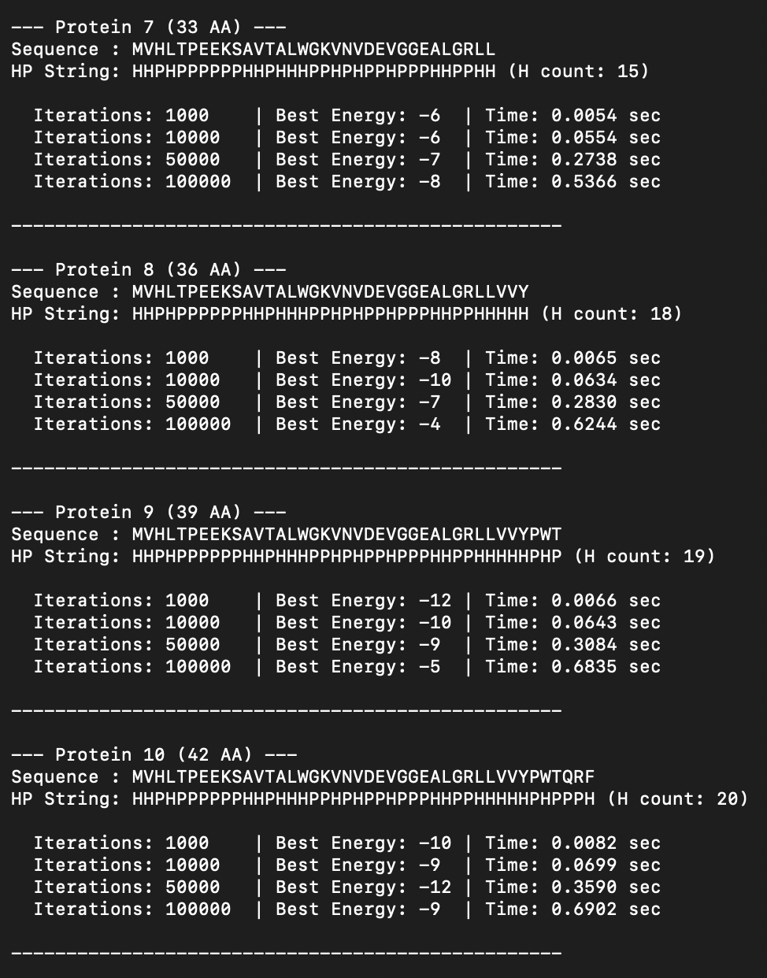
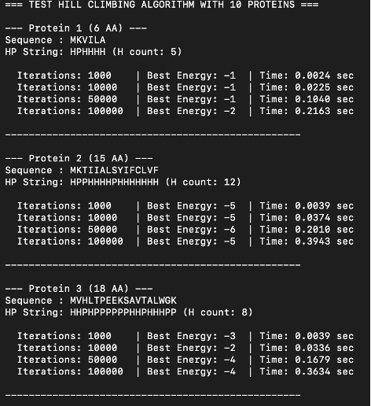
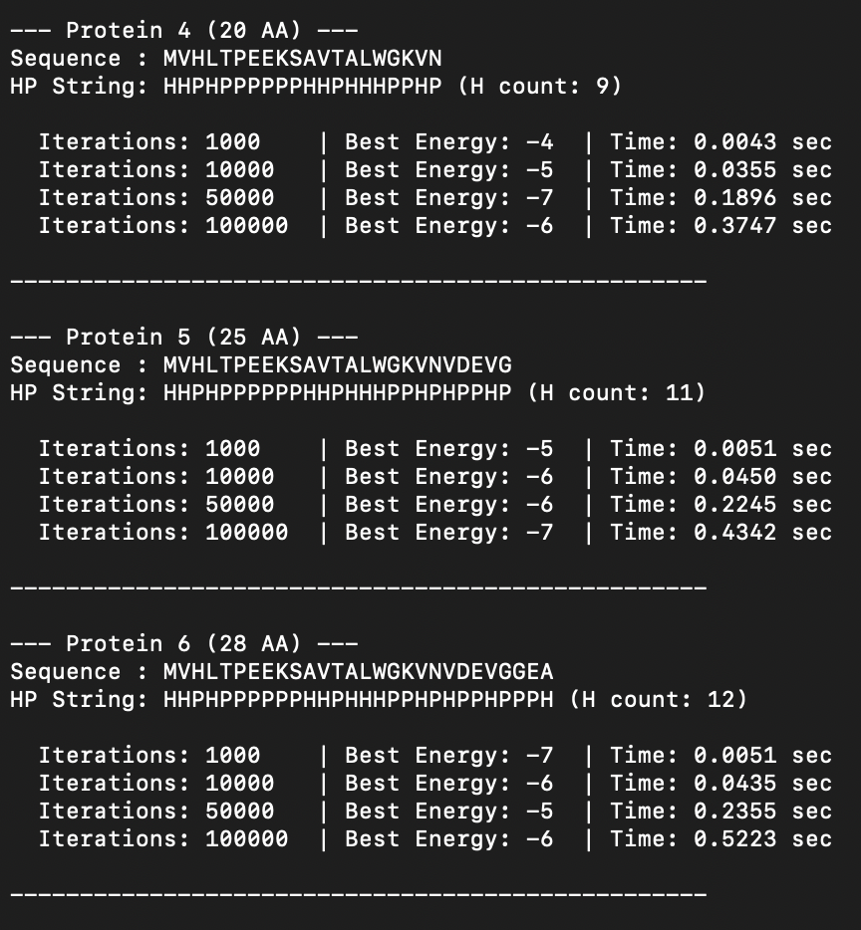

Simulated Annealing (SA) comparison
While the Hill Climbing algorithm is fast and effective, it has a major weakness: it often gets permanently stuck in "local minima." This happens when the protein folds into a shape that is locally stable but not the absolute best global structure, and the algorithm stops because any single move would temporarily worsen the energy. To solve this problem, we implemented a more advanced algorithm called Simulated Annealing (SA). Simulated Annealing is inspired by metallurgy, where metals are heated to extreme temperatures and then slowly cooled to form perfect, strong crystals. In our code, we simulate this process by adding a "Temperature" variable (T) that slowly decreases as the iterations progress. The main difference between SA and Hill Climbing is how they handle "bad" structural moves:
- Hill Climbing is strict: it only accepts moves that improve the energy (or keep it equal). If a move increases the energy (making the fold worse), it is instantly rejected.
- Simulated Annealing is flexible: it can occasionally accept "worse" moves! It calculates the energy difference (DeltaE) and accepts the bad move based on a specifically tuned probability formula: P = e^(-DeltaE / T).

How the Temperature dictates the search: At the beginning of the simulation, the computational Temperature (T) is set very high. Because of this, the algorithm frequently accepts bad moves. This is intentional: by making random, temporary "mistakes," it gives the protein chain enough thermodynamic momentum to jump out of local traps. As the simulation progresses, the Temperature slowly cools down. As T approaches zero, the probability of accepting a bad move drastically shrinks. In the final iterations, when the system is "cold," the SA algorithm becomes just as strict as Hill Climbing, locking the protein into the deepest, most stable energy state it has successfully discovered.

The Algorithm

Algorithm: Simulated Annealing with Pivot Moves
Input:
S: Amino acid sequence in HP format
N: Maximum number of iterations
T_Initial: Starting high temperature (e.g., 10.0)
T_Final: Ending low temperature (e.g., 0.01)
Output:
Best_State: The 2D conformation with lowest free energy
Best_Energy: The lowest energy achieved

Initialize Current_State as a straight, unfolded line on a 2D lattice.
Current_Energy ← Calculate_Energy(Current_State)
Best_State ← Current_State
Best_Energy ← Current_Energy

For iteration = 1 to N do:
Fraction ← (iteration - 1) / (N - 1)
T ← T_Initial * ( (T_Final / T_Initial) ^ Fraction )

Pivot_Index ← Random integer between 1 and length(S) - 2
Rotation_Angle ← Random choice from {90°, -90°, 180°}
New_State ← Apply_Rotation(Current_State, Pivot_Index, Rotation_Angle)

If Is_Self_Avoiding(New_State) is False then:
Continue to next iteration

New_Energy ← Calculate_Energy(New_State)

If New_Energy <= Current_Energy then:
Current_State ← New_State
Current_Energy ← New_Energy

If Current_Energy < Best_Energy then:
Best_State ← Current_State
Best_Energy ← Current_Energy

Else:
Delta_E ← New_Energy - Current_Energy
Probability ← e ^ (-Delta_E / T)

If Random_Float(0, 1) < Probability then:
// The bad move is temporarily accepted!
Current_State ← New_State
Current_Energy ← New_Energy

Return Best_State, Best_Energy

The Simulated Annealing (SA) algorithm operates similarly to Hill Climbing in how it generates physical moves on the grid, but its decision-making logic is fundamentally different. The process can be broken down into these direct steps:

- The Cooling Schedule (Phase 1): Unlike Hill Climbing, SA relies on a "Temperature" variable (T) that actively controls its behavior. At the start of each loop, the algorithm calculates the current temperature. Using an exponential cooling schedule, T begins at a high value (T_Initial) and slowly decays towards near-zero (T_Final) as the maximum number of iterations (N) approaches.

- Generating and Validating the Move (Phases 2 & 3): Just like the baseline model, the algorithm generates a random "neighbor" by selecting a pivot point and rotating a segment of the protein chain. If the new fold mathematically overlaps itself (violates physical constraints), it is instantly rejected.

- Standard Acceptance (Phase 5): If the new conformation has a lower energy (better stability) or equal energy (a plateau) compared to the current state, the algorithm behaves exactly like Hill Climbing: the move is enthusiastically accepted, and the global optimum is securely updated if necessary.

- The SA Acceptance Criterion (Phase 6): This is the core mechanic that defines Simulated Annealing. When the algorithm proposes a worse structural move (i.e., the free energy increases), it does not automatically reject it. Instead, it computes the energy difference (DeltaE) and calculates a specific Probability using the Boltzmann formula: P = e^(-Delta E / T). Then, a random number between 0 and 1 is drawn. If this random number is smaller than P, the bad move is temporarily accepted!

How the Probability works in practice:
- High Temperature (Early iterations): When T is very large, the Probability P approaches 1. The algorithm frequently accepts terrible moves. This is the chaotic "exploration" phase that violently forces the protein out of any local energy traps.
- Large Energy Jump: If the proposed move is exponentially worse (a huge DeltaE), the Probability P drops dramatically, making the algorithm less likely to completely destroy a good structure.
- Low Temperature (Late iterations): As T cools down toward 0.01, the Probability P approaches 0. The algorithm stops accepting bad moves and transitions into a strict, greedy local search to perfectly optimize its final position.
The function to calculate the energy in the SA algorithm is identical to the one used in the Hill Climbinig algorithm. The only thing that changes is how the energy is used after calculating it.

Test and Results

The evaluation of the Simulated Annealing (SA) algorithm across the identical dataset of 10 proteins yielded highly insightful results, decisively confirming its theoretical superiority over the baseline Stochastic Hill Climbing (HC) approach. The comparison unveils three critical observations regarding algorithmic performance, computational overhead, and optimization capabilities:
- Superior Global Optimization (Deep Minimum Discovery) The most prominent finding is SA’s superior ability to discover significantly lower thermodynamic free energies, particularly as the protein chain length and combinatorial complexity increase (Proteins 7 through 10). For the most complex sequence evaluated (Protein 10, 42 AA), the standard HC algorithm peaked at an energy of -12 (and regressed to -9 at 100,000 iterations due to getting trapped in a poor local minimum). In stark contrast, SA successfully leveraged its initial "hot" exploration phase to escape local traps, ultimately converging at an impressive global energy of -14 at 100,000 iterations. A similar trend is overwhelmingly visible across Protein 7 (-12 vs -8) and Protein 8 (-13 vs -4).
- Near-Zero Computational Overhead A primary concern when upgrading from HC to SA is the potential performance bottleneck introduced by having to constantly calculate the exponential cooling schedule and the Boltzmann acceptance probability (e^(-DeltaE / T) ). However, the recorded temporal data conclusively dismisses this concern. The execution time for SA remained remarkably identical to HC, peaking at just ~0.76 seconds for 100,000 iterations on the longest chain. The algorithmic upgrade provides vastly superior folding accuracy with effectively zero penalty to computational speed.
- Mitigation of Early Convergence The erratic behavior observed in the HC data—where 100,000 iterations sometimes produced markedly worse final conformations than 10,000 iterations (e.g., Protein 8) is heavily mitigated in the SA variant. While SA remains a stochastic algorithm and exhibits mild variance (as seen in Protein 7, where 10,000 iterations temporarily outperformed 50,000), its overarching trend explicitly demonstrates that prolonged iteration budgets (100,000) reliably correspond to deeper, more stable energy wells (-12, -13, -13, -14). The controlled cooling schedule reliably transitions the algorithm from chaotic exploration to strict exploitation, effectively locking in the optimal fold.
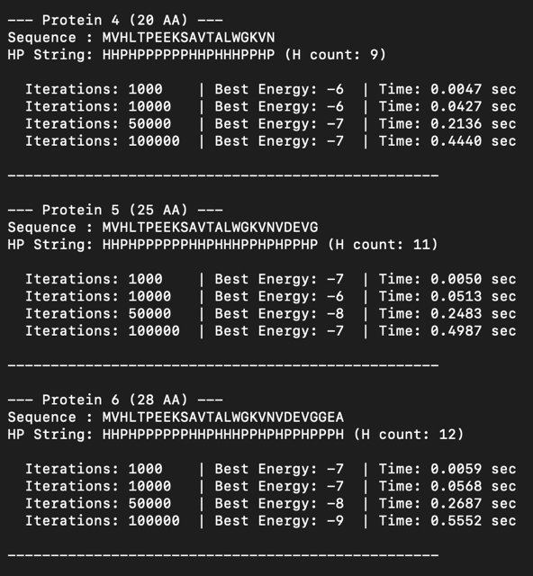
The empirical data validates the implementation of Simulated Annealing for the 2D HP protein folding problem. By probabilistically accepting inferior moves during its early phases, SA circumvents the immediate limits of the energy landscape, consistently driving the protein chain toward a more native, thermodynamically optimal configuration than standard local search techniques.
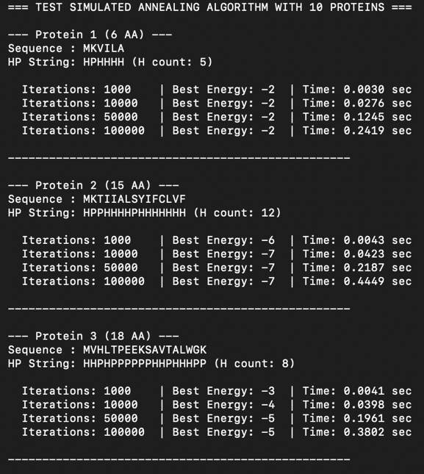

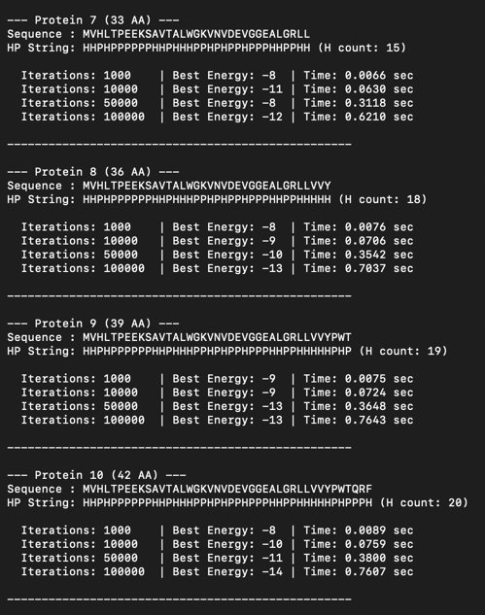

Conclusion
This study evaluated Stochastic Hill Climbing (HC) and Simulated Annealing (SA) for predicting protein folding using the 2D HP lattice model. The empirical testing across 10 protein sequences demonstrated the definitive superiority of SA over standard HC. While HC is fast and effective for very short amino acid chains, its strict acceptance logic caused it to permanently stall in local energy minima on longer sequences (e.g., getting trapped at -9 energy for Protein 10). Because HC strictly refuses to accept temporary energy-increasing moves, it fundamentally lacks the momentum to escape shallow structural traps. Conversely, SA successfully bypassed these local optima. By utilizing a "Temperature" parameter to probabilistically accept worse moves during its early "hot" exploratory phase, SA achieved the thermodynamic flexibility needed to discover significantly deeper and more stable global optima (consistently reaching -14 energy for Protein 10). Furthermore, timing data proved that the advanced probabilistic calculations required by SA introduced virtually zero computational delay compared to HC. Consequently, we confidently conclude that Simulated Annealing is the vastly superior choice for reliably navigating the rugged combinatorial landscape of protein folding.

