**Notice : Berikut beberapa bugs yang saya temukan di automationpractice.com. Terdiri dari beberapa functional bugs dan ada juga beberapa UX / UI Review. Untuk functional bugs, saya buat juga automation scenario nya dengan selenium. Untuk UX / UI review saya berikan anotasi di gambar yang saya sertakan di dokumen ini. Terimakasih. Have a nice day!**

1. **[Home Page][Add to Chart]** Add to Chart Button Does not Work on Many Products

**Summary :** Many Add to Chart Button doesnt work even though it still have a stock on it. This bug happen in a product which doesnt has a complete choice for it size.

**Bugs Reproduce :**

* Open automationpractice.com

* Find a product which has out of stock in some size (Ex : Size S)

* Click Add to Chart Button (Click the button from home page)

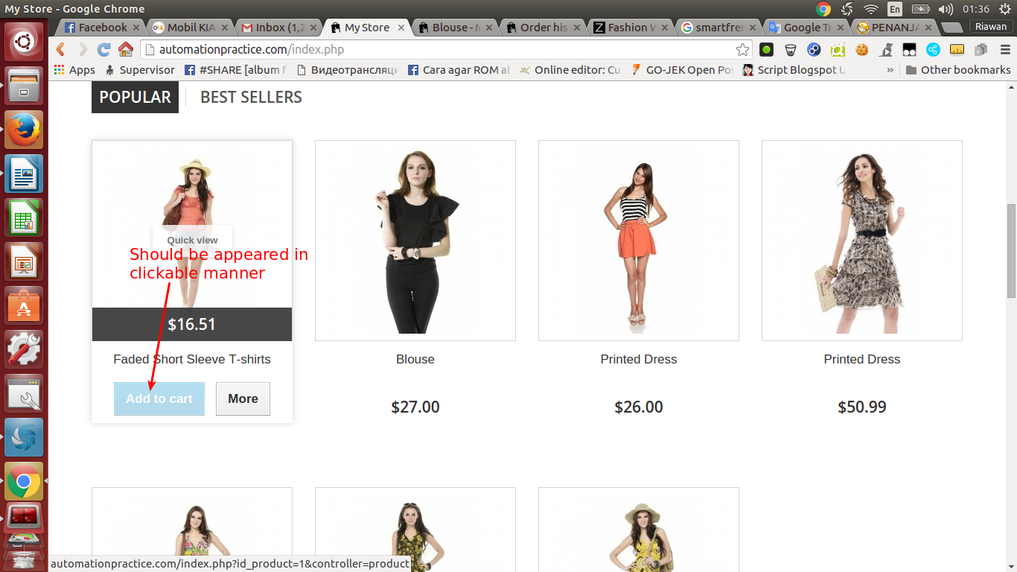

**Defect :**

* Add to Chart button disabled even though selected products still have a stock in various size.

**Expected Results :**

* Add to Chart button must be appeared in clickable mode in a products which still have a stock in various size.

**2. [UI/UX][Navbar]** Navigation Bar Design Failure

**Summary :** Navigation bar design is inconsistent with the requierements.

**Bugs Reproduce :**

**\*** Open automationpractice.com

* Find the navigation bar

* Take an attention on web logo, search bar, shopping chart and category menu

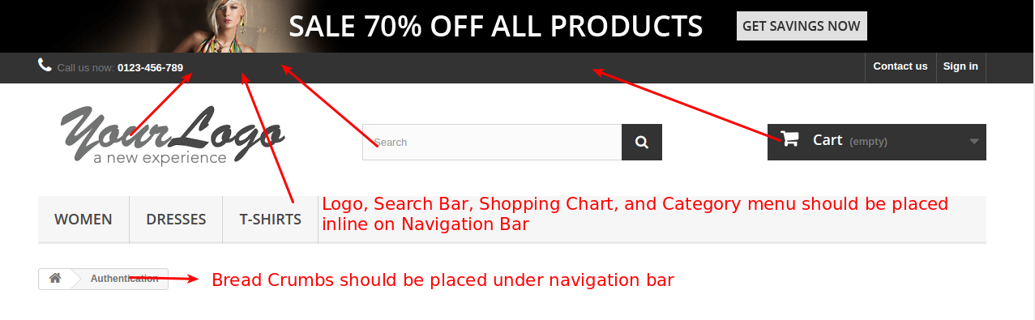

**Expected Results :**

* Logo, Search Bar, Shopping Chart, and Category Menu should be placed inline on Navigation Bar

**3. [UI/UX][Bread Crumbs]** Bread Crumbs Should be Placed Under Navigation Bar

**Summary :** Bread crumbs doesnt placed properly. It should be placed under Navigation Bar

**Bugs Reproduce :**

* Open automationpractice.com

* Click on Sign in link

* Take an attention at Bread Crumbs link

**Expected Results :**

* Bread Crumbs should be placed under navigation bar

* Bread Crumbs should be appear in 2nd layer page (Ex : home/ 2nd layer page...)

**4. [UI/UX][Category Menu]** Incorrect Placement of Products Highlights

**Summary :** There are 2 products highlights which not placed correctly. Products highlights should be placed on Home page area.

**Bugs Reproduce :**

* Open automationpractice.com

* Hover Women menu on Category menu

**Defect :**

* Products highlight placed incorrectly

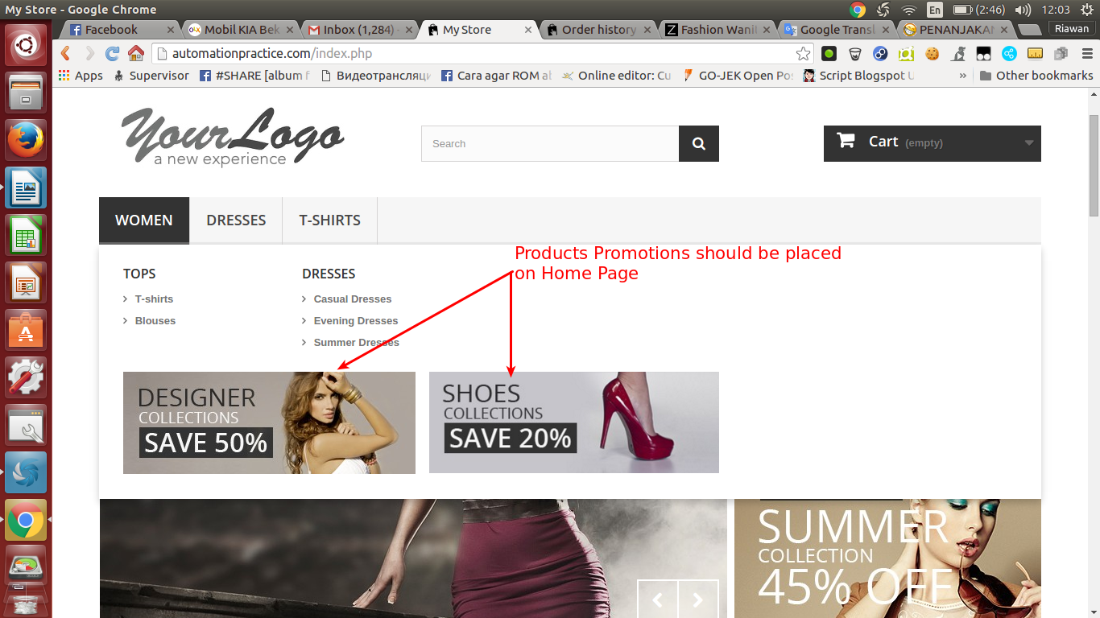

**Expected Results :**

* Products highlights placed on home page area

**5. [Footer][Information]** User Doesnt Directed to Information Page

**Bugs Reproduce :**

* Open automationpractice.com

* Scroll down the page

* Click on Information Link which appeared in footer container box

**Defects :**

* User doesnt directed to clicked link (Information link)

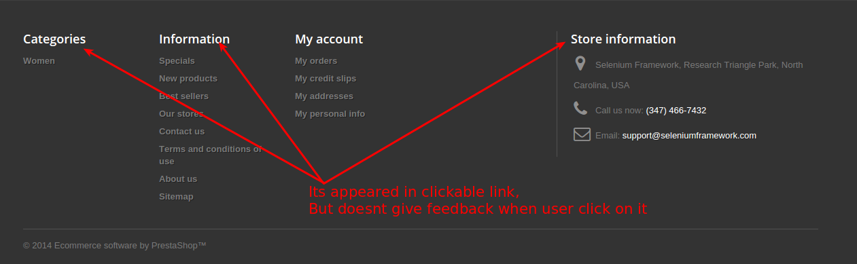

**Expected Results :**

* User directed to information page when clicking the link

**6. [Footer][Categories]** User Doesnt Directed to Categories Menu Page

**Bugs Reproduce :**

* Open automationpractice.com

* Scroll down the page

* Click on Categories Link which appeared in footer container box

**Defects :**

* User doesnt directed to clicked link (Categories link)



**Expected Results :**

* User directed to Categories Menu page when clicking the link

**7. [Footer][Store Information]** User Doesnt Directed to Store Information Page

**Bugs Reproduce :**

* Open automationpractice.com

* Scroll down the page

* Click on Store Information Link which appeared in footer container box

**Defects :**

* User doesnt directed to clicked link (Store Information link)



**Expected Results :**

* User directed to Store Information page when clicking the link

**8. [UI/UX][Category Menu]** Incorrect Arrengements of Category Menu

**Summary :** There are 3 Sub-Menu which not arranged correctly. The Sub-Menu Category should be arranged based on design requirements.

**Bugs Reproduce :**

* Open automationpractice.com

* Hover Dresses menu on Category menu

**Defect :**

* Sub-Category menu not arranged correctly

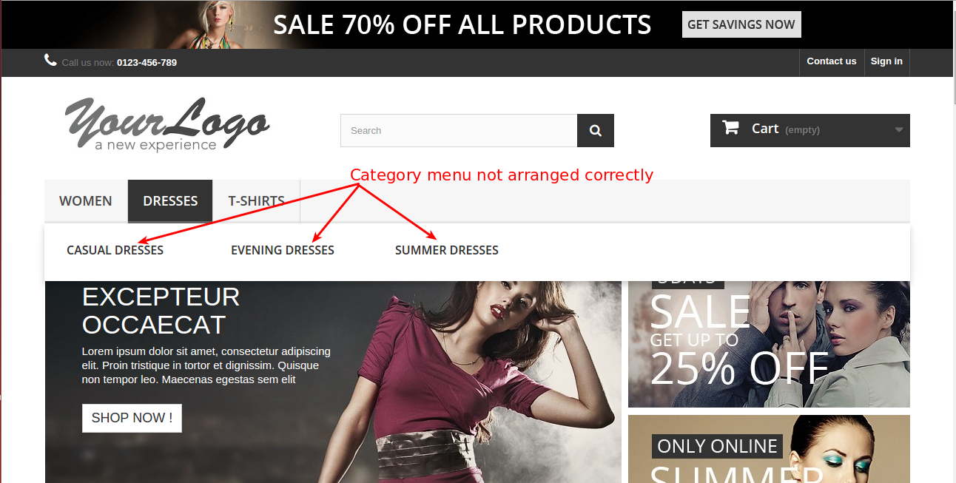

**9. [Sign In][Create an Account]** User Doesnt Get The Activation Email

**Summary :** User didnt get the activation email after finishing the registration process

**Bugs Reproduce :**

* Open automationpractice.com

* Click Sign In

* Enter a valid email

* Finish the registration process

* Cek the email inbox

**Defect :**

* User didnt get the activation email

**Expected Result :**

* User get an activation email after finishing the registration process

**9. [Sign In][Create an Account]** User Can not Dismiss The Error Notice

**Summary :** User Can not Dismiss The Error Notice

**Bugs Reproduce :**

* Open automationpractice.com

* Click Sign In

* Enter an invalid email

* Click the X button

**Defect :**

* User Can not Dismiss The Error Notice

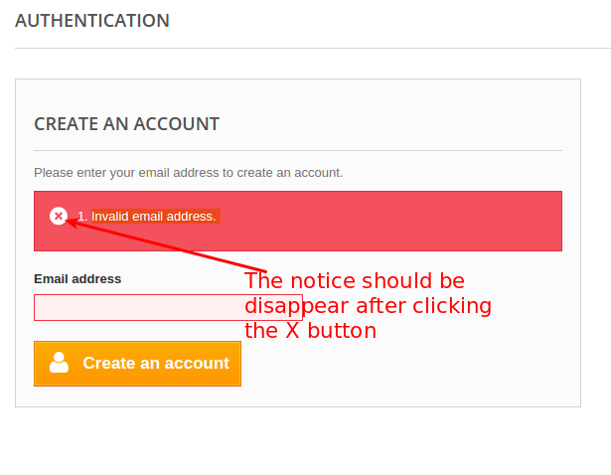

**Expected Result :**

* User Can Dismiss The Error Notice