ANDROID CHAT APPLICATION USING FIREBASE

Submitted to

DEPARTMENT OF
COMPUTER SCIENCE ENGINEERING

Under the Supervision of

Guide/Reviewer’s Name: Ms. Uma N
Signature with Date: ________



By

USN | Name of the student | Semester | Section | Sign.
1NH15CS018 | ARBIND SARAF | 6 | A

NEW HORIZON COLLEGE OF ENGINEERING
Autonomous College Permanently Affiliated VTU, Approved by AICTE & UGC
Accredited by NAAC with ‘A’ Grade, Accredited by NBA
BANGALORE-560 103
2017-18

Functional Block Diagram:

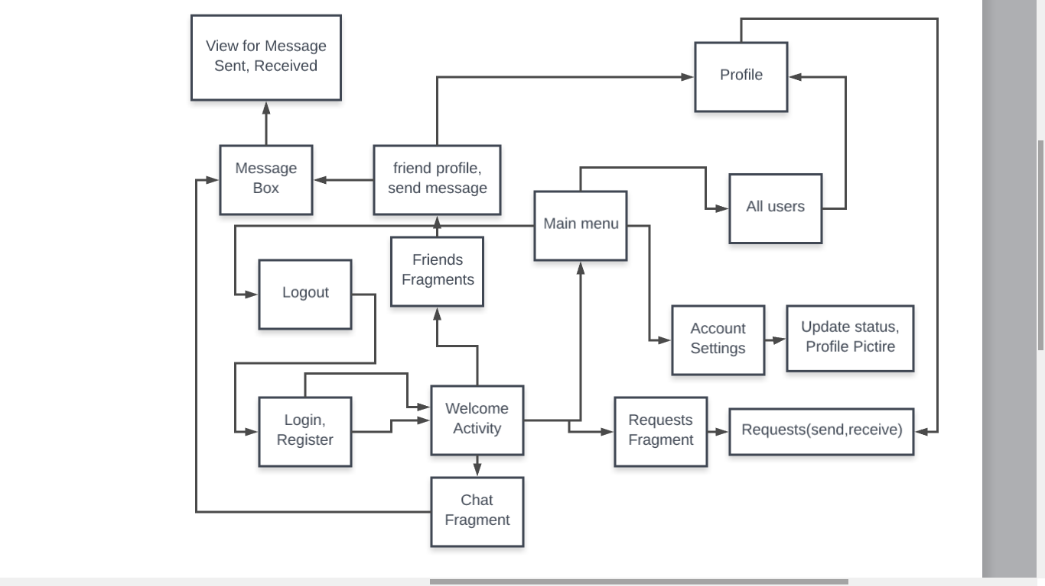
fig: Block diagram for Messaging App

Important Code Snippets:

List of APIs used in App

- Firebase APIs --
'com.google.firebase:firebase-auth:11.0.4'
'com.google.firebase:firebase-database:11.0.4'
'com.google.firebase:firebase-storage:11.0.4'
'com.firebaseui:firebase-ui-database:2.3.0'

- Cirricular Image View --'de.hdodenhof:circleimageview:2.1.0'
- Cropping image --'com.theartofdev.edmodo:android-image-cropper:2.4.+'
- Picasso image utilities --'com.squareup.picasso:picasso:2.5.2'
- Image Compressor --'id.zelory:compressor:2.1.0'
- Offline Features 'com.squareup.okhttp:okhttp:2.5.0'

Partial Execution:

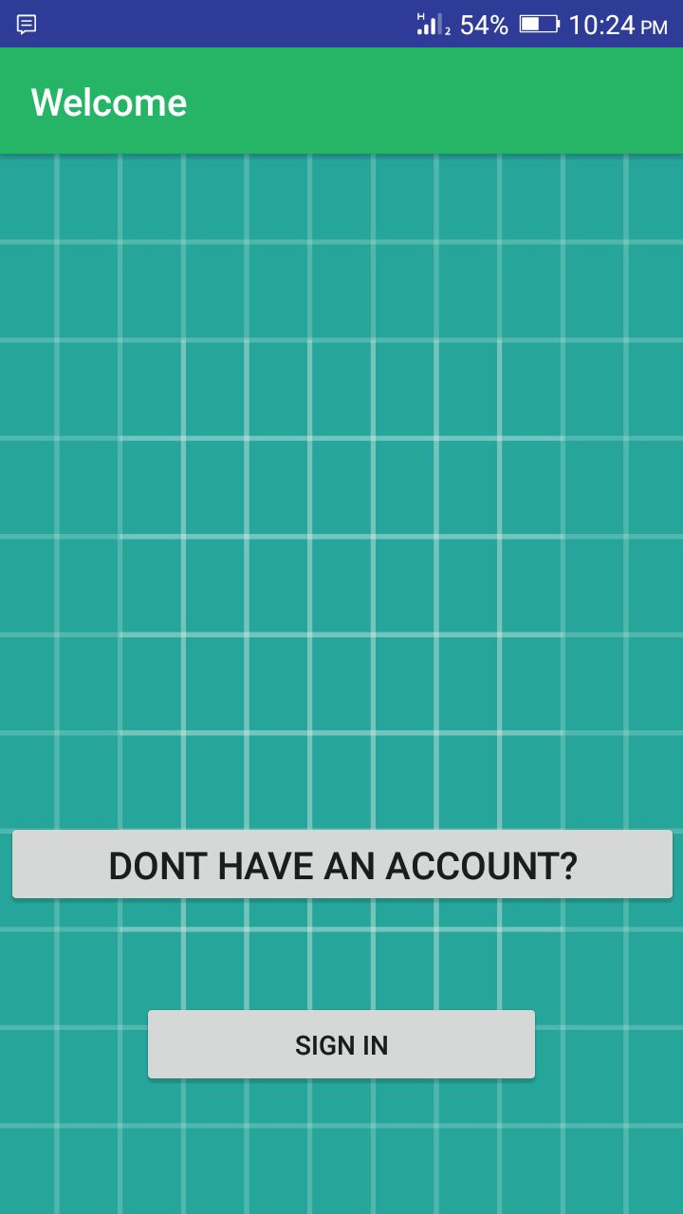
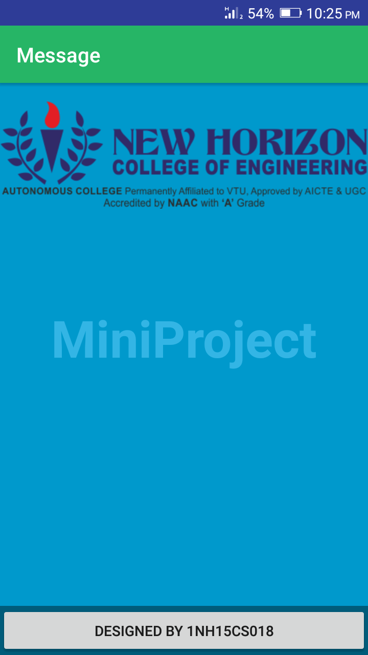
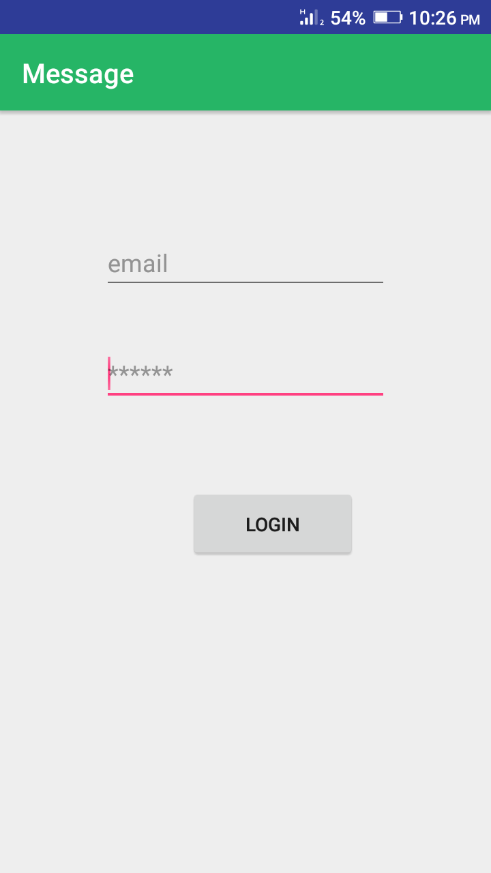

Welcome Activity Startup Activity Login Activity

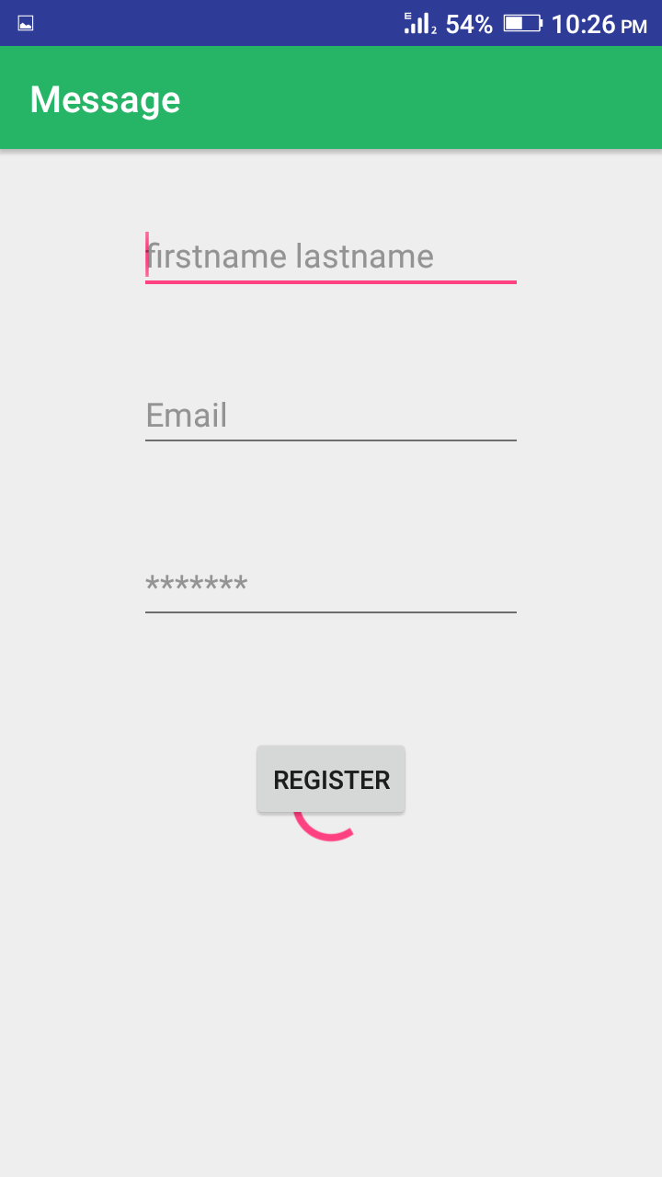
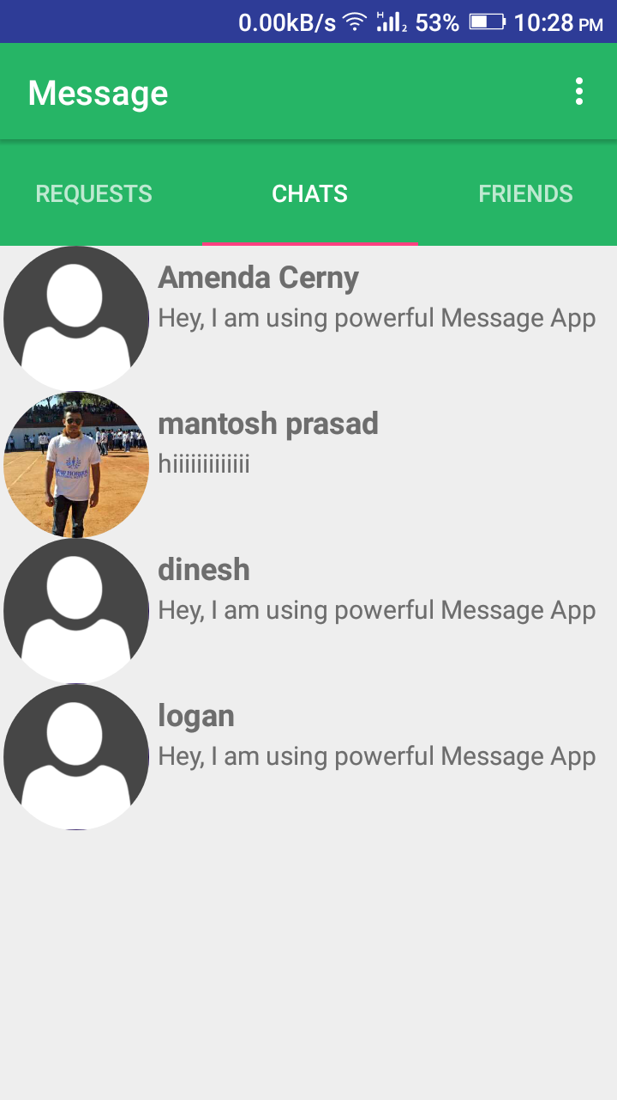
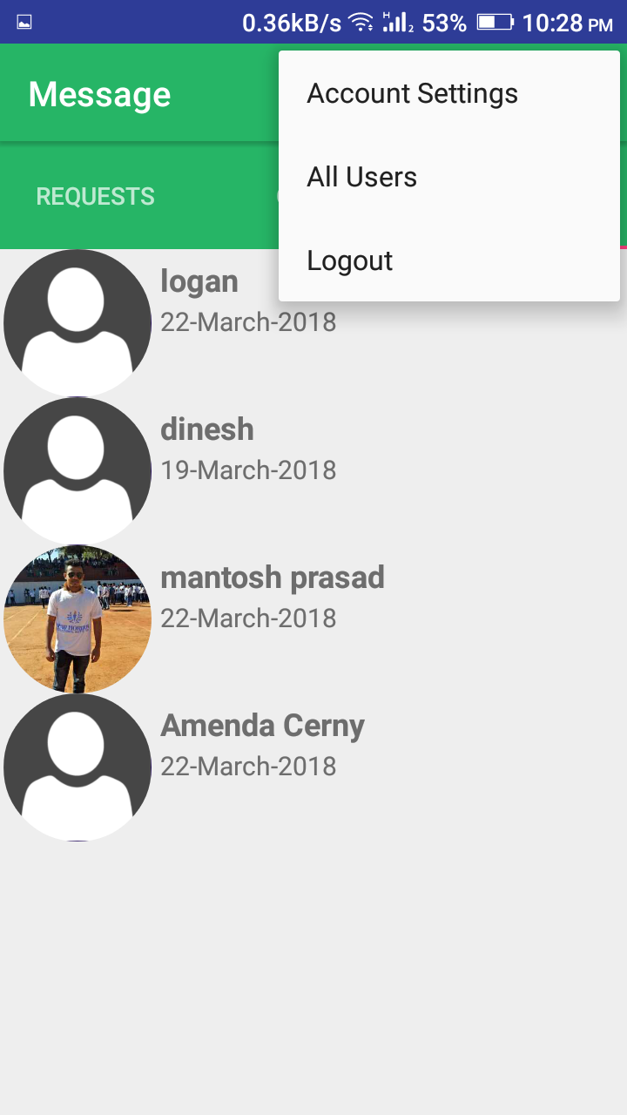

Register Activity Chats Activity Infaltor Menu

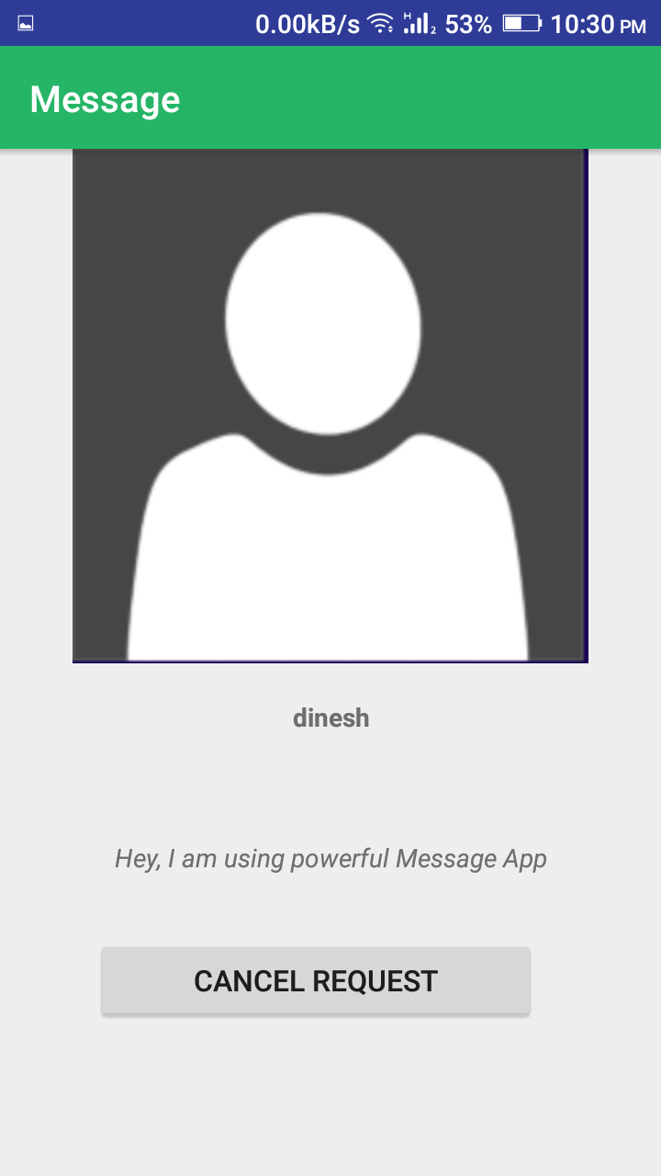
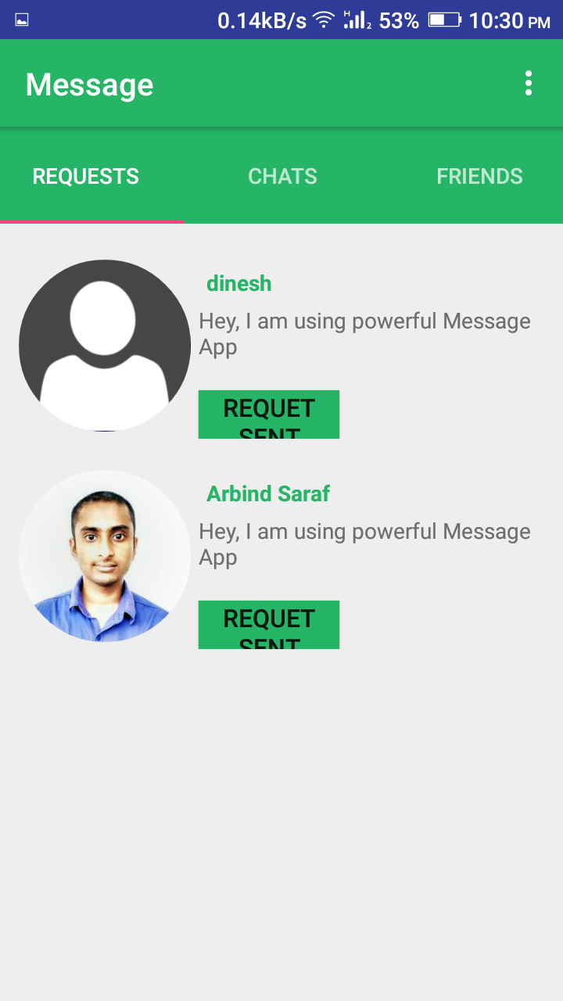
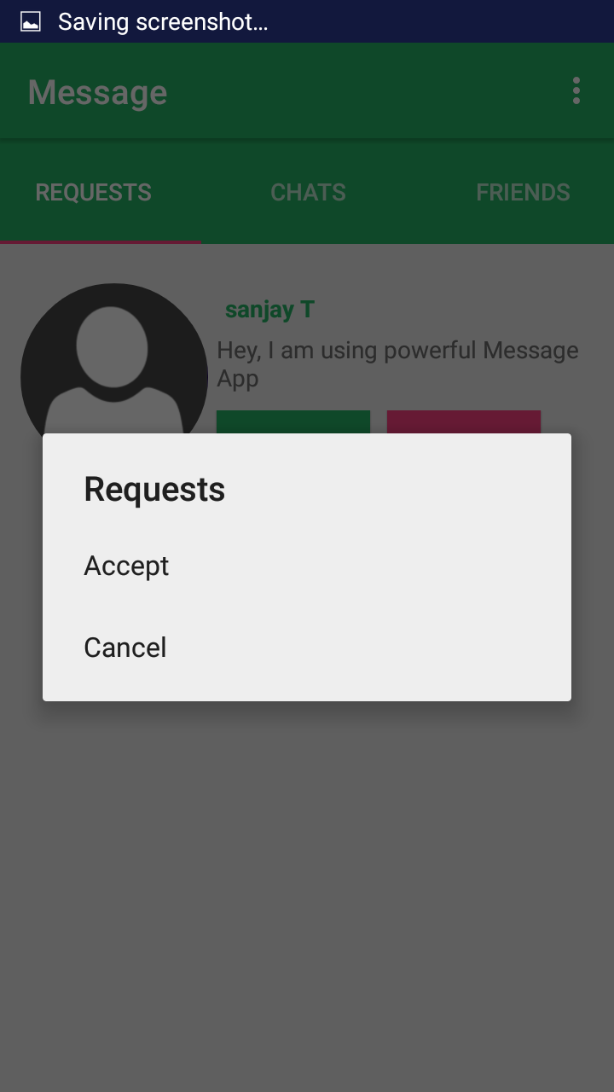

Profile Activity Request Fragment Options for Request

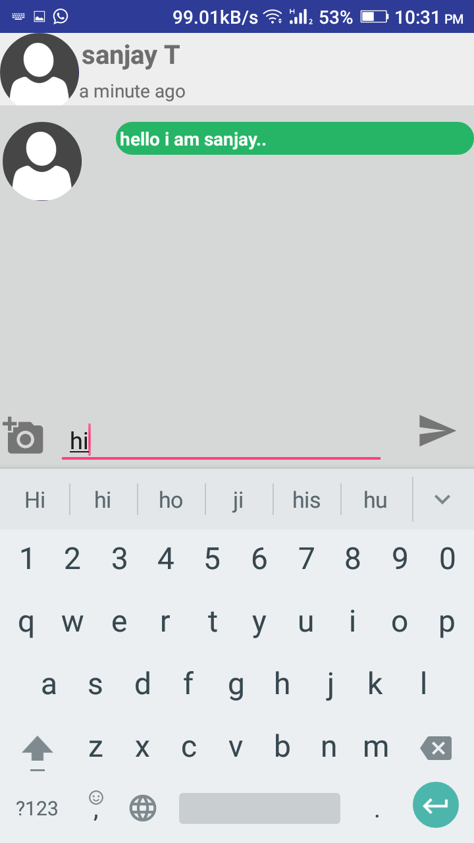
Message Activity

