STUDENT PERFORMANCE CLASSIFICATION USING MACHINE LEARNING
Task: Supervised Classification Model

Student Performance Classification Project

1. Objective
The objective of this project is to build and evaluate a supervised machine learning classification model to predict whether a student will pass or fail.
The project includes data preprocessing, train-test splitting, cross-validation, training multiple classification algorithms, and evaluating the models using several performance metrics.
The following two machine learning algorithms were compared:
Logistic Regression
Random Forest Classifier
The models were evaluated using:
Accuracy
Precision
Recall
F1-Score
ROC-AUC

2. Dataset Description
This project uses the Student Performance dataset, which contains information about students and their academic, demographic, and social characteristics.
The dataset contains:
395 student records
33 original columns
The original dataset includes features such as:
School
Gender
Age
Address
Family information
Study time
Previous failures
Internet access
Absences
Other student-related information
Target Variable
A new binary target variable called Pass was created using the final grade G3:
Pass = 1 when G3 >= 10
Fail = 0 when G3 < 10
The final grade columns G1, G2, and G3 were removed from the model input features to prevent data leakage.
Data leakage occurs when information that directly reveals the answer is given to the machine learning model during training.

3. Data Preprocessing
The dataset was preprocessed before training the machine learning models.
Missing Value Checking
The dataset was checked for missing values using the isnull().sum() function. This helped determine whether any values needed to be filled or removed.
Duplicate Checking
The dataset was also checked for duplicate rows using the duplicated().sum() function.
Preventing Data Leakage
The columns G1, G2, and G3 were removed from the input features. These columns represent academic grades and could provide information directly related to the target variable.
Removing them helps ensure that the models make predictions using the remaining student information rather than directly seeing the answer.
Numerical Feature Preprocessing
Numerical features were processed using:
Median imputation for missing values
StandardScaler for feature scaling
Categorical Feature Preprocessing
Categorical features were processed using:
Most-frequent imputation for missing values
One-hot encoding to convert categorical values into numerical values
A ColumnTransformer was used to apply the appropriate preprocessing method to each type of feature.

4. Train-Test Split and Cross-Validation
The dataset was divided into two parts before training the machine learning models.
* Training Data: 80%
* Testing Data: 20%
The training dataset was used to train the machine learning models, while the testing dataset was used to evaluate their performance on unseen data.
To ensure reliable performance, 5-Fold Stratified Cross-Validation was performed. This method divides the dataset into five equal parts. During each iteration, four parts are used for training and one part is used for validation. The process is repeated five times, and the average accuracy is calculated.
Cross-Validation Results
Model Mean Cross-Validation Accuracy
Logistic Regression 67.85%
Random Forest 68.61%
The Random Forest model achieved a slightly higher cross-validation accuracy, indicating better overall performance and stability.

5. Machine Learning Models
Two supervised machine learning algorithms were used in this project.
Logistic Regression
Logistic Regression is a linear classification algorithm used to predict whether a student will pass or fail. It estimates the probability of belonging to a particular class.
Random Forest Classifier
Random Forest is an ensemble learning algorithm that combines multiple decision trees to improve prediction accuracy and reduce overfitting. It is capable of handling both numerical and categorical data efficiently.
Both models were trained using the same training dataset and evaluated using the same testing dataset to ensure a fair comparison.

6. Results
The performance of both machine learning models was evaluated using Accuracy, Precision, Recall, F1-Score, ROC-AUC, and Cross-Validation Accuracy.
Performance Comparison
Model | Accuracy | Precision | Recall | F1-Score | ROC-AUC | Mean CV Accuracy
Logistic Regression | 65.82% | 71.67% | 81.13% | 76.11% | 58.85% | 67.85%
Random Forest | 65.82% | 69.70% | 86.79% | 77.31% | 64.08% | 68.61%

Interpretation
Both models achieved the same accuracy of 65.82%. However, the Random Forest model achieved higher Recall, F1-Score, ROC-AUC, and Cross-Validation Accuracy. Therefore, Random Forest performed slightly better overall.

7. Project Screenshots

- Dataset Loaded Successfully
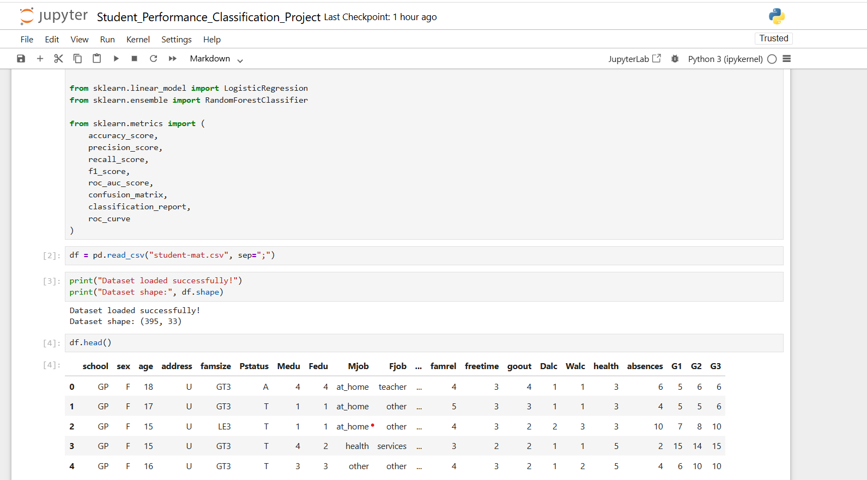
- Pass/Fail Distribution Graph
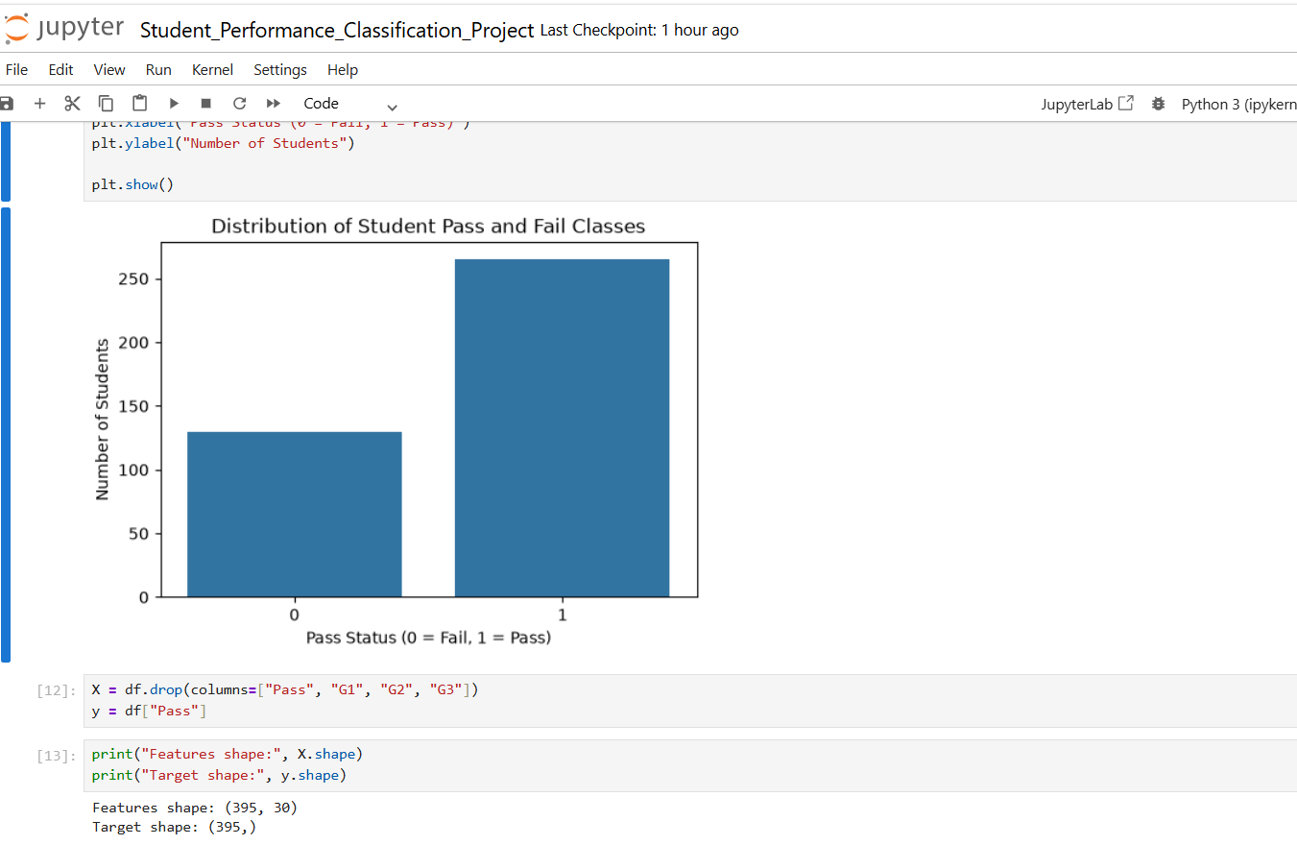
- Logistic Regression Confusion Matrix
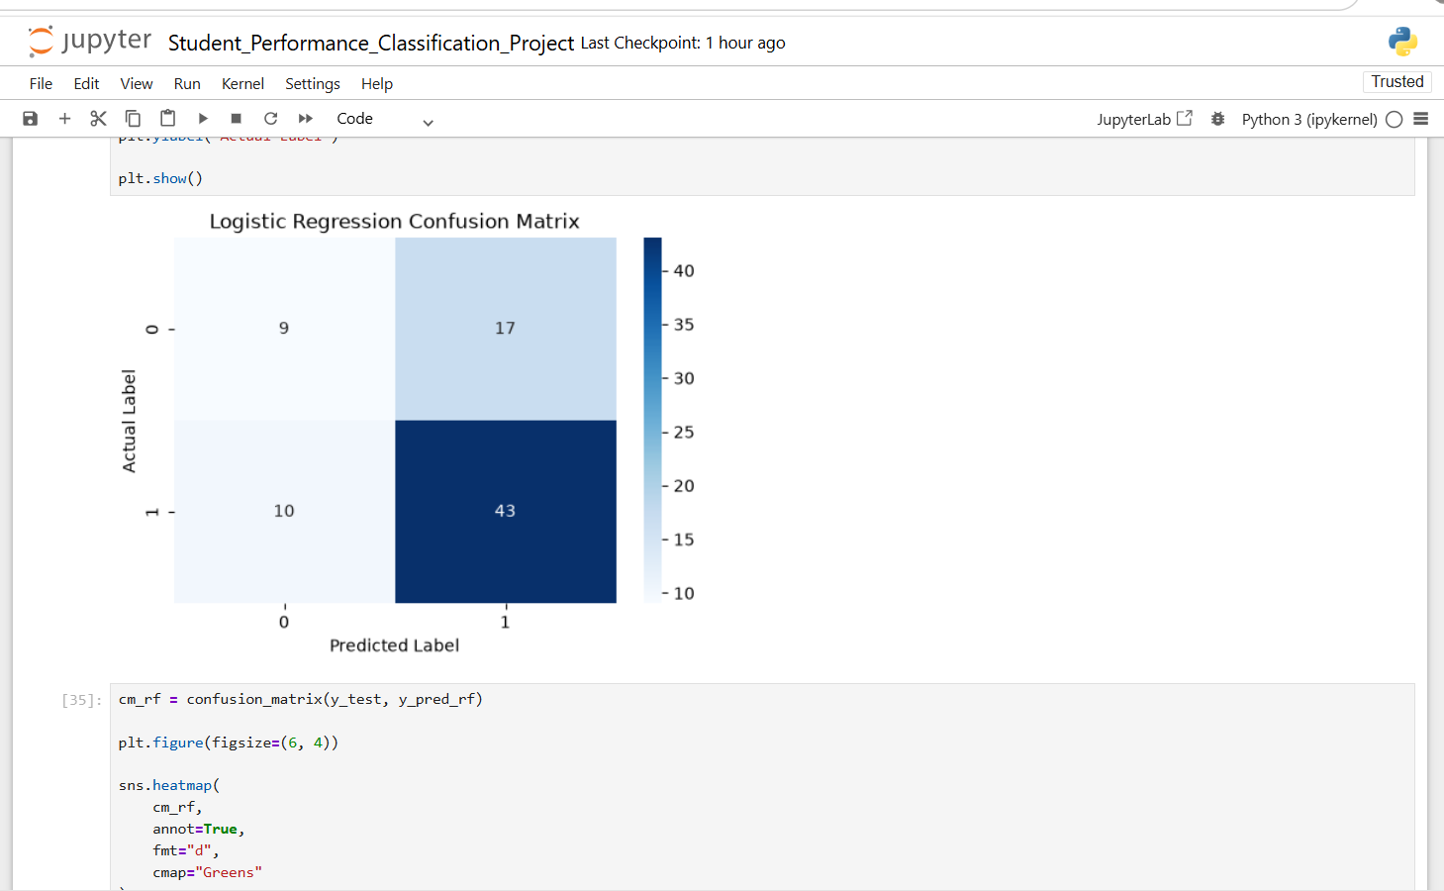
- Random Forest Confusion Matrix
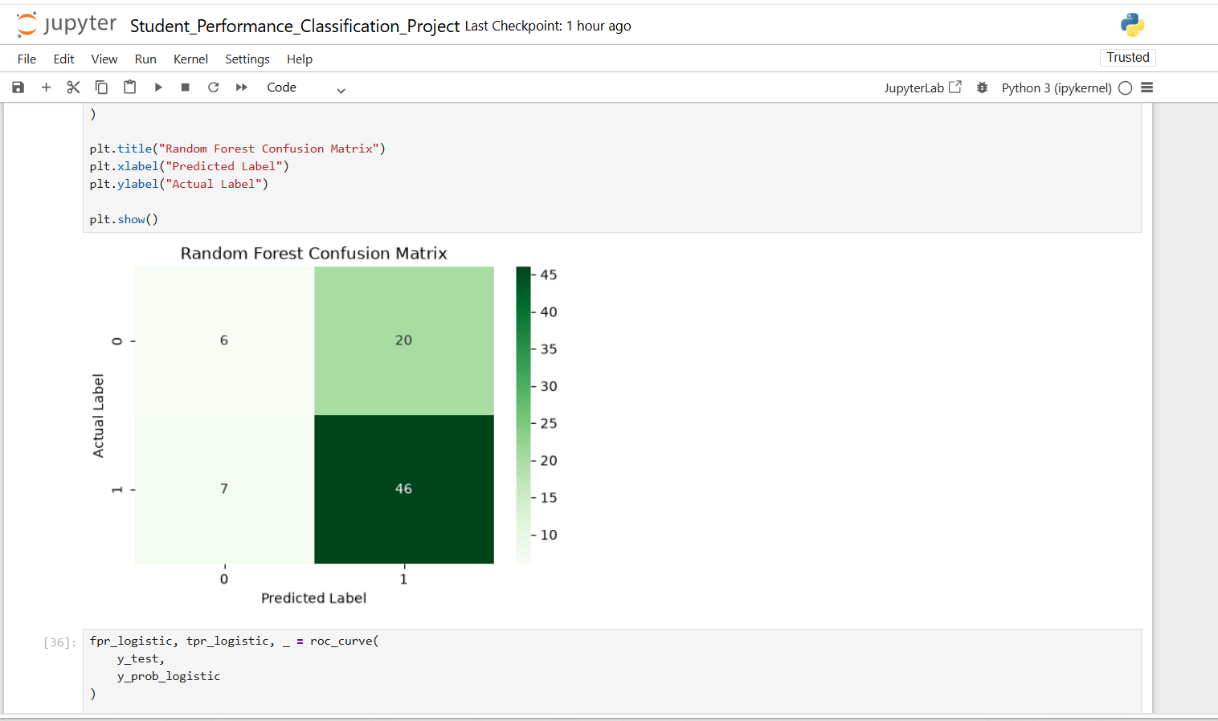
- ROC Curve Comparison
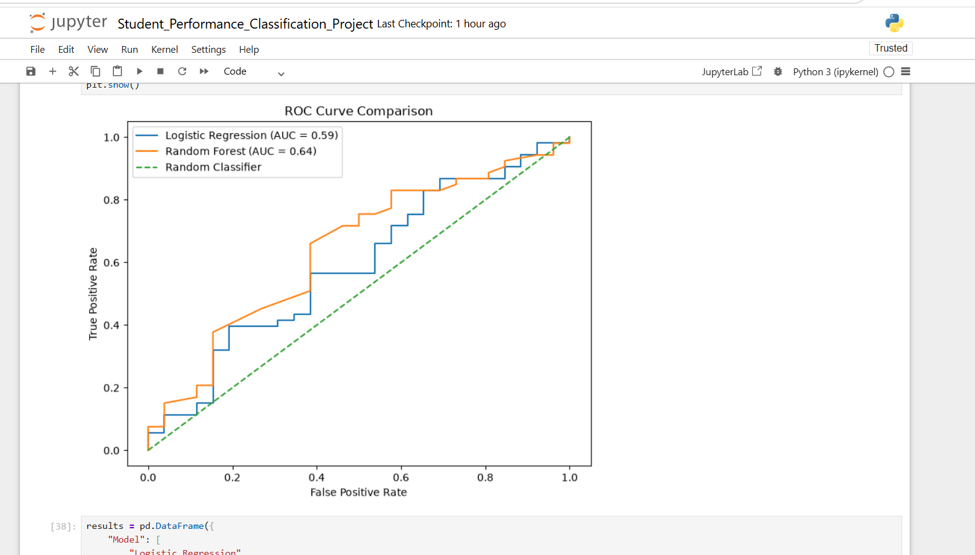
- Model Comparison Graph
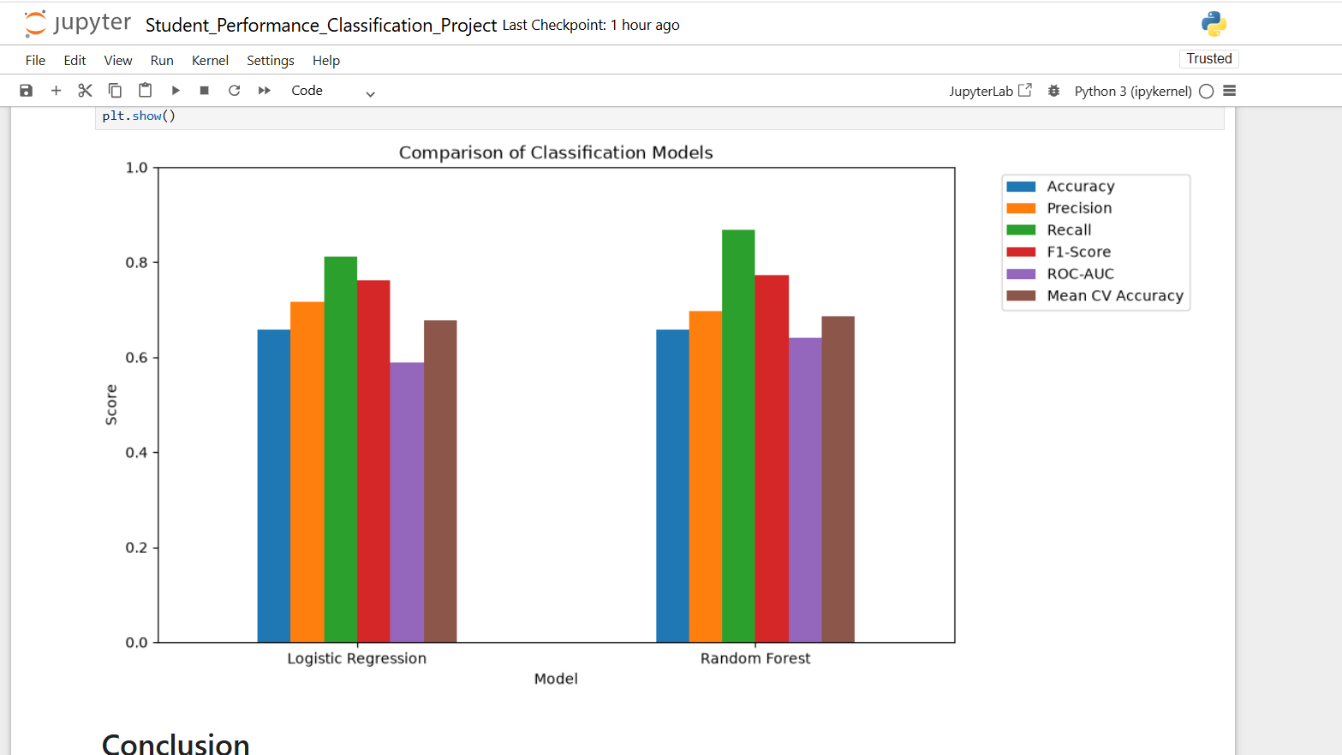

8. Conclusion
This project successfully developed a supervised machine learning classification model to predict whether a student would pass or fail.
The dataset was preprocessed by checking missing values, duplicate records, encoding categorical features, scaling numerical features, and preventing data leakage.
Two machine learning algorithms, Logistic Regression and Random Forest, were trained and evaluated.
Based on the evaluation metrics and 5-fold cross-validation, the Random Forest Classifier was selected as the best-performing model because it achieved better Recall, F1-Score, ROC-AUC, and Cross-Validation Accuracy.
This project demonstrates how supervised machine learning can be applied to educational data for student performance prediction.

